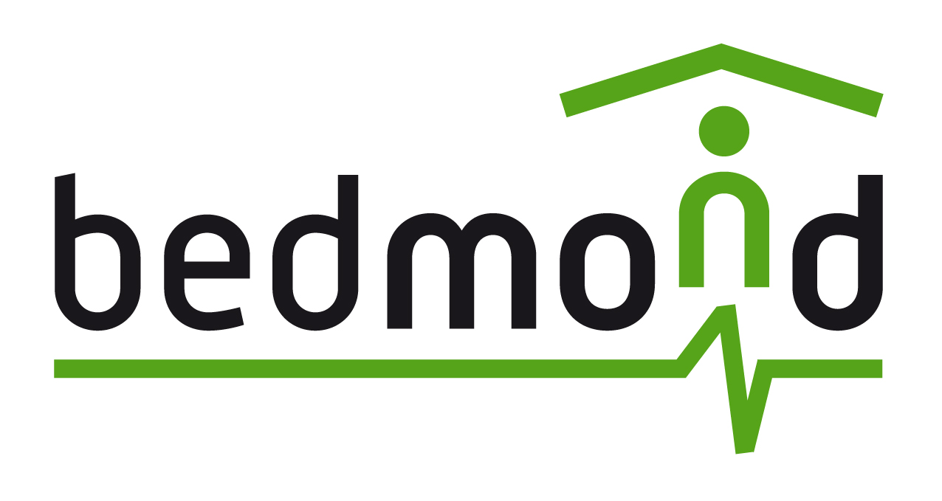
WHAT IS IT?
- BEDMOND is a “Behaviour pattern based assistant for the early detection and management of neurodegenerative diseases”, an AAL technology-based system focused in elderly people while living at home.
WHOM is it FOR?
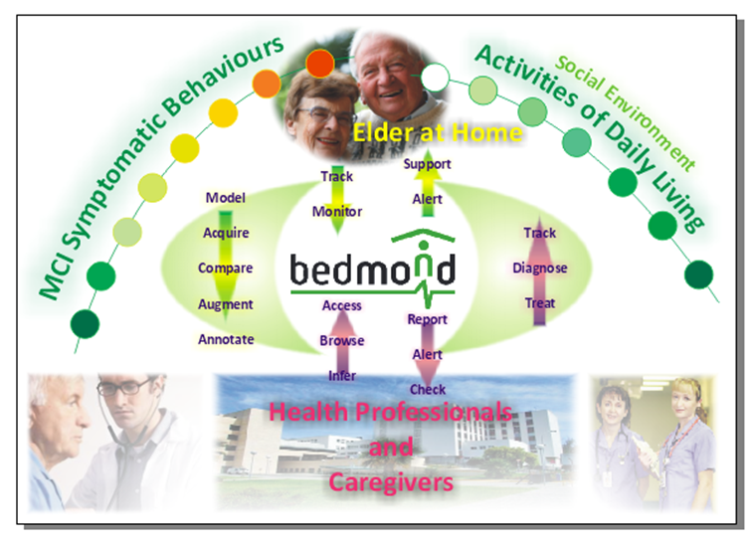
- Elderly people oversensitive to MCI (Mild Cognitive Impairment)
- Healthcare professionals:
  - doctors (neurologists, geriatrists, gerontologists)
  - formal caregivers (nurses, carers)
- Informal caregivers: family members, neighbours, close friends.

WHY IS IT NECESSARY?
- Healthcare professionals’ research overwhelms with very convincing arguments that the detection of MCI at an early stage supports a longer independent life at home for the patient because pharmacological treatment can be applied from the very beginning symptoms of such a critical disease for our Society.
- Healthcare professionals are in a need of objective data about daily behaviour and activities of the person to infer robust conclusions about a possible cognitive decline related to neurodegenerative disease and not to the normal ageing process. This objective data can be provided by a non-intrusive sensor-based home and an adaptive activity recognizing and tracking software, which later uses the health professional knowledge to interpret adequately that amount of information to fit and match it on an international scale for cognitive decline screening.
WHAT IS IT FOR?
- Bedmond system tools provide support in both stages: early diagnosis and disease tracking. For both stages, several tools are fitted for the specific needs of end users: health professionals, caregivers and the elder himself.
- During the early diagnosis,
  - The elder receives no support from Bedmond system in order not to disturb his daily life while still sane. A technical alarm system module can be installed at home. Bedmond is transparent while living alone.
  - The health professional periodically receives a report which has processed intelligently the sensor information about the elder’s activity and behaviour. This report shows “attention points”, just up to MCI stage, specific information about deviations on daily routines and behaviour patterns - concerning the MCI appearance- and screening questionnaires fulfilment when requested. He can also check evolution history and trends as relevant information.
  - The caregivers are daily reported with main information about previous-day activity: meals, medications, visits in and visits out. She also has a friendly tool to annotate the elder’s appointments and their fulfilments.
- During the treatment process,
  - The elder receives some support from Bedmond system prescribed by the doctor in order to help him in his daily life, now on a cognitive decline phase: digital agenda to remind appointments and medication intakes, alarms ….
  - The health professional receives a similar report to pre-diagnosis stage, with the desired periodicity, now normally shorter than in pre-diagnosis stage. Specific periodical questionnaires for cognitive decline screening are provided.
  - The caregivers are daily reported, empowered with some disease concerned information. Besides the digital agenda, the caregiver will have now a tool for acquainting the doctor periodically with the elder’s behavioural diary tool.
HOW DOES IT WORK?
- Bedmond provides a scalable hardware platform composed of a group of wireless and wired sensors in a home network controlled by a specific STB on a TV set.
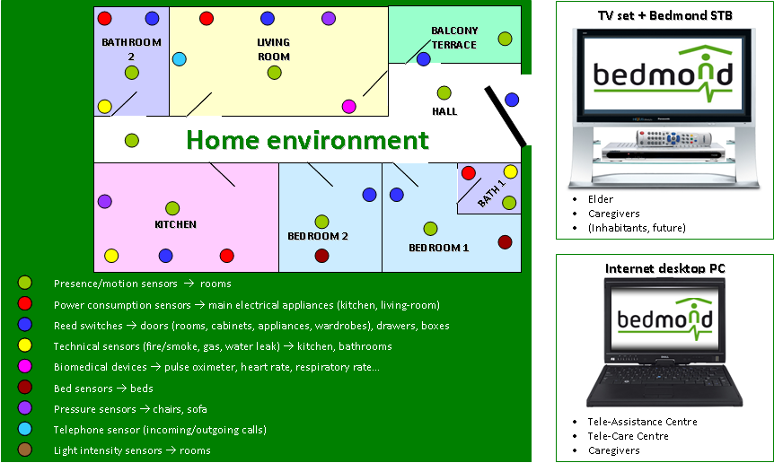
- Bedmond firstly analyses the person and then designs and records the best-matching behaviour and activity pattern of the elderly person while being at home.
- Then, Bedmond system tracks and monitors the daily activity and behaviour of the elder and compares it against the pattern. Deviations are calculated and interpreted through doctor’s and physician international scales’ criteria.
- Some risky situations (alarms in general) are warned in real time to persons at home (elder and caregivers).
- Some specific daily activities are reported to the caregivers.
- With deviations detected, these are intelligently interpreted for the health professional to be acquainted with normal or out-of-range performance, on a web application interface. Then, he will decide, with information provided, the actions to take.
- Data acquisition and basic processing is done at home Bedmond unit, while strong processing and interpretation are on tele-care Bedmond unit (server side).
SOME BEDMOND STRENGTHS
- Iterative design and scalable modular software and hardware, based on international standards.
- Consortium composition: multidisciplinary, very close to end-user and also to market, and trong research group.
SOME BEDMOND COMMITMENTS:
- Standards, Open Source and Commercial devices:
  - KNX protocol standardized under ISO/IEC 14543, EN 50090, EN 13321-1
  - OSGI (Open Service Gateway Initiative) specification
  - ISO/IEEE 11073 Health informatics
  - EN 50134 Social Alarm Systems
  - ISO/IEC 24752 Universal Remote Console (UCH/URC)
  - H.OM.E.R., open source AAL middleware to engage system intelligence with sensors data transparently and to keep sensors layer and interaction layer independently
  - Sensors selected are off-the-self low-cost devices
  - Others
- Ethical issues:
  - Privacy, security and confidentiality of all data related to elderly person: Ethical Committee as staff of the project team
  - Unobtrusive sensor platform (wireless and KNX sensor network)
- User involvement through an iterative process for design and development and for a ready-to-market product result
FINAL FOOTNOTES:
- BEDMOND is a European R&D project, partly co-funded by the AAL JP Programme and the NFA from Austria (FFG), Portugal (UMIC) and Spain (MITYC & ISCIII).
- Bedmond consortium: AIT (AT), CURE (AT), IBERNEX (ES), INGEMA (ES), METICUBE (PO) and TECNALIA (ES)
- More info at → http://www.bedmond.eu; Contact person → Alberto Martinez (alberto.martinez@tecnalia.com), TECNALIA

