AAL Joint Programme

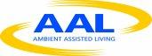

Connected Vitality, the Personal Telepresence Network (CVN)

D9.7 Final report CVN project

Author: | PRE
Contributors | PRE,
Dissemination:: | Public
Contributing to: | WP9
Date: | 02.06.2013
Revision: | 0.1

Document history

Version | Date | Author | Description
0.1 | 08.05.2013 | PresenceDisplays | First Setup
 | 02.09.2013 | PresenceDisplays | Final

Table of content
1. Introduction 4
2. Public and private funding opportunities per end-user market 5
3. Project results 7
4. Project results enduser perspective 9
5. Project result pr 9
6. Conclusive 10

Introduction

This document is an overview of the ConnectedVitality project www.connectedvitality.eu. The project resulted in a lot of benefits; a very nice communicator for elderly, intuitive and easy to use, fitting their needs completely. A trial proven businessmodel, novel technologies, a patent and scientific results.

Public and private funding opportunities per end-user market
We developed the ‘second best’ connection, after meeting face to face, especially tuned for elderly users. We call it YoooM, with YoooM the users engage in contact with family, friends and care professionals over distance. It enables seniors to communicate and interact according to their individual needs, abilities, and chosen lifestyle. Especially elderly with mobility problems are helped with this solution as it stops the isolation position they are in.

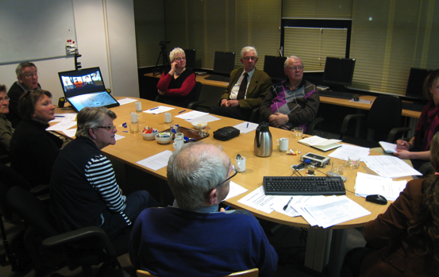
We observe that current technologies for immobile seniors above 80 are not perfectly suited for their needs. They are either too difficult to operate or suffer from a low social presence and community capacity. In order to actually meet the requirements of this target group, over 500 elderly, family and care professionals where placed in the lead of the development process via interviews, workshops, heuristic evaluations, user studies in the lab and field test in Spain, Sweden and the Netherlands.

During the evaluation, the solution performed better than expected. It rated with an average of 4.5 on a scale of 5 by family and friends who had contact over distance, outperforming any comparable solution currently on the market.
Figure 1, workshop at Sensire, the Netherlands

As a result, the main advantage is its intuitive use and way to connect. It fits the social needs of elderly for contact over distance with care and family/friends.

The technological novelties developed in the process are the three communication formats developed: Meet, Club and Classroom. These formats allow one-to-one communication, to engage in group activities, and the Classroom format enables to engage in learning processes. Another novelty is the addition of body language and the capacity to conduct activities over distance. Furthermore, for extra economic impact a low cost version of the interface is also developed.

At this moment elderly, municipals, welfare organizations, families and care organizations are in the process of testing units. In addition, multiple parties are willing to place orders to acquire the solution as first versions are expected to hit the market in Q4 2013.

The main barriers are related to sales and marketing channels, to overcome this barrier a bottom up approach is planned to be used. Using experiences and knowledge from the field test, where we proved the bottom up approach to be a success, as elderly like to try and use before purchasing.
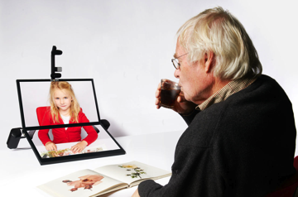
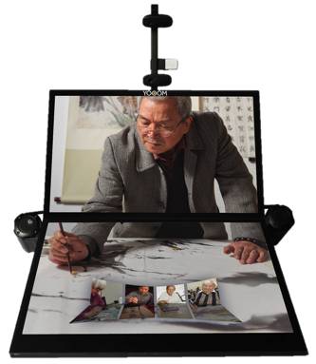

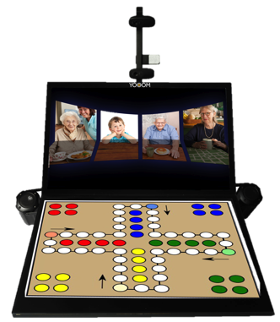
Figure 2
Meet format

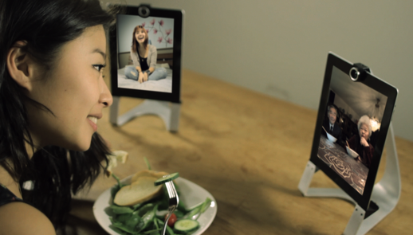
Figure 5
YoooM tablet version
Figure 4
Club format
Figure 3 Classroom format

Project results
All the work packages were completed successfully. The result of each work package is detailed in the deliverables of this project. Some deviations were proposed by the consortium to get a better insight of end-users care environment and practices.

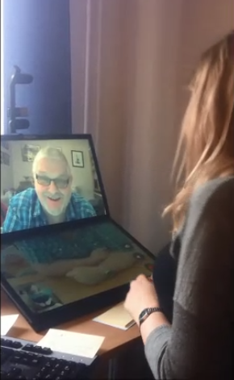
The performance of the project consortium was very good, in the beginning there were communication, knowledge, skill and cultural differences, which gave some struggle. However, after consortium meetings, initial results and continuous communication among partners, these problems were overtaken. Each partner could experience the added value of each other. In these way challenges of user research, shared vision, integration of technical modules, reorganization due to loosing partners from the consortium, and the organisation of the field tests could easily be managed by consensus in the consortium. Any decision had to be forced. Furthermore, selecting from the start the partners, based on its specific qualities proved to be very successful in delivering results.
Figure 6, field usage Arvika Sweden

Various relevant scientific results, already published in scientific conferences and journals, were obtained from the development of the project. From a social science perspective it was possible to understand variables affecting communities enabled by ICT. These variables, such as closeness and connectedness, existing in social structures were evaluated. Using the concept of social presence, the implications and requirements to build a community supported by ICT were defined. In particular, a deep understanding of the experiences of a user when communicating via video communication mediated tools, such as YoooM, was obtained. This includes the importance of body language, a non-verbal cue, required for social presence. It also includes the inner social requirements and needs of aging population. The aforementioned knowledge guided the design, rapid prototyping and further development of the CVN-ICT system always focusing on the identified requirements and needs. As a result, three communication formats were developed and validated: meet, club and classroom.
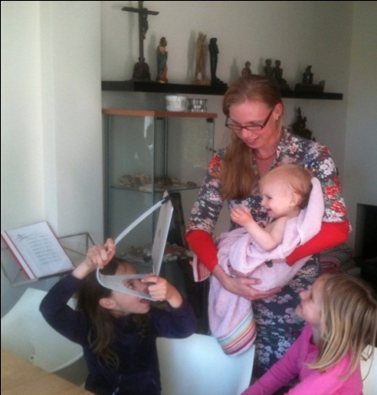
Another relevant result of this project is the understanding of health care practices and market structure. This in-depth knowledge was obtained via workshops, presentations, interviews, meetings and focus groups with health care institutions, government bodies, and important stakeholders in the care environment. During this process it was revealed the importance of informal careers in the development of a more sustainable health care system. Therefore, an approach to empower informal carers was followed to develop the service in this project.
As a result, services to empower informal carers and create communities of care, around elderly users, were developed:
1) YoooM - family connection, a highly appreciated format for families to be together over distance, about 80% of the families in the field test families are still using it and other families want to buy it.
Figure 7, field usage at family, the Netherlands
2) ConnectedVitality community and Care 0.0, which embeds care-tasks in modules for care organisations and municipalities. This creates better care with less cost by organizing a social community around the elderly centred in care-tasks. The biggest benefit is that elderly can stay longer in their own home while receiving better care with less money. Talks are on-going with municipals and care organisations to implement this service. With few organizations are already testing care modules and willing to expand their tests, this approach is proving to be successful.

Project results enduser perspective
The field tests show that primary end-users enjoy using the YoooM. The YoooM as a family connector was rated by elderly users in average 4.5 out of 5, and even improved 10% after the 6 weeks of the field test, which shows a high acceptance in a family environment. The likeliness is increased when they are social persons, when they have a strong bonding with family and friends, and particularly when they have difficulty visiting other members of their social network (which was the 90% of our end-users in the field test).

For secondary end-users, it offers a new way to improve the informal care system on a low cost and effective way. It supports clients in isolation with social tools and at the same time allows running professional assistance over distance by informal carers. Currently, 80% of the calls received in CallCenters are related to social needs, therefore this percentage can be lowered by providing social tools to end-users and informal carers to overcome isolation.

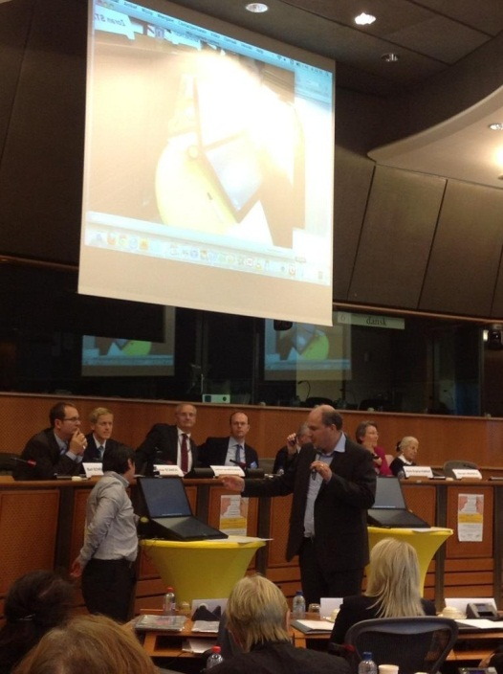
For tertiary end-users, government and semi government, it offers a good way to distinct themselves, offering to the public low budget family connection tools. Different municipals show interest in this scenario and are requesting project proposals.

Project result pr

ConnectedVitality resulted in 12 scientific publications on social presence, human interfaces for technology, community building in social sciences, and usage of ICT for social innovation. Dozens of presentations were given by the partners, in international and local forums, including public press articles and presentations in educational environments which showed that this project is catching the imagination of different audiences.
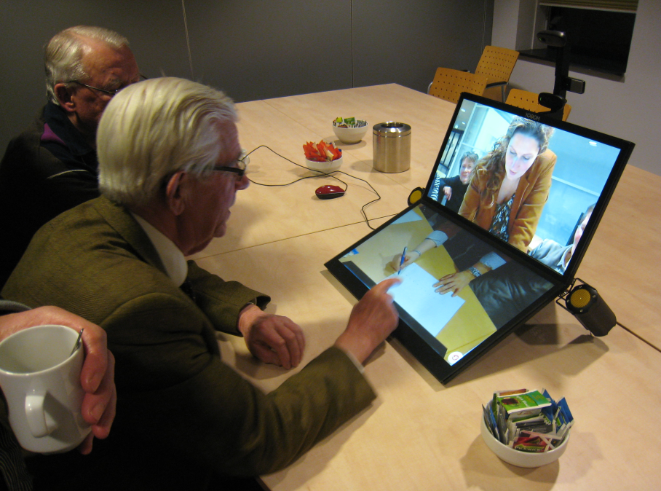
Figure 10, Presentation to elderly end users
Figure 8, Presentation in the eu Parliament

Conclusive
The project resulted in a lot of benefits; a very nice communicator for elderly, intuitive and easy to use, fitting their needs completely. A trial proven businessmodel, novel technologies, a patent and scientific results. But also on the team level and personal level. For me as coordinator it was a wonderful experience; learning Europe, elderly and how though elderly innovation is, work habits and lots of insights and knowledge. I want to thank from my hart everyone who made it possible.
Kind regards,
Robbert Smit

