Community Building

Author(s): Manfred Feichtenschlager, Federica Bosco

Organisation(s): Hilfswerk Salzburg
Aldia Cooperativa Sociale

Document Number: D8
Version/Date: 1.6/15.06.2016
Document Type: Deliverable
Dissemination Level: Public
Checked and released by: Federica Bosco, Manfred Feichtenschlager

Funded by the European Commission and Partner States within the Active and Assisted Living Programme

Revisions

Rev. | Date | Author | Description
0.1 | 31.08.2018 | Manfred Feichtenschlager | Template created
0.2 | 10.10.2018 | Manfred Feichtenschlager | Editing the chapters
0.3 | 15.10.2018 | Manfred Feichtenschlager | Completion of the content HWS
0.4 | 05.11.2018 | Federica Bosco | Supplementing the content ALDIA
0.5 | 07.11.2018 | Manfred Feichtenschlager | Merging and finalizing the content

Acknowledgement

Table of Contents
Revisions i
Acknowledgement i
List of Figures iv
List of Tables iv
1 Executive Summary 1
2 Introduction 1
2.1 Purpose of the paper 1
2.2 Definitions, acronyms and abbreviations 1
2.3 Links to other Deliverables 1
2.4 Basic Structure of the Paper 1
3 Initial Assessment Objectives 3
4 Community Building Process in Austria 4
4.1 Recruiting of Volunteers 4
4.1.1 Distribution of Information 4
4.2 Acquisition of Co-operating Partners 5
4.2.1 Health Sciences (FH Salzburg): 5
4.2.2 Health and Nursing School (Universitätsklinikum Salzburg) 5
4.2.3 School of Health Professions (Berufsförderungsinstitut Salzburg) 6
4.2.4 Haematology and Urology (Landeskrankenhaus Salzburg) 6
4.2.5 Freiwilligenbörse (aka „Volunteer Forum“) Salzburg 6
4.3 Results 6
4.4 Conclusion 6
4.5 Perspectives regarding the Recruiting Process 6
4.6 Workshops for Volunteers 7
4.6.1 Workshop Contents 8
5 Community Building Profess in Italy 9
5.1 Introduction 9
5.2 Current situation in Italy 9
5.3 Homecare services in Italy 10
5.4 Home Assistance Service 11
5.5 Elderly people in Aldia 12
5.6 Volunteers 13
5.7 Recruiting of Volunteers 14
5.8 Acquisition of Co-operating Partners 14
5.9 Results 15
5.10 Workshop contents 15
6 Summary 16
7 References 18

List of Figures
Figure 1 familiäres Pflege- und Betreuungspotenzial (source: Land Salzburg 2008) 3
Figure 2 Flyer for the recruiting process of volunteers 5
Figure 3: Presentation slides – education (source: presentation 2nd workshop volunteers) 8
Figure 4: Presentation slides – collaboration (source: presentation 2nd workshop volunteers) 8
Figure 5: Presentation slides – motion promotion (source: presentation 2nd workshop volunteers) 9
Abbildung 6: Home Assistance Service 11
Figure 7: Flyer for the recruiting process of volunteers 14
Figure 8: Workshop contents 16

List of Tables
Table 1: Workshops for Volunteers 7

Executive Summary
Working conditions in the field of home nursing & care are challenging. The present and even more the future demographic changes makes it imperative to explore new pathways to handle home nursing and care in a professional way. Besides the technical possibilities provided by the project CiM, the end user partners ALDIA & Hilfswerk Salzburg tried to establish a community. This community consisted of various different groups within the organizations that tried to pursue a common goal: to provide an excellent informal nursing and care system next to the professional services.

Introduction

Purpose of the paper
This document represents the official deliverable D8 of the AAL JP project CiM – CareInMovement.

Definitions, acronyms and abbreviations
CiM CareInMovement
HSa Hilfswerk Salzburg (end user organization in Austria)
Aldia End user organization in Italy
PEU Primary-end-user (care recipient)
SEU Secondary-end-user (relatives, volunteers, end user organisation employees)
CareInMovement Mentor Divisional head within the end user organization who guides the project
CareInMovement Assistant Employee of the end user organisation who is in direct contact with the end users and is responsible for recruitment, training and accompaniment
Community consists of volunteers that provide their time and resources to support people who need support and nursing care

Links to other Deliverables
This paper is closely linked to the deliverables 4.1 (User Requirements) and 16 (Guidelines for recruitment and trial execution).

Basic Structure of the Paper
The document describes the strategies of ALDIA and HSa to build up a community.
The focus lies on building up a sustainable care community by mobilizing and empowering volunteers and family carers through:
- Promoting standardized collaboration between the community, formal carers and care recipients
- The plan was to apply a time-based care currency system as a kind of compensation/incentive. Which did not succeed.
- Attract informal carers to use the service as preventive measure for controlling and improving their health status

Initial Assessment Objectives
Working conditions in the field of home nursing & care are challenging. The present and even more the future demographic changes makes it imperative to explore new pathways to handle home nursing and care in a professional way. Especially the field of informal home care provided so far by family members is rapidly changing. Family based home care is constantly decreasing due to two major factors. According to demographic research the evidence for the hypothesis lies in the “family structured care potential analysis figures”. These statistical indices are divided in two variables. On the one hand the population of women age 45 – 65 and on the other hand the population of senior citizens age 80 and older.
The reason for the two indices derives directly from the situation as follows: the population of women age 45 – 65 is primarily taking care of the elderlies at home, thus representing the largest group of home care relatives. Furthermore, among the population of senior citizens age 80 and older you will find highest percentage of people in need of nursing and care.
The correlation between the two variables is very significant given the quota representing the indices for the number of people to be taken care of and the number of people available as possible caretakers.
The graph below depicts the quota and the development in the county of Salzburg up to the year 2032. The data clearly shows the rapid deterioration in the correlation between available caretakers and the number of people having to take care of. Up to the years 2017/2018 the correlation between generations was fairly stable, e.g.: one could count 3 caretakers for one person dependent on care. Starting 2019 the correlation will change dramatically, nearly cut down by half.on the average
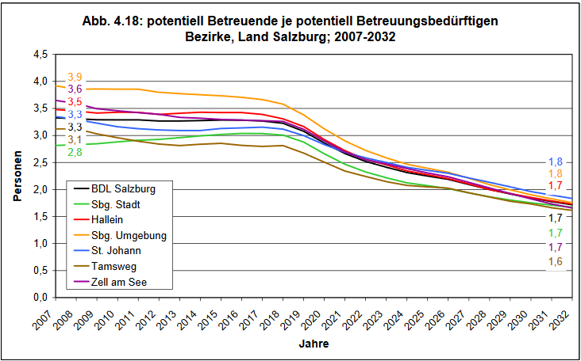
Figure 1 familiäres Pflege- und Betreuungspotenzial (source: Land Salzburg 2008)
In the formal sector, a constant decrease in professional personnel can be detected over the past years. Recruiting professional and highly qualified personnel for long-term care has become more and more difficult through the years.
This is due to a number of factors including training, pay gap and and the so-called image problem.
First of all there is still not enough people being educated and trained in the field of nursing.
Second there is still a massive pay gap between acute care and long-term care.
Third of all the field of long-term care is still trying to find a way out of its poor image.
All these problems and challenges require diverse, multiple and extensive solutions. One of the most promising problem solving approaches is the use of innovative technologies as the field of Active Assisted Living represents. Here the project partners set their goal to developing a system that provides technical support as well as setting up an informal net, aka community, given all necessary assistance to people dependent on care.
Besides recruiting participants for the project, the end user organization such as ALDIA & Hilfswerk Salzburg were also asked to set up a community within the project. The task of this community was to support caregiving relatives as well as professional caretakers.
Results of the user analysis was that both elderlies as well as caregiving relatives would greatly appreciate support given by volunteers.
At this stage, along with mobilisation exercises conducted with like-minded people and family members, elderlies would appreciate the support of volunteers as well.
The following paragraph consists of strategies and activities conducted by Hilfswerk Salzburg in cooperation with SRFG, in recruiting volunteers and supporters for the project.

Community Building Process in Austria
The project designed community had to bring together various different groups: the main objective was to set up an all encompassing net of people that could handle the challenges particularly with regard to the support given to people dependent on care and nursing. As mentioned above it is extremely important to bring together various different personas being able to face the challenges arising from future socio-political circumstances. This so-called COMMUNITY consists of caregiving relatives (informal carers) as well as volunteers. Hilfswerk Salzburg was able to use its network to provide a perfect setting for all the elderlies. Hilfswerk Salzburg also tested various techniques for the recruiting process.
In addition to the measures mentioned in deliverable 16 (D16) on how to recruit the different target groups (elderlies, formal and informal carers), Hilfswerk Salzburg also came up with different approaches on how to recruit more volunteers for already existing communities.

Recruiting of Volunteers
The following lists all measures taken by Hilfswerk Salzburg to recruit volunteers for the project:

Distribution of Information
The former project leader for Hilfswerk Salzburg, Tanja Kefer, and her assistant Johanna Stegmüller, had specific information material designed and printed.
In February of 2017 they distributed flyers to passers-by at the Shopping center Europark, and provided information about the project. Furthermore they gave out flyers to different stores and pinned information material onto various Bulletin Boards all over Klessheim, Puch and Oberalm. Almost 200 flyers were floating around the area at that time. Flyers were also distributed among the district offices of Hilfswerk Salzburg all over the county of Salzburg. There these flyers would be distributed to general stores, drug stores and to municipal offices and passers-by as well.
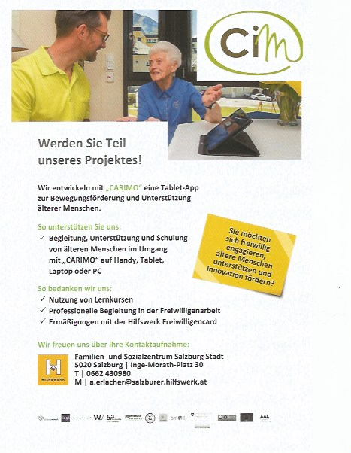
Figure 2 Flyer for the recruiting process of volunteers

Acquisition of Co-operating Partners

Health Sciences (FH Salzburg):
In February of 2017 Mrs Kefer & Mrs Stegmüller contacted the head of Health Sciences at the Fachhochschule Salzburg, Mrs Babette Grabner. Mrs Grabner was very interested in the project. She gave the representatives of Hilfswerk Salzburg the opportunity to present the project to the members and students of the Fachhochschule in order to encourage them to participate. Once again flyers were distributed and necessary information pinned onto the Bulletin Board.

Health and Nursing School (Universitätsklinikum Salzburg)
Mrs Stegmüller also contacted the Vice President oft he Health and Nursing School , Mr Widelreuther. Mr Widelreuther requested a digital version of the information material. He also guaranteed to forward the information to his students. A print version has been sent to the administration office.

School of Health Professions (Berufsförderungsinstitut Salzburg)
Mrs Stegmüller contacted the head for the School of Health Professions at Berufsförderungsinstitut Salzburg, who also agreed to distribute the flyers to his students by means of information technology.

Haematology and Urology (Landeskrankenhaus Salzburg)
In March of 2017 information material has been delivered to the haematology and urology ward of Landeskrankenhaus Salzburg and pinned onto their Bulletin Boards. All the nursing staff in charge has been informed as well

Freiwilligenbörse (aka „Volunteer Forum“) Salzburg
The Volunteer Forum works as an internet platform for people interested in engaging in volunteer work in the county Salzburg. Social organizations can “head hunt” for volunteers through the Volunteer Forum. On the other hand people interested in doing volunteer work can get in direct contact with the organizations through the Forum and hand in their applications. Hilfswerk Salzburg placed advertisements giving information about the project and the volunteer work in general. Hilfswerk Salzburg also appointed mentors to work as contact persons in the region. Throughout the whole period 4 people sent in their application for participating in the CiM project through the Volunteer Forum.

Results
The results of the efforts as mentioned above was truly somewhat disillusioning: only 2 people from the central region would report back to the project leader. Both of them would resign their engagement as soon as they have been told that they would not receive any payment for their efforts. The mentors successfully intervened and luckily, 9 volunteers and 3 civilian service personnel were found to participate in the project. The mentors and assistants supported the volunteers throughout the whole project according to the defined standards of the project.

Conclusion
As to the basic conceptual approach, the following can be said: speaking of the supply side, Carimo focuses strongly on the individual needs of the test group. By doing such things, the project is highly accepted by the test group. At the same time it is lacking interesting aspects for the volunteers, thus encouraging the volunteer group. The only option volunteers have at the moment is to register joint activities.

Perspectives regarding the Recruiting Process
Playing games proved to be surprisingly one of the major attractions of Carimo. Hilfswerk Salzburg requested to integrate multiplayer online games in the system (12/17). Through playing games Hilfswerk Salzburg tried to increase the attractiveness of Carimo thus motivation the volunteers to participate in the project.
Another all so important lesson learnt from the project was that the volunteers needed a lot more support in that particular project CiM than in any projects.

Workshops for Volunteers
To introduce the project to volunteers on a close basis, members of Hilfswerk & SRFG conducted and carried out several workshops
List of workshops:
Area | Date/Time | Participants | Premises
City of Salzburg | 02.12.2015  14:00 – 16:00 | 5 volunteers (3 already active as volunteer,  2 potential volunteers)  1 employee of Salzburg Research | Zentrum Walser Birnbaum
Pinzgau | 02.12.2015  16:00 – 17:30 | 3 volunteers (1 already active as volunteer,  2 potential volunteers)  2 employees of Salzburg Research  1 employee of Hilfswerk | Familien- und Sozialzentrum Zell am See
City of Salzburg | 09.03.2016  15:30 – 17:30 | 2 women (already working as volunteers)  2 employees of Salzburg Research | Landesgeschäftsstelle Hilfswerk Salzburg
Pinzgau | 09.03.2016  15:30 – 17:30 | 3 women (1 already working as volunteers, 2 potential volunteers)  2 employees of Salzburg Research  1 employee of Hilfswerk | Familien- und Sozialzentrum Zell am See
Table 1: Workshops for Volunteers

Workshop Contents
Services
- Collaboration
- Education
- Motion promotion
Education, training
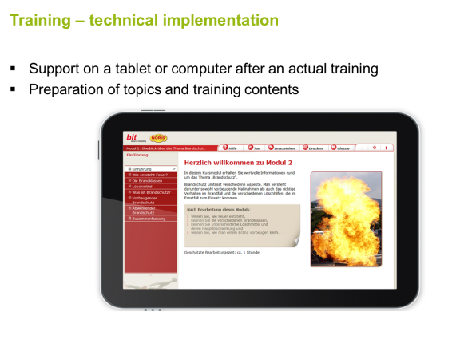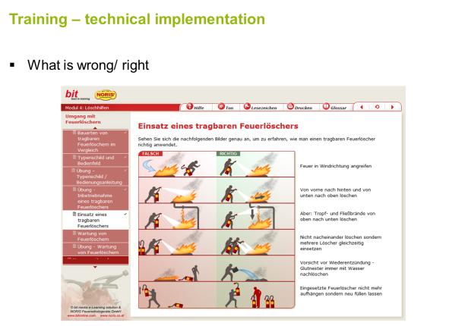
Figure 3: Presentation slides – education (source: presentation 2nd workshop volunteers)
Collaboration and communication
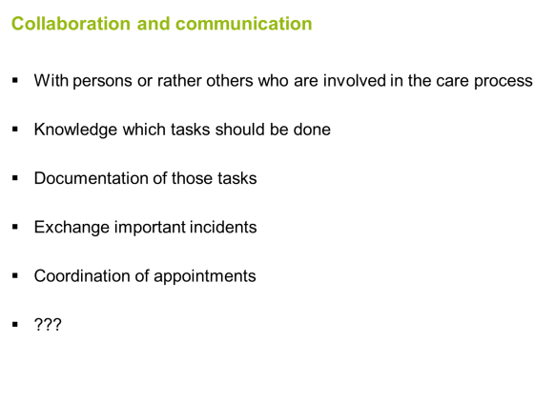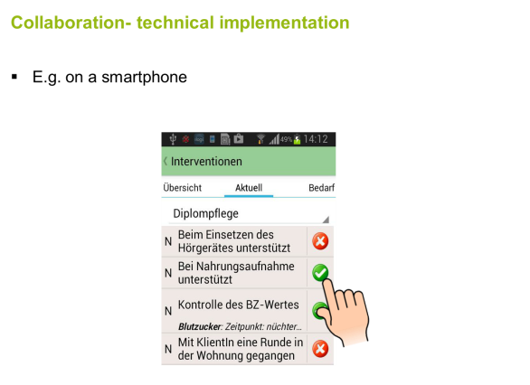
Figure 4: Presentation slides – collaboration (source: presentation 2nd workshop volunteers)
Motion promotion
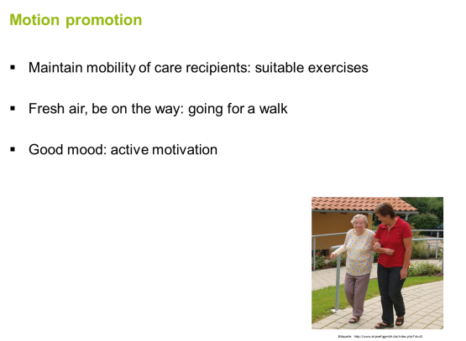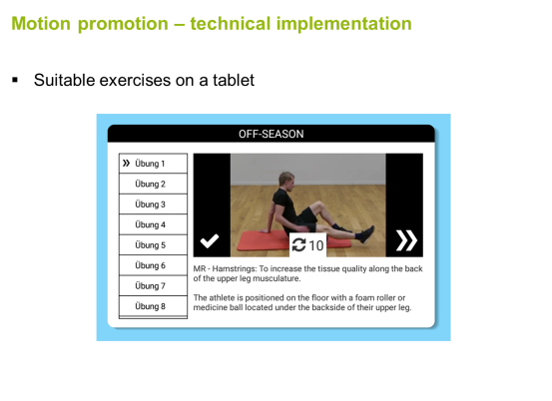
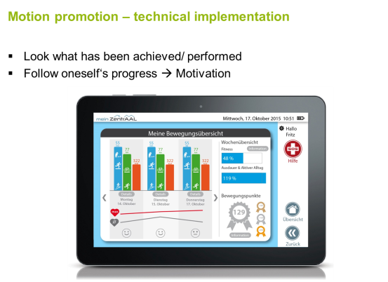
Figure 5: Presentation slides – motion promotion (source: presentation 2nd workshop volunteers)

Community Building Profess in Italy

Introduction
The initial approach proposed in the project for building a community was the creation of a time bank. Regarding the time banking component it turned out that considering all framework conditions (end user partners: accruals in the balance sheet, value stability etc.; volunteers: possible reduction of minimum pension due to an income via the time banking system, insurance etc.) this component is not viable for an eight months test phase. Instead of the time banking component a “volunteers’ management” component will be implemented with the possibility to later include a time banking module. Other than current available models which are implemented bottom up (by a community) these conditions will focus on top down approaches which are suitable for companies.

Current situation in Italy
In Italy, the ageing process is more evident than in other countries. As a matter of fact, our country has the highest percentage of people aged 80 or over, and is ranked second place for people aged 65 or over, where Germany takes the lead. Italy has Europe's oldest population: it is the European country with the highest percentage of over-80-year-olds. According to Eurostat, the statistical office of the European Union, the over-80-year-olds living in Italy are almost 4 million (3.977.000 - three million nine hundred seventy seven thousand actually), corresponding to 6.5 percent of the country’s population. A significant data, especially compared to the average percentage of Europe, 5,3% (26.7 million people). The aging process is often accompanied by deep changes in the family composition, mainly concerning the number of people composing the household. With regard to social demand and social needs, there is concerning data showing that about 30% of over-sixty-year-olds live alone, with the percentage of the female component reaching 37,5 percent against the 14.5% of men. Moreover, family ties and social bonds that in the past have acted as a protection for many elderly people from conditions of social and economic marginality have increasingly become more fragile, especially in the larger cities and in the northern, more industrialized part of the country.

In the last few years, the global economic crisis has further accentuated situations of isolation and discomfort in a substantial number of elder people, increasing their need for help and social support.
Although it may seem that the part of the population mostly affected by the crisis is the younger segment, the data actually show that it was the elderly who suffered the most because of this generalized crisis.
These assumptions about a worsening in the living conditions of old people are confirmed by data regarding household debt structure, which provide evidence of an increased financial vulnerability of families.

Homecare services in Italy
In Italy, the local Municipalities and in some cases the local Health Authority are the main providers for social services for the elderly, while it is possible for private structures to provide the services in agreement with these institutions. Homecare services are addressed mainly to retired people who, for various reasons, are not able to independently care for themselves and fulfil the basic tasks needed for everyday life, but who lack the money to pay for private professional services and have no family members who can provide help.
The relevant legislation that in Italy govern the supply of Home Care Service is the Law 328/2000 "Framework Law for the realization of the integrated system of interventions and social services" and, at a regional level (i.e. Lombardy), the Regional Law 3/2008 "Government of the services network and interventions in the social and health field". Law 328, in Article 15 (Home support for non self-sufficient elderly people), ensure that the National Fund for Social Policy yearly finances services for old people who are not self-sufficient in order to "promote their autonomy and support the household in providing homecare assistance for elderly people who request it". The Regional Law also ensure, in Article 17 (regional levels of assistance and interventions for non self-sufficient people) the creation of a special Fund for non self-sufficiency, in order to promote the autonomy and independence of the elderly also through homecare assistance.
The Homecare Service does not provide medical or nursing services (except interventions in order to prevent bedsores and support in the correct usage of drugs), nor specialized rehabilitation interventions. Instead, they provide services such as personal care assistance (personal hygiene, help with dressing and undressing, mobilization, support in walking, etc.) and small housekeeping activities (make the bed, clean the spaces, reorganise the rooms, etc.). The Service is also aimed at facilitating the maintenance of relations with the territorial environment (assistance during everyday activities outside the house, such as small errands, doctor’s visits, socialization...), and at supporting informal (family) or formal caregivers (in-home nurses) with assistance and homecare activities.

Home Assistance Service
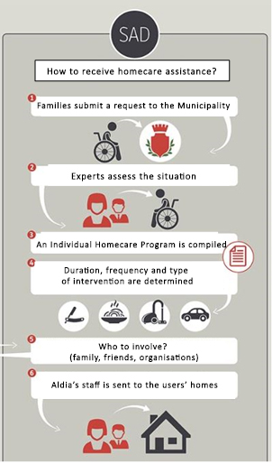
The aim of the Home Assistance Service (Servizio di Assistenza Domiciliare or SAD in Italian) is to promote continuity in the lifestyle of the elderly, allowing them to stay at home for as long as possible, delaying their institutionalization or avoiding it altogether. This approach has its roots in the belief that maintaining an individual’s life context, as well as maintaining his or hers social network of relationships and links with the territory, is the best way to guarantee to non self-sufficient elderly people good life conditions and a certain level of well-being.
Abbildung 6: Home Assistance Service
That being said, it is also true that unfortunately the health and autonomy levels of most of the elderly who require Home Assistance Services are seriously compromised.

It is important to highlight that the Home Assistance Service aims to empower, as far as possible, the individual and his/her family: it does not aspire to replace the individual’s residual autonomies, but to reinforce their skills. For the same reason, it does not promote family behaviours that completely delegate assistance activities to formal insititutions, but focuses on the empowerment of caregivers as well as care receivers.

As a rule, the staff in charge of carrying out Home Assistance Services is qualified as ASA (Ausiliario Socio-Assistenziale, a professional figure provided for by Italian legislation with an assistential role) or OSS (Operatore Socio-Sanitario, equivalent to an healthcare assistant). Coordination of the service is generally carried out by a social worker employed by the Municipality, in collaboration with the Social Cooperative that provides the staff for the service.
The service is usually organized so that the user pays only a part of the service, with the Municipality funding the remaining costs. Calculation of the share payable by the user is based on an index called ISEE (Indicatore di Situazione Economica Equivalente, i.e. ‘Equivalent Financial Position Indicator’), which indicates someone’s financial standing in any given year on the basis of family status, earnings, property and expenses. Obviously, people in particular situations of need can be granted an exemption to payment, which would be fully covered by the Social Welfare Service.
Today, approximately 13 million of Italians are over 65 years old and, according to ISTAT forecasts (the Italian National Statistics Institute), in 2043 the elderly will be 32 percent of the population, and half of them will be over 80 years old. By now, about 39 percent of the population already suffers from a chronic disease, while among over-75-years-olds about 67% have two or more diseases. According to the Unisalute Health Observatory, last year one out of three Italians needed some sort of homecare services, whether personally or for a relative. The request for that kind of assistance was sometimes temporary, following an accident or an unexpected hospitalization, while in other situations was continuous, especially when involving an elderly person or an individual with a chronic and disabling illness.
"In our country only 50 out of a thousand of over-65-years-olds receive assistance – a report from Dr. Damiani of Unasalute reports – a rate not even close to the average of 70 out of a thousand that can be found in the OECD member states. This being said, the optimal average value is actually 100 people out of every thousand, a rate that can be found, for example, in Holland, Denmark, Switzerland”. This is confirmed by data from the Home Health Monitoring System (SIAD) of the Ministry of Health: in 2014 the national average for homecare services users was 2.31 percent of the segment of population aged 65 and over. This data does not take into account users with a low-intensity assistance service, I. e. an intervention that counts less than 4 homecare visits per month.

Elderly people in Aldia
Aldia has under its care about 250 elderly people. The current situation shows that:
- 100 of our users are residents in a retirement home;
- Of the remaining 150, which are Homecare Service users, unfortunately the 70% is over 85 years old and has a compromised health level (dementia, sight problems, and impaired mobility).
The consequence that ensue from this data is that the numbers of potential CIM users we originally took into account, based on the raw number of elderly people in Aldia’s care, had to be scaled down because of the actual characteristics of our homecare users. Since in Italy it is extremely rare for the Municipalities to spend money on welfare interventions for elderly people with a good level of self-sufficiency, even when in need of social interventions, most of the seniors in our have a seriously compromised health level, or are simply too old.
Even when we assists individuals with a less compromised health level, the homecare service is funded for elderly who are alone, without a family, and that is the other reason that justifies why family members are very few.
All above stated, it is now clear why Aldia can offer the CIM service to a reduced number of users.

Volunteers
As for the number of volunteers, the situation is slightly different.
In the last years, the world of volunteering has changed. The social and civil commitment is not has strong as before, and the generation of volunteers born in the 50s is retiring, while not being replaced by younger people, except for a tiny share. This means that the resources coming from the world of volunteering and social commitment risk running out. Some organizations, such as the Red Cross, Avis, or even local Parishes, are able to provide a constant stream of new and young volunteers for their projects. Fact is, in those kind of organisations volunteers immediately enter a world in which they are immediately assigned a precise role; therefore, the commitment they undertake and its purpose look clearer, and that is something that in other kinds of associations (like Social Cooperatives) probably is perceived in a slightly more laborious way. The consequence is that the number of available volunteers that every night and day work in a completely disinterested way is progressively smaller. To that, we could also add that time availability is changing due to new roles division within the family, and both men and women have increasingly less standardized work times.
Our purpose in looking for volunteers is to recreate that lost dimension of "good neighborhood" that characterized social life in Italy until the 80s, when our country officially entered post-modernity: a network of relations developed between people linked by kinship or proximity breaking their isolation and improving their quality of life.
Within the Carimo project, the creation of a Time Bank would have been functional and very useful for a more efficient organisation of the volunteers. A Time Bank govern the exchange of services and is based on three principles:
Exchange: we give to receive, we receive to give.
Value of the performance expressed in time: regardless of the service exchanged, the currency is the time used.
Equality between the subjects involved: time being the currency, the performances of an housewife, a retired person or a professional are valued the same.
Even if the ideal way to govern the exchange would be to stay “equal” in terms of services given and received, the rules are not so rigid and even those who “get in debt” can continue to ask and exchange performances. What truly matters is not the economy under the exchange, but the exchange itself, which is what maintains alive those relationships. The exchange itself is what keeps the Time Bank alive.
Considering all framework conditions (end user partners: accruals in the balance sheet, value stability etc.; volunteers: possible reduction of minimum pension due to an income via the time banking system, insurance etc.) this component is not viable for an eight months test phase.
However, we were unable to put in practise the project; this probably caused the lack of volunteers, and even those we initially involved lost interest.

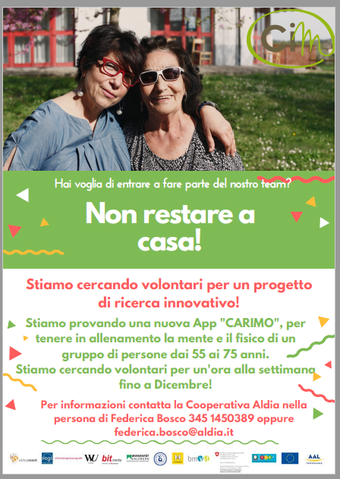
Recruiting of Volunteers
We prepared some papers explaing role and activities in order to motivate persons to act (Fig.1). We left these papers in the municipalities receptions and directly to the social assistants involved in the project.

Figure 7: Flyer for the recruiting process of volunteers

Acquisition of Co-operating Partners

We met University of Pavia in particular the Faculty of Motor Sciences, who seemed a promising category both for their age and for their course of study. An attempt was also made with young undergraduates who could be interested in the project. In this last case, also we organized a focus group with 3 students and their professors who answer our "call to act".
However, a bureaucratic problem regarding insurance coverage unfortunately got in the way: the University required that we make a formal contract to the students in order to gain access to working insurance coverage, but that of course would have meant to employ the students, de facto leaving us without any volunteers even should the students accept to collaborate with the project.
We met a volunteer association "Vasi di Creta" and with the president, we discuss how to involve members but they didn't find anyone that want to use new technology.
There was Federica's phone number on the papers but nobody call back.

Results
Aldia has more or less 500 members around Italy; 150 of them work in Pavia and Erba area. They were interested to participate with a time bank as volunteers because they felt a way to be useful but at the same time, they would have had a positive effect for themselves as well. Without time bank they lost their motivation. In fact at the end we were able to find only 3 persons.
By the beginning of the CIM project, we had received three nominations: thee women who were promptly recruited. All of them are still operating on our behalf in order to assist our elders using the CIM devices and supporting them in everyday life.

Workshop contents
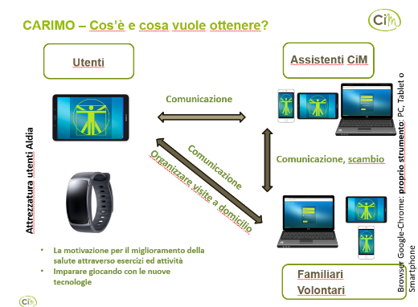
To introduce the project to volunteers on a close basis, members of Aldia conducted and carried out a workshop.
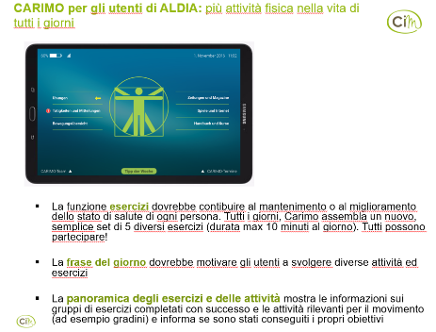

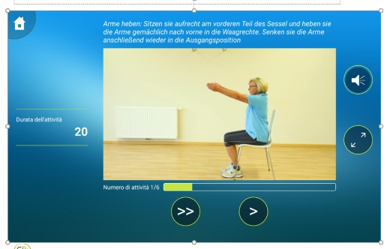
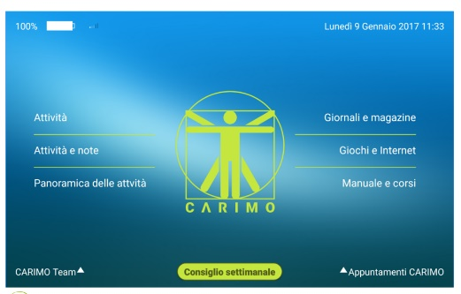

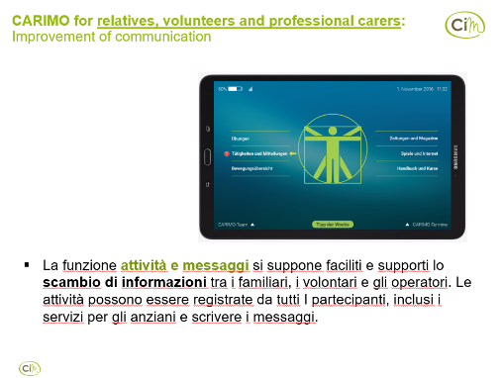
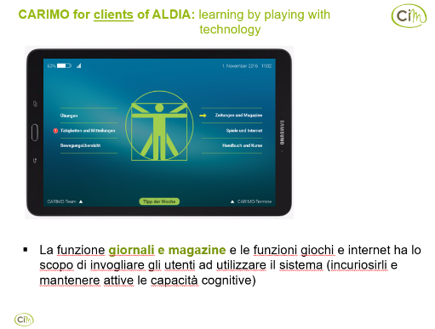

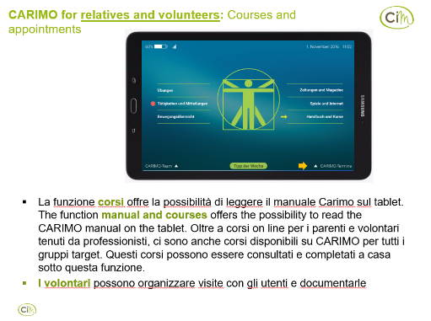
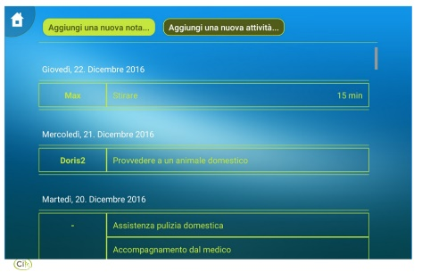

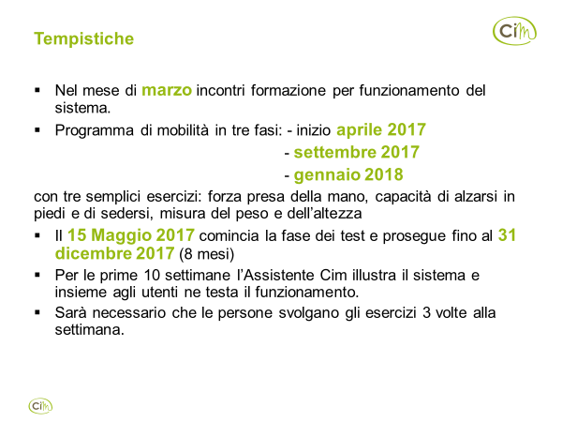
Figure 8: Workshop contents

Summary
All things considered, one can say that Hilfswerk Salzburg and Aldia succeeded in recruiting volunteers for the project using various means of access to the field. Overall the total response was not as successful due to the fact that the greater good resulting from the outcome of the project could not be seen by the volunteers. Generally speaking it can be said that recruiting volunteers has become more and more difficult over the past years. Above all, it seems to be the time consuming commitment that does not correspond with the expectations of the people showing a certain interest to the cause. Factors like spontaneity and flexibility have become an important issue for volunteers as well. As a reaction to the general trend, the county of Salzburg established a co-operative platform, the so-called „Freiwilligenzentrum Salzburg“. By combining their aims and resources, several organisations have set their task to utilize synergies among each other, thus making volunteer work as attractive as it used to be.
There is definitely a potential to involving volunteers in nursing and home day care setting, particularly in view of the different socio-political systems in terms of the dissolutions in traditional family structures thus not being able to provide home care nursing for instance. Thus, one of the biggest challenges of the near future will lie in establishing structures particularly designed to counterbalance loneliness and isolation experienced in old age.

References
Bundesministerium für Arbeit, Soziales, Gesunheit und Konsumentenschutz 2018. Angehörigenpflege in Österreich. Einsicht in die Situation pflegender Angehöriger und in die Entwicklung informeller Pflegenetzwerke. https://www.sozialministerium.at/site/Service_Medien/Infomaterial/Downloads/Angehoerigenpflege_in_Oesterreich

Land Salzburg 2008. Bevölkerungsprognose 2008, Eigendruck. https://landversand.salzburg.gv.at/WebRoot/Store/Shops/Landversand/5252/A37B/A34B/699E/AB9C/4DEB/AE3E/24F2/bevprog08-langf.pdf

Schneider, Cornelia, and Birgit Trukeschitz. 2015. “‘Let Users Have Their Say’ - Experiences on User Involvement from the AAL Pilot Region Salzburg.” In 6th International Carers Conference. Gothenburg.

