DL 1.1

Project Management
WP1 – Project Management Folder

Version 1.0
Release: 1st of June 2015

Document Information

Purpose of Document
This document contains the management arrangements for delivering the IntegrAAL project. It specifies the partnership methodology for the project including the central role of service user groups together with the roles and responsibilities of the various actors from individual partners. It also describes how and when regular meetings are held and organised.

Organisation Responsible
Nourish Care Systems Limited is the lead partner and the organisation responsible for this deliverable. All project partners have a responsibility in contributing to the project management arrangements that will ensure the successful completion of the IntegrAAL project.

Authors and Contributors
Partner | Name | Contribution | Date
NSC | Kevin Poulton | Author | 1st June 2015

Version History
Version | Date | Description | Author
1.0 | 1st June 2015 | First draft release. | K Poulton

Project Summary

Background
The internet revolution and growth in mobile- and micro-technologies has generated changes in the way we live, work, play and communicate in ways that would have been previously unimaginable. Despite elderly populations accounting for a disproportionate use of healthcare resources [1], this group has traditionally been under-served by the technologies that are changing the way we live in so many other aspects of our lives.

Purpose of IntegrAAL
Project IntegrAAL (Integration of AAL (Active Assistive Living) Components for Innovative Care Pathways) aims to explore the fundamental question of how we can first understand the challenges faced by some of these older people, and then take available technologies and design and develop new ways of introducing them in meaningful ways in order to improve health outcomes, quality of life, and cost-effectiveness of delivering care. More specifically, IntegrAAL intends to understand the circles of care that are responsible for delivering the day-to-day care for these populations, both formal and informal, and design and develop systems based on handheld mobile technologies to foster and facilitate communication within the circle of care. In addition, the use of newer Internet of Things devices incorporated into the information management system creates the opportunity to develop new care pathway paradigms that have the potential to revolutionise the approach to care of the elderly living at home.

Study design
The first phase of the IntegrAAL project will focus on research, whereby through structured focus groups and one-to-one interviews information will be gathered in order to understand, define and design care pathways and technological innovations to serve them. In the second phase, the technology will be tested by the use of structured surveys, health outcome data collection and in-depth interviews of both subjects and their carers. Comparisons will be made over time as well as against a control group.

Expected outcomes of IntegrAAL
IntegrAAL will serve as an exploratory project with expectation of developing a marketable output for improved care of the elderly, as well as the foundation for future research on a larger scale.

Partners and supporter’s logos

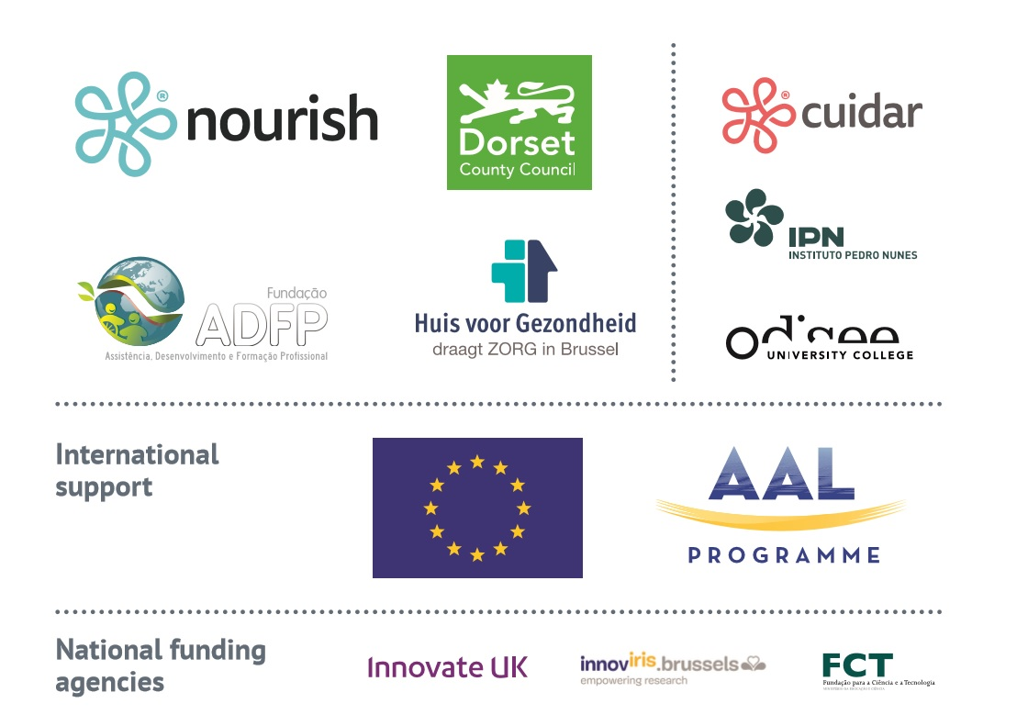

Table of Contents
1. Document Information 2
1.1. Purpose of Document 2
1.2. Organisation Responsible 2
1.3. Authors and Contributors 2
1.4. Version History 2
2. Project Summary 3
2.1. Background 3
2.2. Purpose of IntegrAAL 3
2.3. Study design 3
2.4. Expected outcomes of IntegrAAL 4
2.5. Partners and supporter’s logos 4
3. Table of Contents 5
4. Introduction 7
4.1. IntegrAAL Project 7
4.2. Partners 7
5. Management Arrangements 8
5.1. Overview 8
5.2. Consortium Agreement 8
5.3. Meeting Arrangements 15
5.4. Communications 15
5.5. Financial Arrangements 16
6. Conclusion 16
Appendices 16

Introduction

IntegrAAL Project
This document describes the management arrangements to ensure the delivery of the IntegrAAL project which is supported by the Ambient Assisted Living (AAL) Joint Programme. The General Assembly of the AAL Joint Programme approved the outcome of the evaluation of the 2014 Call for proposals (AAL-2014-1) on the 13th October 2014. The project is expected to be completed within 30 months of the kick off date of 2nd January 2015.

Partners
There are seven partners in the project consortium from 3 countries that participate in the AAL Joint Programme.
Name | Type | Role | Country | Website
Nourish Care Systems Ltd | SME | Lead Partner | UK | www.nourishcare.co.uk
Dorset County Council | Public Service Provider | End-user | UK | www.dorsetforyou.com
The university college vzw Odisee | Academia | Research lead | BE | www.odisee.be
Huis voor Gezondheid | Sector Network Group | End-user | BE | www.huisvoorgezondheid.be
Instituto Pedro Nunes | Applied Sciences Institute | Technical application | POR | www.ipn.pt
Associação de Desenvolvimento e Formação Profissional | Service Provider | End-user | POR | www.adfp.pt
AlertiSugere Lda | SME | Technical application | POR
The chosen partners cover a range of organisations that provide the variety of expertise required for the successful delivery of this project. The project is led by a business organisation that is focused on maximising the opportunity for producing a viable business proposition at the project end.
The project management is overseen by a Project Management Committee (PMC) comprised of all project partners.

Management Arrangements

Overview
The overview of the project management arrangements is described in the presentation given at the project kick off meeting held in Bournemouth, UK on 14/15 January 2015. This presentation is attached as Appendix a to this report.
The Project Delivery Plan arrangements are set out in report DL–1.2.

Consortium Agreement
Details of the project managerial provisions that describe how the project will operate are included in section 04 of the Consortium Agreement that has been agreed by all partners. That section is reproduced below.

“04 MANAGERIAL PROVISIONS
  - CO-ORDINATION AND MANAGEMENT
The project coordinator will appoint a Project Manager (PM). Their primary responsibility will be co-ordinating the various actions of the work packages and ensuring delivery of the management arrangements.
A Project Management Committee (PMC) will be formed involving the PM and all project leads from partner organisations. This group will be responsible for “driving” the project and ensuring that all the necessary milestones, project reports and key events are met or undertaken.
Project delivery meetings will start with the Kick-off Meeting (KoM) and end at the Close Down Meeting (CDM). The project coordinator will be responsible for organising and chairing these meetings. Prior to kick-off a Project Management Folder clarifying all functions, activities and responsibilities in the project will be prepared and circulated for approval at the Kick-off meeting. This project will be in line with the project outlined in the proposal submitted to the AAL programme (attachment 2). Small adjustments and added detail will be reflected on a baseline project to be presented at the Kick-off Meeting.
The PMC and the communication lines between each function are clear and documented (see organogram below). The Project Management Folder, agreed by all project partners, shall be used as a steering tool for the management of the project.
Following the initial meeting there will be 4 project delivery meetings in 2015, and 4 meetings in 2016. It is anticipated that half of these meetings will be virtual utilising skype or other internet based technology. The rest will be face to face at partner locations. These meetings will include travel time. Particular attention will be paid to adherence to deadlines, implementation of originally planned project activities and outcomes and financial management. In this way every partner will be actively involved in the decision making process.

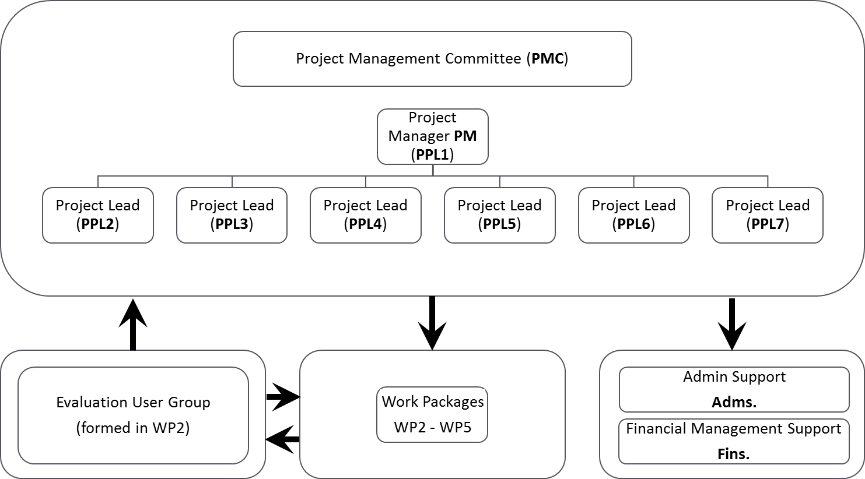
The responsibilities of the PMC are:
- To ensure the various users groups are established and that their views are central to all decision making;
- Interface with the AAL CMU
- Determining actions to deliver the approved project
- Guiding and directing the Work Packages and their leaders in the delivery of their actions
- Ensuring that the appointed Project Manager is held accountable
- To adopt a clear process for managing risk, and monitor risk across the whole project
- Acting as the arbiter to resolve any disputes through discussion, negotiation and as a last resort if that fails through an independent disputes procedure
- Approving eligible expenditure
- Monitoring the achievement of key performance indicators and expenditure
- Identifying variations to predicted profiles and requesting modifications to the approved project plan
- Ensuring output reports and deliverables are produced on time
Provision will be made for the creation of ad hoc committees should that prove necessary. The creation of these committees will be coordinated by the PMC to deal with specific matters.
Any member of the PMC (hereinafter referred to as "Member"): should be present or represented at any meeting of such committee, may appoint a substitute or a proxy to attend and vote at any meeting, and shall participate in a cooperative manner in the meetings.
  - VOTING RULES
The PMC shall not deliberate and decide validly unless four (4) of its Members are present or represented (quorum).
Each member of the PMC present or represented in the meeting shall have one vote.
Defaulting Parties may not vote.
Decisions shall be taken by a simple majority of the votes. In case of a tied vote, the chairman, i.e. the project coordinator, has the casting vote.
A Party which can show that its own responsibilities or liabilities (work, time for performance, costs, intellectual property rights or other legitimate interests) would be severely affected by a decision of a PMC may, with the agreement of the chair be granted a deferral sufficient to allow those parties to seek internal approval for the proposed decision.
When the decision is foreseen on the original agenda, a Member may veto such a decision during the meeting only.
When a decision has been taken on a new item added to the agenda during the meeting, a Member may veto such decision during the meeting and within 15 days after the draft minutes of the meeting are sent.
In case of exercise of veto, the Members of the PMC shall make every effort to resolve the matter which led to the veto to the general satisfaction of all its Members.
A Party may be identified as a Defaulting Party if evidence of their breach of a material term is brought before the PMC and the Members vote that the Party should be so classified.
A Party may not veto decisions relating to its identification as a Defaulting Party. The Defaulting Party may not veto decisions relating to its participation and termination in the Consortium or the consequences of them.
Once identified as a Defaulting Party the Party will be given 30 days to (1) remedy the default or (2) produce an action plan to remedy the default. After 30 days the PMC will take a further vote to decide either (1) the actions were satisfactory and the identification as Defaulting Party is withdrawn, or (2) the actions were not satisfactory and the Defaulting Party must leave the consortium.
A Party requesting to leave the Consortium may not veto decisions relating thereto.

  - POWERS AND RESPONSIBILITIES
PMC:
- To ensure the various users groups are established and that their views are central to all decision making;
- Interface with the AAL CMU
- Determining actions to deliver the approved project
- Guiding and directing the Work Packages and their leaders in the delivery of their actions
- Ensuring that the appointed Project Manager is held accountable
- Acting as the arbiter to resolve any disputes through discussion, negotiation and as a last resort if that fails through an independent disputes procedure
- Approving eligible expenditure
- Monitoring the achievement of key performance indicators and expenditure
- Identifying variations to predicted profiles and requesting modifications to the approved project plan
- Ensuring output reports and deliverables are produced on time
Chairman
- Calling and chairing meetings
- Managing meetings including encouraging participation and contribution by Committee members; time management and timeliness of discussion; identification, confirmation and recording of decisions made and maintaining discipline.
- Facilitating the Committees development
- Sorting and solving problems arising in the Committee
- Representing the Committee in meetings and events
Project Manager
- Maintain the Committee’s records and minutes of meetings
- Coordinate information collected from partners and draft deliverables prior to approval and submission.
- Maintaining communication to and from the Committee
- Ensure that information reaches all the members in good time especially where action is needed
- Circulate agendas and minutes of previous meetingsat least two weeks prior to the meeting
Project Management Committee Members
- To attend and contribute to PMC meetings including identification of agenda items, reading, preparing and presenting reports and participating in opinion sharing and discussions.
- To lead on specified Work Packages
- To collate and present information required for the production of deliverables.
- Prepare and present financial claims to their National Contact Point in accordance with their NFA’s.
- In collaboration with the Chair arrange and host PMC meeting held in their region.
- To advise the Chair of any point of disagreement around the management of the project and its delivery and engage positively in any conflict resolution discussion.
  - FOLLOW-UP AND SUPERVISION
Each Party undertakes to follow the production schedule and budget specified in the Description of Work and in the Grant Agreement.
In view of the evolving character of the project, these timetables are generally subject to change. However, the risk of uncontrolled time and cost escalation is very real. To limit this risk, it is desirable to provide for a strict and effective inspection and supervision system managed by the PMC, including:
- frequent progress meetings (at least quarterly);
- frequent technical and financial progress reports (at each meeting);
- optional extraordinary meetings; “

Meeting Arrangements
Regular meetings of the consortium are essential to maintain the momentum required to deliver the project on time and to ensure partners are fully informed about and involved in partnership arrangements. Four full consortium meetings are expected to be held each year. As modern information technology is a central feature of this project it is planned that half of these meetings will be virtual, facilitated by commonly accessible software that enables effective video conferencing. The physical meetings are essential as these allow partners to meet and discuss project issues in a common space as well as experience Care settings within the different national territories. Time to explore these arrangements are the cultures that underpin them are considered a key part of the projects ethos. Physical meetings will therefore be held within each of the participating regions. The host partner will be responsible for the arrangements of these meetings including meals. Other partners will be responsible for their own travel, accommodation and subsistence costs getting to and from the meeting. English will be the first language of all meetings.
Including the Kick off and Close Down meetings at the beginning and end of the project it is anticipated that 12 consortium meetings will be held, although that might change to meet the demands of the project.
Additional bipartisan meetings of project member’s way also be expected to share experiences and address detailed issues that do not require the attention of the whole PMC.

Communications
E-mail will be the mail method of communicating between partners. A central file depository will also be established to share information and facilitate collaborations on project documents. A central project management system will also be established to enable partners to appreciate and contribute to project activities.
National partners may also establish regular project meetings to incorporate a wider level of interest and help disseminate the project activities within their organisations.

Financial Arrangements
It is the nature of AAL supported projects that there is no central funding but that individual partners are supported by their own National Funding Agency (NFA). The amount of support and level of intervention is determined separately by each partner by their respective NFA through a finance agreement for the life of the project. Each partner reports progress of the project to their NFA at intervals determined in the agreements to draw down the appropriate financial support for that period.
The lead partner will report the overall financial position to the AAL Central Management Unit as part of the periodic project reporting arrangements but will not be involved in any distribution of project finances to partners.

Conclusion
This project management portfolio explains how the IntegrAAL project is being managed. With a number of partners representing different Nation States it is important to ensure in the delivery of the project that partners are not only aware of their duties and responsibilities but that the participants develop as a team working to a collective goal. The management arrangements described in this folder are aimed at achieving and supporting that situation.

Appendices
a

