DL 1.2

**Project Delivery Plan**

WP1 – Project Management

Version 1.1

Release: 21st of December 2015

# Document Information

## Purpose of Document

This document describes the systems and methods that outline and programme the key actions required to ensure the project is delivered on schedule. It includes the operational milestones to be achieved along with the resources required to be deployed. details of the management arrangements for this project are set out in DL 1.1 Project Management Report.

## Organisation Responsible

Nourish Care Systems Limited is the lead partner and the organisation responsible for this deliverable. All project partners have a responsibility in contributing to the project management arrangements that will ensure the successful completion of the IntegrAAL project.

## Authors and Contributors

|  |  |  |  |
| --- | --- | --- | --- |
| Partner | Name | Contribution | Date |
| NSC | Kevin Poulton | Author | 1st June 2015 |
|  |  |  |  |

## Version History

|  |  |  |  |
| --- | --- | --- | --- |
| Version | Date | Description | Author |
| 1.0 | 1st June 2015 | First draft release. | K Poulton |
| 1.1 | 21st December | Amendments with Tricuro | K Poulton |
|  |  |  |  |

# Project Summary

## Background

The internet revolution and growth in mobile- and micro-technologies has generated changes in the way we live, work, play and communicate in ways that would have been previously unimaginable. Despite elderly populations accounting for a disproportionate use of healthcare resources [1], this group has traditionally been under-served by the technologies that are changing the way we live in so many other aspects of our lives.

## Purpose of IntegrAAL

Project IntegrAAL (Integration of AAL (Active Assistive Living) Components for Innovative Care Pathways) aims to explore the fundamental question of how we can first understand the challenges faced by some of these older people, and then take available technologies and design and develop new ways of introducing them in meaningful ways in order to improve health outcomes, quality of life, and cost-effectiveness of delivering care. More specifically, IntegrAAL intends to understand the circles of care that are responsible for delivering the day-to-day care for these populations, both formal and informal, and design and develop systems based on handheld mobile technologies to foster and facilitate communication within the circle of care. In addition, the use of newer Internet of Things devices incorporated into the information management system creates the opportunity to develop new care pathway paradigms that have the potential to revolutionise the approach to care of the elderly living at home.

## Study design

The first phase of the IntegrAAL project will focus on research, whereby through structured focus groups and one-to-one interviews information will be gathered in order to understand, define and design care pathways and technological innovations to serve them. In the second phase, the technology will be tested by the use of structured surveys, health outcome data collection and in-depth interviews of both subjects and their carers. Comparisons will be made over time as well as against a control group.

## Expected outcomes of IntegrAAL

IntegrAAL will serve as an exploratory project with expectation of developing a marketable output for improved care of the elderly, as well as the foundation for future research on a larger scale.

## Partners and supporter’s logos

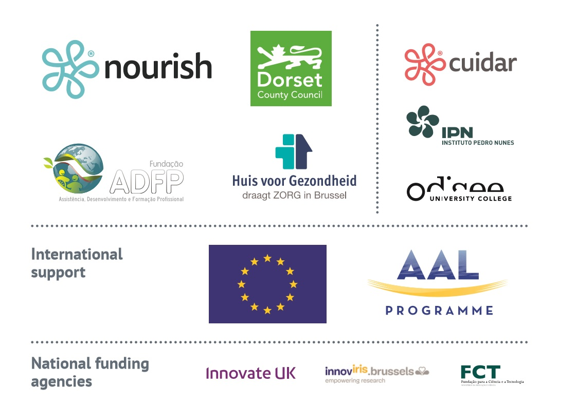

# Table of Contents

1. Document Information 2

1.1. Purpose of Document 2

1.2. Organisation Responsible 2

1.3. Authors and Contributors 2

1.4. Version History 2

2. Project Summary 3

2.1. Background 3

2.2. Purpose of IntegrAAL 3

2.3. Study design 3

2.4. Expected outcomes of IntegrAAL 4

2.5. Partners and supporter’s logos 4

3. Table of Contents 5

4. Delivery Plan 7

4.1. Deliverables & Milestones 7

4.2. Resources 8

4.3. Finance 9

4.4. Trello 10

4.5. Software Development 11

4.6. Risk Management 13

5. Conclusion 13

Appendices 13

# Delivery Plan

The IntegrAAL Project Delivery Plan comprises several interconnected parts that together enable management oversight and control of the project to ensure it achieves its objectives. In order to meet the operational needs of project delivery these need to be dynamic system that is able to track, record and respond to the inevitable changes and new opportunities that will occur in the delivery environment since the forecasts contained in the project proposal developed in 2014.

## Deliverables & Milestones

The key deliverables and milestones to be met for the delivery of this project are set out in the tables below:

***Deliverables overview list***

|  |  |  |  |  |  |
| --- | --- | --- | --- | --- | --- |
| Del. no. | Deliverable name | from WP no. | Nature/type of deliverable | Dissemination level  (Public or restricted) | Delivery date  (project month) |
| DL-1.1 | Project Management Folder | WP1 | Document | Public | M01 |
| DL-1.2 | Project Delivery Plan | WP1 | Document | Public | M01 |
| DL-1.3 | Calendar Year Reports | WP1 | Document | Public | M12, M24 |
| DL-2.1 | User Group Setup Report | WP2 | Document | Public | M3 |
| DL-2.2 | Needs Analysis Report | WP2 | Document | Public | M5 |
| DL-3.1 | System Design | WP3 | Document | Restricted | M5 |
| DL-3.2 | Technology Products | WP3 | Product | Restricted | M16 |
| DL-3.3 | Care Pathways | WP3 | Document | Public | M8 |
| DL-3.4 | Process for Monitoring of Performance and Outcome | WP3 | Document | Public | M8 |
| DL-4.1 | Monitoring and Evaluation Reports | WP4 | Document | Public | M27 |
| DL-4.2 | User Feedback Report | WP4 | Document | Restricted | M27 |
| DL-4.3 | Skills Evaluation Report | WP4 | Document | Public | M27 |
| DL-5.1 | Draft Business Plan/Business Model | WP5 | Document | Restricted | M14 |
| DL-5.2 | Business Plan | WP5 | Document | Restricted | M30 |
| DL-5.3 | Skills Plan | WP5 | Document | Public | M30 |
| DL-5.4 | End of Project Report | WP5 | Document | Public | M30 |

These deliverables will be produced as part of the specified reporting arrangements to the AAL Central Management Unit.

***Milestones overview list***

|  |  |  |  |  |
| --- | --- | --- | --- | --- |
| No. | Milestone name | WP involved | Expected date  (project month) | Means of verification |
| ML-­‐01 | Project Kick Off Meeting | WP1 | M1 | Meeting Held, Minutes Taken |
| ML-­‐02 | End User Forum Created | WP2 | M3 | User Group Setup Report |
| ML-­‐03 | Product Requirements Finalised | WP3 | M5 | System Design |
| ML-­‐04 | Integration Test Successful | WP3 | M16 | Technology Products |
| ML-­‐05 | Pilots Finalised | WP4 | M27 | Monitoring and Evaluation Reports |
| ML-­‐06 | Project Close Down Meeting | WP1 | M30 | Meeting Held, Minutes Taken |

While the Project Kick Off meeting was held in M1 following the start of the project on 2 January 2015 the expected dates of meeting milestones ML-02 and ML-03 were very optimistic. The operational requirements to establish the multi-national project team and complete the necessary Consortium and Finance Agreements led these two milestones to be achieved a little later than initial expectations. Both milestones were achieved within the first delivery year and did not impact the commencement of the other workpackages.

## Resources

The main resource to be applied to this project is participants time. This is recorded broken down by workpackage in the following table.

***Summary overview of staff effort in person months (pm)***

|  |  |  |  |  |  |  |  |
| --- | --- | --- | --- | --- | --- | --- | --- |
| Partic. no. | Participant | WP1 | WP2 | WP3 | WP4 | WP5 | Total (P*M) |
| 1 | Nourish Care Systems Ltd | 15 | 4.15 | 7.3 | 5.55 | 44 | 76 |
| 2 | Dorset County Council | 1 | 6.6 | 11.5 | 16.4 | 1 | 36.5 |
| 3 | The university college vzw Odisee | 1 | 3.7 | 9 | 12.85 | 0 | 26.55 |
| 4 | Huis voor Gezondheid | 0.5 | 4.8 | 1 | 8.3 | 0.5 | 15.1 |
| 5 | Instituto Pedro Nunes | 1 | 0 | 20 | 2.25 | 0 | 23.25 |
| 6 | Associação de Desenvolvimento e Formação Profissional | 0.5 | 5.15 | 0.5 | 7.55 | 0.5 | 14.2 |
| 7 | AlertiSugere Lda | 0.5 | 3.85 | 12 | 6.45 | 12.5 | 35.3 |
|  | Total |  |  |  |  |  | 226.9 |

The prolonged delay experienced by the Portuguese partners (no 5,6 and 7) in finalising the financial agreements with their NFA has had some impact on the time they could commit to the project in the first year. However, this was mitigated by goodwill by all parties who were able to continue to contribute to the project with the assurance of financial support for the project from the Portuguese authorities.

At the time of the development of the initial project submission and the project commencement it was anticipated that all effort would be provided by participant’s staff. This situation changed in October 2016 when, due to an internal reorganisation resulting from transformation of service, Dorset County Council had to seek approval to use the services of a contractor. The Council had joined others in the area to launch a ground breaking new Local Authority Trading Company (LATC) 'Tricuro'. While the staff involved would remain largely unchanged the organisational arrangement was different prompting the request for a variation from INNOVATE UK, the National Funding Agency (NFA) for the area. The explanation for the change is set out in a letter dated 16 October reproduced as Appendix a. Approval of this change was given by letter dated 10 December 2015 which is reproduced as Appendix b.

## Finance

It is the nature of AAL supported projects that there is no central funding but that individual partners are supported by their own NFA. The amount of support and level of intervention is determined separately by each partner by their respective NFA through a finance agreement for the life of the project. Each partner reports progress of the project to their NFA at intervals determined in the agreements to draw down the appropriate financial support for that period.

The inability of the Portuguese partners to conclude their financial agreements has had a limited effect on the ability on the project to apply all of these resources when required. This concern has been mitigated by the goodwill of all parties based on assurances that the agreements will be concluded as soon as possible based on the agreed start date of 2nd January 2015.

The lead partner will report the overall financial position to the AAL Central Management Unit as part of the periodic project reporting arrangements but will not be involved in any distribution of project finances to partners.

The financial breakdown of the project by partner is set out in the table below. It identifies the NFA’s contributions together with that of the partner organisation, if any, and the resulting NFA intervention rate. As the funding for the Portuguese partners is not yet included in any agreement the table includes both the original figures included in the initial proposal and the anticipated contract levels.

## 

## Trello

In line with the philosophy of the AAL programme the project adopted a cloud based project management system that allows all partners to be kept informed about as well as contributing to and participating in project delivery. Trello is a simple list of list system that organises the delivery of the project. It not only illustrates project progress at any time it provides warnings of slippage in timescales enabling resources to be reallocated to that task.

The system can also be used to create Gantt and other visual representations of project delivery like the one set out below.

***Gantt Chart***

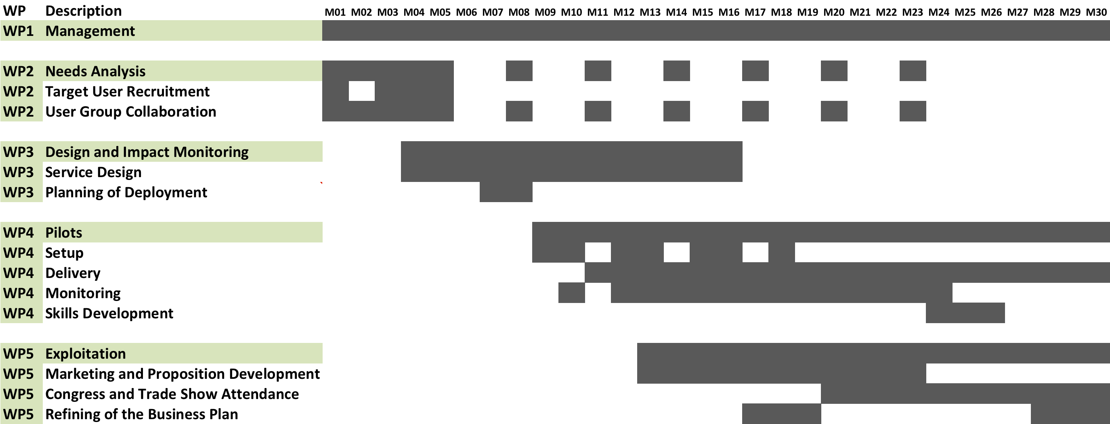

## Software Development

The project proposes delivering three main technology components:

* + - **Integration Platform**: Nourish IntegraTM provides an open API and integration wrappers for commonly used systems in social care delivery scenarios (e.g. case management systems, rostering, time tracking, or telecare alarm systems);
    - Context Specific Care **Service Apps**: apps to support better care, service delivery tracking, recording and reporting, and better communication across different care providers and selected Commercial off-the-shelf **IoT components, Wearables, Telecare and Telehealth** devices, integrated through a business logic layer and fully integrated into Nourish IntegraTM;
    - **IntegrAAL Social Engine (main innovation)**: a reasoning engine that uses data from care notes from care service apps (treated as human sensors), telecare sensors and wearable devices and generates stimuli to people within the circle of care (who are treated as human actuators);

These components require complex developments in available software and the creation of new software systems. This will be achieved by a detailed software development plan that includes the various actions required together with the resources to be deployed over the life of the project. The work breakdown and Gantt chart for this plan plan is set out below.

***Work Breakdown***

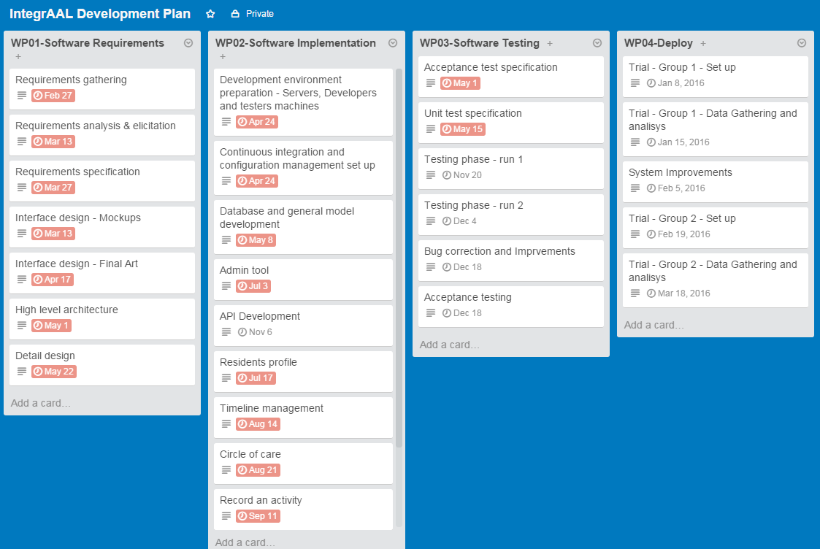

***Gantt chart***

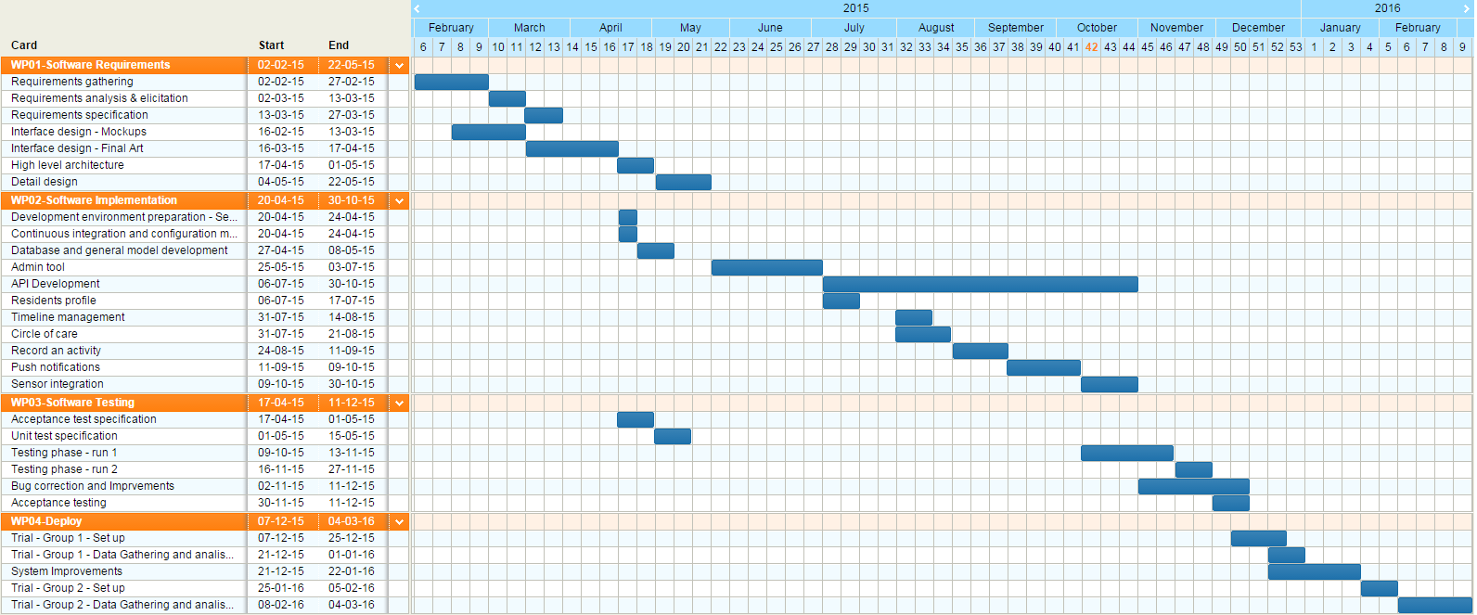

## Risk Management

A project risk register was included with the original project proposal. This was reviewed and updated in October 2015 informed by the experience of managing the delivery of the project over the first nine months of the project life. A copy of the expanded risk register is attached as Appendix c.

The three main risks identified are:

* Delay in reaching key milestones
* Loss of key personnel to the project, and
* The project concludes there is no realistic prospect for a commercial value

The register includes actions to mitigate or record these and the other identified risks. The register will continue to be reviewed and further amended as perceived circumstances demand.

# Conclusion

This project delivery plan explains the interrelated components that are in place to aid the delivery of the IntegrAAL project. With a number of partners representing different Nation States it is important to ensure that the systems not only assist project managers but are also accessible and understandable to all partners. Each of the components are dynamic rather than static to reflect and respond to changes in the delivery environment.

# Appendices

a

b

c 