DL 3.3

Care Pathways
WP3 – Pilot Design and Impact Monitoring

Version 3
Release: 31st of December 2015
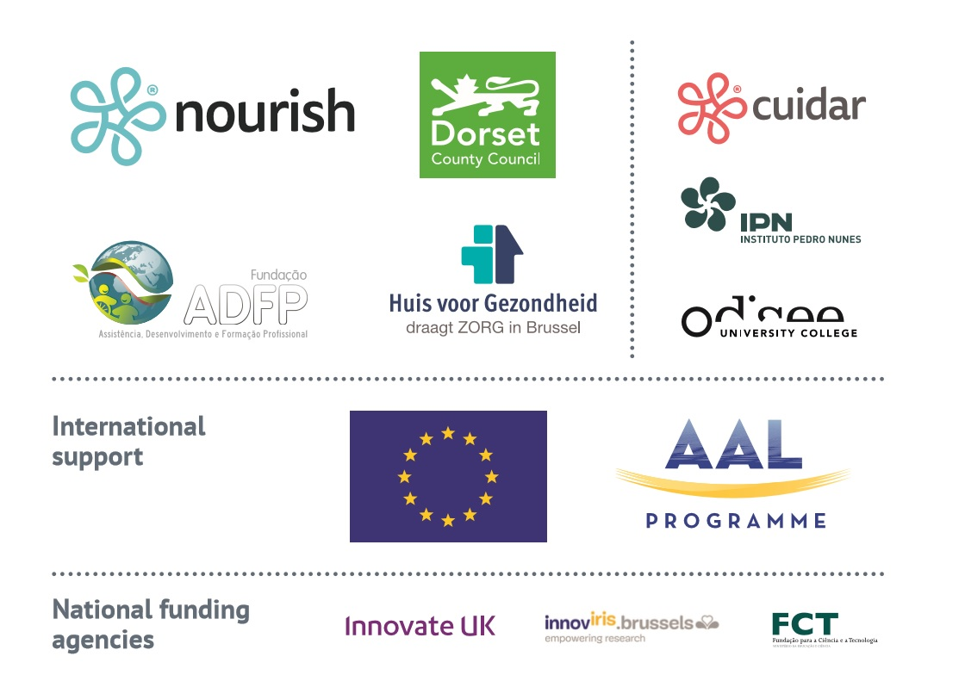

Document Information

Purpose of Document
This document contains the care pathways documented in the IntegrAAL project.

Organisation Responsible
Nourish Care Systems is the organisation responsible for this deliverable. All partners involved in care delivery are contributors and reviewers of the document.

Authors and Contributors
Partner | Name | Contribution | Date
NCS | Nuno Almeida | Author | 23rd April 2015
DCC | Helen Nicholson | Contributor | 21st April 2015
Odisee | Ellen de Cuyper | Contributor | 30th Nov 2015
HvG | Ulrike Dragon | Contributor | 30th Nov 2015
ADFP | Natalia Leandro | Contributor | 30th Nov 2015

Version History
Version | Date | Description | Author
0.1 | 5th of March 2015 | Template released. | N. Almeida
1.0 | 23rd of April 2015 | First draft release. | F. Dumez
2.0 | 30th of Nov 2015 | Reviewed version. | N. Almeida
3.0 | 31st of Dec 2015 | Reviewed version. | N. Almeida

Executive Summary
Background
The internet revolution and growth in mobile- and micro-technologies has generated changes in the way we live, work, play and communicate in ways that would have been previously unimaginable. Despite elderly populations accounting for a disproportionate use of healthcare resources [1], this group has traditionally been under-served by the technologies that are changing the way we live in so many other aspects of our lives.

Purpose of IntegrAAL
Project IntegrAAL (Integration of AAL (Active Assistive Living) Components for Innovative Care Pathways) aims to explore the fundamental question of how we can first understand the challenges faced by some of these older people, and then take available technologies and design and develop new ways of introducing them in meaningful ways in order to improve health outcomes, quality of life, and cost-effectiveness of delivering care. More specifically, IntegrAAL intends to understand the circles of care that are responsible for delivering the day-to-day care for these populations, both formal and informal, and design and develop systems based on handheld mobile technologies to foster and facilitate communication within the circle of care. In addition, the use of newer Internet of Things devices incorporated into the information management system creates the opportunity to develop new care pathway paradigms that have the potential to revolutionise the approach to care of the elderly living at home.

Care Pathways
This document describes the pathways that were identified across all sites, as well as the adaptations that were designed in the context of IntegrAAL.

Table of Contents
1. Document Information 2
1.1. Purpose of Document 2
1.2. Organisation Responsible 2
1.3. Authors and Contributors 2
1.4. Version History 2
2. Executive Summary 3
3. Table of Contents 4
4. Introduction 5
4.1. Glossary 5
5. Care Settings and Pathways 6
5.1. Methodology 6
6. Dorset, England 7
6.1. Care Pathway Design 9
6.2. Specific Changes to Existing Pathway 12
7. Brussels, Belgium and Miranda do Corvo, Portugal 14

Introduction

Glossary
AAL | Active Assistive Living
Care pathway | Multidisciplinary management tool based on evidence-based practice for a specific group of patients with a predictable clinical course, in which the different tasks (interventions) by the professionals involved in the patient’s care are defined, optimized and sequenced either by hour, day or visit.
IntegrAAL | Project acronym for Integration of AAL (Active Assistive Living) Components for Innovative Care Pathways
Nourish Integra Platform | Cloud-based data management platform to support care providers in managing care data in a person-centred manner. It enables assessment, care planning, care recording using mobile devices, and outcome management as well as reporting. It also enables care providers to make use of IoT devices as well as wearable devices in the context of care provision.
IoT device | Internet of Things device, normally a sensor device connected to the internet enabling the monitoring of location, movement, or temperature amongst others.
Pilot | A small-scale preliminary study conducted in order to evaluate feasibility, time, cost, adverse events, and effect size (statistical variability) in an attempt to predict an appropriate sample size and improve upon the study design prior to performance of a full-scale research project.
Evaluation | Structured interpretation and giving of meaning to actual impacts of proposals or results.
SMAS-30 [2] | Self-Management Ability Scale, refers to the core behavioural and cognitive abilities which presumably contribute to sustainable well-being in later life.
ICEPOP | Investigating Choice Experiments for the Preferences of Older People
ICECAP-O | ICEPOP CAPability instrument for Older people
ECI | Experience of Caregiving Inventory
CBS | Caregivers Burden Scale
ICD10 | 10th revision of the International Statistical Classification of Diseases and Related Health Problems

Care Settings and Pathways
This section describes the care pathways that currently exist at each setting, changes to the pathway (if any) and how the pathway will be supported by technology during the intervention.
All pathways will be focused on older people as described in the research protocol document (DL 3.4). The pathways will take into account a person’s journey through various settings, including:
- Their home;
- Hospital;
- Pharmacy;
- GPs;
- Ambulance services;
- Care homes;

Methodology
Each partner in charge of a setting is holding one or more user focus groups to determine:
- Current challenges for people receiving care,
- Current pathways,
- Receptiveness to new approaches, namely more self-management, use of technology to support people in self-managing.
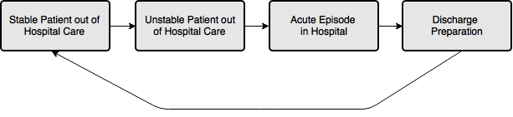
Also, for each setting, partners are identifying the current care pathways in place.
Figure 1 - Classic Patient Journey

The diagrams show who is involved in caring for and supporting these patients, what functions these actors perform, and how different ICT tools facilitate the delivery of these activities. Moreover, this information is visually organised in four stages according to the patient's health status:
1. Stable patient out of hospital care.
2. Unstable patient out of hospital care.
3. In hospital care.
4. Hospital discharge preparation.

Based on the journey for each pilot setting and information gathered from user focus groups a detailed user journey will be designed, including:

Dorset, England
The IntegrAAL pilot in England will take place in the region of Dorset a rural County. The pathway of interest starts during hospital admission, specifically those that results in referrals for the reablement service.
During preparation for hospital discharge, as part of medical assessment, if the medical team has doubts about the ability of the individual to live independently, a multi-disciplinary team will review the case, and a discharge plan is created.
The Community Care Officer (CCO) will be involved as part of this review, and fill in an Assessment. The CCO creates a support plan and on the case management system records the commissioning of the care to the reablement service, adding “DCC Homecare” as a provider, the service parameters and schedule including end date.
Once the Assessment is complete, the reablement team is able to assess the number of hours and daily tasks required to satisfy the requirement. A Community Support Officer (CSO) undertakes the initial visit to commence the REV1 form confirming and adding to the information gathered during the assessment and consider any risks.
Once number of hours is defined, capacity to provide the service is assessed and a start date is set. Scheduling of the service is added on the HOCAS system. Each week the HOCAS system runs a routine to match available formal carers to individuals to deliver the service on a regular basis. Changes are made on a daily basis to respond to formal carer sickness and service user absences.
At week three, a review of the case is conducted to assess evolution of needs. This will result in a recommendation to either:
- Cease reablement;
- Continue for up to 6 weeks from start date, continuously assessing, then cease reablement;
- Referral to long term services;
For options 1 and 2 the CCO ends the provision on the AIS system and ceases involvement with the person’s case on AIS. For option 3 the person is referred to a locality team, who will then do a financial and needs assessment and organise the provision of new long term formal care.,
NOTE: this process is being reviewed under the ACCORD programme and will change from the 1st April 16.

Care Pathway Design
Care pathways usually focus on the transitions between patient statuses, and are represented as a journey across different care settings. The pathways of interest in this study are those related to hospital discharge, temporary reablement service, or long term provision from a formal care provider, either a care home or a home care provider.
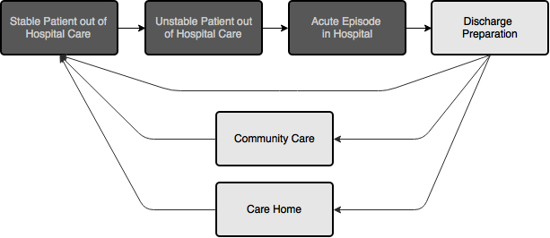
Figure 2 - Hospital Discharge Pathways

Pathways, process and practice are documented in the best practice guidance issued by the Department of Health. Liz Lees, consultant nurse at the Heart of England Foundation Trust and author of several papers on discharge pathways, states that:
Discharge planning is a complex activity, particularly in the context of new services offered outside hospital, like intermediate care, and having a population with more older people, who often have extremely complex care needs. However, effective discharge planning is crucial to ensure timely discharge and continuity of care. It also helps healthcare providers use limited resources most effectively and unnecessary readmissions to be avoided.
Discharge options are also becoming more complex. The NHS has been encouraging a “whole systems” approach involving the NHS, social care partners and the independent sector. This is expressed in several reference papers such as:
- The Care Act 2014, expresses the expectations that NHS teams notify social services of potential needs and planned date of discharge; the assessment notification where the NHS notifies social services is supposed to be extremely brief: “The information contained in an assessment notification is intended to be minimal, both to reflect patient confidentiality requirements and to minimize bureaucracy”;
- Whole system priorities for the discharge of frail older people from hospital care: this put emphasis on the importance of good discharge planning, calling for a “whole system” approach to planning, reviewing and communicating of hospital discharge; this states that “Local health and social care partners should agree to allow read-only access for acute staff to community and social services patient databases in order to expedite care planning”;
- The SilverBook: a multi-agency effort to improve the experience of acute admission for older people; amongst several key recommendations, the chapter 8 of the SilverBook recommends which information should be shared and with whom in the context of acute care for older people;
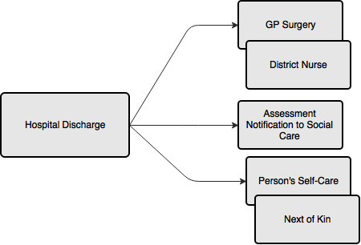
Figure 3 - Typical communications as part of discharge
Communications across border between health and social care are invariably succinct.
Implementing self-management strategies is challenging for this group of patients. Considering the frequency of visits that many patients receive from social care providers it is important to consider the potential for these to play in role in the support to self-management of long term conditions. The significant gaps and/or delays in information sharing and no use of intelligence from supporting technology that is used (thinking telecare) compromise the effective implementation of self-management approaches, and the optimal use of formal and informal management of long term conditions.
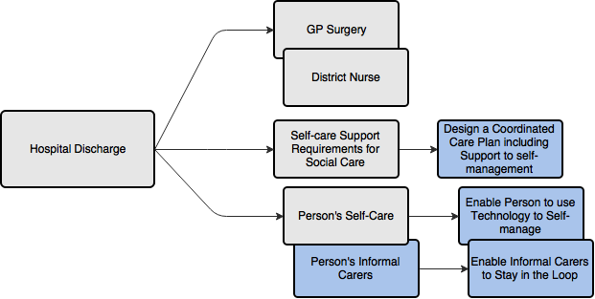
Figure 4 - expansion of the information flow introduced by IntegrAAL

IntegrAAL will augment the pathway to enable a combined view of several aspects of the person’s condition and needs, taking into account the possibility for self-management with support from both a circle of care and technology.
IntegrAAL will support care teams with the assessment and creation of care plans. The project will expand the traditional contact for a next of kin and cater for a wider type of support network.
This means that more than one person in the family can be involved in the care of a person, and even friends can play a role that is coordinated with the bigger picture of support.
The changes to how the pathway is rolled out will take place within the reablement function within Dorset County Council. The reablement function will be supported for the scope of the trial.

Specific Changes to Existing Pathway
On one hand, the planning of services, scheduling and rota design will be performed as before using the local system called HOCAS.
A digital care plan will be added to the process. This will run in parallel with the paper log kept at the person’s home but in the long term, this is envisaged to replace the paper care plan. This care plan will enable the planners of the reablement service to:
- Enrol a new person;
- Define their areas of need;
- Identify and track risks;
- Identify outcomes, define review dates and objectives;
- Define what services will be provided, and how these will deliver the outcomes;
Once this information is on the system, an additional layer is added focussed on giving the person control and independence. This will be done by an Occupational Therapist and includes:
- Mapping and assessing the person’s circle of care: informal carers including close family, friends and volunteers who play a relevant role in the person’s day to day;
- Training people on the circle of care: informal carers are assessed and trained to use the apps or to send and receive SMS messages used by the systems that will be in place;
- Suitable assistive technology is assessed and deployed: as part of IntegrAAL, the project will make available kits that enable people to better self-manage their hydration, remember their medication, or staying active; are we including other available apps on the market they might use to monitor health and bring that data in?
- Setup of circle of care: determining based on the consent obtained from the person and the person’s wishes, the notification process is then setup to alert the person, people in their circle of care and ultimately a formal carer.
This enables the improvement of the ability of the person to self-manage, while ensuring that informal carers are given peace of mind and the ability to support the person while keeping formal carers in the loop as a backup.
Formal carers providing services to older people will also take advantage of multiple aspects of the system. These include:
- Ability to record notes from visits digitally rather than on paper;
- Ability to record times of visits, both manually, or semi-automatically;
- Ability to receive alerts regarding the person they’re going to visit, e.g. if a person was unwell when the family came in previously;
The person will also be engaged in an expanded manner, namely:
- The person will have an up to date view of the planned visits for the week;
- The person’s next of kin or nominated person will also receive this list;
- The person has electronic access to their care plan;
- The person receives support in gaining awareness of their wellbeing, namely how they sleep, how active they are, if they take medication on time, and they stay hydrated;
- The person is able to work with their circle of care to manage their medication reminders, hydration levels and activity;
- The person receives notifications if a carer is running late;
- The person receives notifications if a carer cannot make it today;
- The person receives a summary information about the carer;

Brussels, Belgium and Miranda do Corvo, Portugal
The care pathway identification and design for Belgium and Portugal is ongoing and will follow the same structure of the work outlined for the UK.

Health & Social Care Joint Unit and Change Agents Team, Discharge from hospital: pathway, process and practice,http://www.wales.nhs.uk/sitesplus/documents/829/DoH%20%2D%20Discharge%20Pathway%202003.PDF
Liz Lees, The key principles of effective discharge planning, 17 January 2013,http://www.nursingtimes.net/nursing-practice/specialisms/management/the-key-principles-of-effective-discharge-planning/5053740.article
NHS Interim Management and Support, Effective Approaches in Urgent and Emergency Care, Paper 3, Whole system priorities for the discharge of frail older people from hospital care, http://www.england.nhs.uk/wp-content/uploads/2013/08/dis-old-people.pdf
The Silver Book, Quality Care for Older People with Urgent &Emergency Care Needs,http://www.bgs.org.uk/campaigns/silverb/silver_book_complete.pdf

