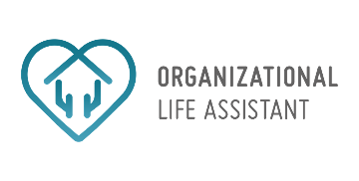

OLA – Organizational Life Assistant

FOR FUTURE ACTIVE AGEING

http://iscte-iul.pt/Libraries/GCI_-_Documentos_e_Formul%C3%A1rios/II_pt.sflb.ashxhttp://www.saapho-aal.eu/sites/default/files/styles/medium/public/logo%20Liquid%20media.jpghttp://inovamais.eu/noticias/wp-content/uploads/sites/7/2014/12/INOVAMAIS_LOGO_NEW.pnghttp://iscte-iul.pt/Libraries/GCI_-_Documentos_e_Formul%C3%A1rios/II_pt.sflb.ashxhttp://www.saapho-aal.eu/sites/default/files/styles/medium/public/logo%20Liquid%20media.jpg

|  |  |
| --- | --- |
| **Project Identification** | |
| Project Number | AAL 2014-076 |
| Duration | 30 months (1st March 2015 – 31th August 2017) |
| Coordinator | Carla Santos |
| Coordinator Organization | Inovamais, S.A. (INOVA+) |
| Website | <http://project-ola.eu/> |

|  |  |
| --- | --- |
| **Document Identification** | |
| Deliverable ID | D1.1 User Requirements specification and use case definition |
| Version/Date | V-A / 29-02-2016 |
| Leader of the Deliverable | SSW |
| Work Status | Finished |
| Review Status | Accepted |

|  |  |
| --- | --- |
| **Deliverable Information** | |
| Deliverable Description | This deliverable encompasses version A and B of this deliverable, which accommodate the user requirement methodology employed and then the results of those activities. |
| Dissemination Level | PU |
| Deliverable Type | R |
| Original Due Date | M11 |

|  |  |
| --- | --- |
| **Authorship & Review Information** | |
| Editor | Artur Kolesinski |
| Partners Contributing | ISCTE-IUL, LM |
| Reviewed by | ISCTE-IUL |

Table of Contents

Executive Summary 8

Document Context 9

Role of the Deliverable 9

Relationship to other Project Deliverables 9

Document Structure 9

Target Audience of the Deliverable 9

Project Description 10

General Description 10

System Description 11

Status and Future Developments 12

Portuguese Personas and Scenarios 13

Seniors 13

Maria 13

Backstory 13

Health Information 13

Architectural Barriers 13

Technological knowledge 14

Fears and Frustrations 14

Motivations 14

Scenario 15

Teresa 18

Backstory 18

Health Information 18

Technological knowledge 18

Fears and Frustrations 18

Motivations 19

Scenario 19

Informal Caregivers 24

Alice 24

Backstory 24

Caretaker’s health information 24

Architectural barriers 24

Technological knowledge 25

Fears and Frustrations 25

Motivations 25

Scenario 25

Pedro 28

Backstory 28

Caretaker’s health information 28

Technological knowledge 28

Fears and Frustrations 28

Motivations 29

Scenario 29

Formal Caregivers 31

Luís 31

Backstory 31

Perceptions regarding senior patients 31

Architectural barriers 31

Technological knowledge 31

Technology in the working environment 32

Scenario 32

Claudia 34

Backstory 34

Perceptions regarding senior patients 34

Architectural barriers 34

Technological knowledge 34

Technology in the working environment 35

Scenario 35

Backstory 37

Perceptions regarding senior patients’ 37

Technological knowledge 37

Technology in the working environment 37

Scenario 38

Polish Personas and Scenarios 39

Senior 39

Ela 39

Backstory 39

Architectural barriers 39

Health status 39

Fears and frustrations 40

Technologies use 40

Scenario 41

Informal Caregiver 43

Nina 43

Backstory 43

Architectural barriers 43

Support 43

Fears and frustrations 43

People in care – caretaker’s health information 44

New technologies – usage and knowledge 44

Scenario 45

Formal Caregiver 47

Halinka 47

Backstory 47

People in care – perceptions regarding senior patients 47

Technological knowledge 47

Scenario 48

Swedish Personas and Scenarios 49

Seniors 49

Arne 49

Backstory 49

Health information 49

Architectural barriers 49

Technological knowledge 49

Fears and frustrations 50

Motivations 50

Scenario 50

Informal Caregivers 52

Magnus 52

Backstory 52

Caretaker’s health information 52

Technological knowledge 52

Fears and frustrations 52

Motivations 53

Scenario 53

Juana 55

Backstory 55

Caretaker’s health information 55

Technological knowledge 55

Fears and frustrations 55

Motivations 55

Scenario 56

Formal Caregivers 57

Martin 57

Backstory 57

Perceptions regarding senior patients 57

Technological knowledge 57

Technology in the working environment 57

Scenario 58

Nina 59

Backstory 59

Perceptions regarding senior patients 59

Technological knowledge 59

Technology in the working environment 59

Scenario 59

Annexes 61

Annex 1 61

# Executive Summary

Try not to exceed one page.

Make sure that what you write really is a summary. It should not be an introduction.

Someone who reads ONLY this section should have an overall impression of all the important things contained in the document. Conversely: someone who reads all the chapters except this one should not miss anything i.e. there should be no information contained in this chapter that is contained only here.

# Document Context

## Role of the Deliverable

Description of the role of this deliverable: goals, scope, expected results, etc…

## Relationship to other Project Deliverables

|  |  |
| --- | --- |
| **Deliv.** | **Relation** |
| Dx.x | Title:  Add a short description and make sure you explain how this document relates to it. |
| Dy.y | Title:  Add a short description and make sure you explain how this document relates to it. |

## Document Structure

This section is not mandatory. If your deliverable has a complex structure, or there are aspects of the structure that are particularly important for readers – include an overview here. If readers can easily see the structure from reading the Table of Contents, then there is no need to repeat the same information here.

## Target Audience of the Deliverable

For example: “This document is a public deliverable. Still, it is mainly intended for the project partners and the European Commission services thus the document will be made public, but not specifically disseminated on a wider scale.”

# Project Description

## General Description

This project aims to provide an answer to the societal challenges by providing an innovative Organisational Life Assistant (OLA), a virtual presence that supports instrumental activities relating to daily living needs of older adults allowing them to be more independent, self-assured and to have a healthier, safer and organized life, while facilitates caregivers by supporting them on offering high-quality assistance

OLA will mediate and facilitate interaction (communication and collaboration) between senior citizens and their informal caregivers or other services or professionals, through technological devices such as standard computers, mobile devices (tablets) and home automation modules. These ICT devices will be based on an innovative multimodal model, embracing various physical/healthy and cognitive characteristics of the older adults and will specifically oriented to increase the level of independence of the elderly, by supporting the possibility of carers' assistance remotely and by improving the accessibility to existing services on the Web, such as shopping on-line services.

Moreover, the OLA will also provide a personalized well-being and safety advices to older users in order to avoid unwanted age related health and safety situations at their own home. Such a well-being and safety advisor makes uses of a combination of collected user information (personal physical/health and cognitive characteristics) and user interaction information extracted through emotion recognition and various sensor settings.

OLA addresses also a major issue that elderly is facing related to memory degradation and gradual decreasing of their cognitive capabilities, enabling them to remember primary health care and fiscal obligations (e.g. personal hygiene, medical and tax compliance) or helping them to find everyday items such as eyeglasses, wallet or keys. It is based on speech dialogue interfaces and space and object reconstruction and classification to capture and store daily routines and their related contexts.

The primary end-users are the big group of older adults of 65+ living alone with or without light physical or cognitive age related limitations, who needs support from care systems. Secondary end-users are both formal and informal caregivers from public or private sectors, supporting them to cope with the increased demand for care.

## System Description

OLA addresses specifically the following main issues:

* **Well-being advisor**: based on the combination of the collected user information (personal, healthy characteristics) and user interaction information extracted through emotion recognition, sensors settings and contextual recorder capturing the routines as done by the older adult) the system will propose to the older adults personal advice adapted to their situation contributing to their preservation and well-being status in home environment. In case of risk (e.g. irregular heart rate, extreme fatigue) the system may ensure an alert to a local medical emergency service.
* **Collaborative care organizer**: based on the ISCTE-IUL and LM knowledge of developing human-computer interaction platforms (HCI), OLA will provide online care collaboration between family and professional caregivers, by enabling a local care network to communicate, access sensor data, and coordinate care tasks. With the OLA assistant, seniors will be able to actively participate in the care organization through voice, even when they are unwilling or unable to use traditional web applications.
* **Safety advisor**: based on the combination of collected user environment information through real-time analysis and augmented reality settings, the system will propose suggestions of environment changes that interfere with accessible paths and provide alerts for intruders or other situations that can create hazard situations. In case of risk (e.g. checking intruders or fire), the system may contact local emergency services.
* **Every day instrumental daily living activities memory support**: the system will anticipate medical and fiscal compliances, remember primary health care and food requirements and could help elderly to find displaced everyday items.
* **Environment analysis**: algorithms for real-time object recognition and scene understanding will be developed based on a number of inputs (i.e. 3D object and space reconstruction by using time-of-flight and augmented reality technology) in order to analyze and decide which action to be taken in order support the elderly by suggesting environment changes and providing hints/advices for safety and accessible environments.
* **Multimodal interaction for elderly**: An adaptive organizational life assistant, a virtual presence will be developed in order to facilitating communication and collaboration between older-adults and informal caregivers or other services or professionals. This will be a user-friendly system that uses multimodal approaches based on non-invasive and minimally obtrusive technologies (i.e. speech, silent speech, touch, gestures, RGB-D sensors).

The overall OLA system is an easy to download and to install software making use of multimodal integrated settings. OLA is in essence a service that enables the elderly user to reduce the demand of care through prevention and self-management, while at the same time also facilitates the supply of formal and informal care assistance.

A series of well-selected use cases where older adults have been supported by caregivers and care professional services will be carried out. Three pilots, in Portugal, Poland and Sweden representing the different use cases will be carried out. 60-90 care units will use the system over a six month period. New evaluation approaches will be used during the pilots, investigating up to which point the OLA services alleviate caregivers support and maintain, or even improve the self-management, health and safe lifestyle of the older adult at home.

## Status and Future Developments

This chapter should present the status of the project considering this deliverable (date, developments, etc…) and future plans/developments of the project and of the deliverable within the project.

# Portuguese Personas and Scenarios

## Seniors

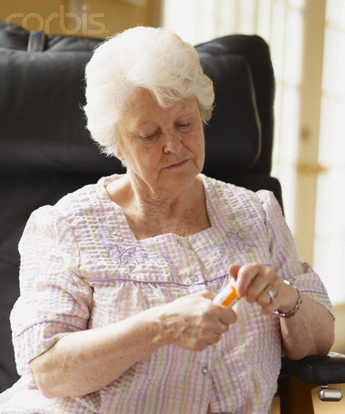

Maria

79 years old

Lisbon

Widowed

Retired

Two sons and one granddaughter

Gets help from Diana a Direct Action Assistant

#### Backstory

Maria lives alone in her apartment in Lisboa. She attended and graduated professional school and owned a small business with her husband. When he died she sold the business and retired. She has a lot of friends and acquaintances made when she ran her little grocery shop. She is not capable of performing house chores on her own, while climbing stair or walking for long periods of time because she gets easily tired and feels chest pain. Every time she needs help she calls Diana a Direct Action Assistant of her area of residency or one of her sons who live in Oeiras. When she is at home though, she sometimes feels a little lonely.

#### Health Information

Maria’s primary concern is her *angina pectoris* that requires her to take medication on a daily basis. Lately she has been feeling some memory problems and is afraid she will forget to take her medication. For these reasons she is not satisfied with her current health condition.

#### Architectural Barriers

Although Maria lives in a 2nd floor apartment without elevator she does not experience any major mobility difficulties in her house. She rarely stumbles in anything and she has only fell once at home.

#### Technological knowledge

Maria owns a cell phone which she regularly uses to talk with her friends. She does not own a computer but her friends have talked to her about how useful it is. Even though she thinks she does not have the income to afford a computer but might have for a tablet or smartphone and is willing to try it out. She would afford to pay something like 1€ to 14€ a month for any assistive technology.

#### Fears and Frustrations

Lately Maria has seen many of her friends become ill and not being able to remain as active as usual (social life / health). She is very saddened by this and fears that she might lose her friends or that the same thing might happen to her. Maria’s biggest fears are forgetting to close doors or windows or to take her medications (mental well-being / health). She is feeling her health declining especially when it comes to walking or climbing stairs, which causes her to face old age in a very negative way. Additionally, because she lives alone, she fears that, if something happens to her, such as injuring herself at home, she will become a burden to her children.

#### Motivations

Maria would really like to improve her overall health, specially her memory. She would also like to have solutions that could help her be more independent in the house (safety), easing the burden of having to perform everything on her own and feeling tired and in pain all the time. She would also like to learn how to use a computer or tablet, especially to keep in touch with her friends when she is home alone (social integration).

#### Scenario

Maria lives alone but she often calls one of her sons for help, since he lives in the close towns. She suffers from a health condition that requires her to take medication on a daily basis. She also has difficulties performing house chores on her own because she gets easily tired and feels chest pain.

To improve her overall health and allow her to be more independent in her house, Maria and her son decided to subscribe the Organizational Life Assistant (OLA) service through the recommendation of Diana (Direct Action Assistant). At first, she thought she would not be able to afford it because her retirement pension is very low. However, the OLA system was very affordable and her son also helped by supporting a portion of the monthly costs. He even bought her a smartphone so she could interact with OLA. In the beginning Maria had some difficulties with the application but quickly adapted. Diana accompanied the implementation process and regularly check if Maria was adapting well to the system. Maria found the OLA virtual avatar to be very friendly and helpful especially in the beginning due to the ease of use via speech. She communicated with it mostly using voice, though she sometimes found it useful to interact with OLA using touch. Since she has a low education level, she liked the fact that she could use OLA to write down notes simply by dictating them.

Maria occasionally experiences memory problems. For instance, she is very worried that she will forget to take her medication. Since she started using OLA, she has been able to manage her medication intake much better. Besides alerting her when to take her medication throughout the day, it also specifies which and how many pills she must take each time. Maria is very pleased that OLA informs her when the medication is about to run out and helps her know when it's time to order more. This is possible because OLA keeps track of her medication intakes, including date, hour and dosage, by requiring Maria to confirm the intake. Whenever necessary, Maria is also able to consult both the prescription information, such as intake schedule, and the medication information, such as side effects.

Having heart problems Maria regularly measures her heart rate. Before she was not always sure if the results were correct. Now when she has OLA she is not worried anymore. The system communicates with her pulse oximeter and heart pressure monitor and in case of any abnormalities informs her and her son immediately.

Besides, Maria also fears that she might forget to close the doors or windows. OLA has also been helping her with this issue by warning her about open doors or windows whenever she leaves the house. When she subscribed the OLA service, a certified technician installed different sensors in several rooms of the house. This proved to be very useful when, one day, Maria decided to go out for grocery shopping. After locking the front door, her smartphone buzzed and OLA displayed a notification on the screen. As she tapped it, the following message was presented both textually and verbally: “Security issue: Your bedroom window is open”. In addition, two options were shown, allowing her to either “Solve” or “Ignore” the issue. She tapped the “Solve” button and then went back to close the window and prepared to leave the house again, but this time OLA did not alert her when she went out the door.

OLA allowed Maria to leave her home safely and reduce the risk of an intrusion.

Sometimes Maria misplaces important objects and then forgets where they are. OLA also helps her in these situations. One day, she could not find her wallet anywhere, so she decided to use OLA to look for it. She used her smartphone to start the “Find an object” wizard. The question “Which object would you like to find?” as well as a list of everyday objects were presented both textually and verbally. Maria tapped the “Wallet” option and an image from the living room camera feed popped up on the screen showing her wallet, which was lying on the coffee table. The message “You can find the wallet in the living room” was also presented textually and verbally. This way, OLA allowed Maria to quickly find her wallet and leave the house to go shopping.

Now that she uses OLA, Maria feels much more independent, as she does not need the help of her son so often. She still contacts him and his other children quite frequently using OLA, either through phone or video calls, which has also helped her address her feelings of loneliness.

Since Maria also fears that she might injure herself at home, so she asked her local Direct Action Assistant (Diana) to help her improve the safety of her house using the OLA environmental analysis feature. She promptly agreed to help, so they downloaded OLA to Diana’s tablet and Marias Smartphone and configured the settings to use the Portuguese norms and regulations. The scan equipment was temporarily made available to Maria and conveniently delivered to her home. Together, they were able to perform the environmental analysis in real-time: while the social worker scanned the house, Maria pointed the smartphone. Suddenly, OLA warned her to an environmental barrier located on the living room by highlighting the area between the sofa and the coffee table. The following message was presented both textually and verbally: “Accessibility issue: The distance between the furniture is too narrow and might restrict the passage”. Maria tapped this highlighted area once and a text box popped up on the screen with the message “Recommendation: Move or remove one of the furniture pieces from this location”, which was also read out loud by OLA. The social worker helped her move the table closer to the wall and farther from the sofa. They then continued to scan the entire house and make the necessary changes.

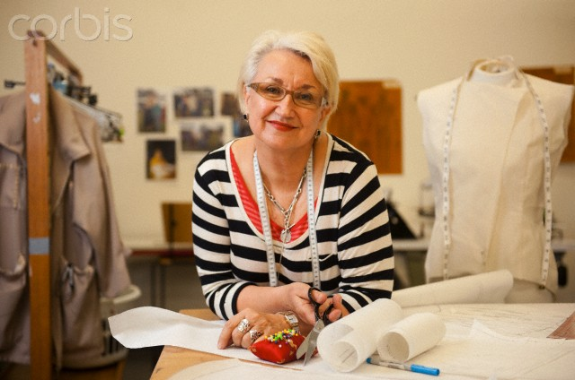Teresa

71 years old

Oeiras

Married

Retired

One son and three grandchildren

Gets help from her son Pedro and is monitored by her doctor Luís

#### Backstory

Teresa lives with her husband in a good house in Oeiras. She attended and graduated primary school. She is a retired seamstress. She is a very dedicated grandmother and between house duties and taking care of her grandchildren she barely has time for any other activities, although she doesn’t go without her Sunday walks with her husband. Her son Pedro is very present in her live and regularly helps Teresa and her husband especially when it comes to technology.

#### Health Information

Teresa overall health is good but she has been feeling some challenges while climbing stairs or walking for long periods of time. After going to the doctor she was diagnosed with light *arteritis* and she is very concerned about it. She also wears glasses with progressive lenses.

#### Technological knowledge

Teresa has a cell phone which she regularly uses to call her son and grandchildren. She does not own a computer or has never used one. She is willing to learn how to use technology because she has seen her son and grandchildren use it. She would be willing to spend 15€ to 59€ a month for any assistive technology.

#### Fears and Frustrations

Teresa’s biggest fear is losing her walking ability (health). She is afraid she won’t be able to keep up with her grandchildren and take care of them as she likes so much to do (mental and physical well-being).

#### Motivations

Teresa would really like prevent her disease from escalating. She would like to manage her schedule better in order to spend time with her family and also take care of herself.

#### Scenario

Teresa lives with her husband. Most days, she barely has time for other activities besides performing her house chores and taking care of her grandchildren. Ever since she was diagnosed with *arteritis*, she fears that she may lose her walking ability. She has already started experiencing some mobility issues, for example, when climbing stairs or walking when for long periods of time.

To help her manage her schedule, prevent her health from deteriorating and improve her mobility in the house, Teresa decided to subscribe the Organizational Life Assistant (OLA) service with the suggestion of her son Pedro. Given that she is not familiar with using technology, she asked her son to help her in this process. Since OLA was available in different versions and platforms, her son decided to offer her his tablet and suggested they could download the Portuguese version to install. She was glad that she could interact with OLA using voice, since she has some vision problems. The OLA virtual avatar also helped her learn how to use its many features by frequently providing her tips and guiding her when necessary.

Teresa has been able to manage her schedule more efficiently using OLA. Its electronic agenda allows her to easily access and update her daily schedule and then warns her every time she has an appointment or any task she had previously scheduled, including her medication dosing. Some of OLA features also help her save time. For example, she is able to create shopping lists that she then uses to search and order products online. Based on her schedule, OLA suggests local services adapted to her needs, such as laundry services, to help her free some of the time she spends on house chores. This way, she has more time to be with her grandchildren.

OLA even helped her create an online profile. Besides suggesting her local social events she can attend, it also allows her to create her own events and invite her friends, either by sending them e-mails and text messages, or by sharing these events on her online profile. Because she wants to motivate her friends to stay healthy, she often invites her friends for her long walks.

OLA also helps Ana to stay active and healthy. With the OLA service she started logging her weight and heart pressure every morning and whenever she goes out for her riverside walks with her husband, she brings OLA on her smartphone paired with the Microsoft Health Band to collect data, such as the number of steps, walked distance and heart rate, so she can monitor her physical activity. OLA then displays this information in easy to understand formats, from tables to charts, allowing her to be aware of her current activity status and to keep track of her evolution over time. This data is also automatically available to her doctor Luís and has helped him monitor her health with longitudinal data instead of sporadic data, allowing a better understanding of Teresa’s heath complains.

In addition, by asking OLA to suggest healthy recipes, Ana has been able to keep a balanced diet. Since she also wants her friends to stay healthy, she frequently shares these recipes with her friends, either through e-mail or social networks.

With the help of her son, Teresa decided to use the OLA environmental analysis feature to improve her mobility in the house, as well as to avoid any injuries that might worsen her health condition. The scan equipment was temporarily made available to Teresa and conveniently delivered to her home. Her son helped her perform a complete environmental scan of her house using the scanning wizard provided by OLA. They also took a picture of its floor plan and uploaded it using the tablet. One hour later, OLA displayed a notification announcing that the environmental analysis results were available. Teresa and her son decided to explore the results using augmented reality. On the bottom left corner of the tablet screen, the floor plan that was previously uploaded was presented with various environmental barriers marked in it. As they moved around the house holding the tablet, they noticed a red dot in the doorway between the entry hall and the living room (Figure 1).

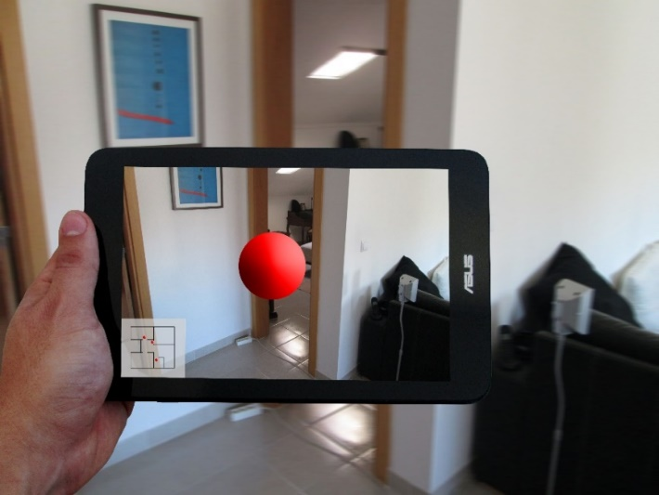

Figure . Shot 1

As Teresa tapped the red dot, a cable that was crossing the doorway was highlighted and a popup appeared on the screen with the message “Fall hazard: There is a cable on the floor in which someone might trip and fall” which was also read out loud by OLA (Figure 2).

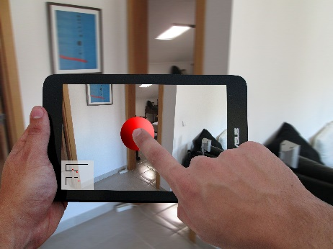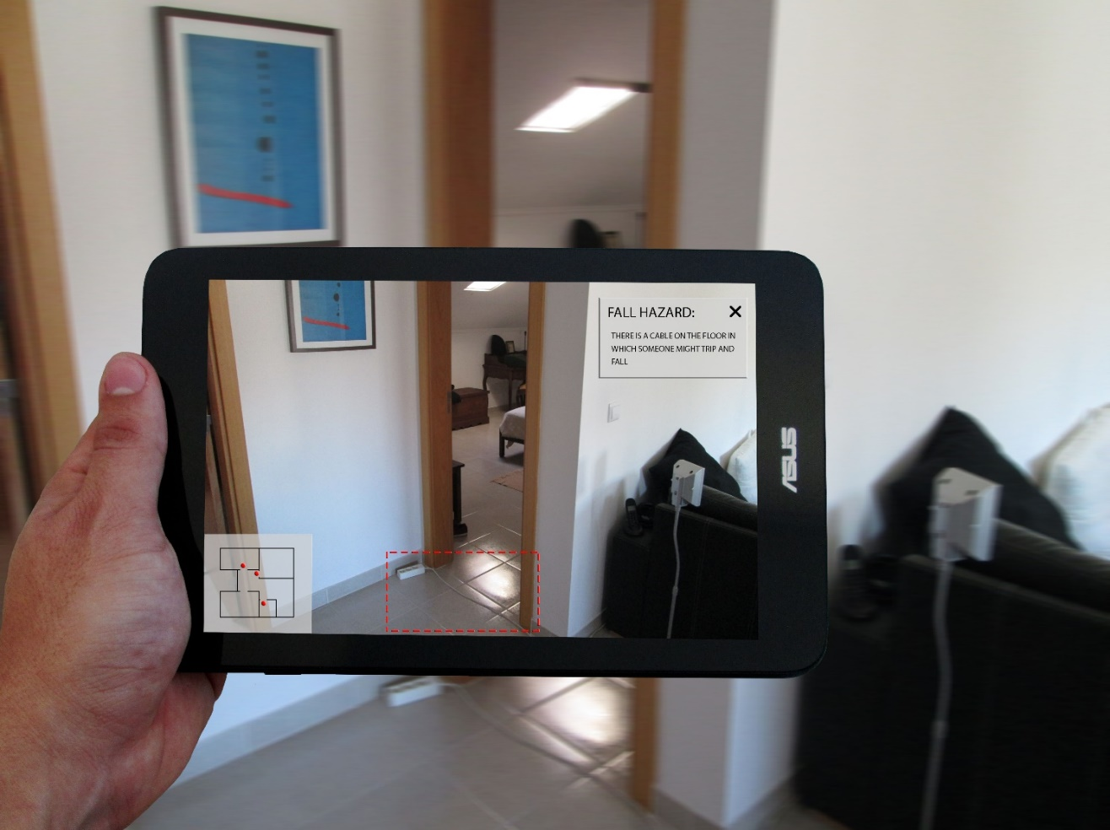

Figure . Shots 2 & 3

As she tapped the cable, a new popup appeared on the screen with the message “Recommendation 1: Lay the cable along a wall or over a door; Recommendation 2: Remove the cable from this location” which was also read out loud by OLA (Figure 3).

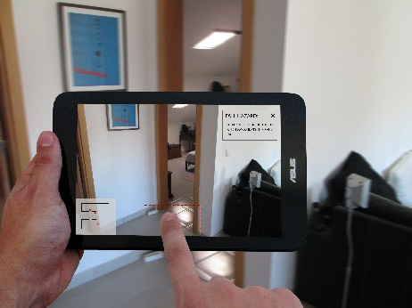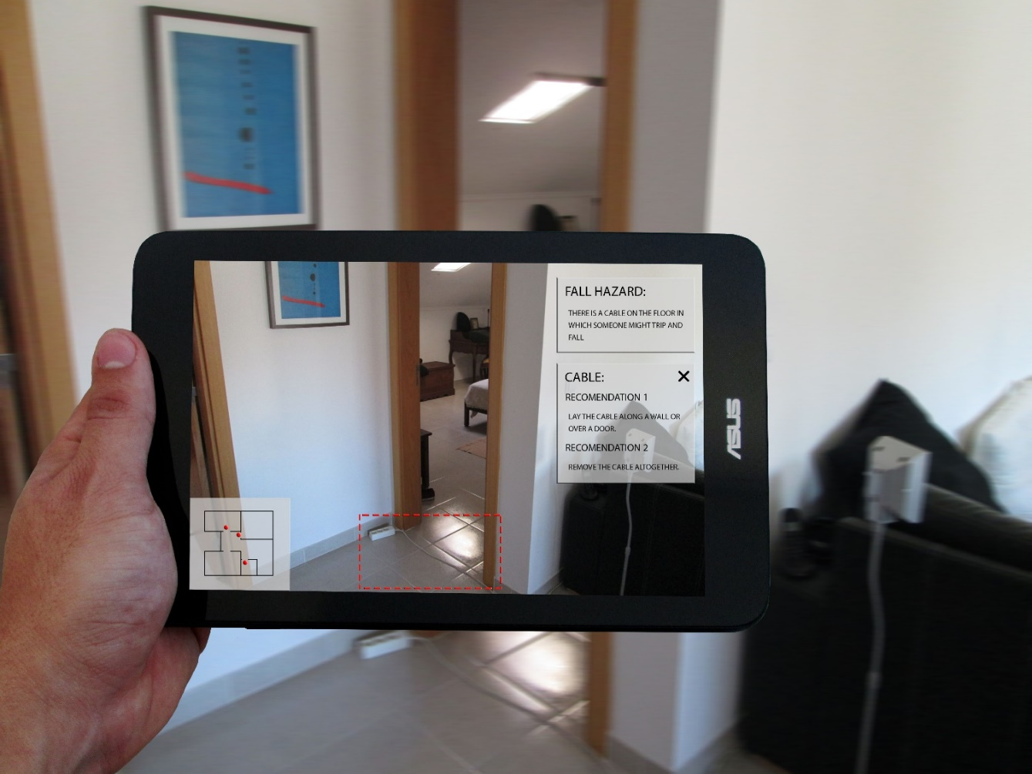

Figure . Shots 4 & 5

Teresa and her son then closed all the popups (Figure 4) and continued to examine the remaining environmental barriers that were identified in her house.

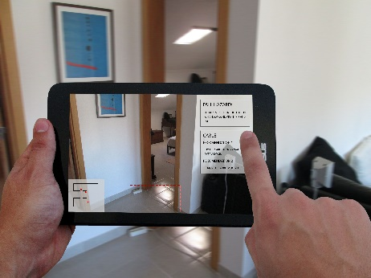 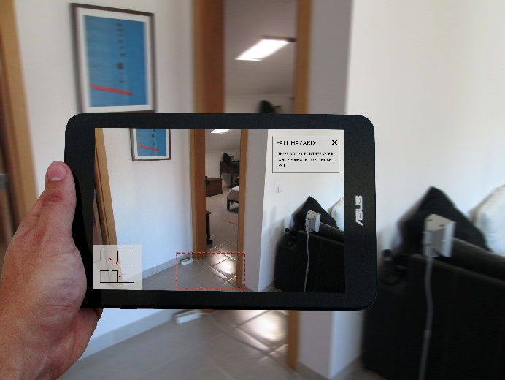

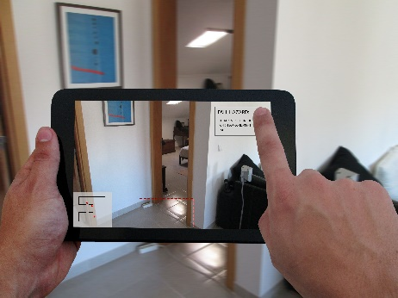 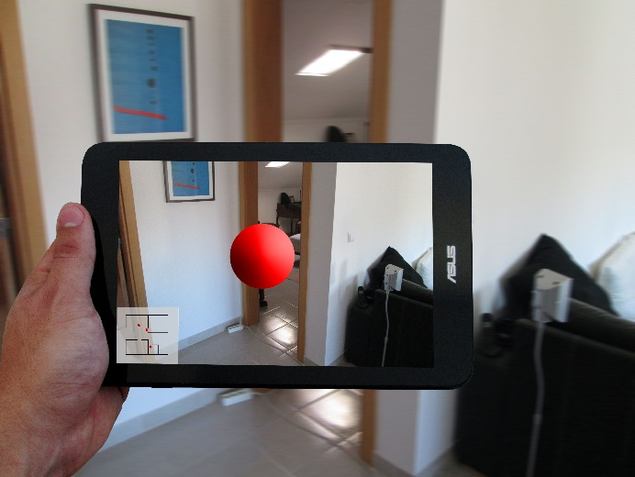

Figure . Shots 6, 7, 8 & 9

Several days later, although she had already performed an environmental analysis of her home, this time she wanted to explore the environmental barriers by navigating through a three-dimensional model of the inner area of his house. To accomplish this, she decided to use her son laptop, to which he downloaded OLA app. He also configured it to use the Portuguese norms and regulations. Teresa then launched the navigation mode of the house model. As she moved through the corridor using the keyboard and mouse, she noticed a red dot on her bathroom doorway. As she clicked it using the mouse, a text box appeared on the screen with the following message: “Accessibility barrier: The doorway is too narrow, which might restrict the passage”. She then closed the text box and continued to examine the remaining environmental barriers identified in her house.

By providing an overview of the environmental barriers existing in her home, OLA helped Teresa and her son to correct them and avoid potential hazards.

## Informal Caregivers



Alice

54 years old

Almada

Married

Cook

Takes care of her sister

#### Backstory

Alice lives with her husband and son in a spacious house in Almada. She attended and graduated high school. She works as a cook at a restaurant, her husband is a car dealer and her son is currently finishing his master thesis. Although both she and her husband are of good health, she has a sister that needs assistance almost every day. Therefore, when she ends her shift in the afternoon she usually goes to her sister’s house to help her.

#### Caretaker’s health information

Alice’s older sister is divorced, has no children and lives alone. Although she is relatively young (59 years old) she has been struggling with joint problems for the past couple of years. Because of that, she is mostly at home and feels lonely very often. Alice does the shopping for her and helps her to clean the house; duties that she is no longer able to fulfil without experiencing severe pain.

#### Architectural barriers

Her sister frequently experiences difficulties when moving around the house because of her joint problems. She even had an accident once, when she fell by tripping on a rug. Although she managed to recover, Alice worries that it may happen again.

When her sister fell and Alice helped her sister she occasionally experienced difficulties when taking care of her sister due to some architectural barriers that exist in her house. The main problem was her sister’s bathroom, which is very small, and the main corridor which is too narrow. This significantly limited her ability to help her sister.

#### Technological knowledge

Alice has a landline and a cell phone which she regularly uses. She also owns a laptop that she uses sometimes to search for recipes or ingredients online.

#### Fears and Frustrations

Alice fears that her sister might become depressed for being alone for the most part of the day. Due to her health problems she does not leave the house neither has many friends that visit her. Alice is also concerned about her safety in the house and fears that she may injure herself again.

#### Motivations

Alice would really like to see her sister live more independently. She would like to have access to social support information and services that would help diminish her sister’s feelings of loneliness. It would also be important if there were any tailored products that would help her sister regain some mobility.

#### Scenario

Alice takes care of her sister who lives alone and has no children. She has to assist her almost every day as she suffers from joint problems that cause her severe pain when performing her daily activities. For that reason, she almost never leaves the house and often feels lonely. Alice is also worried about the difficulties she frequently experiences while moving around the house. To help her sister become more independent and improve her mobility inside the house, Alice decided to adopt the Organizational Life Assistant (OLA) system, which she used mostly on her laptop. She chose to replace her sisters’ old cell phone by a new smartphone so her sister could interact with OLA, since she is already somewhat familiar with this sort of device, although the OLA virtual avatar was essential in helped her learn how to use OLA many features.

Using OLA, Alice was able to schedule occasional visits to her sister’s home by a local social organizationthat provides home support services. Now Alice does not have to help her clean the house so often. In addition, OLA helps Alice and her sister to fulfil her shopping needs and manage her weekly meals. They can create shopping lists simply using voice, to be printed or ordered online. OLA also suggests appealing dishes that they can plan for the week, while also presenting the corresponding list of ingredients to be included in new or previously created shopping lists. These solutions significantly reduced the need for Alice to help her sister on her daily activities.

OLA also helped her sister address her feelings of loneliness. Despite being at home most of the time, she is now able to communicate with Alice and her friends in multiple ways, including phone and video calls and text or voice messages. This helped Alice reduce her number of visits, as she could easily contact her sister from her own home. This helped her feel more connected to her friends and family, as she could keep in touch with them and follow the many things they shared in their profiles. In addition, OLA suggested an online community where she could find support and exchange experiences with other people with the same health condition as her.

Alice also used OLA and its environmental analysis feature to improve the mobility of her sister. Using OLA on her laptop, she requested the environmental scan to be carried out by a qualified technician. On the scheduled day, the technician went to her sister’s house to perform the scan, which took him about one hour. Before leaving, the technician explained to her that the data analysis would take 24 hours and that OLA would alert her as soon as the results were ready. When they became available, Alice used her laptop to navigate through a three-dimensional model of the interior area of her sister’s house. As he moved through the kitchen using the keyboard, she noticed a red dot on the area between the counter and the table. As she clicked it using the touchpad, a text box appeared on the screen with the following message: “Accessibility barrier: The distance between the furniture is too narrow, which might restrict mobility”. She then closed the text box and continued to examine the remaining barriers identified in the house.

Since Alice sister was a little stubborn they downloaded OLA to her tablet and configured its settings to use the Portuguese accessibility norms and regulations. After the initial setup Alice pointed the tablet and suddenly, her sister noticed a red dot in the middle of the bathroom. When she tapped it, a text box popped up on the screen with the message: “Mobility issue: There are no grab rails in the bathroom”. She could also see grab rails highlighted and superimposed on the bathroom walls. When she clicked them, a text box popped on the screen with the message “Recommendation: Place grab rails along the bathroom walls as shown to improve mobility”. She then closed all the text boxes and they continued to explore the remaining environmental barriers identified in the house.

In the end, Alice was able to make several changes to her sister’s house that, over time, proved to improve her mobility.



Pedro

33 years old

Oeiras

Married

Graphic Designer

Takes care of his parents (Teresa and her husband)

#### Backstory

Pedro lives with his wife and 3 children in an apartment in central Oeiras. He has a degree in Design and works as a graphic designer at a marketing company. He earns enough to live an independent and satisfactory life. He is a very caring son, who constantly worries about his parent’s health. He regularly visits his parents since they take care of this children during school afterhours while he and his wife are still at work.

#### Caretaker’s health information

Pedro’s mother overall health is good but she has been feeling some challenges while climbing stair or walking for long periods of time. After going to the doctor his mother was diagnosed with light *arteritis* and Pedro is very concerned about it since she takes care of his children and sometimes feels very tiered.

#### Technological knowledge

Pedro has a landline, laptop and a smartphone. He is always connected to the web through his phone or through his last generation laptop that he also uses to work.

#### Fears and Frustrations

Pedro’s biggest fear is that his mother’s *arteritis* gets worse or that she forgets to take her medication. He is concerned that his mother will start experiencing mobility issues if her condition progresses, such as lack of balance and coordination, or even pain in her joints. He is also worried that he is not taking proper care of her mother by burdening her with his children and is frustrated by the arguments he sometimes has with his father about that subject.

#### Motivations

Pedro would like to be able to monitor his mother health status, treatments and illness evolution in a non-intrusive manner. Any device to help his mother deal with daily routines would also be very likely to interest Pedro. Since he is not very secure about his approach regarding his father’s worries and his mother’s illness, he would also benefit from having access to caregiving skills training. He worries that his parents’ house is not fully prepared to receive someone with mobility issues if his mother’s illness worsens.

#### Scenario

Pedro takes care of his mother who was diagnosed with arthritis. He is always concerned about her health, since she takes care of his children which take a big toil in her health. However, his constant worries have caused some arguments between him and his father, which made him question his abilities as a caregiver. To help him monitor his mothers’ health, as well as to improve his caregiving skills, Pedro and his mother decided to subscribe the Organizational Life Assistant (OLA) system with the agreement of his father. To do so, he gifted his tablet to his mother so she could communicate with OLA, while he interacted with it using both his smartphone and his laptop.

Pedro found OLA to be a great solution to monitor the health condition of his mother. He could easily access her health records, including if that week she and his father went on their regular walk and if anything had happened. As his mother started using the medication control app Pedro could effortlessly and nonintrusively check his mother current and past medication intakes, as well as other health indicators, allowing him to understand its evolution over time. All this information was easy to understand, as it was displayed in charts and other friendly formats. By knowing that his mother was reminded to take her pills and by being notified himself, Pedro felt less worried, as he could call his father or mother whenever she missed a pill. In addition, both Pedro and his parents used OLA to manage medical appointments, from consultations to treatments, by scheduling new appointments online and being reminded whenever there was one.

Pedro also felt his caregiving skills improved using OLA, as he could easily access health information about *arthritis* and related topics, as well as caregiving tips specific to this condition. This allowed him to be more informed when taking important decisions about his mother’s health. OLA even suggested him an online caregiver community where he could find support and exchange experiences with other caregivers in the same situation as him.

Since Pedro was worried about the mobility of his mother he also wanted to do an environmental analysis to this parent’s house. Given that he is very familiar with using technology, he chose to scan the house by himself using the equipment that was temporarily delivered to his parent’s house. He downloaded OLA to his mother’s tablet and configured it to use the Portuguese norms and regulations. He also drew a simplified floor plan of the house in the tablet. After completing the scan process, OLA provided an estimated time for the environmental analysis to be ready, based on the total scanned area. One hour later the OLA app notified him about the results and he decided to examine them with his mother using augmented reality.

Two months later his parents decided to renovate their bathroom since it was one of the problematic areas of the house and asked him to talk to the foreman and there architect. Using OLA on his laptop to navigate through a three-dimensional model of the interior area of his parent’s house he was able to better explain the areas that they want to address and additionally provide the 3d model of his parents’ house to the architect who was able to use it as a reference for the alterations project.

By providing an overview of the environmental barriers that existed in his parent’s home, OLA allowed Pedro and his parents to adapt to his mothers’ current and future needs.

## Formal Caregivers



Luís

38 years old

Lisbon

Married

Medical doctor

Monitors Teresa

#### Backstory

Luís has worked at a Lisbon hospital (São Francisco Xavier) for the last 12 years. His specialty is family medicine and although his patients are from all ages, seniors tend to be more common as they have more health-related problems and need closer monitoring. Having senior parents (Teresa) himself and knowing the challenges they face, he has always tried to give special attention to the older patients.

#### Perceptions regarding senior patients

Luís believes that his patients’ quality-of-life is reasonable and that there is room for improvements. First of all, he strongly feels that the government should invest more in helping this population, in every aspect they can. In particular, solutions regarding daily life activities support and medication intake assistance could have a positive impact in seniors’ health and daily life.

#### Architectural barriers

Luís also works in the urgent care service of the hospital. When assisting older patients in their homes in case of an emergency, he sometimes faces physical barriers that limit his ability to assist them. He frequently encounters corridors that are too narrow and rooms with limited circulation space, preventing the use of stretchers or wheelchairs. Also, he frequently notices that their bathrooms are too small or do not have any hand rails.

#### Technological knowledge

Luís uses a PC with internet connection at work most of the time. He uses systems for clinical activity support (like SAM or SAPE) and does information research. Therefore, he has extended technological knowledge and knows how to take full advantage of the systems.

#### Technology in the working environment

For Luís, the use of ICT in the hospital has improved many processes that were previously complicated and time consuming, in particular the integration of patient’s information and the communication between multidisciplinary teams and with the patient himself. ICT also provides a good support on screening, counselling and referring patients to other specialties. Nevertheless, in his opinion the amount of equipment available at the hospital is still low and their workload prevents them from taking full advantage of the systems. He supports the direct contact with patients and thinks that spending too much time using his computer at a consult could negatively impact his relationship with the patient.

#### Scenario

Luís is a medical doctor who works at a central hospital in a large city. Most of his patients are older adults, so he is well aware of the challenges they face. He believes that they need solutions to support their daily life activities, assist their medication intake and improve their mobility inside their own homes. Whenever he believes their older patients would benefit from it, Luís suggests them to try out the OLA system, and some of them have already started using it.

An example of successful OLA implementation is Teresa. OLA helps him monitor the medication intake, blood pressure and exercise schedule (Length, number of steps taken, heart rate) of Teresa. For Teresa, he has been able to create and update her medication intake schedule directly in the OLA platform, taking into account the medication effects, so she can also have access to it. With Teresa he adjusted hear blood pressure medication from 1 pill every morning to 2 every 12 hours, since she had a big blood pressure drop every morning leaving her tiered.

Additionally this way, Teresa is always reminded when she must take their medication, including how many and which pills she should take each time. Importantly, he is also notified when Teresa and other OLA patients forget to take their medication, as the system requires them to confirm the intake, allowing him to take the actions he considers necessary depending on each case.

Using OLA, Luís can access information on his older patients’ housing conditions, which he often finds to be relevant when taking medical decisions. As long as his OLA patients perform the environmental analysis of their house, he can access information regarding the architectural barriers that may prevent him or other healthcare professionals from providing assistance in case of an emergency. For example, a stretcher or a wheelchair may not go through corridors or doorways that are too narrow. This way, Luís is able to decide which is the most appropriate equipment that he should take with him when providing assistance to OLA patients in case of an emergency.

Inês

39 years old

Lisbon

Married

Social Assistant

#### Backstory

Inês has been a social assistant at a private institution for social solidarity for 14 years. She manages her unit and deals mostly with cases concerning seniors with economic housing issues.

#### Perceptions regarding senior patients

Although Inês considers that her patients’ quality-of-life is good, she is aware that loneliness, age-related declines and the economic difficulties that she aims to solve are still issues that need a good solution. She believes that using ICT technologies for promoting social activities, preventing risk factors, providing contacts and mediating solutions would significantly improve seniors’ well-being.

#### Architectural barriers

From her experience working with older people, Inês knows they often face difficulties moving around inside their own homes and end up stumbling and even falling quite frequently. In most cases, these accidents happen because they trip on rugs or steps. Feeling weak while using the hand basin is also frequent among the older adults she cares for.

#### Technological knowledge

Inês uses a PC at work to manage patients and staff, visit professional websites and manage social activities. These tasks are more related to the institution management and she would also like to have a system that would help her manage patients’ information. She also has access to a tablet in her institution.

#### Technology in the working environment

For Inês, using ICT at work signifies a chance to improve her caregiving quality as she can have easier access to social security information related to her patients and easily communicate with them and other teams working with them. However, the lack of equipment at the institution and the costs involved in acquiring more are big barriers to having a good ICT environment at work.

#### Scenario

Inês is currently working on the case of Rosa, an older lady who recently fell at home after tripping on a step and is now recovering on a rehabilitation centre. Though she still needs to use a wheelchair to move around, Rosa has expressed her wish to go back home. After obtaining her approval, Inês decided to use the OLA environmental analysis feature to find out if the house was prepared for her return. She chose to download the Portuguese version of OLA to the tablet available in her institution. She also took a picture of the floor plan of the house and uploaded it to OLA using the tablet.

The scan equipment was temporarily made available to Inês and conveniently delivered to her office. She brought it to Rosa's place and initiated the environmental analysis process by launching the scanning wizard. As requested by OLA, she prepared the house for the scan by opening all the closed doors. She then started the environmental scan. OLA provided information regarding this procedure, including textual and visual instructions regarding how to manoeuvre the scanning equipment and a step-by-step video tutorial demonstrating how to scan a house. It also provided an interface which helped her throughout the whole process. Using her tablet, she was able to see the area she was currently scanning, as well as the ones she had already scanned. Several tips on how to perform the environmental scan were also presented on the screen.

After completing the scan of the entire house, OLA provided the estimated time for the environmental analysis to be ready, based on the total area that was previously scanned. One hour later, the results became available and Inês decided to examine them using augmented reality. The floor plan that she had previously uploaded was presented on the bottom left corner of the tablet screen with multiple environmental barriers marked in it. As she navigated through the house pointing the tablet, she noticed a red dot on the bathroom floor. When she tapped it, a text box popped up on the screen with the message: “Accessibility barrier: The area between the furniture is too limited, restricting its use by wheelchair users”. She then continued to explore the remaining environmental barriers identified in Rosa’s house.

In the end, Inês exported a report that transcribed the notes and recommendations of all the environmental barriers identified in Rosa’s house, categorizing them into “accessibility barrier” and “fall hazard”. Illustrations for each situation were also added to facilitate its understanding.

OLA helped Inês address all the barriers and hazards that existed in the house, allowing Rosa to return to her now fully accessible home.

Diana

24 years old

Lisbon

Single

Direct Action Assistant

Currently working on the case of Maria

#### Backstory

Diana was always much attached to her grandparents and after high-school she decided to take a professional course and become a direct action assistant working with senior people. She started working at a private institution for social solidarity a year ago and is a very dedicated and caring professional. One of her main duties includes assessing the living and housing conditions of the older adults under her care and searching for social housing alternatives for those living in poor conditions.

#### Perceptions regarding senior patients’

Fortunately, Diana feels that her patients have a very good quality-of-life as they live in a big urban area and have access to all kinds of services. Even though some suffer from depression or anxiety they can easily ask for help at the institution. While at home, she believes they would benefit from monitoring solutions that would provide immediate help in dangerous situations or problematic activities for some like bathing or climbing stairs.

#### Technological knowledge

Diana was never interested in technology other than her mobile phone. At work she prefers to spend time with the patients and does not use a computer at all.

#### Technology in the working environment

Due to her workload and lack of ICT knowledge Diana has never been interested in using computers at work. Nevertheless, she thinks that ICT could benefit the communication between her team and patients at home, improving their satisfaction. Some research on illness prevention would also be useful for her, as she could promote sessions in which she would advise the seniors she works with. She would like to have solutions that could help her assess the housing conditions and search for housing alternatives for older people.

#### Scenario

Diana is currently working on the case of Maria, an older adult who recently started having mobility issue and was worried about falling. Maria had already experienced a falling accident and wanted to avoid further accessibility issues at her house. To help her assess and improve the accessibility of Marias’s home, Diana decided to use the OLA environmental analysis feature. Among other options, she downloaded OLA to the tablet available in her institution. She also configured it to use the Portuguese norms and regulations.

Using OLA on the tablet, Diana was able to perform the environmental analysis in real-time. As she walked through the house with Maria while scanning it, OLA warned her to an environmental barrier by highlighting a rug on the tablet screen. The following message was displayed: “Fall hazard: The rug is folded up and might cause someone to trip and fall”. Bellow, the question “Is this rug slippery?” was also presented, as well as “Yes” and “No” buttons. As Diana tapped the “No” button, another message popped up on the screen: “Recommendation: Unfold the rug and consider removing it from this location”. She promptly unfolded the rug and rescanned the area, but his time OLA did not show any warning nor requested any action. She then continued to examine the remaining rooms of Marias’s house.

OLA provided an overview of the existing environmental barriers in Marias’s house, allowing Diana to solve them in real-time.

# Polish Personas and Scenarios

## Senior

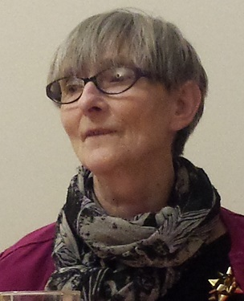

Ela

69 years old

Retired widower

Warsaw

One daughter and one son

#### Backstory

She lives alone in Warsaw. She lives by on her monthly budget of 450 euro. Ela graduated from senior high school. She considers her conditions as quite good as she owns her own apartment on the first floor in the peaceful and green area, so to get there she only has to climb a few stairs.

Ela occasionally goes out both during the day and in the evening for cultural events in her community centre and senior university lectures but as being independent she doesn’t profit from help services in the nearby social centre.

Whenever she needs help she asks her children, living in the same city.

#### Architectural barriers

Ela doesn’t confess any particular problems that she could encounter moving around her house. She hardly ever stumbles or falls, nor feels week reaching for an object or while being in the bathroom. She declares however some problems with too narrow doors and sharp furniture corners in her flat. Some time ago she was attending fitness classes but the pace of classes was too fast and she felt week a few times so she had to resign. She misses her physical activity a lot.

#### Health status

Ela declares to be in a good physical shape. She consults a specialist because of her cardiovascular problems but now her state is stable, nevertheless she feels uncomfortable about monitoring her arterial tension and heart rate and would like to get the solution for this problem.

#### Fears and frustrations

Ela’s cognitive status is very good, however, being conscious of getting older Ela declares her interest for the solutions that could minimize the possible negative effects of memory lost, temporal or spatial disorientation.

Ela lives in a big city but even here she has problems with accessing the doctor, hospital and pharmacy - she wonders whether there is any way to change it.

Staying home alone most of the time Ela is still totally independent in her daily life activities and house chores. Being a bit less fit than few years ago she complains about her bathroom being too small and uncomfortable. Once a week she has a cleaning lady to help her keep the house tidy. She has a family in the same city so whenever she needs something extra (big shopping, money transfers, transport to a hospital, equipment usage) she asks her family members for help.

Ela declares high level of safety. She is preoccupied about robberies while being away for the weekend and worries nobody would help her in case she would fall in the bathroom or from the stairs.

#### Technologies use

Ela has a computer but she hardly ever uses it. She has a mobile and uses it every day. Her grandchildren decided she should have an access to the internet but she grumbles not to have time to learn how to use it fluently so she must be very determined to use it.

Because of her heart problems she has a blood pressure monitor and monitors her blood pressure regularly. She is quite interested in new medical devices for health monitoring and would be ready to pay for a good quality services but no more than 14 euro per month.

In Ela’s opinion some people believe she may be less able to use technologies because of her age but she doesn’t necessarily agree with this judgement. These are stereotypes – she says and she doesn’t care for them. I can do what I’m interested in, of what I care for. Older people are as competent and friendly as the younger ones. Even if she might be seen as a member of senior group, she feels young and competent.

#### Scenario

Ela used to feel somewhat uncomfortable about monitoring her blood pressure and heart rate, but she found OLA to be a good solution for this issue. She started using a digital blood pressure monitor that uses wireless communication to automatically transfer her measurements to the OLA platform. This allows Ela to check her current and past heart rate and blood pressure levels, including her evolution over time. She finds this data easy to understand, as it is displayed in charts and other friendly formats. She is also able to easily share this information with her cardiologist, giving him access to her health data stored on the OLA's platform. That allows her doctor to make important health-related decisions. What is most important, OLA reminds her every time she has to make these measurements as scheduled by her doctor and alerts her if the results are not good enough.

Since Ela wants to avoid potential cognitive losses associated with aging, she started to play some of the serious games recommended by OLA to train her memory and orientation, as well as other cognitive abilities. These games help her monitor her cognitive health by presenting her scores over time and warning her when they are too low. She finds them very useful and funny to play. Moreover, she uses the agenda provided by OLA to keep track of her appointments, as it reminds her every time she has one.

Ela is absolutely conscious of all these positives from using OLA platform but to be honest she is most happy about the short fitness guide videos that she could find thanks to the platform. They are perfectly adjusted to seniors' needs and possibilities.

Because she lives alone, Ela fears that nobody will help her if she falls at home. That is why she started using a digital bracelet with fall detection sensors that is connected to OLA via wireless. When it detects that Ela has fallen, OLA alerts the local authorities and notifies her children, while also sending the location where she fell. This way, Ela feels safer knowing she will receive assistance in case she falls.

Although Ela is not very worried about her mobility inside the house, she decided to try the OLA environmental analysis feature to find out how she can improve her home. She used OLA to schedule the environmental scan. Three days later, a qualified technician went to her house to perform the scan, which took him about one hour. Before leaving, the technician explained to her that the data analysis would take a few hours and that OLA would notify her as soon as they were ready. When the results became available, Ela used her computer to navigate through a three-dimensional model of the interior space of her house. As he moved through the corridor using the keyboard, she noticed a red dot over the low table close to the entrance door. As she clicked it using the mouse, a text box appeared on the screen with the message “Security issue: The height of this furniture is very low, which might cause someone to bump on it and get hurt”, which was also read out loud by OLA. The furniture was also highlighted and, as she clicked it, the message “Recommendation: Remove the furniture from this location” was presented visually and verbally. Ela then closed all the text boxes and continued to navigate through other parts of the house. When she finished, Ela asked OLA to send an e-mail to her daughter and son with the full report of all the environmental barriers that were identified in her house, so they could later help her to address them.

## Informal Caregiver

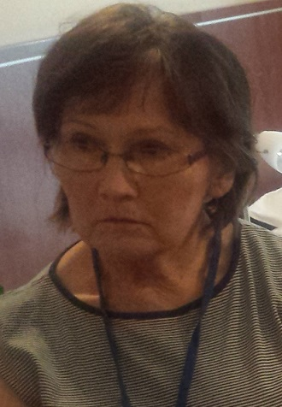

Nina

60 years old

Married

Self-employed

Two daughters

Takes care of her mother

Master degree in economics

#### Backstory

Nina lives in Warsaw and runs her own business. She earns 2000 euro per month. She takes care of her mother who lives with her and her family.

#### Architectural barriers

Nina doesn’t report any particular incidents happening to her mother at home. She has some difficulties while using a bathroom – getting out of the bathtub or shower, sometimes she feels weak while getting up. The spatial barriers Nina faces with in her home are: too narrow corridors, sharp corners and too small bathroom without mobility facilitators.

#### Support

Nina receives help in her work as a caregiver to her mother occasionally. Twice a week a nurse from the local medical centre comes to her house to help her in the daily life activities. If she needs more help she calls for a private nurse/caretaker. In emergency cases she just goes to hospital or calls for an ambulance. The state takes some money for that help from her mother’s pension and she pays additionally for the private care.

#### Fears and frustrations

The work as a caregiver takes more time than Nina expected at the beginning. She has less time for her leisure activities but she takes it as her duty and doesn’t feel overloaded. As Nina is self-employed she was able to adopt her working and leisure hours to her mother’s needs. The only problem she sees is the communication while she is away for a business trip or some holiday. She wishes she had more information on her mother’s health then.

#### People in care – caretaker’s health information

Nina’s mother is a widower, age 89. She has memory problems and some kind of dementia. She can be alone for a short period of time, but Nina prefers not to leave her alone at all. If she has to, she calls her mother to check if she is fine.

Nina’s mother is quite independent. She eats, dresses herself, uses bathroom and toilet independently. She doesn’t need wheel chair to move. She is although weak and can’t do any physical work. She doesn’t prepare meals, nor washes her clothes by herself. Most of her time she stays at home and doesn’t leave for shopping or bank/postal/leisure activities alone. Nina’s mother is not interested in these activities. Going out is too tiring for her. Nina would appreciate any help and assistance in nearly every area of life – if there will be some technologies/devices to make her and her mother’s life easier she would like to use them. She would find most useful someone else’s help and support in medical examination and health monitoring. So far she was able to use just same information and home care support. In Nina’s opinion informal caregivers and seniors should have better access to help services. The supply of the services should be increased as well.

#### New technologies – usage and knowledge

Nina uses internet a lot: for her work (bank services, mail, buy new products) and to keep in touch with friends. She has less time for TV now so she just look through the news online as well during the day. Nina has fixed phone for her mother but she doesn’t use it, she uses her smartphone. She resigned from a fixed computer because now she meets with her clients in different places and works a lot at home - she finds a portable computer or a tablet more useful but in her work as a caregiver so far. Nina would be interested in receiving health, treatments and illness evolution information considering her mother via her devices. She would like to have access to any kind of information about her physical state and safety while being away.

Nina has never used any of the professional telemedical technologies although she declares she would use all of them. She wouldn’t necessarily buy all but would pay for some services – these include telemonitoring and alert services, physical/cognitive rehabilitation and those devices that would help seniors stay active and work for a longer period of time. In her opinion the reasonable monthly fee for that access would be no more than 14 Euros.

Nina agrees that some people consider seniors as less able to use new technologies because of their age, nevertheless she doesn’t this opinion to herself. Older people may interact poorly with devices because of their physical and cognitive limitations.

#### Scenario

Nina takes care of her mother who is 89 years old and lives with her and her family. She suffers from early stage dementia, so Nina prefers not to leave her alone. She is quite independent but she is unable to perform heavy house chores and rarely leaves the house. Nina feels she could use some help taking care of her mother, for example, to monitor her health, improve her mobility inside the house and access support services. For all this, she decided to adopt the Organizational Life Assistant (OLA) system, which she downloaded to technological devices that she frequently uses, namely her laptop and tablet.

Since her mother experiences some difficulties when using the bathroom, Nina decided to use the OLA environmental analysis feature to figure out how she can address them. To accomplish this, she used OLA on her tablet and configured it to apply the Polish accessibility norms and regulations. Since she is familiar with many kinds of technology, she decided to perform the environmental scan herself, so she scheduled the delivery of the scan equipment to her mother’s house. When she received it, she performed the environmental scan following the instructions provided by OLA. Three hours later, the results became available and Nina decided to examine them using augmented reality. She found it very exciting. As she navigated through the house pointing the tablet, she noticed a red dot in the middle of the bathroom. When she tapped it, a text box popped up on the screen with the message: “Mobility issue: There are no grab rails in the bathroom”. She could also see grab rails highlighted and superimposed on the bathroom walls. When she clicked them, a text box popped on the screen with the message “Recommendation: Place grab rails on the bathroom walls to improve mobility”. She then closed these messages and continued to explore the remaining environmental barriers identified in the house.

As Nina travels a lot for business reasons previously she has been worried about her mother while being away. Now as she has OLA installed on the tablet that she keeps at home she has access to her mother’s health parameters thanks to the sensors and health monitoring devices her mother’s uses. Nina's mother feels safer as well. She can easily communicate with her daughter by asking OLA virtual assistant to call her.

## Formal Caregiver

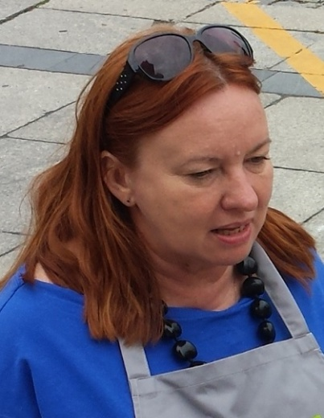

Halinka

53 years old

Nurse

Warsaw

Professionally active

One son

#### Backstory

She has been working in a Residential House for Seniors in Warsaw as a nurse for the last 22 years now. It is a private center but she never uses internet for her daily routine at work. Her patients use internet and sometimes they talk about the information read in the net.

#### People in care – perceptions regarding senior patients

Halinka’s patients are in good or even very good shape. Even so Halinka is aware of the accidents happening to them. They frequently fall and stumble and often have difficulties in moving around. It mostly happens when trip on a rug or a step. In the Residential House for Seniors she works she doesn’t encounter many spatial barriers but narrow circulation space in patients’ rooms.

In her opinion there are several technologies that should be implemented in her center: tele-monitoring, computer programs for physical and cognitive rehabilitation, support devices for home monitoring and personal safety, medication warning devices and support devices for daily activities.

Some of them should be cofounded by the state, these include: rehabilitation processes and fitness, nutrition, daily life activities management assistance.

#### Technological knowledge

In her work she appreciates using people management systems and access to professional websites and web systems allowing selection and ordering of clinical material. As all of her patients live in the residential house she doesn’t need to communicate with them via mail or professional platforms for monitoring and appointment. But health information integrated systems are very useful/helpful in her work because they: triage support, counseling and management of patients, expend and improve access to health care as well as promote the self-care and self-health management on patients and facilitate their decision making. They also allow for the better time management.

Halinka would use some technologies in her work but she lacks equipment and doesn’t have enough knowledge/skills in ICT. The other problem she sees is the age of her patients not being able to learn how to use the platforms and systems.

#### Scenario

Being aware of the accidents that frequently happen to older patients, such as falling and stumbling, Halinka knows it is important to prevent them from happening in the residential house she works in. For this reason, she used the OLA environmental analysis feature to identify and solve the environmental barriers that could potentially exist there. Halinka requested the environmental scan to be carried out by a qualified technician. On the scheduled day, he came to the residential house to perform the scan, which took him about half a day. Before leaving, the technician explained to Halinka that the data analysis would take 24 hours and that OLA would notify her as soon as the results were ready. When they became available, Halinka used the residential home's computer to navigate through a three-dimensional model of the interior area of the building. As she entered one of the patient rooms using the keyboard, she noticed a red dot located in the area between the bed and the desk. As she clicked it using the mouse, a text box appeared on the screen with the following message: “Accessibility barrier: The distance between the furniture is too narrow, which may restrict mobility”. She then closed the text box and continued to examine the remaining barriers identified in the building. When she finished, Halinka was able to make several environmental changes in the residential house which, over time, proved to reduce the number of injuries among older patients. Supervisory board of the residential house was very satisfied with the results of the scanning and recommended further Innovative changes in the center. As the OLA platform has a special offer for residential houses the personnel got access to professional rehabilitation programs tips base that can be used with patients to improve their physical and mental state.

# Swedish Personas and Scenarios

## Senior

### Arne

78 years old

Retired widower

Stockholm

One son and an ex wife

#### Backstory

Arne lives by himself in an apartment in Stockholm. He has a son and an ex-wife who he is still close friends with since the divorce 20 years ago. The few friends he still has are also not well. He feels isolated and lonely now that it is harder for him to get out of the house. He talks on the phone with his son but rarely sees him in person.

#### Health information

Arne suffers from a slow growing form of cancer and also has diabetes. A nurse visits him once a week to administer injections of a drug that slows the progression of the cancer and to monitor his blood glucose. He can move around the house on his own, but he has fallen down several times in the last year. He very rarely goes outside and often feels depressed. He has a hard time to motivate himself to do new things. Perhaps because he knows so few other people.

#### Architectural barriers

Arne's house is cluttered with lots of furniture and things lying around on the floor and on top of the furniture. When h is alone he does not regard the state of the apartment a problem but he often needs to move things in order to open closets and doors. Lately he has had some problems walking. And he would not be able to user a walker or a wheelchair in the apartment without clearing some space.

#### Technological knowledges

He knows very little about technical devices and ICT and he is not really interested in learning more about it. The only device he has is a smartphone designed specifically for elderly users that has a button on the backside that is pre-programmed to call his children.

#### Fears and frustrations

Arne’s biggest fear is that something would happen to him and that it would take a long time before anyone could find him. He doesn't feel comfortable asking for help and he doesn't trust people easily.

#### Motivations

Arne wants to meet other people. He wants to regain the courage to do interesting things and meet new people. The one thing he misses more that anything is a company. He also wants to know that he could get help fast if he needs it.

#### Scenario

Arne feels less isolated since he started using OLA. With its help, he managed to add his contacts to a social network profile that he now uses to meet and talk to new people online. He has reconnected with a few old colleagues. He has made many good friends since then, so he is starting to like visiting his profile and now he talks to people many times a day. OLA allows him to easily manage his contacts list and communicate with them in many ways, including phone and video calls, and text messages. Arne has fun dictating OLA text messages and mails.

Because he lives alone, Arne fears that no one will assist him if something bad would happen to him in his home. OLA also helped him address these safety concerns, since it detects falls. To prevent false alarms, when it detects that Arne has fallen, OLA asks him if he is alright using voice. If he answers that he is not, or in case there is no response, OLA alerts the local authorities and notifies his children, while also sending the location where he fell down. Arne now feels much safer by knowing he will receive timely assistance in case something happens to him.

## Informal Caregiver

Juana ~~Juana~~

74 years old

Divorced

Retired

A son and an ex-husband

Takes care of her ex-husband

No higher education

#### Caretaker’s health information

Juana’s ex-husband is a few years older than she is and has a bad general health status. He has diabetes and is suffering from a slow growing cancer. He has trouble walking and needs help with large part of his daily life activities. He needs to check his blood glucose several times a day and gets a visit from a nurse once a week. He is afraid of falling down and not being able to get up by himself.

#### Technological knowledge

Juana has a smartphone and a tablet. She uses the internet several times per day to read the news, check her Facebook and mail with her friends. She is interested in learning more about ICT.

#### Fears and frustrations

Even though she likes to help her ex-husband and enjoys his company, she has trouble with the more physical aspects of helping him. She is not strong enough to deal with these things. She finds the situation stressful. She worries a lot about her ex-husband and sometimes she has troubles with falling asleep. They have a son together who lives in another town and she fears that there will be no one to take care of her ex-husband if something was to happen to her. Their son has said that he would not mind paying for assistance and/or technical aids.

#### Motivations

She wants to see to it that her ex-husband gets the help he needs. She wants to be able to talk to him several times per day without needing to go by the subway every time. She also wants to know that he is taking his medication properly without having to keep asking him several times each day. she gets tired from all of the subway travels. She wants to be able to communicate with the people helping him as he himself don’t remember what he wants he needs help with when they are there. She also wants to have a better way of communicating with her ex-husband directly from her own home.

#### Scenario

OLA helped Juana when her ex-husband fell at home and hurt his right leg. When he was discharged from the hospital, he still needed to use a walker to move around while he was not fully recovered. To improve the accessibility of his house, as well as to prevent future accidents, she persuaded him to use the OLA environmental analysis feature. She downloaded OLA to her tablet and configured it to use the Swedish accessibility norms and regulations. Although she is quite familiar with using technology, helped Arne perform the environmental scan. After the scan was finished, she was able to examine the environmental analysis results in real-time using augmented reality. As she navigated through the house pointing the tablet camera, OLA alerted her to an environmental barrier located in the corner of the corridor by presenting a red dot on the tablet screen over that area. As she tapped it, the bookcase located in the corner was highlighted and the following message was presented both textually and verbally: “Accessibility issue: The distance between the furniture and the wall is too narrow and might restrict the passage”. Juana also tapped this highlighted area and another text box popped up on the screen with the message “Recommendation: Move or remove the furniture from this location”, which was also read out loud by OLA. After moving the bookcase from the corridor corner, she continued to examine the rest of the house. This way, Juana was able to address all the environmental barriers that existed in the house, allowing her ex-husband to move freely using the walker.

## Formal Caregiver

### Nina~~Nina~~

32 years old

Nurse

Stockholm

Professionally active

Divorced

#### Backstory

Nina is a nurse at a large hospital. She is a single mother with two children. About half of her regular working hours she is visiting people in their homes for medical procedures such as administering medication or taking tests. She is having a hard time trying to manage both a family and her job, this is causing a lot of stress to her. She visits her patient Arne once a week.

#### Perceptions regarding senior patients

Nina likes his elderly patients and has a good rapport with them. However, she is concerned that she does not have enough time for them. Many of the elderly she visits are lonely and she often feel bad leaving them after only a short visit. Much of her time is spent in transit between her patients rather than with them.

#### Technological knowledge

Nina is comfortable with using a computer, tablet or smartphone. In her private life she is using them all the time. The use of these devices are a natural part of her everyday life and it is not really something that she thinks about.

#### Technology in the working environment

She uses computers and web based interfaces several times every day and can see the upside of using ICT. Although she feels that the solutions that she gets are not really mature enough for using with patients. Sometimes she suspects that the some of the new solutions are put in place to give make the bosses look good rather than to help the patients or the staff. She thinks that one of the best features of ICT is how it helps connecting people.

#### Scenario

Nina is deeply dedicated to her work as a caregiver. She treats her work as a mission. Before she discovered OLA platform she was very frustrated about the technology usage in her professional environment. She works as an independent caregiver, mostly in people's houses, because of that she has a chance to try many technological solutions nevertheless she was not satisfied so far. Now she has OLA – the platform that she installed on her smartphone, tablet and portable computer. With this new system she feels she can really do something helpful for her patients. She believes that this solution really works! This multifunctional solution lets her be in touch with her caregivers even while she is away. The platform is also installed on the devices in her patient’s homes. Those devices have wireless connection to medical equipment for health monitoring. Data from measurements taken with the help glucometer, heart rate meter, blood pressure monitor or scale is automatically transmitted to the system and Nina as well as her patients have immediate access to it. The system alerts Nina and other caregivers in case of abnormalities or life danger.

Nina advised those of her patients who live alone to install smart home sensors for the better safety. The sensors are also connected to the system and inform seniors if the forgot to close the door or window when leaving the house.

Some of Nina's patients hardly ever leave their houses because of the mobility problems. They often complain about not feeling safe and comfortable indoors. They are being afraid of accidents that might happen to them while they are alone. To minimize this risk Nina decided to use the OLA environmental analysis feature. She configured it to use the Swedish accessibility norms and regulations. Since she is quite familiar with using technology, she performed the environmental scan herself. The scan equipment was temporarily made available to her and conveniently delivered to her patients' houses. When she finished, she was able to examine the environmental analysis results in real-time using augmented reality. Navigating through the houses pointing the tablet camera, OLA alerted her many times to an environmental barriers located in different areas by presenting a red dot on the tablet screen over that area.

Nina often coaches her patients how to use other OLA's features. How to use OLA's virtual assistant to dictate messages and mails using voice, how to communicate with friends and family members by video calls. Ola simplifies to Nina her work in many other ways. Now she has better access to rehabilitation and nutrition programs. She can customize these programs along with her patients' needs. She is very proud because many of her patients learnt how to use OLA's calendar to schedule their appointments, daily activities and treatments. The OLA platform also allows Nina to easily manage~~s~~ her calendar. She arranges appointments for her patients and the platform sends notification to their devices. Now they never forget about her forthcoming visits. Nina uses the platform to remind her patients to take their medicines and also to see if they are actually taking them something that was hard to know before she started to use OLA also reminds them of eating ion time exercising every now and then and other well-being activities.

Nina uses OLA to monitor the health of Arne. He started using a digital blood glucose meter that uses wireless communication to upload his measurements to the OLA platform. Because this information is registered in his OLA health record, Nina is able to keep track of his current and past glucose levels, including its evolution over time and to check if he is complying with the measurement schedule. She can update health-related information to his OLA health record frequently, so that his family can stay informed about his health at all times. By using OLA to monitor the health of Arne, his family now feel less worried about his well-being and has been able to stay more relaxed and less distracted.

# Annexes

## Annex 1