


D.2.1. (a)

3D object and space reconstruction

OLA – Organizational Life Assistant

FOR FUTURE ACTIVE AGEING







Project Identification
Project Number | AAL 2014-076
Duration | 30 months (1st March 2015 – 31th August 2017)
Coordinator | Carla Santos
Coordinator Organization | Inovamais, S.A. (INOVA+)
Website | http://project-ola.eu/

Document Identification
Deliverable ID | D2.1. (a) 3D object and space reconstruction
Version/Date | V1.0 / 30.06.2016
Leader of the Deliverable | Sara Eloy (ISCTE-IUL)
Work Status | Work in Progress
Review Status | Reviewed

Deliverable Information
Deliverable Description | This deliverable compiles: i) the domestic barriers and the rules to act on those, ii) the detailed system that scan and reconstruct the geometry of a room.
Dissemination Level | PU=Public
Deliverable Type | R/P = Report/Prototype
Original Due Date | M15: May/2016

Authorship & Review Information
Editor | Filipe Gaspar (ISCTE-IUL), Tiago Pedro (ISCTE-IUL), Lázaro Ourique (ISCTE-IUL), Pedro Caetano (ISCTE-IUL)
Partners Contributing | ISCTE-IUL
Reviewed by | Sara Eloy (ISCTE-IUL), Bruno Coelho (Inova+) Arvai Laszlo (BZN)

Table of Contents
2 Executive Summary 6
3 Document Context 7
3.1 Role of the Deliverable 7
3.2 Relationship to other Project Deliverables 7
3.3 Target Audience of the Deliverable 8
4 Acronyms 8
5 Definitions 8
6 Project Description 10
6.1 General Description 10
6.2 System Description 11
7 Deliverable Description 13
7.1 Context in OLA 13
7.2 Mockup 15
7.3 Status and Future Developments 18
8 Architecture barriers and Hazards 18
8.1 Norms and Regulations 18
8.2 Types of Architecture barriers and Home hazards 20
8.3 Rules to act when barriers are identified 20
8.3.1 Width of passage ways inside rooms 21
8.3.2 Cabling across passage zones 22
8.4 Objects to be classified 23
9 3DOSR system 25
9.1 Technical description 25
9.1.1 KinectGrabber 25
9.1.2 KinectProcessor 26
9.1.3 Scanner3DProcessor 27
9.1.4 XParams 28
9.2 Technologies 29
9.2.1 Supported Operating Systems 29
9.2.2 Software requirements 29
9.2.3 Hardware requirements 29
9.3 Software Release and Demos 29
9.4 Configuration Guide 29
9.4.1 Manager.xml 30
9.4.2 Grabber.xml 30
9.4.3 Processor.xml 31
9.4.4 DatasetTUM.xml 33
9.4.5 DatasetMSR.xml 34
9.4.6 Voxel Grid 34
9.4.7 GaussNewton.xml 35
9.4.8 Intrinsic Parameters 37
9.4.9 Full Stereo Parameters 37
10 References 40
11 Appendix 1: Architectural Accessible Design, Norms and Regulations 43
11.1 European Level 43
11.2 National Level 44
11.3 References in the OLA project 46
12 Appendix 2: Mobility Hazards 47
12.1 Architectural Mobility Barriers 47
12.1.1 Width of corridors 47
12.1.2 Corners and turns in corridors 48
12.1.3 Entrance Hall 49
12.1.4 Width of passage ways inside rooms 50
12.1.5 Width of doors 50
12.1.6 Different levels 51
12.1.7 Stairs 52
12.1.8 Bathrooms – Circulation Area 53
12.1.9 Bathrooms – Grab rails and other mobility facilitators 54
12.1.10 Kitchen 55
12.2 Other mobility Hazards 55
12.2.1 Floor coverings 56
12.2.2 Cabling across passage ways 56
12.2.3 Protruding elements 56
12.2.4 Poor Lighting 56
13 Appendix 3 57
13.1 Voxel grid – default settings 57
13.2 Voxel grid – hi-grid settings 59
13.3 Voxel grid – lo-grid settings 61
13.4 Voxel grid – hi-res settings 63
13.5 Voxel grid – lo-res settings 65

Executive Summary

The present deliverable 2.1 a) incorporates: i) the definition of the system that scan and reconstruct the geometry of a room; ii) the definition of the range of possible domestic barriers that can affect older people as well as the definition of a set of standard solutions for those barriers; iii) and the definition of logic rules to act on the hazard situations detected by proposing changes to the space.
The main goal of task 2.1 is an environment analysis system which envisages to identify architecture barriers and hazard situations that may interfere in seniors’ home security and quality of living.
This deliverable contains the definition of the range of possible domestic barriers as well as the definition of a set of standard solutions for those barriers based on good design practices and construction regulations from the partners’ countries (referred before as ii)). The architectural hazards and barriers will compile the regulations and hazardous situations on home environments, from all partner countries of origin. Besides the identification of barriers and solutions this deliverable includes the definition of logic rules to act on the hazard situations detected (referred before as iii)).
The core technology of this task is the software developed in this deliverable (referred in i) ). The 3D object and reconstruction system works as hand-held Kinect 3D scanner, runs at real-time (25Hz) and is suitable to reconstruct the geometry of static indoor scenes/rooms - video of the prototype here (https://www.youtube.com/watch?v=6tNNhp60bOc). The architecture of this sub-system is composed by 4 modules: 1) the KinectGrabber captures and holds in RAM memory RGB-D pairs of images, 2) the KinectProcessor manages the majority of tasks in the system pipeline, 3) the Scanner3DProcessor adds all the computation required for 3D reconstruction and 4) XParams is a class that reads and writes the XML configuration files for the API. These configuration files control the settings for the grabber, processor, voxel grid and other structures and techniques.

Document Context

Role of the Deliverable
Environment Analysis (EA) is one of the challenges proposed in OLA. Awareness of the physical environment is fundamental to prevent unwanted age related health and hazard situations and provide advices for safety and accessible environments. In this deliverable we describe the regulations and hazardous situations at home environments and one of the core technologies developed in the scope of Task 2.1 (WP2) the 3D object and space reconstruction (3DOSR) system.
This task includes the research about domestic barriers that can be found at home as well as good practices and regulation-based solutions to overcome them. This study was done in order to define possible solutions to advice elderly and their caregivers on how to act when an architectural barrier is found. These recommendations will be given to elderly through an Augmented Reality app that previously scanned, reconstructed and recognized the various space in their houses.
From a technical perspective, we describe 3DOSR API regarding: system architecture, scientific background, technologies used, and a configuration manual. This technical documentation will be used for future developments and provide, to all partners within the consortium, an interface to use and integrate 3DOSR system in OLA platform.
This deliverable also describes the consortium integrative vision of the Environment analysis module and the technologies that this module encompasses. This non-technical description is especially useful to complement the OLA concept design and technical specification respectively in deliverables D1.2 and D1.3.

Relationship to other Project Deliverables
Deliv. | Relation
D1.1. | User Requirements specification and use case definition:  This deliverable describes the user requirements and the use cases where environment analysis will be used in OLA system.
D1.2 | Concept design:  This document describes how end users will interact with the environment analysis through OLA platform.
D1.3 | Technical specification:  OLA system input and output devices, other modules that interface with Environment Analysis, and the technologies used will be described in detail in this deliverable.

Target Audience of the Deliverable
This document is a public deliverable. Still, it is mainly intended for the project partners and the European Commission services thus the document will be made public, but not specifically disseminated on a wider scale.

Acronyms
3DOSR | 3D object and space reconstruction
API | Application Program Interface
SDK | Software Development Toolkit
AR | Augmented Reality

Definitions
Pose | Position and orientation
User accessibility need* | User need related to features or attributes that are necessary for a system to be accessible.  Note 1: User accessibility needs vary over time and across contexts of use.
Impairments* | Problems in body function or structure related to a significant deviation or loss.  Note 1: Impairments can be temporary or permanent; progressive, regressive or static; intermittent or continuous.
Universal design* | Design of products, environments, programs and services to be usable by all people, to the greatest extent possible, without the need for adaptation or specialized design.  Note 1: Universal design shall not exclude assistive devices for particular groups or persons with disabilities where this is needed.  Note 2: Terms such as universal design, accessible design, design for all, barrier-free design, inclusive design and transgenerational design are often used interchangeably with the same meaning.
Accessible design* | Design focused on diverse users to maximize the number of potential users who can readily use a system in diverse contexts.  Note 1: This aim can be achieved by (1) designing systems that are readily usable by most users without any modification, (2) making systems adaptable to different users (by providing adaptable user interfaces) and (3) having standardized interfaces to be compatible with assistive products and assistive technology.  Note 2: Terms such as universal design, accessible design, design for all, barrier-free design, inclusive design and transgenerational design are often used interchangeably with the same meaning.
* From: Guide for addressing accessibility in standards (2014) European Committee for Standardization

Project Description

General Description
This project aims to provide an answer to the societal challenges by providing an innovative Organizational Life Assistant (OLA), a virtual presence that supports instrumental activities relating to daily living needs of older adults allowing them to be more independent, self-assured and to have a healthier, safer and organized life, while facilitates caregivers by supporting them on offering high-quality assistance
OLA will mediate and facilitate interaction (communication and collaboration) between senior citizens and their informal caregivers or other services or professionals, through technological devices such as standard computers, mobile devices (tablets) and home automation modules. These ICT devices will be based on an innovative multimodal model, embracing various physical/healthy and cognitive characteristics of the older adults and will be specifically oriented to increase the level of independence of the elderly, by supporting the possibility of careers’ assistance remotely and by improving the accessibility to existing services on the Web, such as shopping on-line services.
Moreover, the OLA will also provide a personalized well-being and safety advices to older users in order to avoid unwanted age related health and safety situations at their own home. Such a well-being and safety advisor makes uses of a combination of collected user information (personal physical/health and cognitive characteristics) and user interaction information extracted through emotion recognition and various sensor settings.
OLA addresses also a major issue that elderly is facing related to memory degradation and gradual decreasing of their cognitive capabilities, enabling them to remember primary health care and fiscal obligations (e.g. personal hygiene, medical and tax compliance) or helping them to find everyday items such as eyeglasses, wallet or keys. It is based on speech dialogue interfaces and space and object reconstruction and classification to capture and store daily routines and their related contexts.
The primary end-users are the big group of older adults of 65+ living alone with or without light physical or cognitive age related limitations, who needs support from care systems. Secondary end-users are both formal and informal caregivers from public or private sectors, supporting them to cope with the increased demand for care.

System Description
OLA addresses specifically the following main issues:
- Well-being advisor: based on the combination of the collected user information (personal, healthy characteristics) and user interaction information extracted through emotion recognition, sensors settings and contextual recorder capturing the routines as done by the older adult) the system will propose to the older adults personal advice adapted to their situation contributing to their preservation and well-being status in home environment. In case of risk (e.g. irregular heart rate, extreme fatigue) the system may ensure an alert to a local medical emergency service.
- Collaborative care organizer: based on the ISCTE-IUL and LM knowledge of developing human-computer interaction (HCI) platforms, OLA will provide online care collaboration between family and professional caregivers, by enabling a local care network to communicate, access sensor data, and coordinate care tasks. With the OLA assistant, seniors will be able to actively participate in the care organization through voice, even when they are unwilling or unable to use traditional web applications.
- Safety advisor: based on the combination of collected user environment information through real-time analysis and augmented reality settings, the system will propose suggestions of environment changes that interfere with accessible paths and provide alerts for intruders or other situations that can create hazard situations. In case of risk (e.g. checking intruders or fire), the system may contact local emergency services.
- Every day instrumental daily living activities memory support: the system will anticipate medical and fiscal compliances, remember primary health care and food requirements and could help elderly to find displaced everyday items.
- Environment analysis: algorithms for real-time object recognition and scene understanding will be developed based on a number of inputs (i.e. 3D object and space reconstruction by using time-of-flight and augmented reality technologies) in order to analyze and decide which action to be taken in order support the elderly by suggesting environment changes and providing hints/advices for safety and accessible environments.
- Multimodal interaction for elderly: An adaptive organizational life assistant, a virtual presence will be developed in order to facilitating communication and collaboration between older-adults and informal caregivers or other services or professionals. This will be a user-friendly system that uses multimodal approaches based on non-invasive and minimally obtrusive technologies (i.e. speech, silent speech, touch, gestures, RGB-D sensors).
The overall OLA system is an easy to download and to install software making use of multimodal integrated settings. OLA is in essence a service that enables the elderly user to reduce the demand of care through prevention and self-management, while at the same time also facilitates the supply of formal and informal care assistance.
A series of well-selected use cases where older adults have been supported by caregivers and care professional services will be carried out. Three pilots, in Portugal, Poland and Sweden representing the different use cases will be carried out. 60-90 care units will use the system over a six-month period. New evaluation approaches will be used during the pilots, investigating up to which point the OLA services alleviate caregivers support and maintain, or even improve the self-management, health and safe lifestyle of the older adult at home.

Deliverable Description

Context in OLA
This project aims to provide an answer to the societal challenges by providing an innovative Organizational Life Assistant (OLA), a virtual presence that supports instrumental activities relating to daily living needs of older adults allowing them to be more independent, self-assured and to have a healthier, safer and organized life, while facilitating caregivers’ job by supporting them on offering high-quality assistance.
Prevention of unwanted age related health and hazard situations can be partially accomplished by analyzing the physical environment where users live. Environment Analysis is one of the issues addressed in OLA. In this module, algorithms for real-time object recognition and scene understanding are being developed to analyze and decide which action to be taken in order to support the elderly by suggesting environment changes and providing hints/advices for safety and accessible environments.
This deliverable describes one of the key technologies of Task 2.1: a 3D object and space reconstruction (3DOSR) system. The 3DOSR works as a hand-held 3D scanner and is suitable to reconstruct the geometry of static indoor scenes/rooms up to 4.5m³ with 5 mm of accuracy or 9.0 m3 with 10 mm of accuracy (details in section 9.2.3). This technology is one of the core sub-system modules of the environment analysis proposed by this consortium which envisage to identify architecture barriers and hazard situations that interfere with seniors’ home security and quality of living.
Figure 1 illustrates the output of 3DOSR system. Objects and space are represented in a gradient of colours. 3DOSR provides 3D geometric information in a known reference coordinate system. The remaining sub-systems of Enviroment Analysis (EA) module are built upon the 3D reconstruction module in a pyramid of technology dependencies (Figure 2) where the only input device is a Kinect sensor and the output device is the user tablet running Windows 10:
3D Object and Space Reconstruction: performs a 3D point cloud reconstruction of the real scene and creates a 3D mesh based on that point cloud. This 3D mesh serves as input for the 3D Object Classification sub-system.
3D Object Classification: based on geometry segmentation, identifies the objects in the scene from a list of possible barriers and classifies them properly (1) as domestic barriers that can affect users.
Hazard Detector: this sub-system analyses the outcome of the object classification sub-system and based on a set of architectural rules and standards, computes changes and suggestions to the environment.
Environment Analysis: displays the feedback generated by the Hazard Detector by means of AR on the tablet screen (2)thus helping users identifying misplaced objects that can be dangerous.
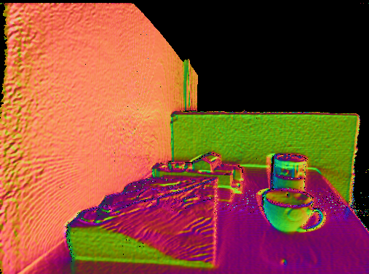
Figure 1. Visual representation of 3D geometry scanned by 3DOSR system.
All technical specifications for the reconstruction, classification and analysis of an existing space will be defined. These components will incorporate i) definition of a system that scans and reconstructs the geometry of a room (section 9); ii) definition of the range of possible domestic barriers that can affect older people and the definition of a set of standard solutions for those barriers (section 8); iii) definition of logic rules to act on the hazard situations detected by proposing changes to the space that may be shown using augmented reality technologies (section 8.3).

Figure 2. Environment Analysis pyramid of technologies.

OLA system input and output devices, other modules that interface with EA, and the technologies used will be described in detail in deliverable D.1.3. EA is a completely independent module within OLA framework although its output will be used as input for other modules such as Security Analysis.

Mockup
An initial mockup center in the post-processing AR interaction was developed and integrated in the “Deliverable 1.1 - User Requirements Specification and Use case definition”. A simplified version of the original mockup is here presented:
- On the bottom left corner of the tablet screen, a floor plan, previously uploaded to the system, is presented showing the detected environmental barriers;
- As the user moves around the house holding the tablet, red dots (warnings) are showed on the screen, superimposed on the architectural barrier detected (Figure 3);
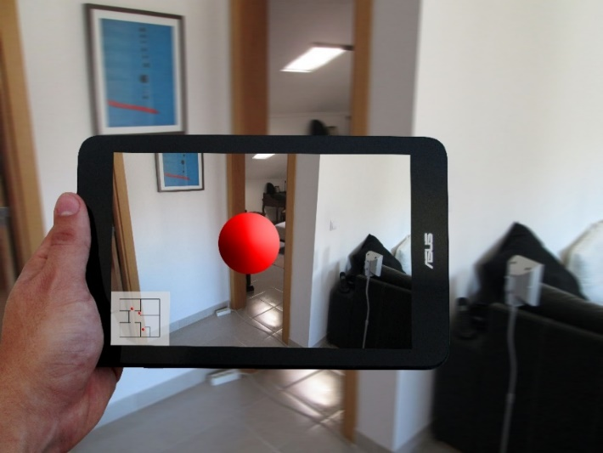
Figure 3 - Red Dot indicating a Warning
- When the user taps the red dot, the barrier is highlighted and a popup warning appears exhibiting the associated message (Figure 4);
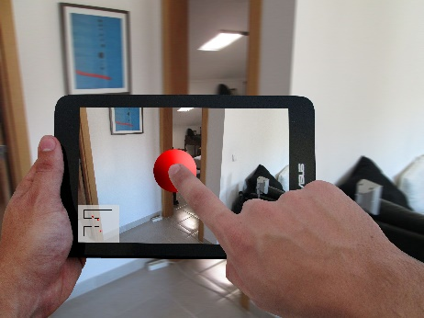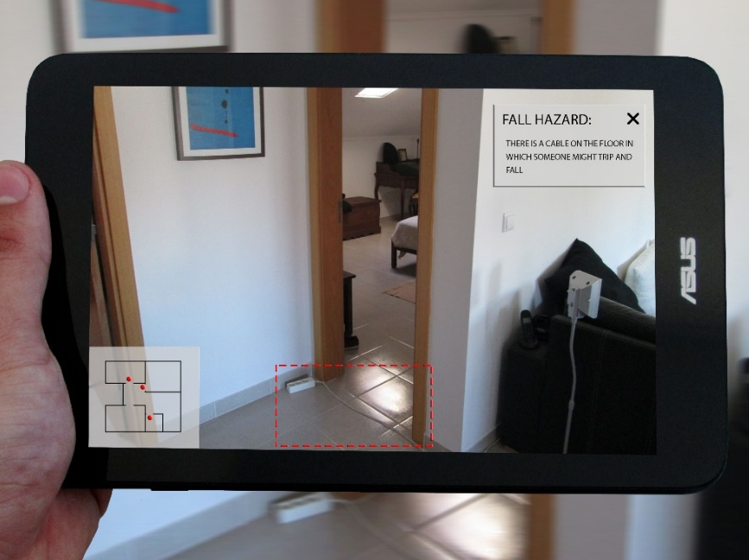
Figure 4 - Shots 2 & 3
- When the user taps the highlighted warning area a new popup appears showing the recommendations for this particular situation (Figure 5)
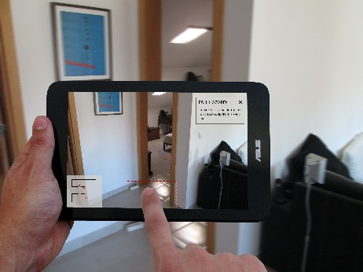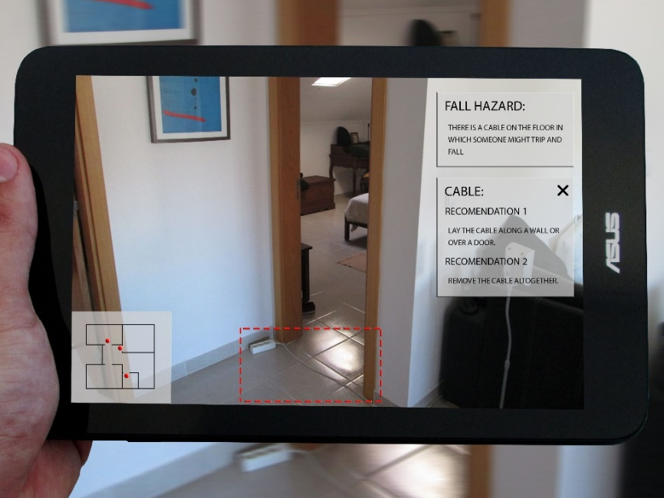
Figure 5 - Shots 4 & 5
- By closing the various popups the user can incrementally return to the original exploration view (Figure 6).
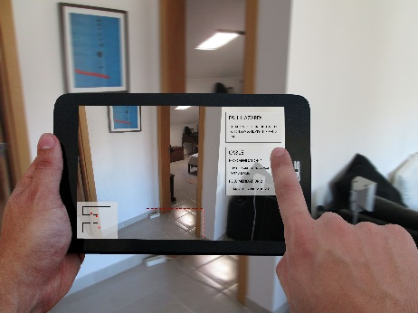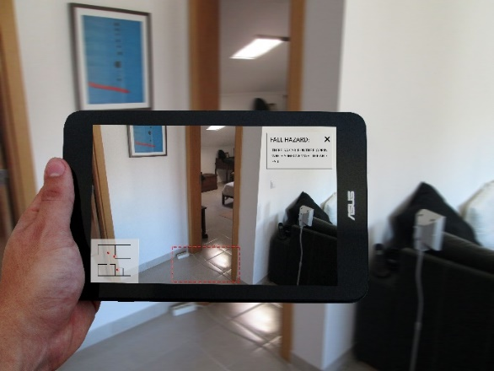
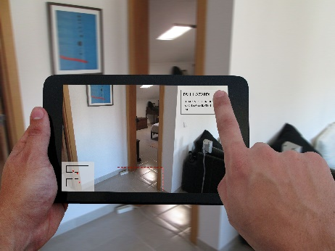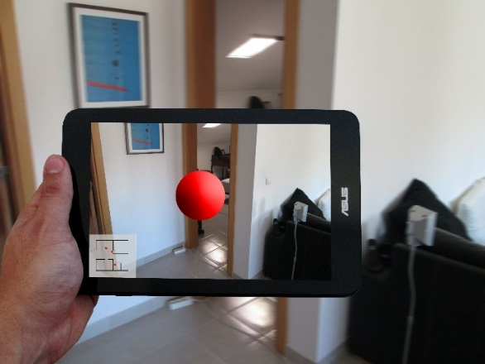
Figure 6 - Shots 6, 7, 8 & 9

Status and Future Developments
This document describes the 3D object and space reconstruction system, an independent module of Environment Analysis (Task 2.1) that scans and reconstructs the geometry of a room up to 3m³ in real time (25Hz). The current status of this system is what this consortium planed as the main goal for deliverable D.2.1(a).
In the future, we plan the following developments to deliver a system capable of proposing space transformations for safety and accessible environments, as defined for deliverable D.2.1(b):
- Fuse/Register several scans using the current 3DOSR system to represent the geometry of larger rooms/house;
- Integrate the 3D object classification technology already developed by ISCTE-IUL |1|;
- Continue the development of the remaining module of Environment Analysis:
  - Hazard Detector;
  - Augmented Reality Viewer.

Architecture barriers and Hazards

Norms and Regulations
With the goal of promoting an inclusive society the concepts of Universal Design and Accessible Design as well as their implementation on services and product design have been introduced all over the world.
Concepts of Universal Design, Accessible Design and Design for All have some differences but in this study we’ll use the expression Universal Design to name the broader domain.
European Commission promotes the adoption of Universal Design by introducing design guidelines, standards and norms on these subjects. In addition to the legislative actions the European Commission and other European organizations [(10), (11), (12)] have produced various guides and reports on the implementation of these measures by the European Union and European Economic Area partners.
At a national level most European states have legislation or design guidelines on the subject of Universal Design that contemplate most of the living areas of day-to-day life.
Most Architectural Barriers design guidelines are targeted to technical professions (e.g. Architects and Interior designers) and lack illustrations which, in some cases, lead to wrong interpretations of the norms preventing the right design options to take place.
Some European states (E.g. Portugal, France) have produced, in collaboration with local institutions, illustrated handbook (13) to clarify the legislation and aid the understanding of the norms.
In other cases (E.g. England) the laws or norms have been created or revised to include illustrations (14).
To support this analysis and in particular to pinpoint the norms that will be considered by OLA tools this report is based our work on the Portuguese “Acessibilidade e Mobilidade para Todos”(13), the English “Document M - Access to and Use of Buildings” (14), the ECA 2003 “Technical Assistance Manual”(10), The Polish Construction Law (15), Swedish Planning and Building Act (16), Byggverkslagen (BVR) (17), Boverkets byggregler (BBR) (18), "Bygg ikapp handikapp” (19)and BÄR (Allmänna råd om ändring av byggnad) (20).
In addition to the situations addressed by the regulations, other hazards may exist that affect the user’s mobility and present a risk of stumble or fall. This type of hazards is also be considered into our analysis and, when relevant, integrated in the OLA-EA application.
Most of these hazards can be noticed and avoided by people with full visual acuity and full range of movements but with the decrease of the visual acuity and range of mobility, traditionally related to old age or particular disabilities, these obstacles can become risks on the day-to-day mobility.
Research [(21), (22), (23)] has demonstrated the importance of identifying and correcting these hazards in order to reduce the number of falls registered on the elderly population.

Types of Architecture barriers and Home hazards
From the various regulations and design guidelines we extracted a comprehensive list of elements to be considered by OLA-EA application. This allowed us to refine the objectives of the application, further define the problems faced by our target group and produce the requirements for the development of the app focusing our efforts on the most pertinent cases.
Mobility hazards:
- Floor coverings:
  - Carpets/floor coverings torn, bent or in poor condition
  - Rugs that slip
- Cabling across passage zones
- Poor Lighting
- Unstable furniture
- Chairs without armrests or with low backs
Architectural Mobility Barriers:
- Width of corridors
- Corners and turns in corridors
- Circulation Area in Entrance Hall
- Width of doors
- Different levels and steps
- Stairs – Various Elements
  - Step edges hard to see
- Circulation Area in Bathrooms
- Grab rails and other mobility facilitators – Bathrooms
- Kitchen
- Protruding elements
This list is fully detailed on Appendix 2 and specifies the regional requirements and variations for the represented countries in the consortium.

Rules to act when barriers are identified
Although we list the multiple norms and respective rules to act when barriers are identified in Appendix 2, we present in this section two of the most common hazards found houses, the regulations it should obey to and one possible mitigation strategy.

Width of interior passage ways
One of the most frequent examples of architectural barriers in houses is a narrow passage way. These cases tend to be overlook, in particular in spaces between walls and furniture with short height (Figure 7), since independent users can pass throw most cases with ease.
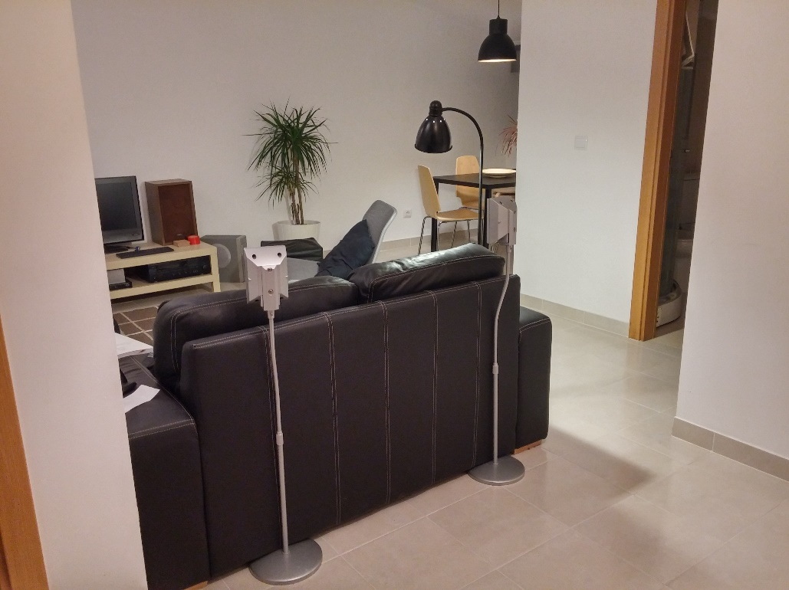
60cm
Figure 7 –Short space between walls and furniture

Norms and Regulations

Portugal:
The width of an interior passage way must be equal or greater than 0,80m if the length of the restricted passage is equal or less then 0,6m, if the length of the passage is greater than 0,6m then the width should be equal or greater then 0,9m. This is considered to be the free passage way which means that it should be measured e.g. between a wall and a piece of furniture or between two pieces of furniture.

Sweden:
Interior passage way should have a minimum width of 120 cm.

Poland:
Interior passage way should have a minimum width of 140 cm. Additional an area should be guaranteed of 1,5mx1,5m.

Logic rule to be implemented in the OLA app for Portugal:
- IF w<0,9m THEN segment scene and classify objects and architectural elements:
  - IF w<0,9m of “wall to furniture” or “furniture to furniture” and w>0.9m “wall to wall” THEN display sign “Remove furniture from passage way to enable people with less mobility to pass”;
  - IF w<0,9m of “wall to wall” and no “furniture” is identified THEN display sign “This passage way is too narrow to enable people with less mobility to pass”;
  - IF w<0,9m of “wall to furniture” or “furniture to furniture” and w<0,9m of “wall to wall” THEN display sign “This passage way is too narrow to enable people with less mobility to pass, but please remove all furniture from passage way to facilitate passage”;
- IF w>0.9m THEN display sign “The corridor has the correct width to enable people with less mobility to pass” or no action.

Cabling across passage zones
A frequent example of fall hazards in houses is cabling placed across passage zones, e.g. Figure 8. This hazard is more problematic to elderly with less mobility less visual acuity.
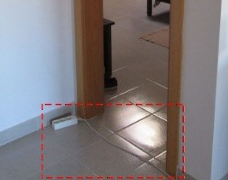
Figure 8 – Cabling across passage zones

Logic rule to be implemented in the OLA app for Portugal:
- IF w<1,2 cm is detected in l<30cm THEN segment scene and classify objects and architectural elements:
  - IF door is detected THEN search for irregularity in floor plan;
    - IF irregularities are detected THEN display sign “A Protrusion was detected in this doorway, please verify and remove any protruding element.”;
    - IF no irregularities are detected THEN no action.

Objects to be classified
Taking into account the barriers and hazards identified, the team defined the categories of objects and building elements that should be recognized by our 3D object recognition and classification application:
- Door (Door panel + Door Frame) (priority 0);
- Floor (a flat horizontal surface) (priority 0);
- Wall (a flat vertical surface) (priority 0);
- Steps and sills (priority 0);
- Handrails (priority 0);
- Tall Pieces of Furniture (e.g. Wardrobes, Bookcases) (priority 0);
- Medium height Furniture (e.g. Dresser and Cabinets) (priority 0)
- Tables (e.g. Dining tables, Coffee tables and Side tables) (priority 0);
- Chairs (With and without arms) (priority 0);
- Sofa (priority 0);
- Rugs (priority 1);
- Cables and Extension Cables (priority 0);
- Countertop (priority 2);
- Toilet and bide (priority 2);
- Pedestal and balanced Lavatory (priority 2);
- Shower cabin (priority 2);
- Bathtub (priority 2);
- Grab Rail (priority 3).

To do so, we are expanding upon the RGB-D ISCTE-IUL Dataset with new categories of objects, collected with ISTAR-IUL RGD-B Retrieval Setup (Figure 9 and 10) and Dataset Toolkit.
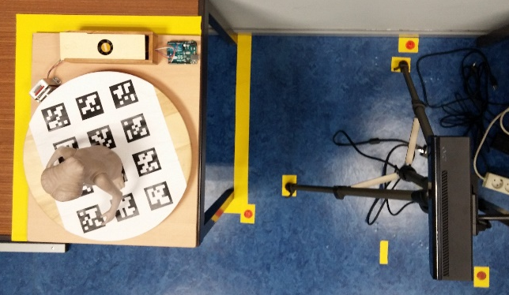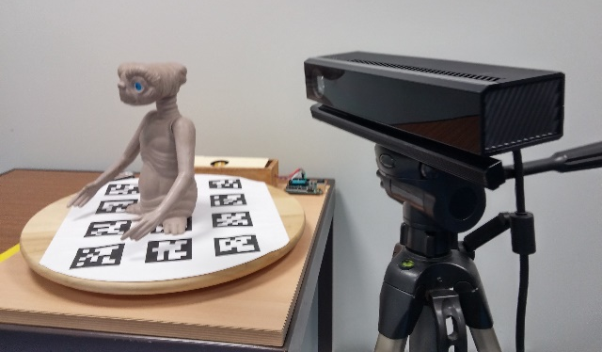
Figure 9 and Figure 10 - ISTAR-IUL RGD-B Retrieval Setup
Due to the restrictions of the turntable of the current ISTAR-IUL RGD-B Retrieval Setup the team opted to collect miniatures of the various objects, up to 30x30x30cm (Figure 11).
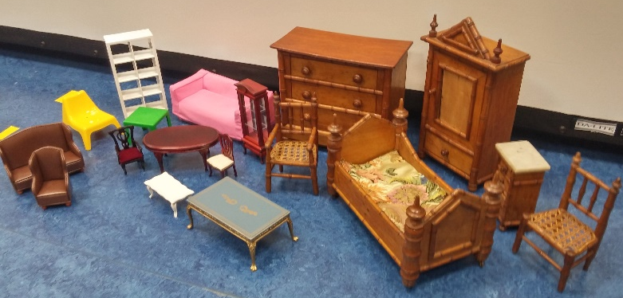
Figure 11 - Examples of the Miniatures Scanned

3DOSR system

Technical description
Our system architecture (Figure 12) was designed to maximize the parallelization between two different tasks: i) RGB-D data grabbing which runs in a separated thread via KinectGrabber class; ii) camera pose estimation and 3D reconstruction that run in the main thread via KinectProcessor class.
Figure 12. 3D object and space reconstruction system architecture diagram.

KinectGrabber
Using a single vision-based RGB-D sensor (e.g. Kinect), this module captures and holds in RAM memory raw images of color (RGB format) and depth. Since cameras are calibrated via the Kinect Calibration Toolbox (3), we know the transformation between RGB and depth sensors. Therefore, for each color point (RGB) we have a corresponding depth value. Raw images are also represented in this module via a 3D colored point cloud in depth camera’s reference frame. Figure 13 illustrates the frame fusion described. KinectGrabber is a capturing data interface that can use the RGB-D input from 4 different grabber types:
- MSKinectGrabber: captures data from Microsoft Kinect for Windows device;
- MSKinectOneGrabber: captures data from Microsoft Kinect One device;
- DatasetTUMRGBDGrabber: captures data from RGB-D SLAM dataset (9) of Technical University of Munich;
- DatasetMSR7ScenesGrabber: captures data from 7-Scenes RGB-D dataset (8) of Microsoft Research;
Both datasets have ground-truth pose information per each pair of raw RGB-D images. We use two different datasets to assess accuracy and performance amongst different real conditions: illuminations changes, perspective changes, scenes with planar objects, close and far objects, texture and texture-less scenes, etc.
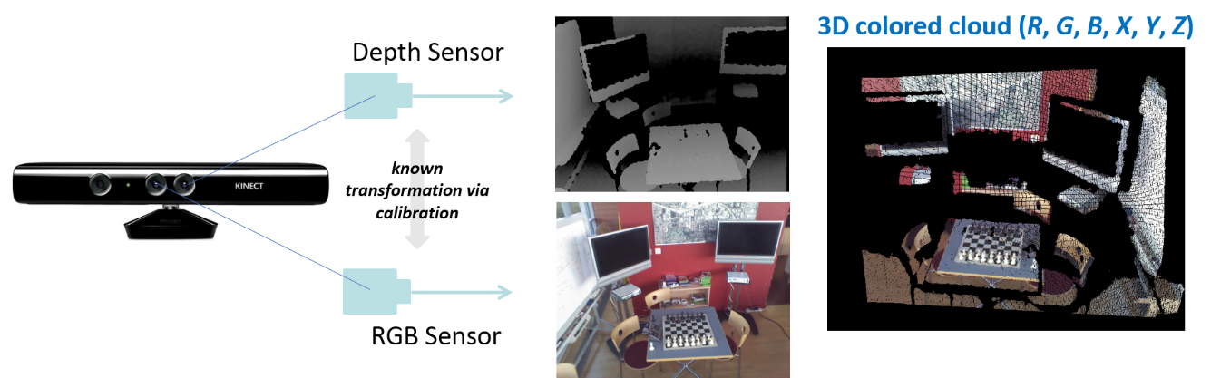
Figure 13. Data from representation from raw RGB-D data to 3D colored clouds.

KinectProcessor
This class manages the majority of tasks in the system pipeline and controls the flow of every class by hierarchically call three control functions available at every class (see Figure 12):
Init(): reserve memory resources, check configurations and start threads;
DInit(): stop all threads, release memory resource, safely close the application;
Update(): update the status of class/application respectively to initialize memory resources.
Additionally, KinectProcessor also synchronizes the shared access to raw images using a double buffer mechanism.

Scanner3DProcessor
Scanner3DProcessor is a derived class of KinectProcessor and adds all the computation required for 3D reconstruction using the following functional modules:

Pre-Processing of depth raw data using Gaussian pyramids – void PreProcessing()
Recent vision-based hardware such as Kinect captures data at real-time (>25Hz) but attain quality limitations such as noise. To generate an accurate 3D point cloud per each captured frame we use two different techniques. First, we filter the depth feed using the bilateral filter (4), an edge-preserving and noise-reducing smoothing filter. Thus, the filtered depth version is used to construct Gaussian pyramids (5) to represent depth, 3D vertex clouds and 3D vertex normals. This is accomplished via GaussianPyramid class. The filtered depth signal is transformed into a multi-space and multi-frequency representation. Similarly to (8), we used three pyramid levels to represent data.
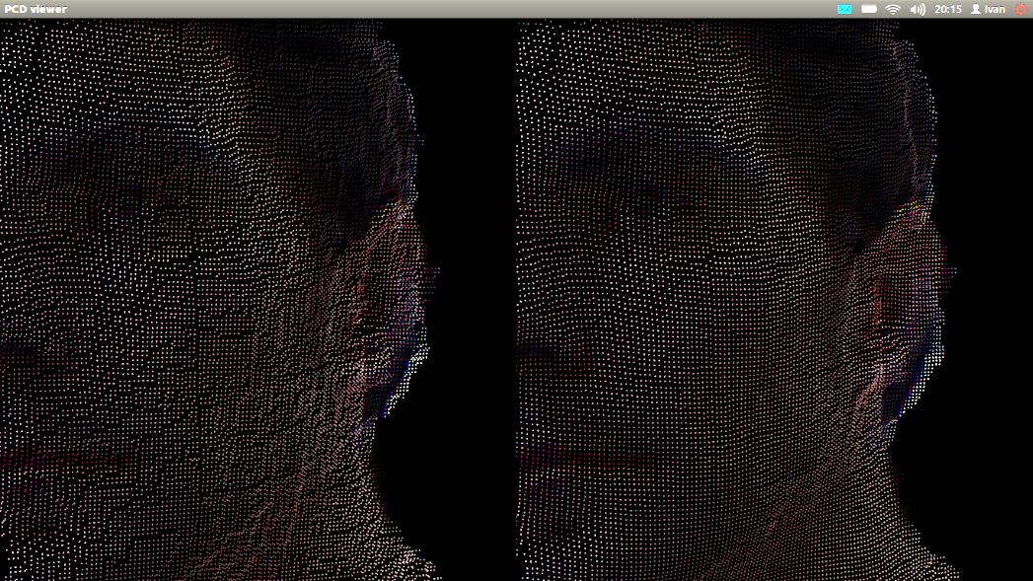
Figure 14. Geometry noise reduction using bilateral filter.

Pose Estimation using Gauss-Newton Minimization – void PoseEstimation()
In a hand-held 3D scanner, the pose estimation is the problem of determining the transformation (rotation and translation) between two images/clouds/surfaces by establishing a sufficient number of correspondences between them. Thus, the pose can be used to register the information from any frame into a global coordinate system. We use the depth camera’s reference frame. Figure 15 illustrates the correspondences used for pose estimation between three contiguous 3D point clouds and the subsequent 3D registration in frame k coordinate system (usually k = 0). Pose information will be used to estimate the real camera pose and register virtual objects perfectly aligned with the real scene (augmented reality), or to determine objects’ pose relations after object classification and provide suggestions to users. We used a variation of ICP (Iterative Closest Points) algorithm (6) – computed in PosEstGaussNewton class – that iteratively minimizes the point-plane distance between the two contiguous Gaussian pyramid of images that were computed in the pre-processing stage.

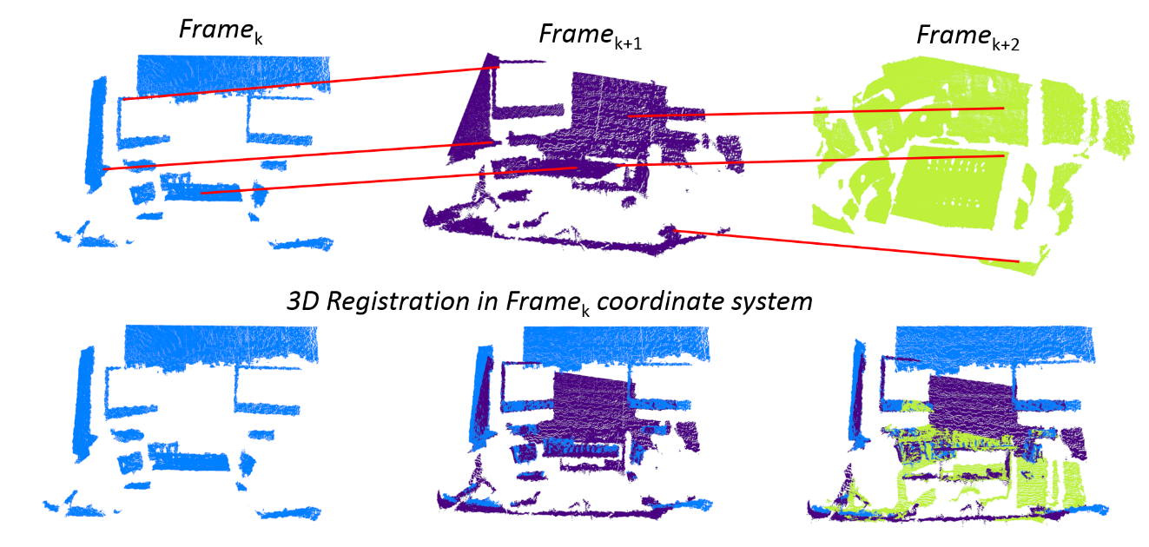
Figure 15. Top) 3D point clouds of frames k to k+2 with matching point connect by red lines. Bottom) 3D registration in depth reference frame of the k^{th} frame.

3D Geometry Representation via Voxel Grid – void Reconstruction3D()
Generating a 3D surface from a set of points can be performed throughout several methods. Once we have the transformation between contiguous frames the goal is merge both into more refined and detailed global model of the scene observed. We used a voxel grid representation – VoxelGrid class – since this structure proven to accurately represent 3D surfaces from several noisy observations into a global model. Moreover, a voxel grid requires low memory bandwidth and produce quality 3D geometry representations in the final render (7). The only limitation is the fixed resolution that must be define for the voxel grid a-priori. However, for the purpose of OLA we do not need to generate realistic 3D geometry renders.

XParams
This class is a generic implementation of a XML reader and writer to hold the API’s option parameters. There are several derived class of XParams that hold different configurations. Please see Configuration Guide section.

Technologies
This section describes the software and the hardware requirements to run or develop based on 3D object and space reconstruction API.

Supported Operating Systems
- Windows 8.1 (64-bit)
- Windows 10 (64-bit)

Software requirements
- Microsoft Visual C++ 2012 Redistributable (x64).
- Microsoft .NET Framework 4.5 SDK.
- Kinect for Windows Runtime v1.8 (for Microsoft Kinect for Windows).
- Kinect for Windows Runtime v2.0_1409 (for Microsoft Kinect One).
- OpenCV 3.0.0. (64-bit)
- GLut 1.1.0. and Freeglut 2.8.1. (64-bit)
- VTK 6.3 (64-bit)
- Eigen 3.0.5
- CUDA 7.5

Hardware requirements
- Dual-core CPU with at least 1.5GHz core speed.
- NVIDIA graphics card with CUDA capability 3.0 (9)
    - The 3DOSR API requires 300MB of graphic memory to manage internal structures
    - Additional, there is a trade-off between 3D reconstruction accuracy and GPU memory footprint:
    - Each voxel requires 4 bytes of GPU memory
    - For a voxel grid with 512 voxels in each axis (X, Y, Z) the system needs to represent 512³ voxel which results in the minimum graphic memory of 512 MB (512³ x 4 bytes). If each voxel represents 5mm³ of volume the total volume represented by this configuration is 2.56 m³ (5mm x 512 voxels).
    - For a NVIDIA GeForce 770M with 3072 MB of graphic memory the maximum volume represented is:
    - 4.5 m³ with 5 mm of accuracy using 900³ voxels. This configuration requires 2.7GB of graphic memory to represent the voxel grid.
    - 9.0 m³ with 10 mm of accuracy using 900³ voxels. This configuration requires 2.7GB of graphic memory to represent the voxel grid.

Software Release and Demos
The 3DOSR API will be released internally, within the consortium, resorting to Microsoft services, namely OneDrive as it is already used for other sharing of information. Demonstrations of the 3DOSR will be regularly available in the same platform as the API evolves as described in the “Status and Future Developments” section.

Configuration Guide
This section intent to provide a detailed description about the configuration options available in the API. The target audience are both developers and users in the consortium that want respectively to integrate this API as a cloud-based service of the OLA platform or to test the application.

Manager.xml
The Manager file encompasses a list of other configuration files that will be described and have their parameters explained in order to better suit the 3D reconstruction module to the user needs.
<path>D:\Demo3DScanner\config\HighResParams\</path>
Path – define the file directory where all .xml configuration files must be. The options below define the name of the configuration files used.

<grabberFilename>Grabber.xml</grabberFilename>
<processorFilename>Processor.xml</processorFilename>
<datasetMSRFilename>DatasetMSR.xml</datasetMSRFilename>
<datasetTUMFilename>DatasetTUM.xml</datasetTUMFilename>
<globalVBOFilename>GlobalVBO.xml</globalVBOFilename>
<voxelGridFilename>VoxelGrid.xml</voxelGridFilename>
<poseEstGaussNewtonFilename>GaussNewton.xml</poseEstGaussNewtonFilename>
<depthIntrinsicsIdealFilename>DepthIdealVGA.xml</depthIntrinsicsIdealFilename>
<depthIntrinsicsFilename>DepthVGA.xml</depthIntrinsicsFilename>
<colorIntrinsicsIdealFilename>ColorIdealVGA.xml</colorIntrinsicsIdealFilename>
<colorIntrinsicsFilename>ColorVGA.xml</colorIntrinsicsFilename>
<fullProjectionIdealFilename>FullStereoIdeal.xml</fullProjectionIdealFilename>
<fullProjectionFilename>FullStereo.xml</fullProjectionFilename>

Grabber.xml
This file contains parameters to configure the source of RGB-D data (sensors or datasets). Every parameter has a comment in the configuration file that either describes it or lists the supported options.
<grabberType>1</grabberType>
Grabber type – defines the device or dataset that provides the RGB-D data to the application. Currently, the supported devices are Microsoft Kinect for Windows and Microsoft Kinect One. Alternatively, the 3D reconstruction system can use the RGB-D data available in two public datasets: MSR 7 Scenes (8) and TUM RGBD (9).
<nearMode>1</nearMode>
Near mode – if the grabber is a Microsoft Kinect this parameter defines whether the sensor is in near mode (depth range from 0.4 meters to 3.0 meters) or not (depth range between 0.8 and 8.0 meters)..
<minDepth>0.5</minDepth>
Minimum depth – float value that defines the distance, in meters, from the sensor to the near clip plane for the depth sensor. Everything between the sensor and this plane isn’t captured by the depth sensor.
<maxDepth>3.0</maxDepth>
Maximum depth – float value that defines the distance, in meters, from the sensor to the far clip plane for the depth sensor. Everything farthest than this distance isn’t captured by the depth sensor.
<colorWidth>1920</colorWidth>
Color width – defines how many pixels the RGB frame have on its width. Currently, 1920 and 640 are the only values supported respectively for Kinect One and Kinect for Windows.
<colorHeight>1080</colorHeight>
Color height – defines how many pixels the RGB frame have on its height. Currently, 1080 and 480 are the only values supported respectively for Kinect One and Kinect for Windows.
<colorNumChannels>3</colorNumChannels>
Number of color channels – defines how many color channels the system uses to represent color. Currently the only option supported is 3 for Red, Green and Blue.
<depthWidth>512</depthWidth>
Depth width – defines how many pixels the depth frame will have on its width. Currently, 512 and 640 are the only values supported respectively for Kinect One and Kinect for Windows.
<depthHeight>424</depthHeight>
Depth height – defines how many pixels the depth frame will have on its height. Currently, 424 and 480 are the only values supported respectively for Kinect One and Kinect for Windows.
<colorRawNumChannels>4</colorRawNumChannels>
Number of raw color channels – defines how many color channels the sensor captures. Currently, the only option supported is 4 for Red, Green, Blue and Alpha.

Processor.xml
This file contains parameters to configure several options to control data processing, namely depth filtering options, pose estimation options and debug printouts.
<useCUDA>1</useCUDA>
Use CUDA – defines data is processed using CUDA or CPU.
<alignColor>1</alignColor>
Align color – defines if the color data is to be mapped onto the depth data.
<alignColorMode>2</alignColorMode>
Align color mode 2 – defines the mapping technique used.
<bilateralFilterWidth>5</bilateralFilterWidth>
Bilateral filter width – parameter of the non-linear bilateral filter applied to the depth channel data to reduce noise and smooth data. This parameter specifies the filter kernel size (width and height). See Technical description section.
<sigmaSpace>4.5</sigmaSpace>
Sigma space – parameter of the bilateral filter applied to the depth channel data. This parameter specifies the variance used in the Gaussian distribution to weight pixels based on its spatial difference (in image coordinates). See Technical description section.
<sigmaIntensity>30</sigmaIntensity>
Sigma intensity – parameter of the bilateral filter applied to the depth channel data. This parameter specifies the variance used in the Gaussian distribution to weight pixels based on its range difference (in depth distances). See Technical description section for details.
<depthNumLevels>3</depthNumLevels>
Number of image pyramid levels – defines how many levels are used to represent the depth image in a Gaussian Pyramid. See Technical description section for details.
<pyramidDownScaleWidth>3</pyramidDownScaleWidth>
Pyramid down scale width – Gaussian Pyramid kernel size to down-sample each level of the pyramid using a bilinear interpolation. See Technical description section for details.
<dataRepType>2</dataRepType>
Data represention data – enumeration to used either a voxel grid or a global vertex buffer with color (RGB) and position (XYZ) per entry. See Technical description section for details.
<useGTPose>0</useGTPose>
Use ground-truth pose –
<poseEstType>3</poseEstType>
Pose estimation type – currently not supported since only PosEstGaussNewton is used. See Technical description section for details.
<writePoseData>0</writePoseData>
Write pose data – defines whether the pose estimation is to write to a file.
<numPosesToWrite>990</numPosesToWrite>
Number of poses to write – defines the number of poses (one per frame) that will be written.
<pathToWrite>D:\outputData\</pathToWrite>
Path to write – path to write pose estimation data.
<filenameF2F>F2F_data.txt</filenameF2F>
Filename to store frame2frame data (pose from current frame to previous frame).
<filenameF2G>F2G_data.txt</filenameF2G>
Filename to store frame2model data (pose from current frame to global reference frame).
<filenameMatch> Match_data.txt</filenameMatch>
Filename to store matching data, namely the number of matches and the average error per iteration.

DatasetTUM.xml
This file contains parameters to configure which data sequence from TUM RGB-D SLAM dataset is used as source of RGB-D data when the grabber type selected is the DataseTUMRGBDGrabber.
<dataPath>D:\data\TUM-RGBD-SLAMDataset\</dataPath>
Data path – filepath for the dataset.
<dataCollection>"fr1"</dataCollection>
Data collection – specify the collection of data used as data source – check (9) to see available collections.
<dataSequence>"360"</dataSequence>
Data sequence – specify the sequence name within the collection selection in the above option – check (9) to see available sequences.
<colorFolder>"rgb"</colorFolder>
Folder containing color images.

<depthFolder>"depth"</depthFolder>
Folder containing depth images.
<colorFile>"rgb.txt"</colorFile>
File inside color folder that lists available color images.
<depthFile>"depth.txt"</depthFile>
File inside depth folder that lists available depth images.
<inertialFile>"accelerometer.txt"</inertialFile>
File with inertial ground truth information collected from Kinect accelerometer.
<poseFile>>"groundtruth.txt"</poseFile>
File with ground truth pose information collected through an external tracking system. See [5] for details.

<imgExt>".png"</imgExt>
Color and depth image extensions.

<depthScaleFactor>5000.00</depthScaleFactor>
Depth scale factor to transform raw depth images of this dataset in regular raw depth image (millimeters). This is a dataset internal configuration. CANNOT be changed.

DatasetMSR.xml
This file contains parameters to configure which data sequence from MSR 7-Scenes dataset is used as source of RGB-D data when the grabber type selected is the DatasetMSR7ScenesGrabber.
<dataPath>D:\data\MSR-RGBD-Dataset7Scenes\</dataPath>
Data path – filepath for the dataset.
<dataCollection>"heads"</dataCollection>
Data collection – specify the collection of data used as data source - see (8) to check available collections.
<dataSequence>"seq-01"</dataSequence>
Data sequence – specify the sequence name within the collection selection in the above option - see (8) to check available sequences.
<dataPrefix>frame-</dataPrefix>
Data prefix – dataset internal configuration. CANNOT be changed.
<colorImgExt>".color.png"</colorImgExt>
Color image extension – specifies which file extension is used for color images.
<depthImgExt>".depth.png"</depthImgExt>
Depth image extension – specifies which file extension is used for depth images.
<poseFileExt>".pose.txt"</poseFileExt>
Pose file extension – specifies which file extension is used for poses.
<numFrames>1000</numFrames>
Number of frames – maximum number of frames streamed to the API.
<numDigitsInID>6</numDigitsInID>
Number of digits in ID – dataset internal configuration. CANNOT be changed.

Voxel Grid
This file contains the parameters to control the Voxel Grid (7). The quality of the reconstructed point cloud depends directly on the values specified for the size of the grid and the size of the cubic voxel. There’s a trade-off between these parameters and the respective memory footprint. For maximum quality increase the Voxel Grid size and lower the value for the size of the voxel. A voxel grid with 512 voxels in each axis will take up 512 MB graphic memory as each voxel requires 4 bytes representation.
As the voxel size lowers, the resolution (voxels per meter per axis) of the reconstructed model rises but the size of the reconstructed real space shortens. If the voxel grid size rises the quality of reconstruction is the same, the volume of the reconstructed real space grows but the memory footprint is much higher.
<startX>-0.56</startX>
Start X – starting position on the X axis of the voxel grid, measured in meters.
<startY>-0.56</startY>
Start Y – starting position on the Y axis of the voxel grid, measured in meters.
<startZ>0.00</startZ>
Start Z – starting position on the Z axis of the voxel grid, measured in meters.
<sizeX>512</sizeX>
Voxel grid size X – defines the number of voxels in the X axis.
<sizeY>512</sizeY>
Voxel grid size Y – defines the number of voxels in the Y axis.
<sizeZ>512</sizeZ>
Voxel grid size Z – defines the number of voxels in the Z axis.
<voxelSize>0.0025</voxelSize>
Voxel resolution – defines the size of the individual voxel as a cube, measured in meters.
<truncationDist>0.0075</truncationDist>
Truncation distance – defines a volume around the surface where the distance between its outside voxels and the surface aren’t computed.
<maxWeight>30</maxWeight>
Maximum weight – maximum number of frames used to average the values stored on the voxel grid.
<rayStep>0.0060</rayStep>
Ray step – samples the parametric ray to analyse the voxels that are intersected. This value should always be lower than the value for the Truncation distance. If this value is higher than the Truncation distance, there’s the risk of not analysing any voxel inside the volume defined by the Truncation distance.
<resetDistance>0.0</resetDistance>
Reset distance – resets the Truncation distance parameter to the specified one.
<resetWeight>0.00</resetWeight>
Reset weight – resets the Maximum weight parameter to the specified one.

GaussNewton.xml
Contain several parameters to control the pose estimation using the Guassian pyramids.
<vertexMaxDistMM>100.0</vertexMaxDistMM>
Vertex maximum distance MM – maximum distance threshold, in millimeters, to consider as a true match two 3D points from contiguous 3D point clouds.
<normalMaxAngleDeg>30.0</normalMaxAngleDeg>
Normal maximum angle degree – maximum angle threshold, in degrees, to consider as a true match two 3D points from contiguous 3D point clouds based on its normals.
<reductionKernelID>6</reductionKernelID>
Reduction kernel ID – specifies which reduction kernel is to be used - see ￼.
<reductionNumThreads>128</reductionNumThreads>
Number of reduction threads – defines the number of CUDA threads used for pose estimation reduction - see ￼.
<reductionNumBlocks>128</reductionNumBlocks>
Number of reduction blocks – defines the number of CUDA blocks used for pose estimation reduction - see ￼.
<stopCond>1.0e-15</stopCond>
Stop condition – defines the threshold value under which the function minimization stops.
<numLevels>3</numLevels>
Number of levels of Gaussian pyramids - (depth, 3D vertices, 3D normals).
<numIts0>10</numIts0>
Number of iterations 0 – defines the number of iterations for the 0th level of the pyramid.
<numIts1>5</numIts1>
Number of iterations 1 – defines the number of iterations for the 1st level of the pyramid.
<numIts2>4</numIts2>
Number of iterations 2 – defines the number of iterations for the 2nd level of the pyramid.
<usePyramid4Pose>1</usePyramid4Pose>
Use pyramid for pose – defines if the depth pyramid is to be used to calculate the pose. Otherwise the raw data is used instead.
<poseWithCUDA>1</poseWithCUDA>
Use CUDA for pose – defines if CUDA is to be used to calculate the pose.
<useCastedMaps>0</useCastedMaps>
Use casted maps – defines if raycasted maps are used for pose estimation instead of frame2frame.
<useStopCond>0</useStopCond>
Use stop condition – defines if the stop condition is to be used to stop the pose estimation iteration.

Intrinsic Parameters
There are four files to define the intrinsic parameters of color and depth cameras:
- DepthIdealVGA.xml - depth intrinsic parameters used if a dataset is the source of depth data;
- ColorIdealVGA.xml - color intrinsic parameters used if a dataset is the source of color data;
- DepthVGA.xml - depth intrinsic parameters used if a real camera is the source of depth data;
- ColorVGA.xml - Color intrinsic parameters used if a real camera is the source of color data.
Intrinsic parameters files hold the following configurations:
<fy>365.897186</fy>
Focal length X – float value to define the X position of the focal plane.
<fy>365.897186</fy>
Focal length Y – float value to define the Y position of the focal plane.
<ppx>255.934601</ppx>
Principal point X – float value to define the absolute ideal position where the camera should be centred along the X axis.
<ppy>205.048996</ppy>
Principal point Y – float value to define the absolute ideal position where the camera should be centered along the Y axis.

Full Stereo Parameters
Contain a series of matrices to represent: a) the intrinsic parameters of the color camera; b) the intrinsic parameters of the depth camera; c) the extrinsic parameters, i.e., the pose, between color and depth sensors.
- FullStereo.xml – used if the data source is a dataset;
- FullStereoIdeal.xml – used if the data source is a real camera.

<camMatColor type_id="opencv-matrix">
<rows>3</rows>
<cols>3</cols>
<dt>d</dt>
<data>
5.2555519142883713e+002 0. 3.1950000000000000e+002 0.
5.2268127734950917e+002 2.3950000000000000e+002 0. 0. 1. </data></camMatColor>
Color camera matrix – 3x3 matrix representation of the color intrinsic parameters.
<distortionColor type_id="opencv-matrix">
<rows>1</rows>
<cols>5</cols>
<dt>d</dt>
<data>
4.1406270475257918e-002 -9.9792391693409990e-002
-2.6166088791669054e-003 -6.7323468799892778e-003
-7.4370342794394584e-002</data></distortionColor>
Color distortion matrix – matrix representation of the distortion of the RGB sensor.
<camMatDepth type_id="opencv-matrix">
<rows>3</rows>
<cols>3</cols>
<dt>d</dt>
<data>
5.9967744131722634e+002 0. 3.1950000000000000e+002 0.
5.9682768372992928e+002 2.3950000000000000e+002 0. 0. 1. </data></camMatDepth>
Depth camera matrix – matrix representation of the depth sensor position.
<distortionDepth type_id="opencv-matrix">
<rows>1</rows>
<cols>5</cols>
<dt>d</dt>
<data>
-1.9800324219029211e-001 1.2032980433105940e+000
-6.2385169645151816e-003 2.6836588484499468e-003
-2.1871856102234353e+000</data></distortionDepth>
Depth distortion matrix – matrix representation of the distortion of the depth sensor.
<rotMat type_id="opencv-matrix">
<rows>3</rows>
<cols>3</cols>
<dt>d</dt>
<data>
9.9962563580467934e-001 -1.4046144931898279e-003
-2.7324262116590215e-002 1.0076670080581189e-003
9.9989384426764338e-001 -1.4535639059726510e-002
2.7341778458825194e-002 1.4502663679452023e-002
9.9952093519691176e-001</data></rotMat>
Rotation matrix – matrix representation of the rotation from depth reference frame to color reference frame.
<transVec type_id="opencv-matrix">
<rows>3</rows>
<cols>1</cols>
<dt>d</dt>
<data>
-2.6112501819217107e-002 -1.3559763341363981e-003
1.8328882525997586e-003</data></transVec>
Translation matrix – vector representation of the translation from depth reference frame to color reference frame.
<essentialMat type_id="opencv-matrix">
<rows>3</rows>
<cols>3</cols>
<dt>d</dt>
<data>
-3.8921745544969397e-005 -1.8523589497362524e-003
-1.3286845315242898e-003 2.5461643246106652e-003
3.7612633030918583e-004 2.6049909919630489e-002
1.3291559985661127e-003 -2.6111634451474176e-002
3.4251084861275567e-004</data></essentialMat>
Essential matrix – 3x3 matrix representation. Given a point p, in normalized image coordinates, in the depth reference frame and the essential matrix E, the corresponding point p’, in normalized image coordinates, in the color reference frame is obtain by solving p^{T}’Ep = 0.
<fundamentalMat type_id="opencv-matrix">
<rows>3</rows>
<cols>3</cols>
<dt>d</dt>
<data>
-6.2401615679680093e-008 -2.9861392777265973e-006
-3.8443294664088778e-004 4.1016510176311019e-006
6.0923858533578845e-007 2.0598090437440267e-002
3.1549284691732095e-004 -2.4434592008646970e-002 1. </data></fundamentalMat>
Fundamental matrix – 3x3 matrix representation matrix. Given a pixel coordinate p in the depth reference frame and the fundamental matrix F, the corresponding pixel coordinate p’ in the color reference frame lie the the epipolar line obtain by solving p’Fp = 0.
<rmsColor>1.9261003856219450e-001</rmsColor>
RMS color – root mean square error of color calibration.
<rmsDepth>2.6006948527582887e+000</rmsDepth>
RMS depth – root mean square error of depth calibration.
<rmsStereo>1.8946463448676409e+000</rmsStereo>
RMS stereo – root mean square error of stereo/extrinsic calibration.

References
3D Object Classification
- Proença, Pedro; Dias, Miguel Sales; Gaspar, Filipe. “Good Appearance and 3D Shape Descriptors for Object Category Recognition”. ISVC. Crete, Greece, 2013.
Augmented Reality
- Costa, Fábio; Eloy, Sara; Dias, Miguel Sales; Gaspar, Filipe; Lopes, Mariana; Faria, Nuno. “ARch4models: a tool to augment physical scale models”. SimAUD. London, England, 2016.
Kinect Calibration
- http://www.ee.oulu.fi/~dherrera/kinect/
Scene 3D Reconstruction
- Tomasi, Carlo; Manduchi, Roberto. “Bilateral filtering for gray and color images,” in Computer Vision, 1998. Sixth International Conference on . IEEE, 1998, pp. 839– 846.
- Andelson, E.H.; Anderson, C.H.; Bergen, J.R.; Burt, P.J.; Ogden, J.M. "Pyramid methods in image processing". 1984.
- Blais, G.; Levine, M. “Registering multiview range data to create 3d computer objects”. IEEE Transactions on Pattern Analysis and Machine Intelligence (PAMI). August, 1995.
- Foley, James D.; Andries van Dam; John F. Hughes; Steven K. Feiner (1990). "Spatial-partitioning representations”.
- Newcombe, Richard; et. al. ”KinectFusion: Real-Time Dense Surface Mapping and Tracking”, in ISMAR 2011.
NVidia CUDA technology
- CUDA capabilities, https://developer.nvidia.com/cuda-gpus.
- Mark Harris, Optimizing Parallel Reduction in CUDA, http://docs.nvidia.com/cuda/samples/6_Advanced/reduction/doc/reduction.pdf.
RGBD Datasets
- Microsoft Research 7-Scenes RGBD dataset, http://research.microsoft.com/en-us/projects/7-scenes
- Technical University of Munich RGBD SLAM dataset, http://vision.in.tum.de/data/datasets/rgbd-dataset
Universal Design
- United Nations, Convention on the Rights of Persons with Disabilities, 2007. Available at http://www.un.org/disabilities/convention/conventionfull.shtml
- ARAGALL, F., ECA - Technical Assistance Manual, EuCAN, Ville de Luxembourg - Luxembourg, 2003. Available at http://www.eca.lu/index.php/documents/eucan-documents/13-2003-european-concept-for-accessibility-2003/file
- ARAGALL, F., NEUMANN & P., SAGRAMOLA, S., Design For All In Progress, From Theory To Practice, EuCAN, Ville de Luxembourg - Luxembourg, 2013. Available at http://www.eca.lu/index.php/documents/eucan-documents/29-eca-2013-design-for-all-in-progress-from-theory-to-practice/file
- EUROPEAN COMMITTEE FOR STANDARDIZATION & EUROPEAN COMMITTEE FOR ELECTROTECHNICAL STANDARDIZATION, CEN-CENELEC GUIDE 6 - Guide For Addressing Accessibility In Standards, 2nd Edition, CEN-CENELEC, Brussels – Belgium, 2014 . Available at ftp://ftp.cencenelec.eu/EN/EuropeanStandardization/Guides/6_CENCLCGuide6.pdf
- TELES, P., PEREIRA, C., SILVA, P., TELES, M., FERREIRA, L., OLIVEIRA, M., PAIS, A., et al., Acessibilidade e Mobilidade para Todos, 1st Edition, Inova, Porto - Portugal, 2007. Available at http://www.inr.pt/uploads/docs/acessibilidade/GuiaAcessEmobi.pdf
- HM GOVERNMENT, Approved Document M - Access to and Use of Buildings, NBS, London, 2013. Available at http://www.planningportal.gov.uk/uploads/br/BR_PDF_AD_M_2013.pdf
- Parliament of Poland (Senate and Sejm), Construction Law, 29 August 2014. Available at http://www.architektura.info/index.php/prawo
- National Housing Board BÄR, Allmänna råd om ändring av byggnad, Sweden, 2006. Available at http://www.boverket.se/globalassets/publikationer/dokument/2007/allmanna_rad_om_andring_av_byggnad_bar.pdf
- National Housing Board BÄR, Byggverkslagen (BVR), Sweden, 2013
- National Housing Board BÄR, Boverkets byggregler (BBR) (2015:3), Sweden, 2015. Available at http://www.boverket.se/globalassets/vagledningar/kunskapsbanken/bbr/bbr-22/boverkets-byggregler-bfs-20116-tom-20153
- National Housing Board BÄR, Bygg ikapp handikapp, Sweden, 2006. Available at http://www.stockholm.se/Global/Frist%C3%A5ende%20webbplatser/Trafikkontoret/Tillg%C3%A4nglighet/Synligt%20Kannbart%20Tillgangligt%20Anvandbart.pdf
- National Housing Board BÄR, Allmänna råd om ändring av byggnad, Sweden, 2006. Available at http://www.boverket.se/globalassets/publikationer/dokument/2007/allmanna_rad_om_andring_av_byggnad_bar.pdf
- CARTER, S.E., CAMPBELL, E.M., SANSON-FISHER, R.W., REDMAN, S. & GILLESPIE W.J., Environmental hazards in the homes of older people., Age and Ageing 1997; 26: 195-202
- SATTIN, R., RODRIGUEZ, J., DECITTO, C., WINGO, P., SAFE GROUP, Home Environmental Hazards and the Risk of Fall Injury Events Among Community-Dwelling Older Persons, Journal of the American Geriatrics Society, Volume 46, Issue 6, pages 669–676, 1998. Available at http://onlinelibrary.wiley.com/doi/10.1111/j.1532-5415.1998.tb03799.x/abstract;jsessionid=53380EE4406151D96D0D7BEF73119699.f04t04?userIsAuthenticated=false&deniedAccessCustomisedMessage=
- STEVENS, M., D’ARCY, J., Preventing Falls in Older People: Impact of an Intervention to Reduce Environmental Hazards in the Home, Journal of the American Geriatrics Society, Volume 49, Issue 11, pages 1442–1447, 2001. Available at http://onlinelibrary.wiley.com/doi/10.1046/j.1532-5415.2001.4911235.x/abstract
- CACHADINHA, C., PEDRO, J. & FIALHO, J., Functional Limitations Associated With Housing Environmental Problems Among Community-Living Older People, XXXVII IAHS World Congress on Housing, Santander, Spain, 2010. Available at http://www.researchgate.net/publication/228421118_Functional_limitations_associated_with_housing_environmental_problems_among_community-living_older_people
- COUNCIL OF EUROPE, Accessibility: Principles And Guidelines, Strasbourg Cedex, 2004. Available at http://www.coe.int/t/e/social_cohesion/soc-sp/Accessibility-%20principles%20and%20guidelines.pdf
- GOMES, R., FREITAS, M., PEDRO, J., ALMENDRA, R., Space Use Conflicts In Cramped Dwellings - A Comprehensive Analysis Of Portuguese Households, european network for housing research 2015 Conference, Lisboa, 2015. Available at http://www.academia.edu/13565578/Space_use_conflicts_in_cramped_dwellings_A_comprehensive_analysis_of_Portuguese_households_presentation_
- PEDRO, J., A Acessibilidade Em Edifícios De Habitação, Laboratócio Nacional de Engenharia Cívil, Lisboa, 2003. Available at http://www.researchgate.net/profile/Joao_Pedro9/publication/260421040_A_acessibilidade_em_edifcios_de_habitao/links/0deec531201641f17d000000.pdf
- PEDRO, J., Legislação Portuguesa sobre Acessibilidade, V Congresso Português de Osteoporose, Universidade Católica, Lisboa, Lisboa, 2006. Available at http://www.academia.edu/5496639/Legisla%C3%A7%C3%A3o_Portuguesa_sobre_Acessibilidade_apresenta%C3%A7%C3%A3o_
- PEDRO, J., MEIJER, F., VISSCHER, H., Technical building regulations in EU countries - Comparison of their organization and formulation, CIB World Congress 2010, Manchester, 2010. Available at http://repository.tudelft.nl/view/ir/uuid%3A271ce8b7-0e7e-47a1-bb3f-10ceb51d1951/
- PORTUGUESE GOVERNMENT, Diário da República, 1.a série, N.o 152 - Decreto-Lei n.º 163/2006, Lisboa – Portugal, 8th of August 2006. Available at https://dre.pt/application/dir/pdf1s/2006/08/15200/56705689.pdf
- SATTIN, R., Falls Among Older Persons: A Public Health Perspective, Annual Review of Public Health, Vol. 13, Pages 489-508, 1992. Available at http://www.annualreviews.org/doi/abs/10.1146/annurev.pu.13.050192.002421?journalCode=publhealth
- STEVENS, J., Falls Among Older Adults—Risk Factors And Prevention Strategies, Journal of Safety Research, Volume 36, Issue 4, Pages 409–411, 2005. Available at http://www.sciencedirect.com/science/article/pii/S002243750500071X
- STEVENS, J., OLSON, S., Reducing Falls And Resulting Hip Fractures Among Older Women, Home Care Provider, Volume 5, Issue 4, Pages 134–141, 2000. Available at http://www.sciencedirect.com/science/article/pii/S1084628X00778014
- Plan- och bygglagen (PBL) (2010:900), Sweden, 2010. Available at http://www.notisum.se/rnp/sls/lag/20100900.HTM

Appendix 1: Architectural Accessible Design, Norms and Regulations
With the goal of promoting an inclusive society the concepts of Universal Design and Accessible Design, as well as their implementation on products, services, norms and guidelines have been implemented all over the world.
The United Nations “Convention on the Rights of Persons with Disabilities” reaffirms the right of all people to a “Full and effective participation and inclusion in society” (Art 3, paragraph C), implements the principle of “Respect for difference and acceptance of persons with disabilities as part of human diversity and humanity” (Art 3, paragraph D) and obliges all State Parties to “adopt all appropriate legislative, administrative and other measures for the implementation of the rights recognized in the present Convention” (Art. 4, Paragraph A).
In the context of OLA partners aim at enable older people, with and without disabilities, with or without mobility restrictions, to perform their day-to-day activities by reducing unnecessary architectonic barriers therefore ensuring their rights as humans.
This appendix presents a brief analysis of the European norms and regulations on Universal and Accessible Design, in particular relating to Architectural Barriers.

European Level
In addition to the legislative actions the European Commission and other European organizations have produced various guides and reports on the implementation of these measures. From this wide range of documentation, we highlighted the following:
- The “Guide for addressing accessibility in standards” (2014) from the European Committee for Standardization and the European Committee for Electrotechnical Standardization which provides helpful information to the various Universal Design and Accessible design processes by compiling various international standards on this subjects;
- The European Concept of Accessibility (ECA) “Technical Assistance Manual” (2003) which through the collaboration of the various partners representing 22 European countries (19 EU members and 3 non EU members) provides a basic guideline and tools on the subject of Accessible Design in particular on the built environments;
- The European Concept of Accessibility (ECA) “Design for All in progress, from theory to practice” (2013) which compiles various case studies on the implementation of Accessible Design measures.

National Level
At a national level most European states have introduced legislation or created norms on the subject of Universal Design that contemplate most areas of day-to-day life.
Some European states (E.g. Portugal, France) have produced, in collaboration with local institutions, illustrated handbook [e.g. Acessibilidade e Mobilidade para Todos (PT) Figure 16 ] to clarify the legislation and aid the understanding and application of the norms.
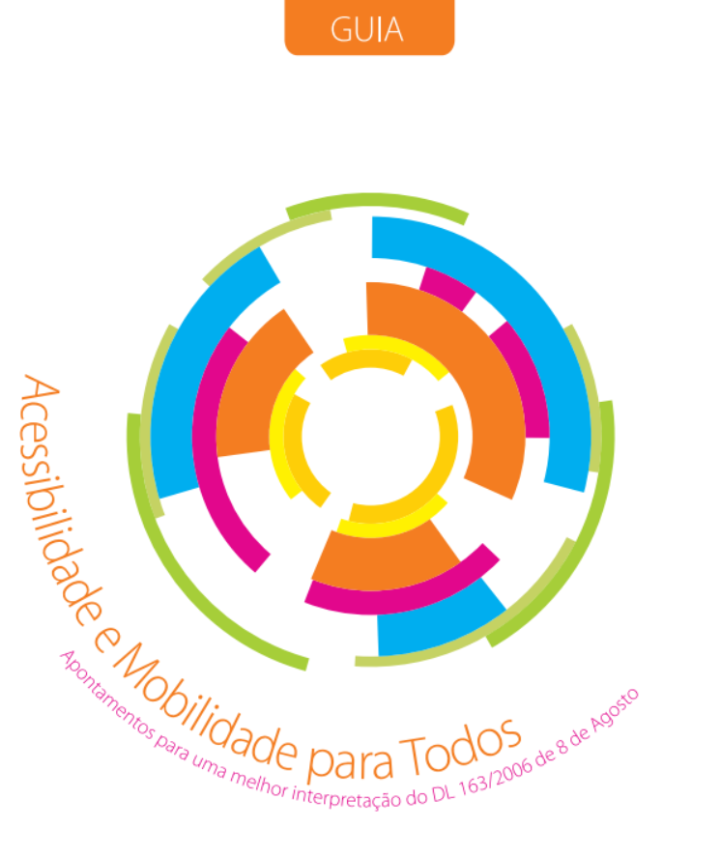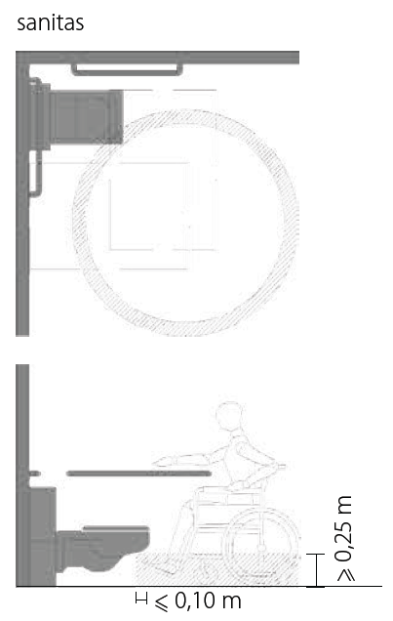
Figure 16 – Cover of the Portuguese illustrated handbook and an example of the type of illustrations available in the document (Instituto Nacional para a Reabilitação, 2007)
In other cases (E.g. England) the laws or norms have been created or revised to include illustrations [e.g. Document M - Access to and Use of Buildings (UK)].
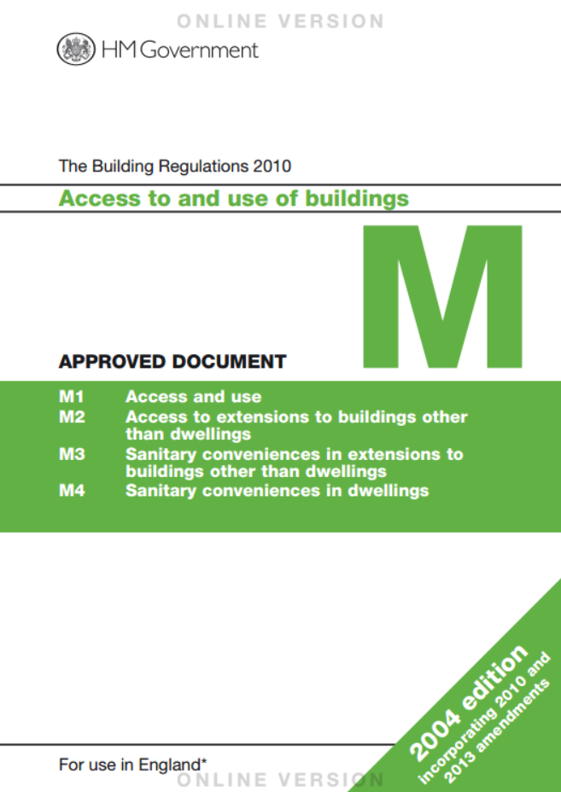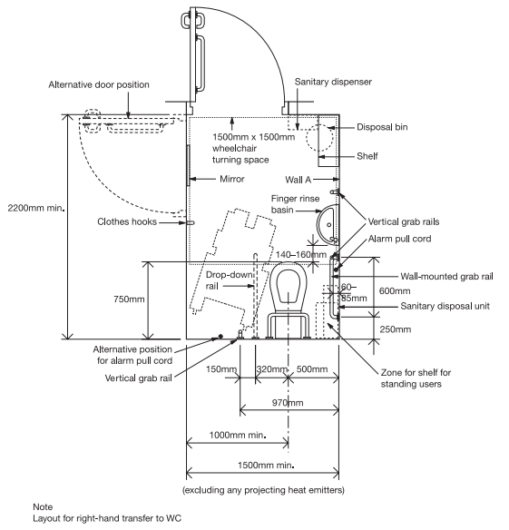
Figure 17 – Cover of the English Building Regulations and an example of the type of illustrations contained in the document (HM Government 2013)

References in the OLA project
All the EU member countries have accessibility design guidelines although there are some differences between them regarding e.g minimum dimensions. Taking into account OLA objectives and following ECA guidelines we will opt to distinguish between those differences in size in the Architectural Barriers analysis.
To support this analysis and in particular to pinpoint the norms that will be considered by our tools we will base our work on the Portuguese “Acessibilidade e Mobilidade para Todos”, the English “Document M - Access to and Use of Buildings”, the ECA 2003 “Technical Assistance Manual”, The Polish Construction Law, Swedish Planning and Building Act, Byggverkslagen (BVR), Boverkets byggregler (BBR), "Bygg ikapp handikapp” and BÄR (Allmänna råd om ändring av byggnad).

Appendix 2: Mobility Hazards
We will now highlight the proposed architectural norms and mobility hazards to be considered by OLA-EA application and the proposed elements that should be considered in the app. This will allow us to refine the objectives of the application, further define the problems faced by our target group and produce the requirements for the development of the app focusing our efforts on the most pertinent cases.

Architectural Mobility Barriers
Architectural mobility barriers are the architecture element on which norms and regulation exist with established minimal parameters to enable accessibility.

Width of corridors

Portugal:
Corridors should have at least 0,9m of free width if there length is less than 1,5m and don’t provide lateral access or 1,1m of width in all other situations.

Sweden:
Corridors should have a minimum width of 120 cm.

Poland:
Corridors should have a minimum width of 140 cm.

General Description of the proposed feature to be implemented in the OLA app:
- The app should scan the space and build a 3d model of the space and verify if corridors, one by one, respect this rule at their narrowest point;
- If a corridor doesn’t comply with the norm the system should be able to differentiate the walls from the furniture and reassess the compliance wall to wall;
- If corridor doesn’t comply the user should be notified of this situation, if it complies the app should assess what pieces of furniture should be removed so that the corridor complies with the norm;
- The app should advice which of the furniture to remove by highlight it on the display / 3D Model.

Corners and turns in corridors

Portugal:
A minimal area should be assured for a free turn of a wheelchair bound user according to the figure above:
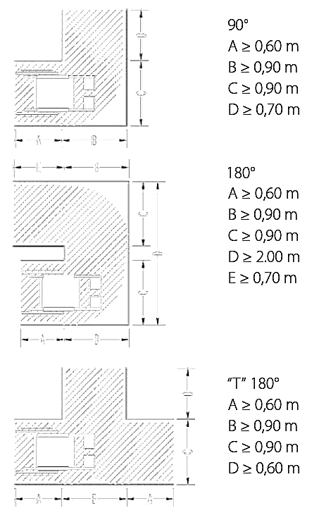
Figure 18 – Adaptation of the illustrations available in Guia da Mobilidade
(Instituto Nacional para a Reabilitação, 2007)

Sweden:
Corridors need to be wide enough to allow the turning a wheelchair towards any door opening and corner. Which requires a turning radius of 130cm.

Poland:
Corridors need to be wide enough to allow the turning a wheelchair towards any door opening and corner. Which requires a turning radius of 140cm.

General Description of the proposed feature to be implemented in the OLA app:
- The app should scan the space and build a 3d model of the space and verify if corners respect this rule at their narrowest point;
- If a corner doesn’t comply with the norm the system should differentiate the walls from the furniture and reassess the compliance wall to wall;
- If corner doesn’t comply the user should be notified of this situation, if it complies the app should assess what pieces of furniture should be removed so that the corridor complies with the norm;
- The app should advice which of the furniture to remove by highlight in on the display / 3D Model.

Entrance Hall

Portugal:
A free area with the diameter of 1,5m should be available at the entrance of every house.

Sweden:
A free area with the diameter of 1,5m should be available at the entrance of every house. Additionally, there should also be a space to sit and/or a place to store a walker/wheelchair and storage of outerwear and shoes.

Poland:
A minimum width of 1,2m should be provided to allow a turn of 90º, the depth of the entrance hall should at least 0,8m or greater when the door opens to the inside, begging added to the 0,8m the length of the door panel.

General Description of the proposed feature to be implemented in the OLA app:
- From the 3d model of the entrance hall the app should verify if a cylinder with 1,5m of diameter and 2,2m of height can be vertically placed within the negative space available;
- If the cylinder could not be placed the user should be warned that his/her entrance hall doesn’t comply with the norms and that this could impair de accessibility of their house.

Width of passage ways inside rooms

Portugal:
The width of an interior passage way must be equal or greater than 0,80m if the length of the restricted passage is equal or less then 0,6m, if the length of the passage is greater than 0,6m then the width should be equal or greater then 0,9m. This is considered to be the free passage way which means that it should be measured e.g. between a wall and a piece of furniture or between two pieces of furniture.

Sweden:
Interior passage way should have a minimum width of 120 cm.

Poland:
Interior passage way should have a minimum width of 140 cm. Additional an area should be guaranteed of 1,5mx1,5m.

General Description of the proposed feature to be implemented in the OLA app:
- The app should scan the space and build a 3d model of the space and verify if the passage way respects this rule at its narrowest point;
- If the passage way doesn’t comply with the norm the user should be notified of this situation and the app should highlight where the potential hazard is.

Doorways

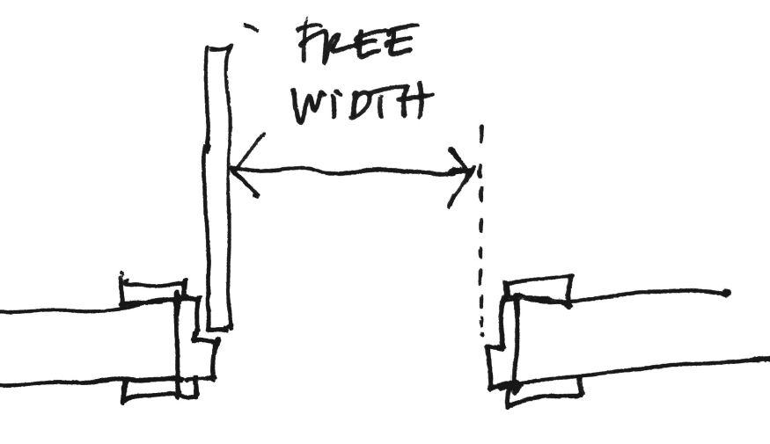
Figure 19 – Free width between the door frame and the door panel

Portugal:
The free width between the door frame and the door panel when open should be equal or greater to 0,77m at its open position at 90º. Additionally if a doorstep is present it shouldn’t be higher 20mm preferably with rounded edges.

Sweden:
The free width between the door frame and the door panel when open should be equal or greater to 0.76m at its open position at 90º. Additionally if a doorstep is present it should be removed altogether or have a maximum height of 15mm.

Poland:
The free width between the door frame and the door panel when open should be equal or greater to 0.90cm at its open position at 90º. Additionally if a doorstep is present it should be removed altogether or have a maximum height of 15mm.

General Description of the proposed feature to be implemented in the OLA app:
- The app should request the user to open the door in question;
- The app should scan the door frame and verify if the distance between the two vertical elements is bigger than 0,8m (in the Portuguese and Swedish cases) or 0,9cm (in the Polish case) and if a door step is present;
- If the distance is bigger than 0,8m (in the Portuguese and Swedish cases) or 0,9cm (in the Polish case) and the doorstep is lower than the maximum permitted in the country the user shouldn’t receive any warnings, if it doesn’t the user should be notified of the noncompliance.

Different levels

Portugal:
A step, isolated or in a group, should have 0,18m maximum riser and the tread should be at least 0,28m. If between areas or rooms there exist a sill this should not be higher 2cm preferably with rounded edges.

Sweden:
A step, isolated or in a group, should have a thread of at least 0.25m. If between areas or rooms there exist a sill this should not be higher 15mm.

Poland:
A step, isolated or in a group, should have 0,20m maximum riser and the tread should be extrapolated from the step riser with the formula$2H+W=≥0,6m but ≤0,65m$ (H=Riser W=Tread). If between areas or rooms there exist a sill this should not be higher 1,5cm.

General Description of the proposed feature to be implemented in the OLA app:
- The app should be able to identify the presence of a step or a sill and verify the height of the riser and depth of the tread.
- If the height and depth of the steps don’t respect the norm the user should be notified and advised to add a friction strip with contrasting color to the edge of the steps.
- If there is only one or two steps the user should be notified and advised to add a friction strip with contrasting color to the edge of the steps.

Questions Information:
- The app should ask if the step(s) is/are slippery (Yes or No Question), if the user responds “Yes” the app should advise the addiction of friction strip with contrasting color to the edge of the steps or platform;
- If the user answered negatively to the previous question, then the app should ask if the step is easy to differentiate from the rest of the floor (Yes or No Question), if the user responds negatively the app should advise the addiction of friction strip with contrasting color to the edge of the steps or platform.

Stairs
In case of a multi-story house and in particular in the case of stairs various norms must be fulfilled:

Portugal:
- The width of the stairs, discounting the area occupied by handrails, should be at least 1m;
- The riser of steps should be constant thought the stair, the riser should have 18cm maximum and the tread should be at least 28cm;
- The first step can have different measurements from the rest, if it complies with the following formula: $2a+b=2a^{'}+b'$ in which “a” is the riser of the first step, “b” the tread of the first step, “a’” the riser of the other steps of the stair and “b’” the tread of the other steps;
- The top and bottom landings should at least have a length of 1,2m;
- If in any intermediate landing there is a change of direction there should be guaranteed at least the same space as in corridors;
- Stairs that overcome a height higher than 40cm should have handrails. The handrails should be continuous, have a height between 85cm and 90cm measured from the edge of the steps and at the start and end of the stair it should extend an extra 30cm.

Sweden:
- Stairs wider than 2.5 meters should be divided into two or more lanes;
- The riser of steps should be constant thought the stair, the tread should be at least 0,25m;
- Stairs should have railings that limit injuries due to falls. Railings should support the weight of a person, be at least 90cm high and easy to grab.

Poland:
- The width of the stairs, discounting the area occupied by handrails, should be at least 0,8m;
- The riser of steps should be constant thought the stair, should have 0,20m maximum riser and the tread should be extrapolated from the step riser with the formula$2H+W=≥0,6m but ≤0,65m$ (H=Riser W=Tread);
- The landings should at least have a length of 0,8m, if in any intermediate landing there is a change of direction it should be guaranteed the necessary space to perform the turn;

General Description of the proposed feature to be implemented in the OLA app:
- The app should be able identify the presence of stair and identify the individual steps and landings;
- The app should verify the presence of handrails and verify the height this element;
- The app should then verify the height of the riser and depth of the tread;
- If the height and depth of the steps don’t respect the norm the user should be notified and advised to add a friction strip with contrasting color to the edge of the steps or platform.

Questions Information:
- The app should ask if the step(s) is/are slippery (Yes or No Question), if the user responds “Yes” the app should advise the addiction of friction strip with contrasting color to the edge of the steps or platform;
- If the user answered negatively to the previous question, then the app should ask if the step is easy to differentiate from the rest of the floor (Yes or No Question), if the user responds negatively the app should advise addiction of friction strip with contrasting color to the edge of the steps or platform.

Bathrooms – Circulation Area

Portugal and Poland:
A free area with the diameter of 1,5m should be available, which can include the shower basin if it’s at floor level with no projection. On one of sides of the toilet seat there should be a free space for a wheelchair.

Sweden:
A free area with the diameter of 1,3m should be available. One side of the toilet seat should have a free space for a wheelchair and the other side should have sufficient space for an assisting person.

General Description of the proposed feature to be implemented in the OLA app:
- From the 3d model of the bathroom the app should verify if a cylinder with 1,5m of diameter and 2,2m of height can be vertically placed within the negative space available;
- If the cylinder could not be placed the user should be warned that the bathroom might not be accessible to wheelchairs.

Bathrooms – Grab rails and other mobility facilitators

Portugal:
Grab rails should be present in the following situations:
- If the toilet is located in the corner of the room – grab rails should be placed in the wall above the water reservoir and in the wall contiguous to the toilet;
- If the toilet does not have any contiguous walls - retractable grab rails should be placed in either sides of the toilet;
- If the bathroom has a bathtub – One grab rails should be placed along the length of the bathtub and one on the shorter side of the bathtub;
- If the bathroom has a shower – At least two grab rails should be placed;
- If the bathroom has a urinal – Two grab rails should be placed, one on each side of the urinal;
- Although not mandatory, additional grab rails can be place on each side of the lavatory if needed.

Sweden:
Grab rails should be present in the shower room. And be designed in a way to limit accidents from falling.

Poland:
Grab rails should be present in the following situations:
- If the toilet is located in the corner of the room – grab rails should be placed in the wall above the water reservoir and in the wall contiguous to the toilet;
- If the bathroom has a bathtub – One grab rails should be placed along the length of the bathtub and one on the shorter side of the bathtub;
- If the bathroom has a shower – At least two grab rails should be placed;
If a closed shower cabin is present it should have a length of at less 2.5 m and a width of at least 1.5 meters and be equipped grab rails.

General Description of the proposed feature to be implemented in the OLA app:
- From the 3d model of the bathroom the app should verify if grab rails are detected;
- If grab rails are detected the app should verify the positioning of them in relation to the bathroom fittings or prompt the user to verify them and if needed correct them;
- If no grab rails are detected the app should advise the addiction of grab rails.

Kitchen

Portugal:
A passage way with a width equal or greater than 1,5m should be available between the counters or the counter and the wall.

Sweden:
A passage way with a width equal or greater than 1.2m should be available between the counters or the counter and the wall.

Poland:
A passage way with a width and length equal or greater than 1,5m should be available between the counters or the counter and the wall.

General Description of the proposed feature to be implemented in the OLA app:
- The app should scan the space and build a 3d model of the space and verify if the passage way respects this rule at the defined situations;
- If the passage way doesn’t comply the app should notify the user of this situation.

Other mobility Hazards
In OLA-EA partners will include other hazards that are not considered in the current norms and regulation.

Floor coverings
Identification of rugs and carpets and identification of irregularities on these objects.

General Description of the proposed feature to be implemented in the OLA app:
- Identification of torn, bend or in poor condition floor coverings;
- Highlight the area in question and warn the user to the risk of fall.

Additional Information:
- The app should ask the user if there is a slippery rug and if the answer is yes warn about the risk of fall.

Cabling across passage ways
Cabling crossing corridors, doors and passage ways.

General Description of the proposed feature to be implemented in the OLA app:
- Detection of cabling crossing corridors, doors and passage ways throw the floor.
- Highlighting the cable and warning of the tripping hazard and recommend the redirecting them.

Protruding elements
Protruding elements on walls and furniture at low height.
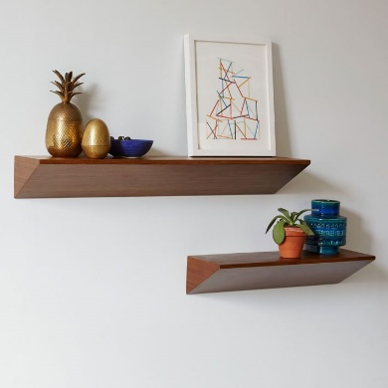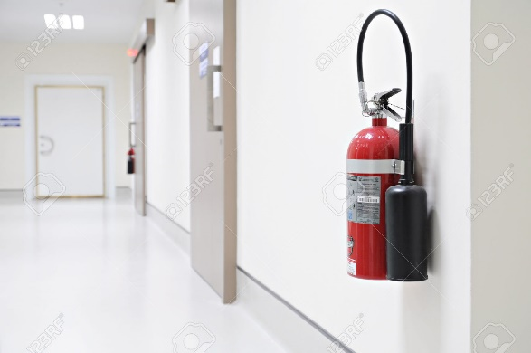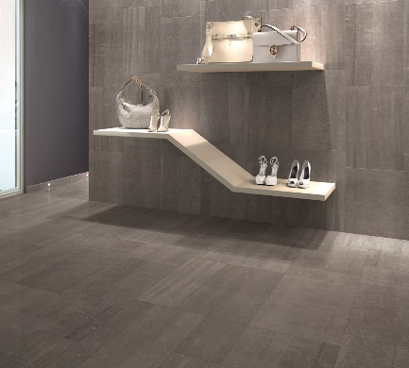
Figure 20 – Examples of protruding elements: shelves, fire extinguishers, among others

General Description of the proposed feature to be implemented in the OLA app:
- Detection of protruding elements on walls and furniture at low height.
- Highlighting the element and warning of the hazard and recommend the removal of this elements.

Poor Lighting
In corridors and circulation area a minimum illumination level of 100 lx (EN 12464-1:2011) should be provided.

General Description of the proposed feature to be implemented in the OLA app:
- Detection throw the illumination sensor of the tablet the illumination level should be verified;
- If a minimum level of 100lx is not available the user should be noticed and a prompted to increase the artificial lighting available.

Appendix 3

Voxel grid – default settings
These are the default settings that translate the optimal trade-off between the size of the voxel grid and the individual voxel size and serves as a comparison with the other settings.
The parameters that will be modified are the sizeX, sizeY, sizeZ and voxelSize. These changes will impact the framerate displayed in the window bar (FpsRender), the quality and the size of the reconstructed volume.
For all 3D reconstruction screenshots: the top-left square depicts the 3D reconstructed model; top-right depicts the RGB feed; bottom-right depicts the depth feed and the bottom-left depicts a point cloud with vertices and normals.
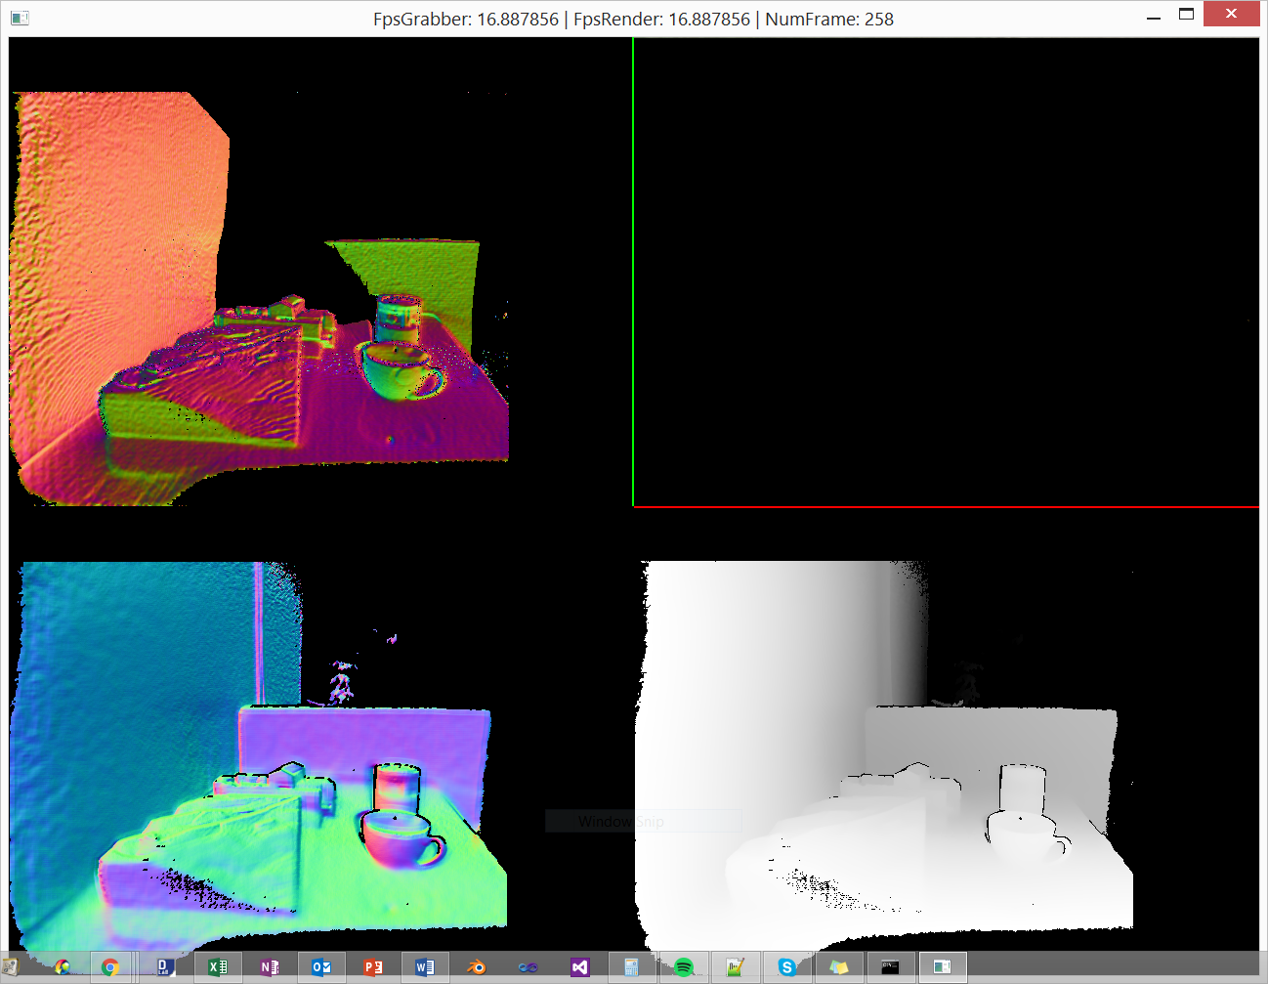
Figure 21. 3D reconstruction for default settings
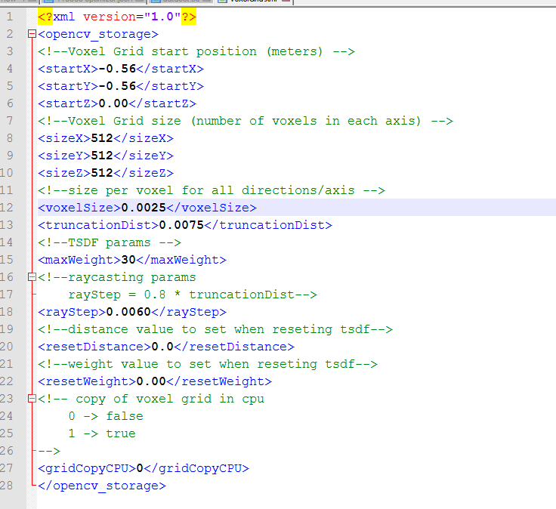
Figure 22. Default settings for the voxel grid

Voxel grid – hi-grid settings
These settings comprehend a bigger voxel grid size (more voxels per axis) which lengthens the reconstructed volume but has an impact on performance.
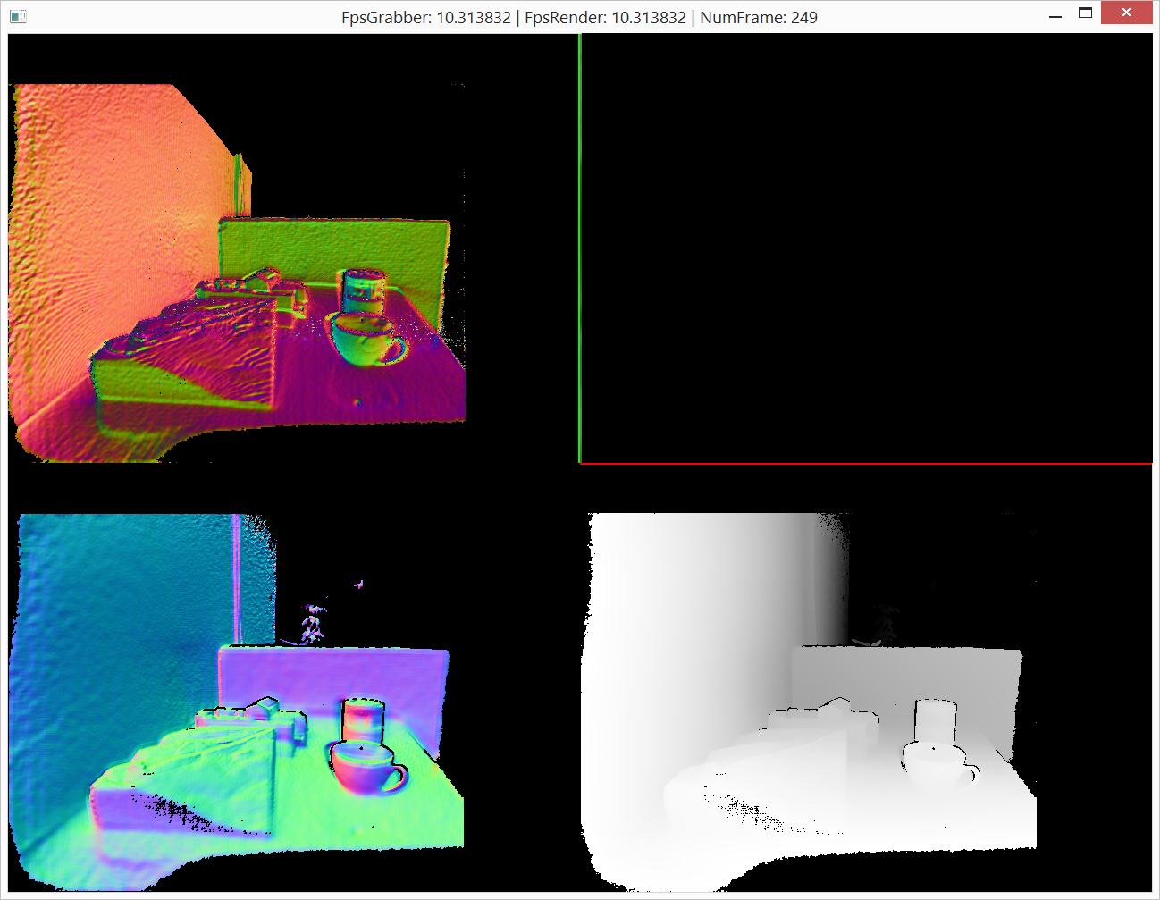
Figure 23. 3D reconstruction for high grid size settings
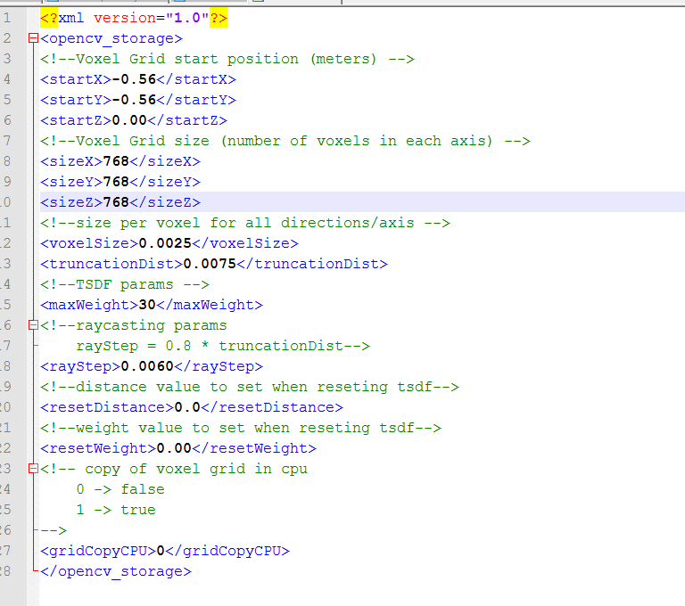
Figure 24. High grid size settings

Voxel grid – lo-grid settings
These settings comprehend a smaller voxel grid size (fewer voxels per axis) which shortens the reconstructed volume but boosts performance.
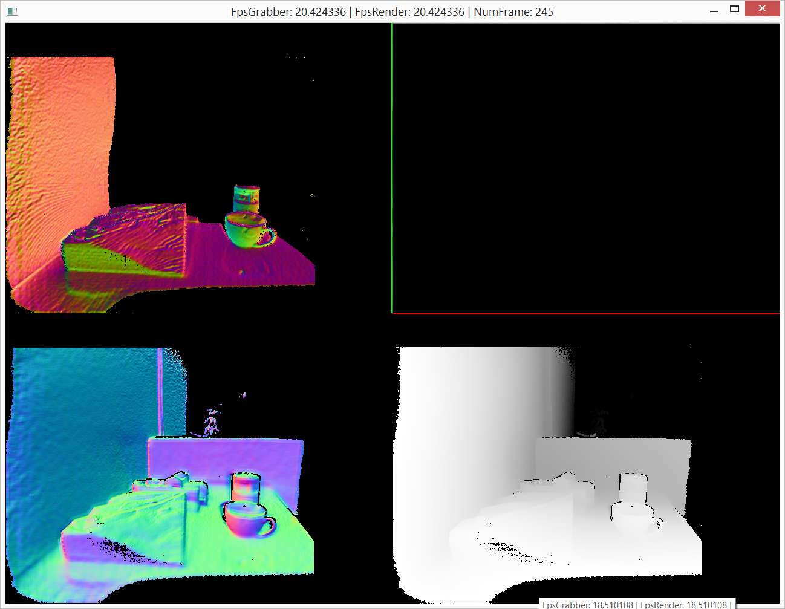
Figure 25. 3D reconstruction for low grid size settings
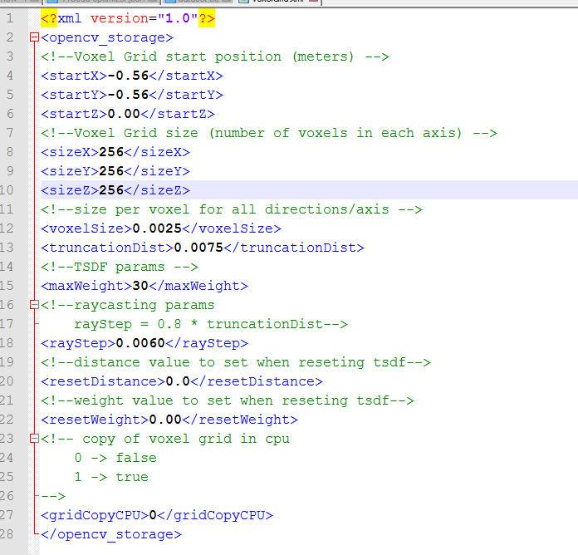
Figure 26. Low grid size settings

Voxel grid – lo-res settings
These settings comprehend a lower voxel grid resolution (fewer voxels per cubic meter) which lengthens the reconstructed volume but decreases the 3D model’s quality.
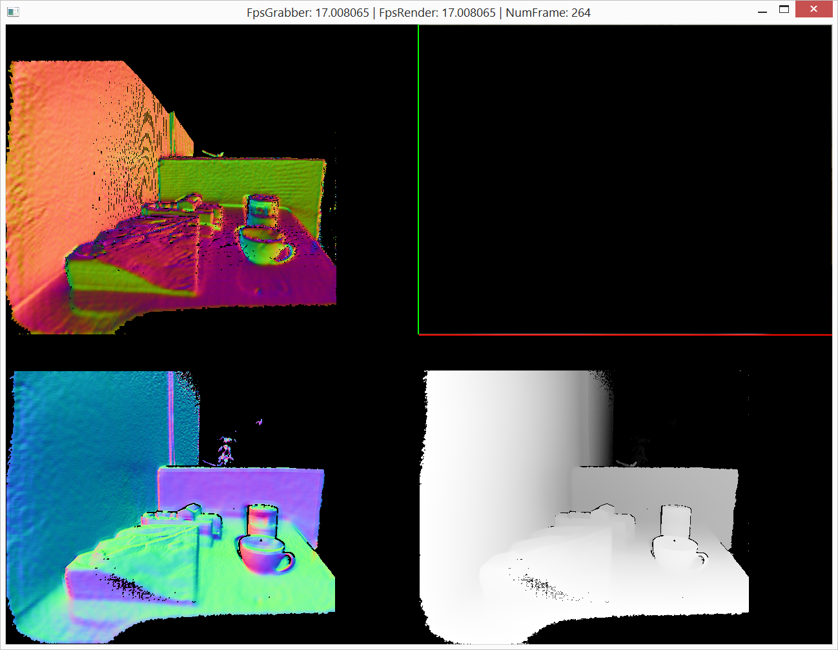
Figure 27. 3D reconstruction for Low resolution settings
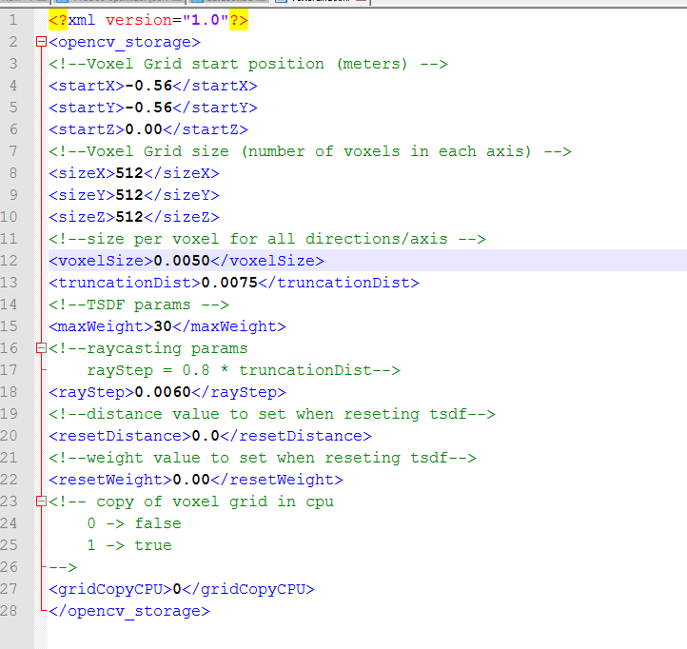
Figure 28. Low resolution settings

Voxel grid – hi-res settings
These settings comprehend a higher voxel grid resolution (more voxels per cubic meter) which shortens the reconstructed volume but increases the 3D model’s quality.
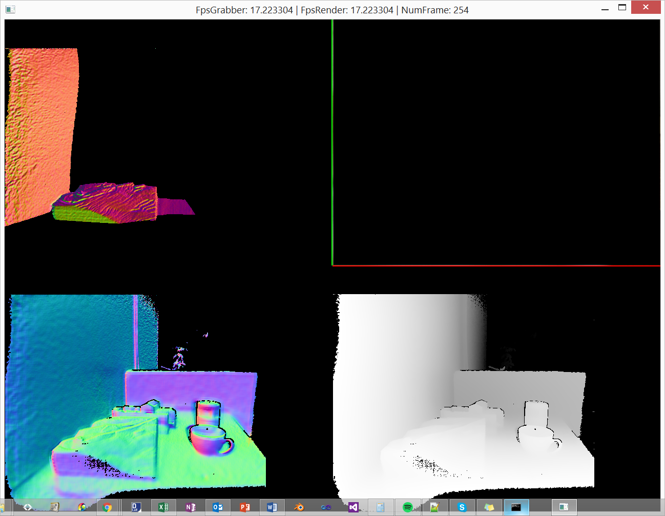
Figure 29. 3D reconstruction for high resolution settings
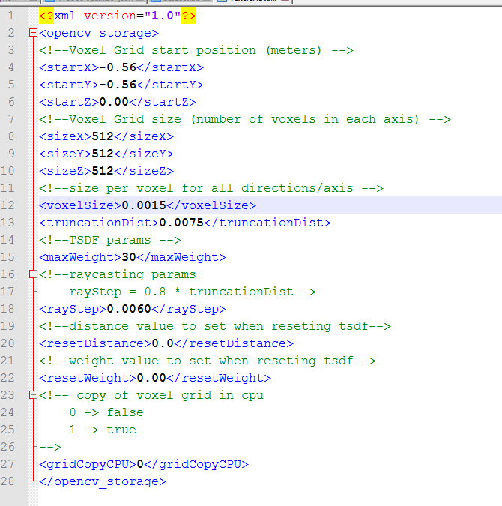
Figure 30. high resolution settings

Comparison table
Quality | Reconstructed Volume | Framerate
Default | 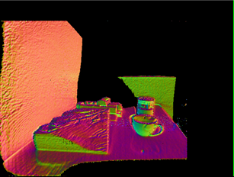 | 16.9
Hi-grid | 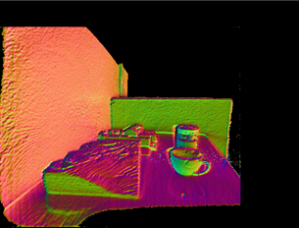 | 10.3
Lo-grid | 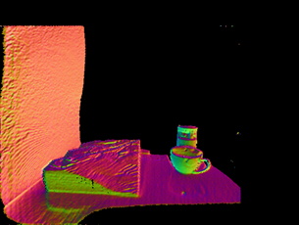 | 20.4
Lo-res | 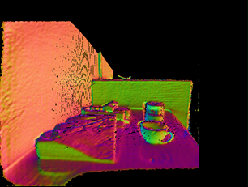 | 17.0
Hi-res | 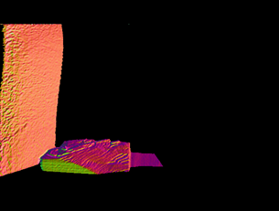 | 17.2

Key bindings

1 | Show/Hide Color image
2 | Show/Hide Depth image (original)
3 | Show/Hide Depth image (filtered)
4 | Show/Hide Normal map (original)
5 | Show/Hide Normal map (filtered)
6 | Show/Hide Depth Pyramid (which one?)
7 | Show/Hide Casted VS. Filtered depth and normal maps
9 | Show/Hide Aligned Color(RGB)
q | Show/Hide 3D Cloud (original)
a | Show/Hide 3D-RGB Cloud (original)
w | Show/Hide 3D Cloud (filtered)
e | Show/Hide 3D Casted Cloud (filtered)
z | Show/Hide auxiliary 3D ground-truth
x | Show/Hide auxiliary 3D info

Photos from: http://www.westelm.com/products/wedge-shelf-acorn-w1552/, http://pt.123rf.com/photo_30232114_instale-um-extintor-de-inc%C3%AAndio-na-parede-no-hospital.html, http://www.archiproducts.com/pt/produtos/83405/back-revestimento-de-pisos-paredes-para-interiores-back-brown-ceramiche-keope.html

