### cid:image001.png@01D0AF3A.88E66970http://www.aal-europe.eu/wp-content/uploads/2013/06/AAL-Logo-small.jpg

D2.3 a) First version of

the input/output interfaces

OLA – Organizational Life Assistant

FOR FUTURE ACTIVE AGEING

http://inovamais.eu/noticias/wp-content/uploads/sites/7/2014/12/INOVAMAIS_LOGO_NEW.pnghttp://iscte-iul.pt/Libraries/GCI_-_Documentos_e_Formul%C3%A1rios/II_pt.sflb.ashxhttp://www.saapho-aal.eu/sites/default/files/styles/medium/public/logo%20Liquid%20media.jpg

|  |  |
| --- | --- |
| **Project Identification** | |
| Project Number | AAL 2014-076 |
| Duration | 30 months (1st March 2015 – 31th August 2017) |
| Coordinator | Carla Santos |
| Coordinator Organization | Inovamais, S.A. (INOVA+) |
| Website | <http://project-ola.eu/> |

|  |  |
| --- | --- |
| **Document Identification** | |
| Deliverable ID | D2.3 a) First version of the input/output interfaces |
| Version/Date | V1.0 / 01.07.2016 |
| Leader of the Deliverable | Sara Eloy (ISCTE-IUL) |
| Work Status | Finished |
| Review Status | Accepted |

|  |  |
| --- | --- |
| **Deliverable Information** | |
| Deliverable Description | This deliverable presents the multimodal output and input interfaces developed for the OLA application, with special emphasis put in the graphical version. |
| Dissemination Level | PU |
| Deliverable Type | R |
| Original Due Date | 07/2016 |

|  |  |
| --- | --- |
| **Authorship & Review Information** | |
| Editor | Lázaro Ourique (ISCTE-IUL) |
| Partners Contributing | Nelson Carvalho (MSFT) |
| Reviewed by | Sara Eloy (ISCTE-IUL), Bruno Coelho (INOVA+) |

Table of Contents

1 Executive Summary 6

2 Document Context 7

2.1 Role of the Deliverable 7

2.2 Relationship to other Project Deliverables 7

2.3 Target Audience of the Deliverable 7

3 Project Description 8

3.1 General Description 8

3.2 System Description 9

4 OLA app 11

5 Interface design and used devices: concepts 12

5.1 Multimodal Input 12

5.1.1 Mouse and Keyboard 12

5.1.2 Touch with audiotactile feedback 12

5.1.3 Voice Commands 13

5.1.4 Eye-tracking 13

5.1.5 Gesture Detection 13

5.1.6 Health Sensors 13

5.2 Multimodal Output 13

5.2.1 Voice Synthesis 13

5.2.2 Avatar with Voice Synthesis 13

5.3 Interface design 14

6 OLA app: interface Mockups 17

6.1 Home 17

6.2 News 17

6.2.1 News Selection 17

6.2.2 News Panel 18

6.3 Messaging 19

6.3.1 Messaging Inbox 19

6.3.2 Message Panel 20

6.3.3 New Message 21

6.4 Agenda 22

6.4.1 Monthly View 22

6.4.2 Daily View 23

6.4.3 Add Event 24

6.5 Contacts 25

6.5.1 General Contacts List 25

6.5.2 Group Contacts List 26

6.5.3 Individual Contact 27

6.5.4 New Contact 28

6.6 Surveys 28

6.6.1 Surveys Panel 28

6.6.2 Surveys Response 29

6.7 Health Hub 31

6.7.1 Sensors Hub Panel 31

6.7.2 Adding Sensors 32

6.8 Settings 33

6.8.1 Themes 33

6.8.2 Speech 34

6.8.3 User 35

6.8.4 Location 35

6.8.5 Orientation 36

6.8.6 Keyboard and Language 37

6.8.7 About 37

7 References 39

# Executive Summary

This Deliverable presents the user interface developed for the main application of the OLA project.

This app will mediate and facilitate the interaction between senior citizens and their informal caregivers, other services or professionals as well as with friends, through technological devices such as standard computers, mobile devices (tablets) and home automation modules.

The interface was designed to ensure the compatibility of the various interaction input devices - keyboard, mouse, touch, gaze, gesture and voice – and to enable customization. Windows 10 Universal Design Guide was used as a base for the layout design which is a fully responsive design.

This deliverable includes the mockups for Home, News, Messaging, Agenda, Contacts, Services, Surveys, Sensors Hub, Weather and Settings panels, as well as a wide range of possible colour pallets for personalization.

# Document Context

## Role of the Deliverable

This deliverable presents various input and output devices integrated in the OLA application with a special focus on the user interface developed for the application.

## Relationship to other Project Deliverables

|  |  |
| --- | --- |
| **Deliv.** | **Relation** |
| D1.1 | User requirements specification and use case definition |
| D1.2 | Functional description of the OLA system, in combination with a concept design document that will be used to guide the system implementation. |
| D1.5 | Usability evaluation of field Trials in Sweden Poland and Portugal |

## Target Audience of the Deliverable

This document is a public deliverable. Still, it is mainly intended for the project partners and the European Commission services thus the document will be made public, but not specifically disseminated on a wider scale.

# Project Description

## General Description

This project aims to provide an answer to the societal challenges by providing an innovative Organisational Life Assistant (OLA), a virtual presence that supports instrumental activities relating to daily living needs of older adults allowing them to be more independent, self-assured and to have a healthier, safer and organized life, while facilitates caregivers by supporting them on offering high-quality assistance

OLA will mediate and facilitate interaction (communication and collaboration) between senior citizens and their informal caregivers or other services or professionals, through technological devices such as standard computers, mobile devices (tablets) and home automation modules. These ICT devices will be based on an innovative multimodal model, embracing various physical/healthy and cognitive characteristics of the older adults and will specifically oriented to increase the level of independence of the elderly, by supporting the possibility of carers' assistance remotely and by improving the accessibility to existing services on the Web, such as shopping on-line services.

Moreover, the OLA will also provide a personalized well-being and safety advices to older users in order to avoid unwanted age related health and safety situations at their own home. Such a well-being and safety advisor makes uses of a combination of collected user information (personal physical/health and cognitive characteristics) and user interaction information extracted through emotion recognition and various sensor settings.

OLA addresses also a major issue that elderly is facing related to memory degradation and gradual decreasing of their cognitive capabilities, enabling them to remember primary health care and fiscal obligations (e.g. personal hygiene, medical and tax compliance) or helping them to find everyday items such as eyeglasses, wallet or keys. It is based on speech dialogue interfaces and space and object reconstruction and classification to capture and store daily routines and their related contexts.

The primary end-users are the big group of older adults of 65+ living alone with or without light physical or cognitive age related limitations, who needs support from care systems. Secondary end-users are both formal and informal caregivers from public or private sectors, supporting them to cope with the increased demand for care.

## System Description

OLA addresses specifically the following main issues:

* **Well-being advisor**: based on the combination of the collected user information (personal, healthy characteristics) and user interaction information extracted through emotion recognition, sensors settings and contextual recorder capturing the routines as done by the older adult) the system will propose to the older adults’ personal advice adapted to their situation contributing to their preservation and well-being status in home environment. In case of risk (e.g. irregular heart rate, extreme fatigue) the system may ensure an alert to a local medical emergency service.
* **Collaborative care organizer**: based on the ISCTE-IUL and LM knowledge of developing human-computer interaction platforms (HCI), OLA will provide online care collaboration between family and professional caregivers, by enabling a local care network to communicate, access sensor data, and coordinate care tasks. With the OLA assistant, seniors will be able to actively participate in the care organization through voice, even when they are unwilling or unable to use traditional web applications.
* **Safety advisor**: based on the combination of collected user environment information through real-time analysis and augmented reality settings, the system will propose suggestions of environment changes that interfere with accessible paths and provide alerts for intruders or other situations that can create hazard situations. In case of risk (e.g. checking intruders or fire), the system may contact local emergency services.
* **Every day instrumental daily living activities memory support**: the system will anticipate medical and fiscal compliances, remember primary health care and food requirements and could help elderly to find displaced everyday items.
* **Environment analysis**: algorithms for real-time object recognition and scene understanding will be developed based on a number of inputs (i.e. 3D object and space reconstruction by using time-of-flight and augmented reality technology) in order to analyze and decide which action to be taken in order support the elderly by suggesting environment changes and providing hints/advices for safety and accessible environments.
* **Multimodal interaction for elderly**: An adaptive organizational life assistant, a virtual presence will be developed in order to facilitating communication and collaboration between older-adults and informal caregivers or other services or professionals. This will be a user-friendly system that uses multimodal approaches based on non-invasive and minimally obtrusive technologies (i.e. speech, silent speech, touch, gestures, RGB-D sensors).

The overall OLA system is an easy to download and to install software making use of multimodal integrated settings. OLA is in essence a service that enables the elderly user to reduce the demand of care through prevention and self-management, while at the same time also facilitates the supply of formal and informal care assistance.

A series of well-selected use cases where older adults have been supported by caregivers and care professional services will be carried out. Three pilots, in Portugal, Poland and Sweden representing the different use cases will be carried out. 60-90 care units will use the system over a six-month period. New evaluation approaches will be used during the pilots, investigating up to which point the OLA services alleviate caregivers support and maintain, or even improve the self-management, health and safe lifestyle of the older adult at home.

# OLA app

The OLA app is thought of as the aggregator of information from various devices, services and platforms that currently exist in the Assisted Living market, as well as, future devices and services.

When designing the application, we took into account the conclusions of various studies on the adoption and use of information and communications technologies (ICT) by the elderly (e.g. Cohen-Mansfield & Biddison, 2007; Davis, 1989; Fischer, David, Crotty, Dierks, & Safran, 2014; Kijsanayotin, Pannarunothai, & Speedie, 2009; and Peek et al., 2014)

Blaschke, Freddolino, & Mullen, (2009) conducted a systematic review to identify barriers faced by the elderly when using information and communications technologies (ICT), which were grouped in 5 main categories:

1. Age-related issues: impaired vision; problems with manual dexterity and mobility; memory and cognition challenges; and limitations in activities of daily living;
2. Characteristics of existing technology: complex screens and small print; standard computer keyboard format; usability issues with system designs; computer jargon; technologies that simply do not work well or easily;
3. Attitudinal issues: absence of perceived benefit; perception that technology is dangerous, too expensive, complicated, confusing, and too difficult to learn; low confidence in their ability to handle computers;
4. Training and support issues: financial barriers to access training; absence of qualified training opportunities, provided in settings with sensitive and caring trainers; lack of adequate support for the learning process;
5. Cost: financial barriers to access ICT devices and services.

Phiriyapokanon (2011) examined the state of the art on user interfaces for the elderly and proposed preliminary guidelines for the design of such interfaces. This author highlighted the multimodal characteristic of the input and output interfaces as one of the most importance factor in ease of use.

Taking into account the state of the art we opted to implement a multimodal input and output interfaces and follow the Universal Windows Platform App User Interface Guidelines (Microsoft Corporation) in the design of the Graphical User Interface (GUI) as it addresses most of the difficulties faced by the elderly.

# Interface design and used devices: concepts

## Multimodal Input

To ease the navigation within the OLA app and to mitigate potential barriers and difficulties faced by the elderly, a wide range of input devices were considered when designing the application interface. The input devices range from the standard mouse, keyboard (Figure 1), touch and voice, to the more innovative like eye-tracking and gesture (Figures 2 & 3).

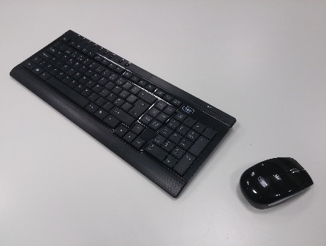 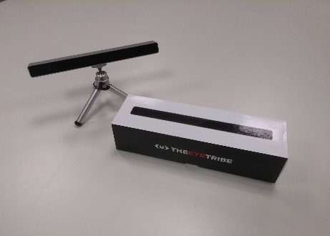 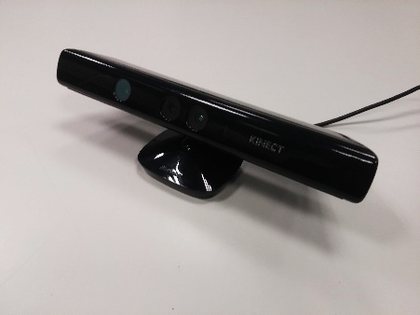

Figure 1 - Traditional Keyboard and Mice Interface

Figure 2 – Eye-tracker for Gaze Input

Figure 3 – Kinect V1 for Gesture Input

### Mouse and Keyboard

Mouse and keyboard are the standard input devices for computers and thus were considered to be used as input devices. Although the goal is to mainly use touch input the keyboard was still considered an essential device for the input of large blocks of text, e.g. in e-mails, and as an alternative for elderly which face problems with on-screen keyboards.

### Touch with audiotactile feedback

As previously mentioned the aim was to use touch as the main input for navigating process in the OLA app. It’s been shown (Hwangbo, Yoon, Jin, Han, & Ji, 2013) that touch inputs combined with audiotactile feedback aids the use of the applications by elderly, in particular computer illiterate elderly as it allows for a more intuitive navigation.

This function is dependent on the hardware, on the availability of a haptic motor or vibration motor, and on the operating system definitions.

### Voice Commands

The use of voice commands in our app is intended to provide an alternative to touch and keyboard and mouse inputs in large display like television screens and projection, as well as, when using the app while having the hands occupied with other tasks.

### Eye-tracking

The introduction of eye-tracking in this project as an input device is meant to allow elderly with low mobility in the upper limbs or paraplegics.

The eye-tracker functionality utilizes the eye-tracker input and when the user fixates on an element for more than the predefined time, by default 5 seconds, a left click is registered.

### Gesture Detection

As with voice commands, gesture detection is intended to provide an alternative to touch and keyboard and mouse inputs in large display like television screens and projection.

### Health Sensors

Various health related devices, e.g. Microsoft Band and Smart Scales, can be pair with the OLA app to input various health related data, e.g. heart rate, weight and body mass index, this are further specified in Deliverable 3.3.

## Multimodal Output

In addition to the traditional Graphical User Interface the consortium partners opted to implement further output modalities that complement particular input devices or address the barriers identified in the state of the art review.

### Voice Synthesis

The voice synthesis was thought as the main feedback when using voice input, in particular, when using the app while performing other tasks. This functionality also allows the app to give extra information about a particular section when the pointer hovers over a particular bottom for an extended period of time.

### Avatar with Voice Synthesis

In addition to the voice synthesis system an avatar (Figure 4) will be introduced to the application and can be enabled to complement the voice synthesis system giving it a virtual persona.

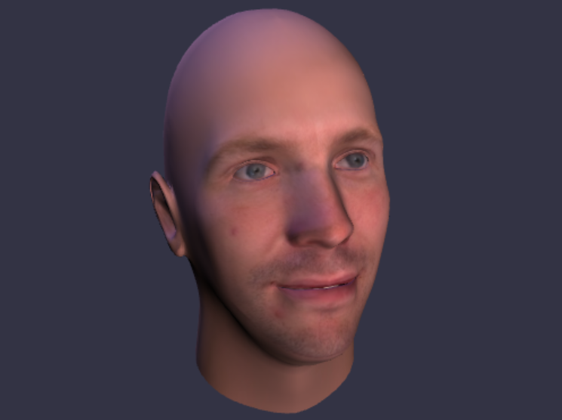

Figure 4 - Avatar

## Interface design

The design of the Graphical User interface was based upon the Microsoft Design Language Style Guide (2016) and incorporated the concepts gathered throw the state of the art review in particular Phiriyapokanon (2011) *Is a big button interface enough for elderly users?*.

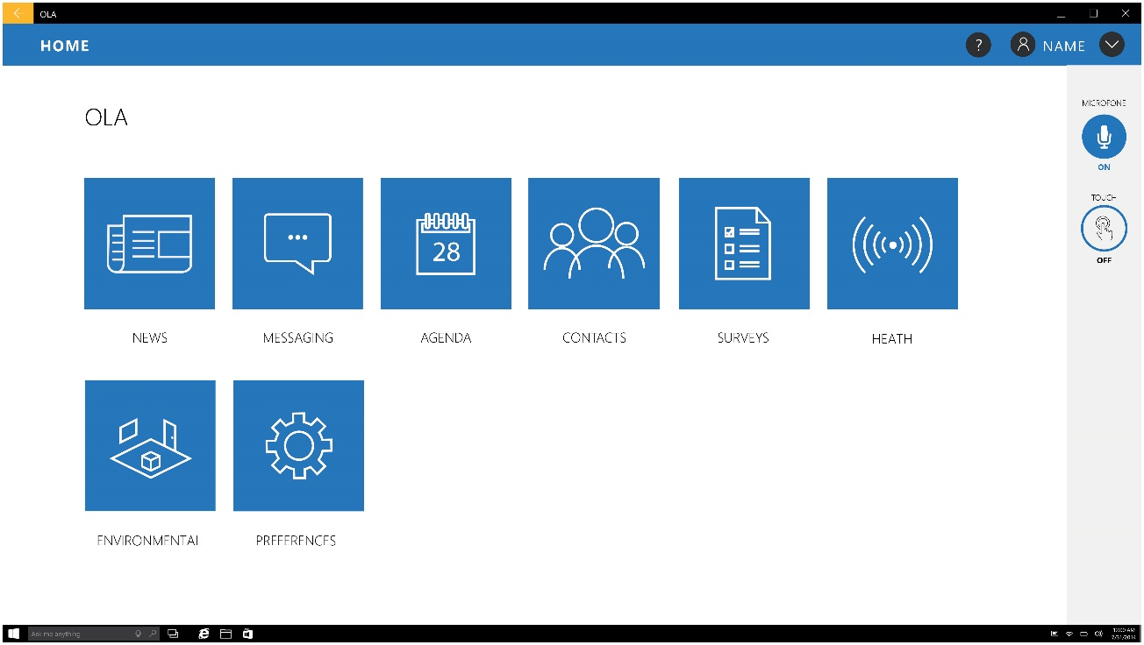

Figure 5 – Mockup of the Home page

The main interface is based on big buttons’ interface in the ascent color with stylized line icons in white, to maximize contrast ratios, and large text labels underneath, following the recommendations by Phiriyapokanon (2011).

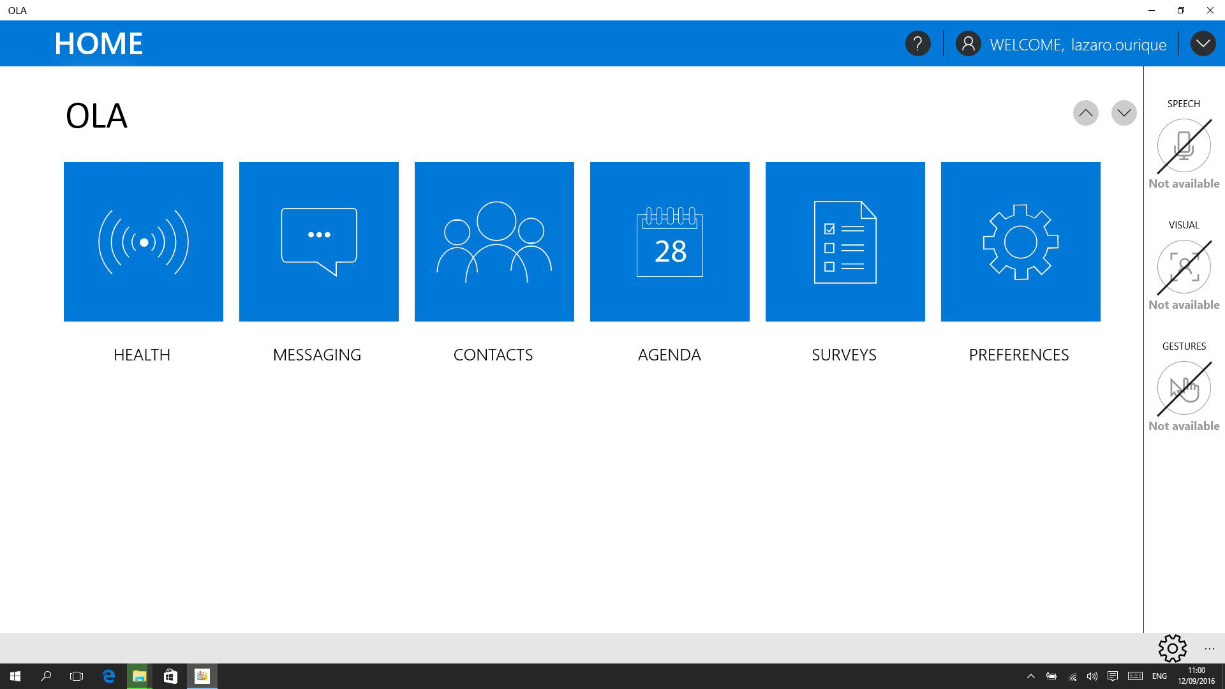

Figure 6 – Screenshot of the Home Page on the App Alpha Version

The background colour of the interface is white with the accent colour being Blue tone, #0078d7 for its high level of contrast with white, following Owsley, Sekuler, & Siemsen (1983), *Contrast sensitivity throughout adulthood,* that indicate “from the 20s to the 80s, there is a decrease in contrast sensitivity for intermediate and high spatial frequencies the becomes more pronounced with age” (Owsley et al., 1983, p. 697).

Three elements are persistent across all menus: an upper blue horizontal bar with a help button, the currently logged-in username and a button for accessing a dropdown menu with user settings; a side bar with various toggle buttons for the input methods - e.g. Voice, Eyetracking and Gesture - and a bottom bar with some quick settings buttons that adapts to the context of each individual menu.

When any selection is done (Figure 7) the unmarked elements are kept at a low contrast color scale and the selected ones are highlight with the accent colour.

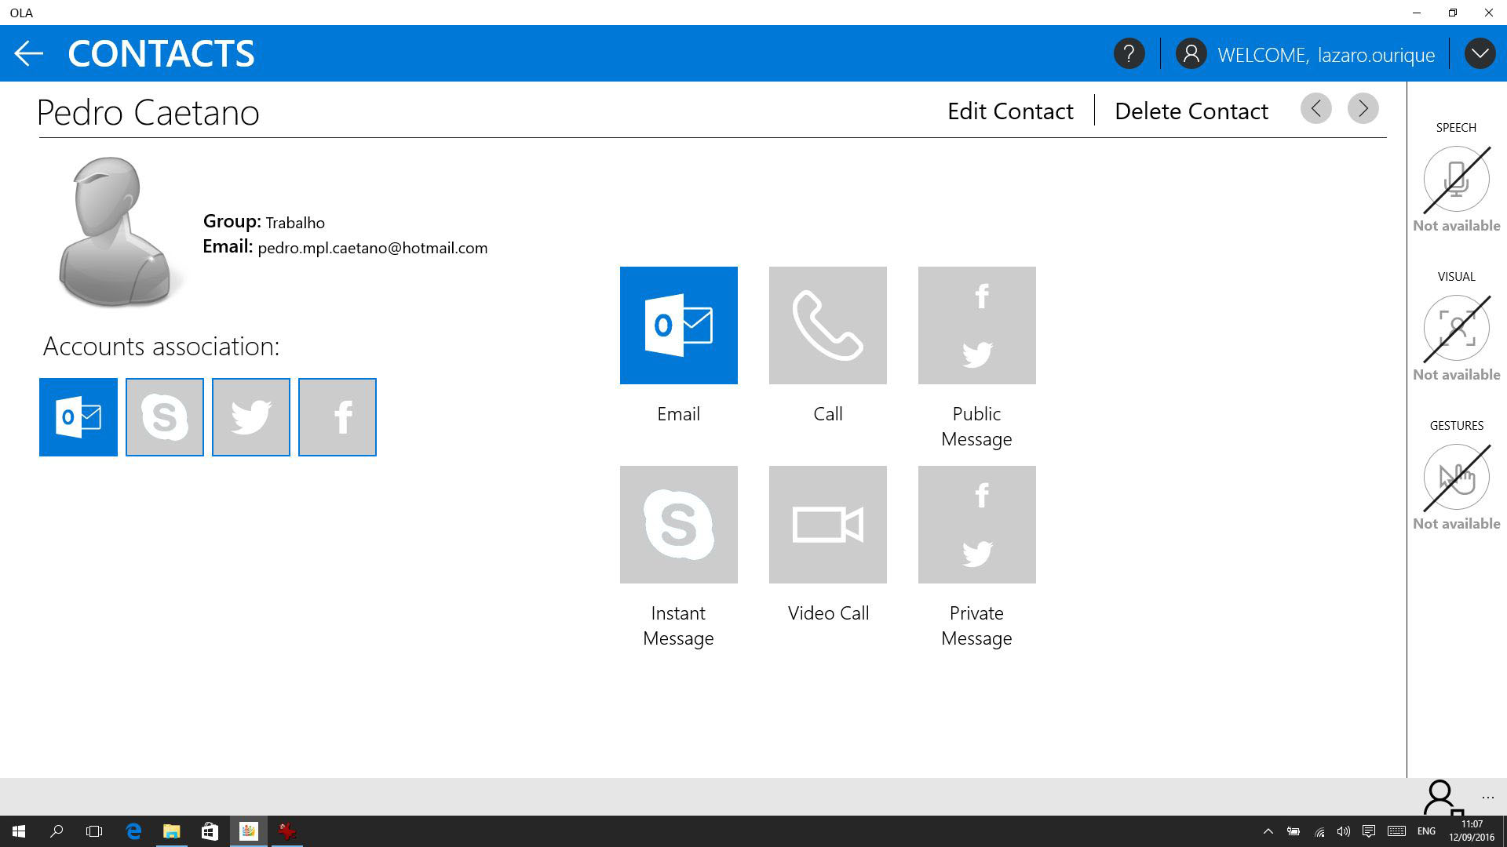

Figure 7 – Screenshot of the Contact Menu on the App Alpha Version

Finally, the popup menus follow the general rules previously described but appear above the darkened window to highlight it (Figure 8).

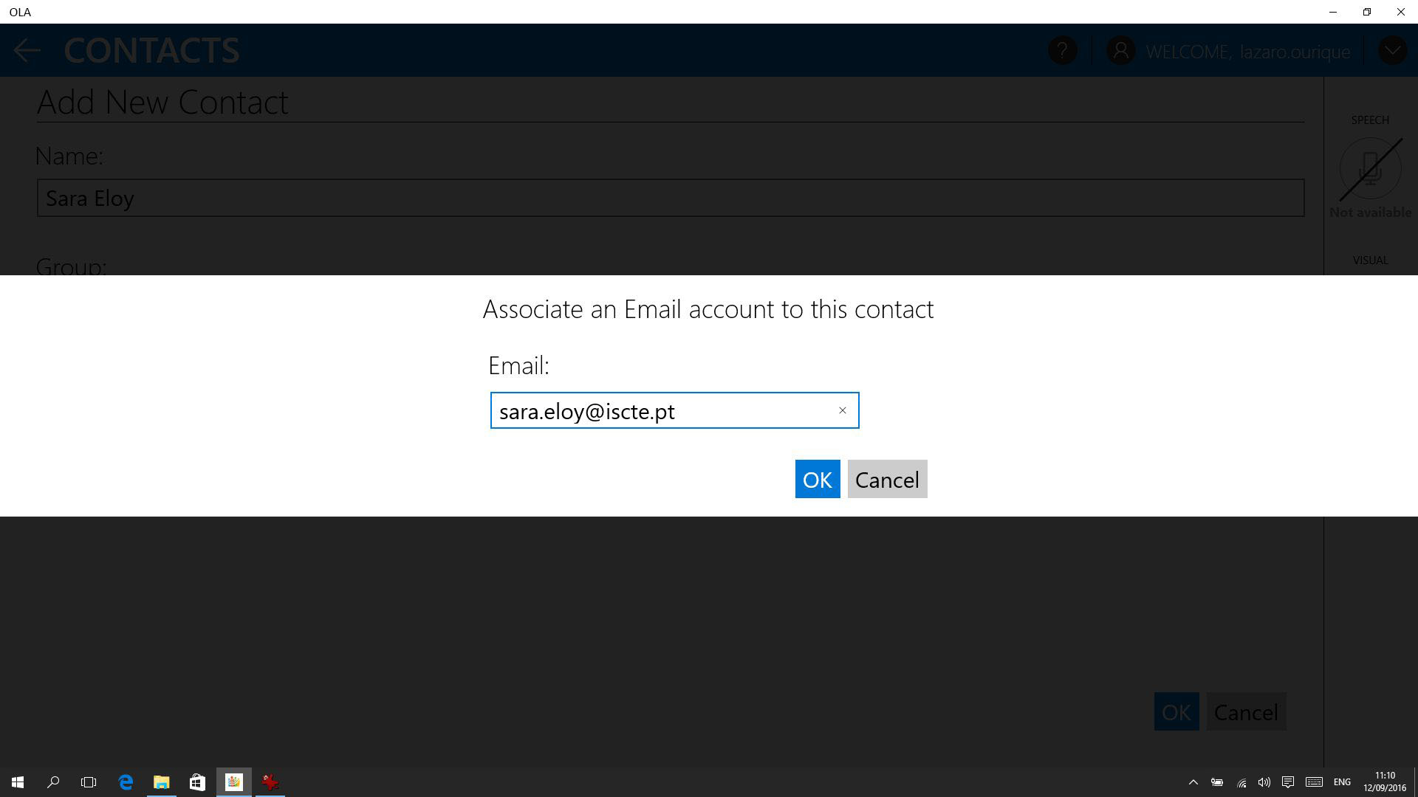

Figure 8 – Screenshot of a POP Up Menu on the App Alpha Version

# OLA app: interface Mockups

Mockups were created to enable the demonstration of the OLA app concept, allow for the collection of feedback and perform low-tech internal tests on the concept of the application.

The mockups now presented gives us a glimpse at what the OLA project will have regarding the range of features defined by the project partners up to May 2016.

## Home

The application’s Home page (Figure 9) shows all the services offered by the assistant. The use of a high-density grid pattern and the combined use of large iconography and text aims to ease the selection of the services by eye-tracking, gesture and touch as well as disambiguate the multiple names and commands for voice interaction.



Figure 9 – Home page

## News

### News Selection

Like the Home page, the News selection page (Figure 10) utilizes a high-density layout with large imagery, in this case thumbnails, in addition to the titles and excerpts of each news. The user can choose between general categories of news, e.g. world, finance, and technology.

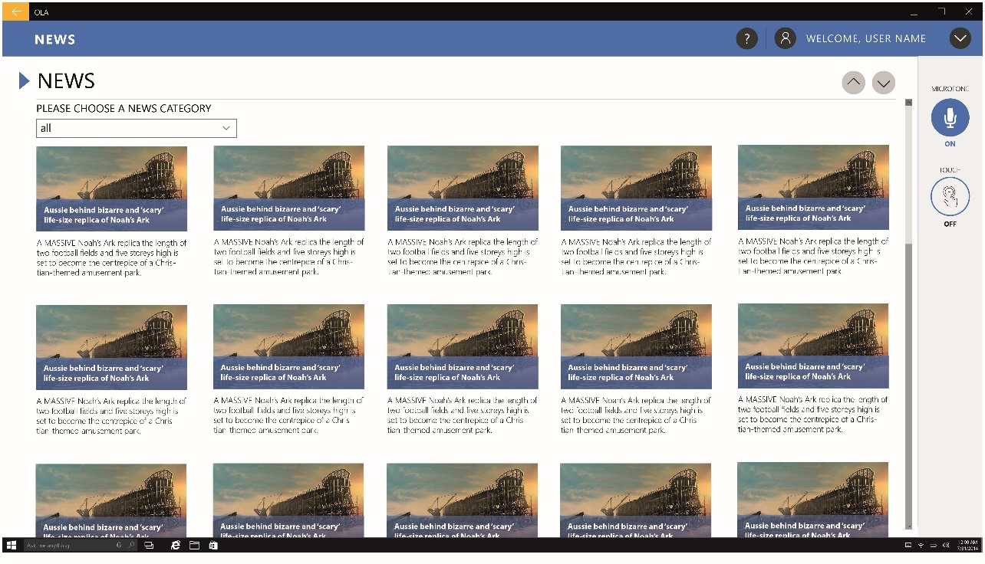

Figure 10 - News Selection

### News Panel

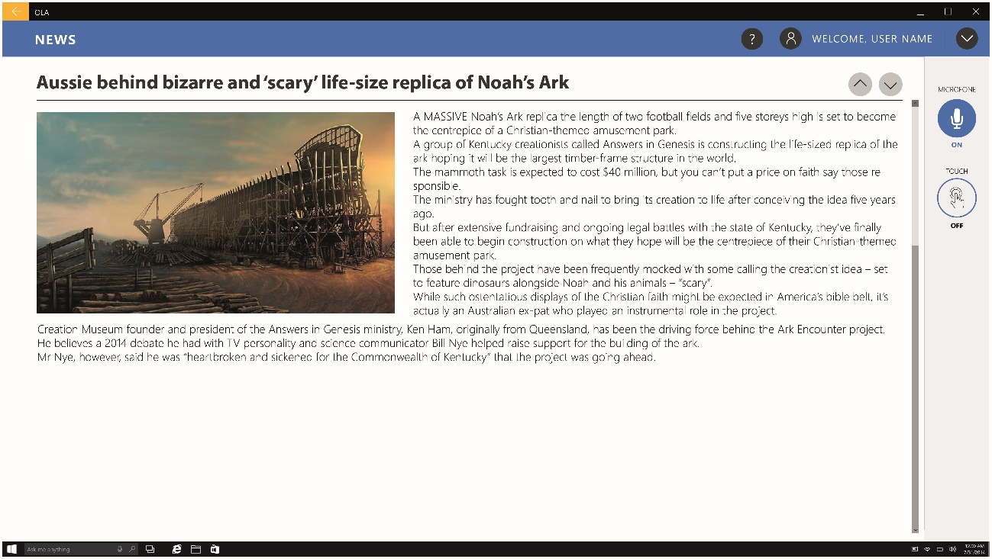

Figure 11 - News Panel

After selecting the news’ category on the news panel, a new page is presented with a single news article (Figure 11) with traditional layout. In this layout, text is justified and an image is presented in the top left corner with the text flow around it.

## Messaging

### Messaging Inbox

The Messaging Inbox (Figure 12) presents a list layout with all the messages received. The inbox is organized by day and there is a scroll bar to scroll up and down the messages. A menu bar with a dropdown filter list - enabling to filter messages by type, e.g. E-mail, Facebook message – and additional options buttons complete this interface.

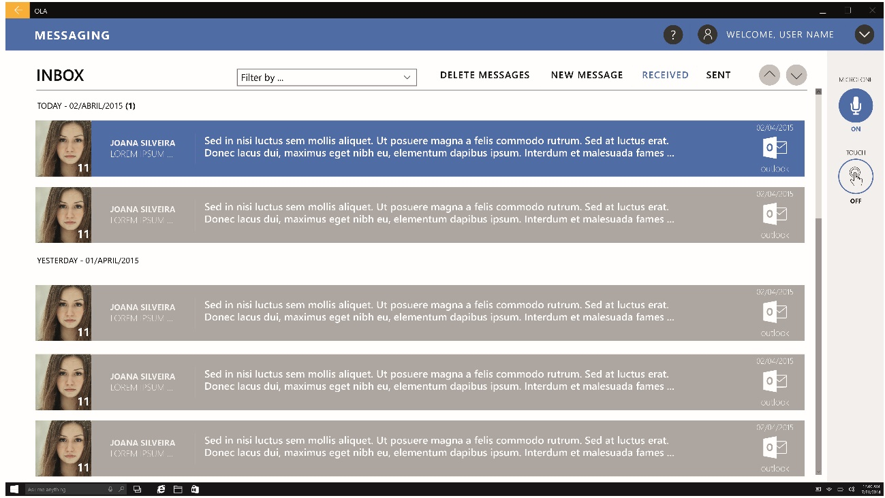

Figure 12 - Message Inbox

### Message Panel

The Message panel (Figure 13), like the message inbox is presented in a simple layout with a header with the associated contacts, from and to, and an icon of the messaging platform used, e.g. outlook, facebook messenger, twitter.

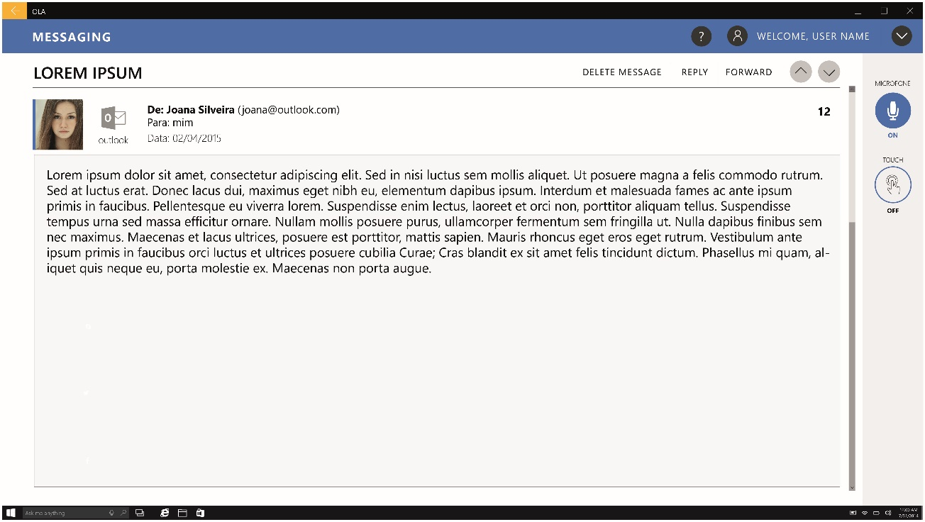

Figure 13 - Message Panel

### New Message

The New Message icon exists in the Message Inbox panel. The Mew Message menu (Figure 14) utilizes a high-density layout with large iconography of the available platforms for Public and Private messaging. The selected platforms are highlighted with the user interface main colour, while the unselected platforms are presented in a grey scale in addition to a selection box.

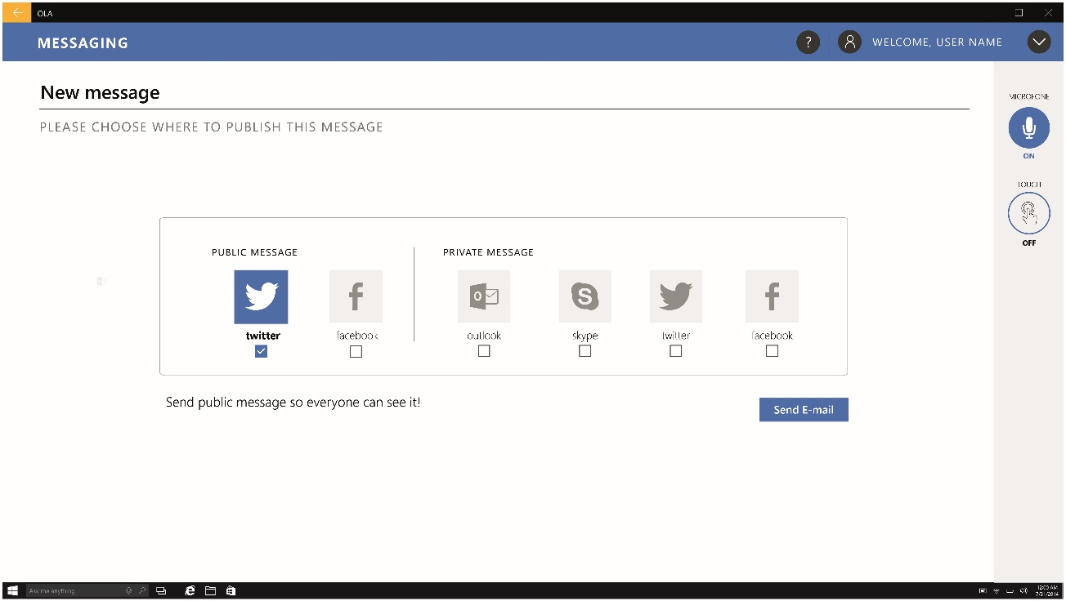

Figure 14 - New Message, platform selection panel

The new message writing panel (Figure 15) is a traditional e-mail layout with several text input boxes for receiver, subject and text body.

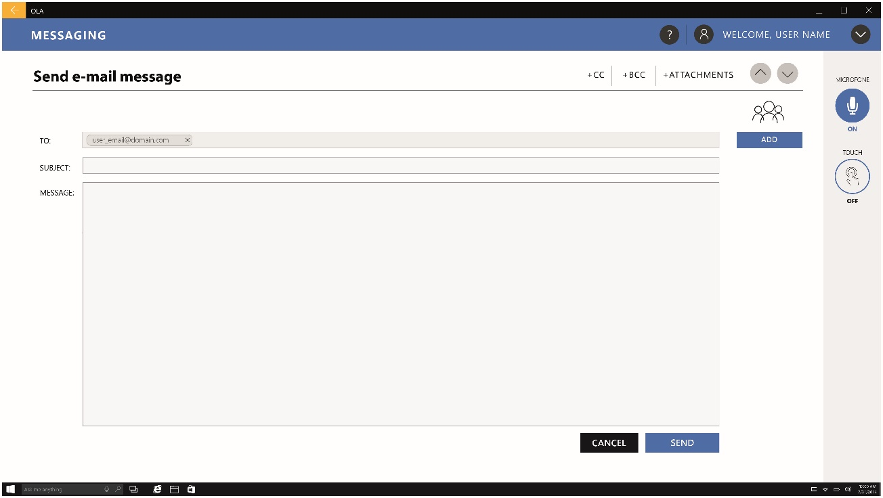

Figure 15 - Mew Message, writing panel

## Agenda

### Monthly View

The Agenda is display by a monthly view (Figure 16) compiling all the events and their associated reminders for the month. Event days are highlighted with a circle in their top-right corner (see Figure 16). When a day is selected its square is highlighted with a dark grey colour (Figure 16) and the reminders for that day are displayed on the right side of the interface.

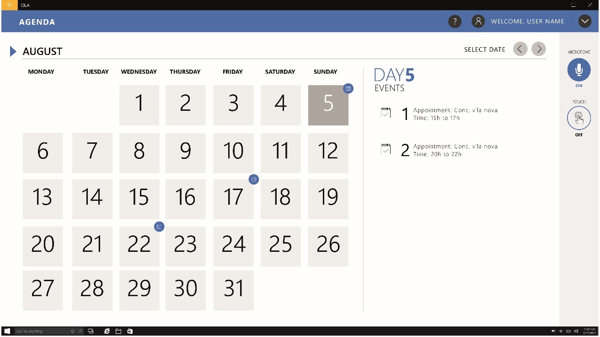

Figure 16 – Calendar Monthly View, with reminder

### Daily View

When a particular day is selected, a panel with a simple list view of the Event(s) of that day is prompted (Figure 17). In this list the user can add or delete a particular event.

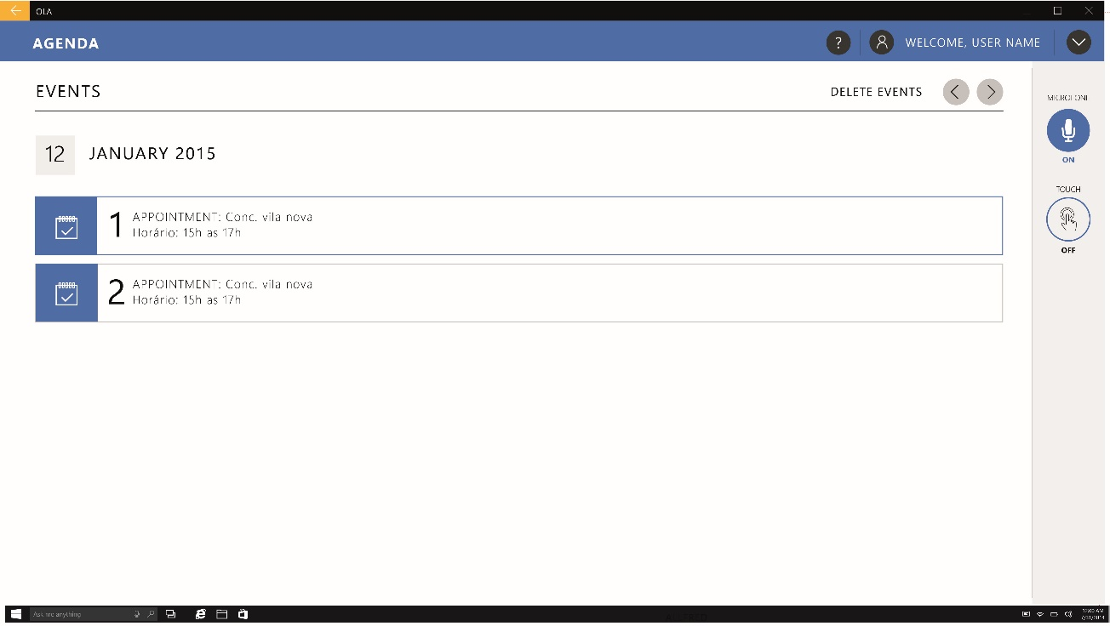

Figure 17 - Calendar Monthly View, With Reminder

### Add Event

When adding events (Figure 18) the app returns to a simple layout with text input boxes for Subject, Start and End time, Location and Description.

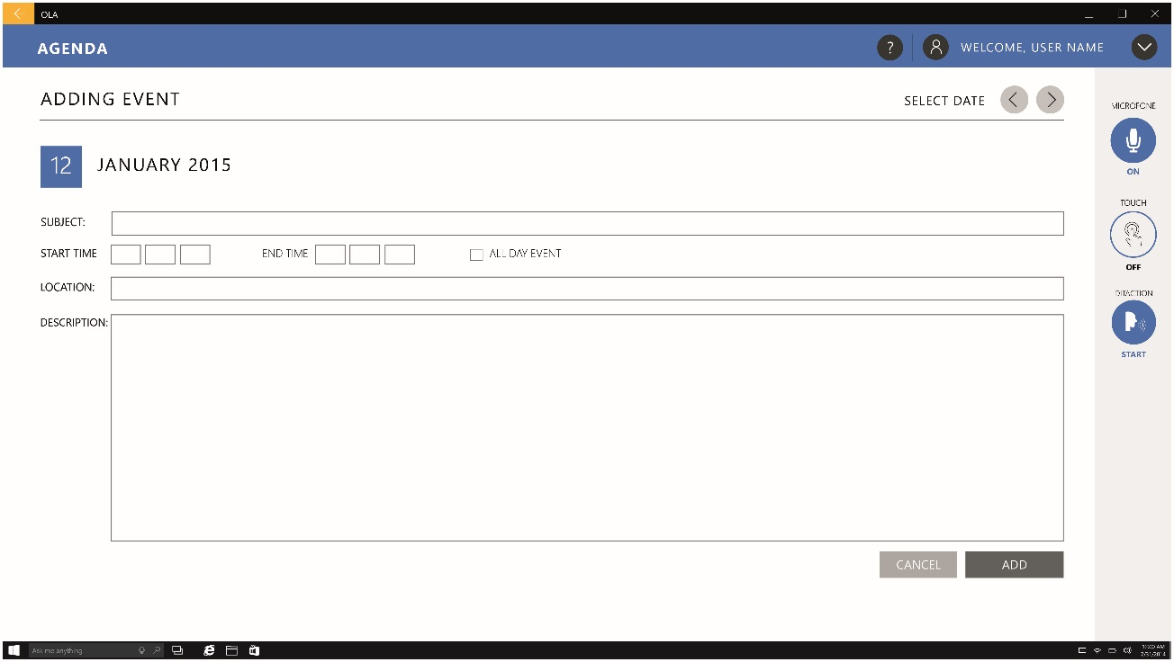

Figure 18 – Add Reminder

When adding time and date a prompt appears to facilitate their selection (Figure 19).

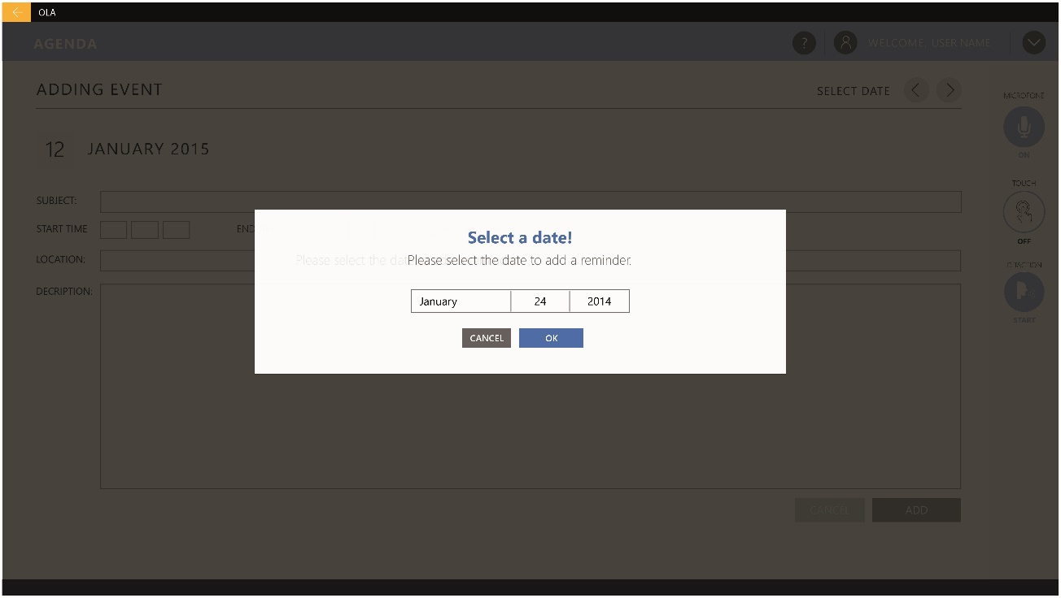

Figure 19 - Add Reminder, Data Selection Prompt

## Contacts

### General Contacts List

The Contact list is a high-density layout, in which the contacts are organized by alphabetic order (Figure 20). The user can filter contacts by groups or messaging - e.g. outlook, Facebook messenger and skype - and social platforms – e.g. twitter and Facebook (Figure 21). On the top bar users can create new groups and add new contacts.

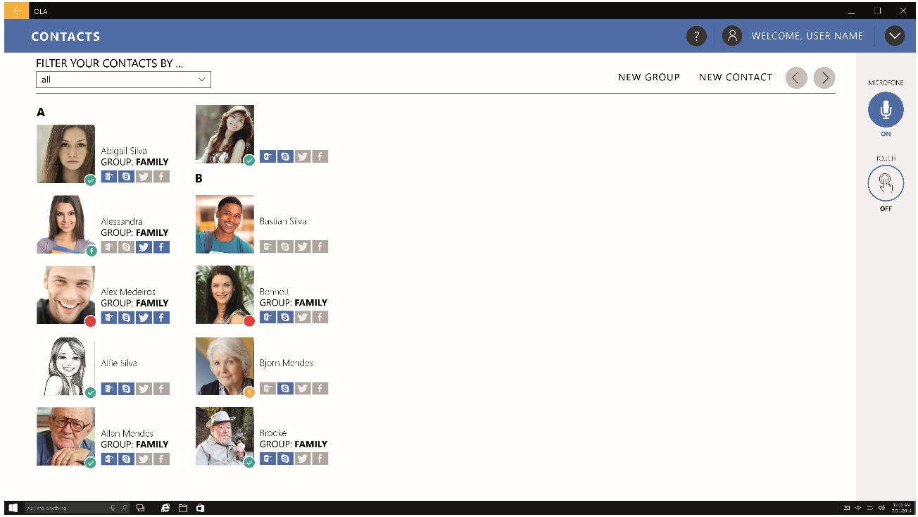

Figure 20 – Contacts, Without Filter

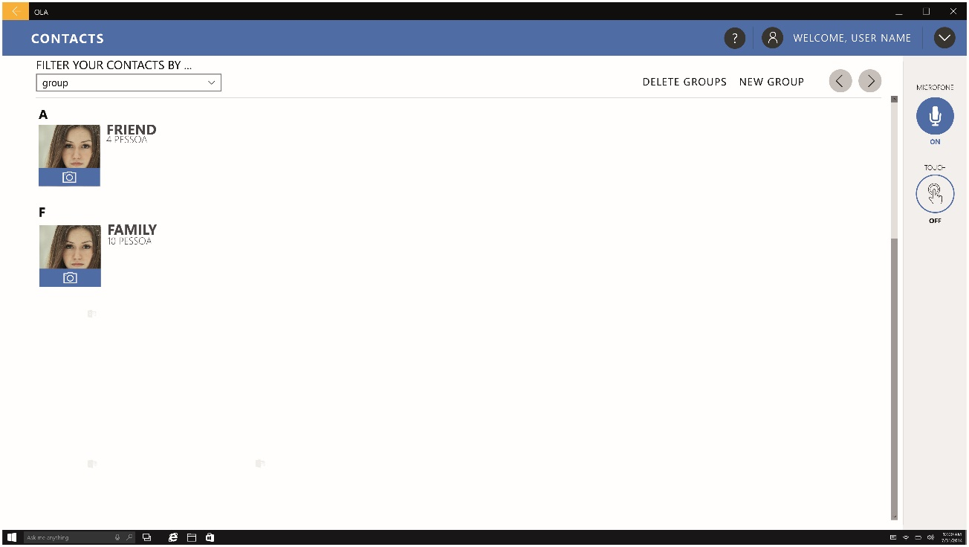

Figure 21 - Contacts, With Group Filter

### Group Contacts List

Users can select a particular group to restrict the contacts results and manage the group, e.g. deleting group (Figure 22).

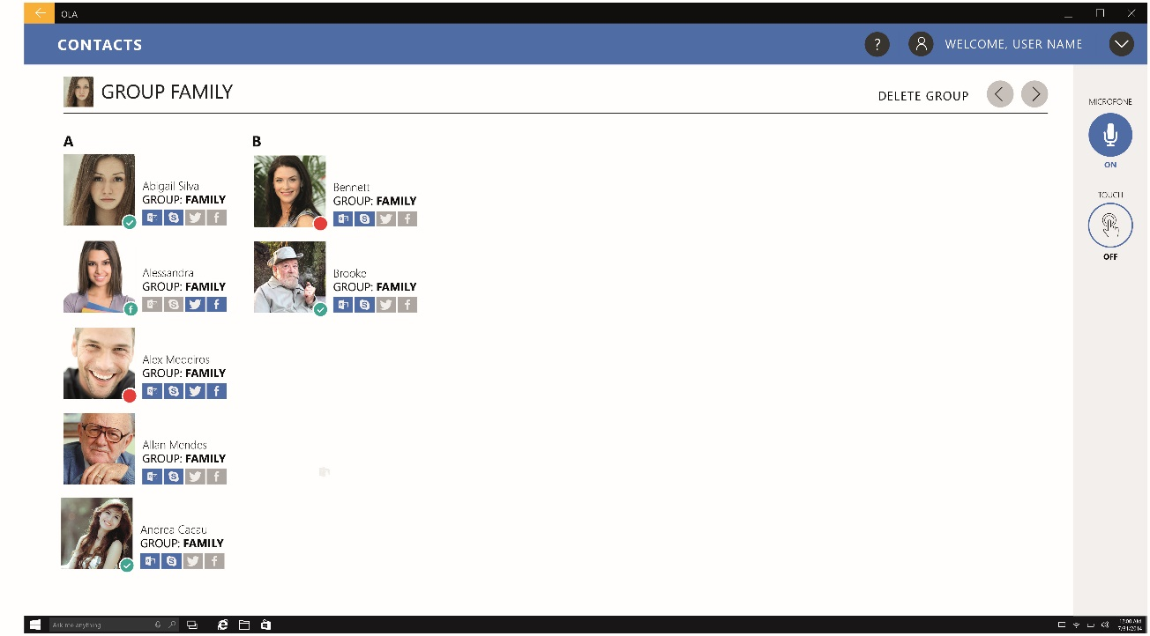

Figure 22 - Contacts Family Group

### Individual Contact

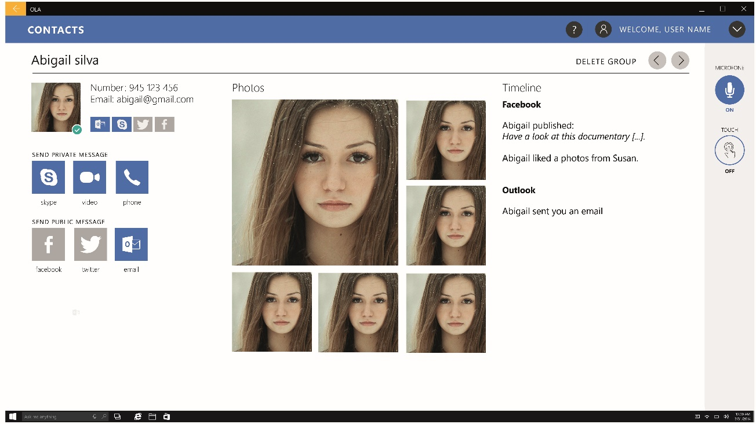

Figure 23 - Individual Contact

Users can select individual contacts and from their individual contact panel private messages can be sent. In this individual contact panel a small compilation of photos collected from various social platforms is displayed as well as a list of the last messages exchanged (Figure 23).

### New Contact

When adding new contacts (Figure 24) the app shows a traditional layout with multiple text input boxes for Name, Phone number, Address, Group, and buttons to associate with various platforms.

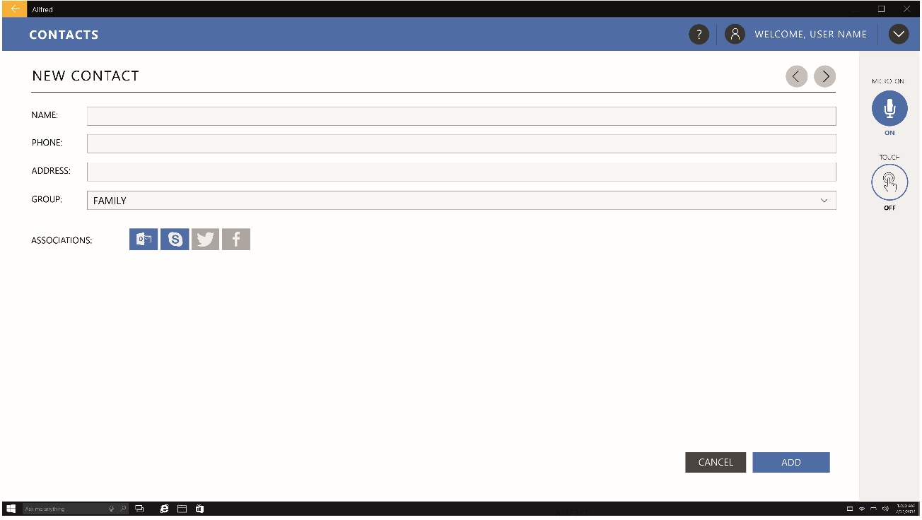

Figure 24 - New Contact

## Surveys

### Surveys Panel

Due to the need to survey the users on subjects like user satisfaction with the application, quality and satisfaction with home care and impact of technology on elderly and caregivers lives, surveys may need to be applied. To allow these actions a new module was designed (Figure 25 & 26). This module will allow formal caregivers and service providers to create and send surveys to target users.

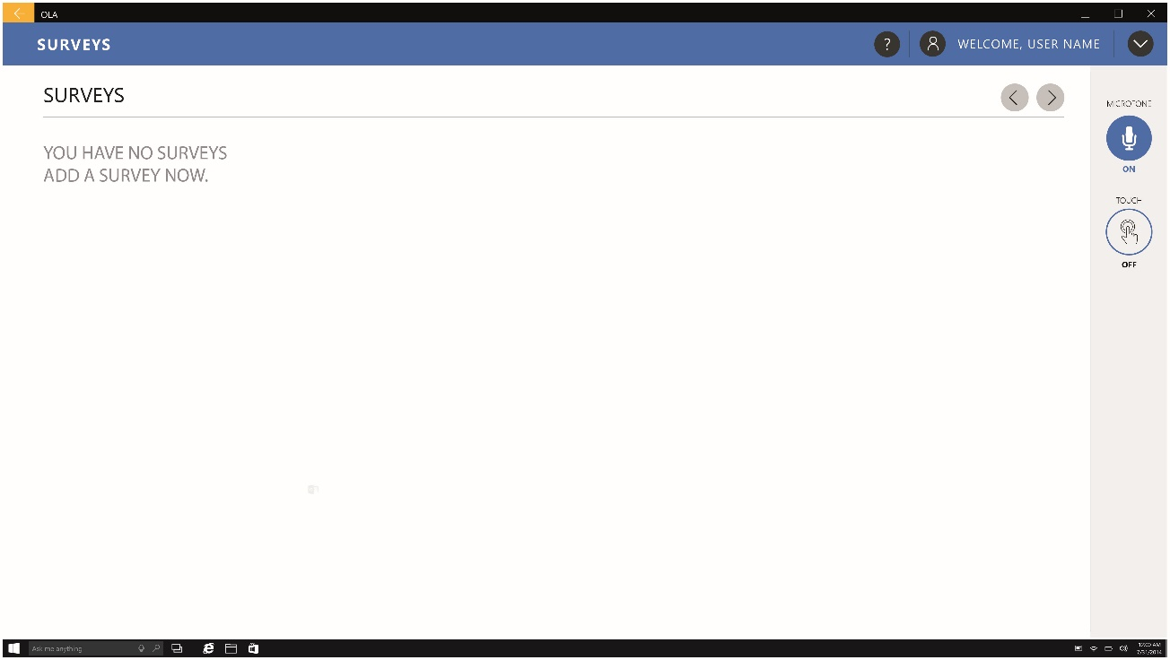

Figure 25 - Survey Panel, Without items

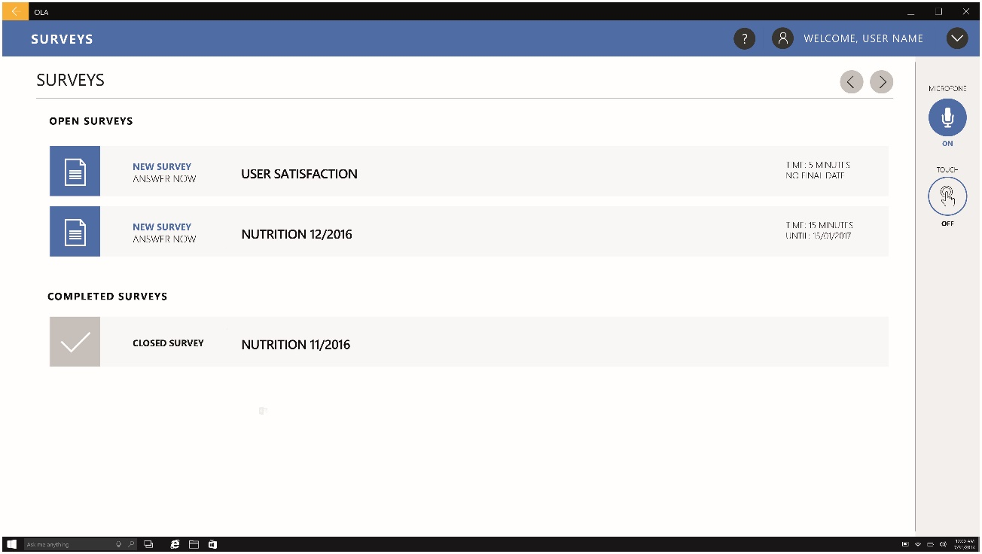

Figure 26 - Survey Panel, With Items

### Surveys Response

In the proposed design the questions of the surveys are divided into individual panels to simplify the interactions with the module (Figure 27 & 28).

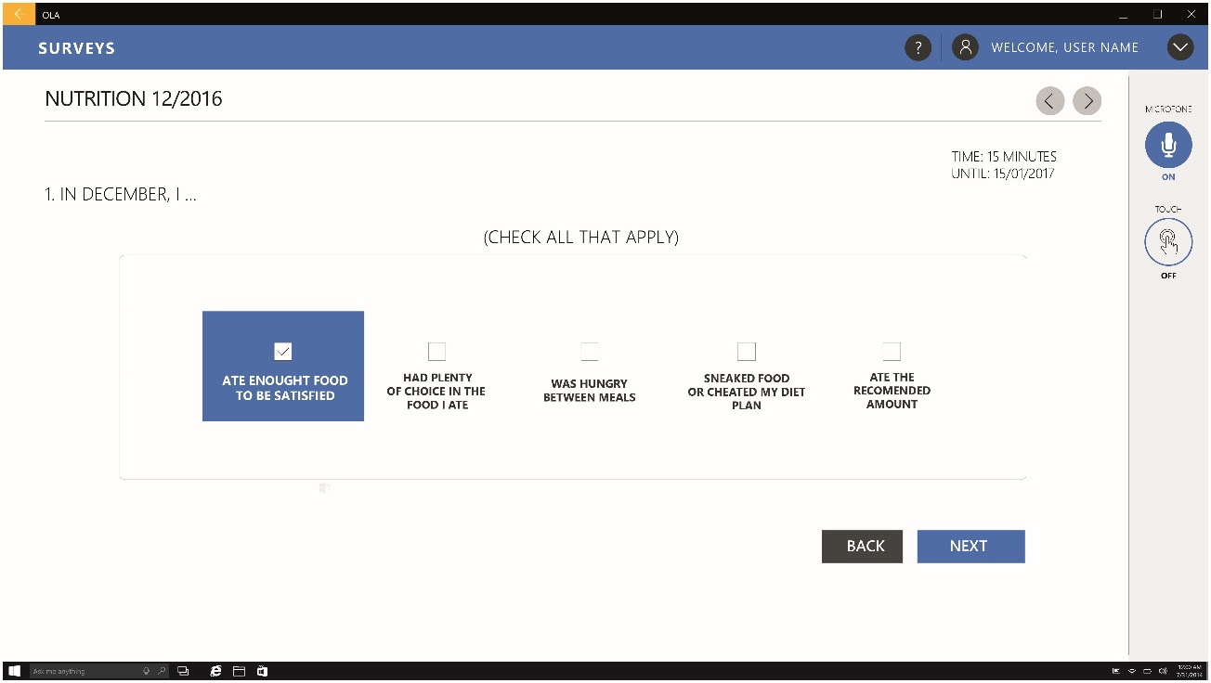

Figure 27 - Survey Response

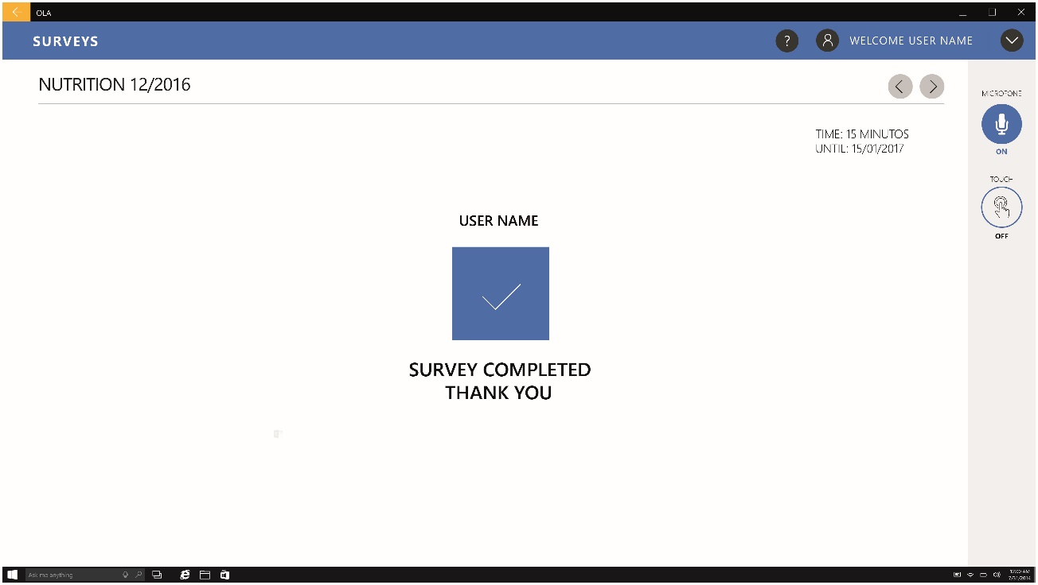

Figure 28 – Survey Completion

## Health Hub

### Sensors Hub Panel

To consult the data from the various sensors associated to the user’s account a sensors hub was designed that displays all the sensors data in a simple list (Figure 29 & 30).

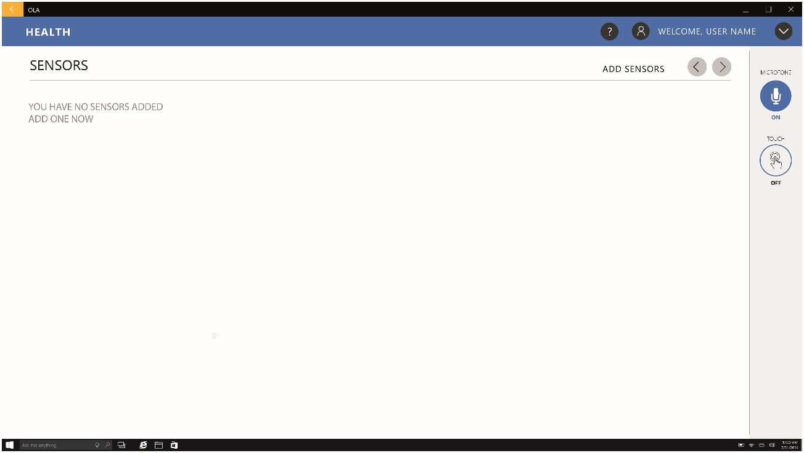

Figure 29 - Sensors Hub, Without items

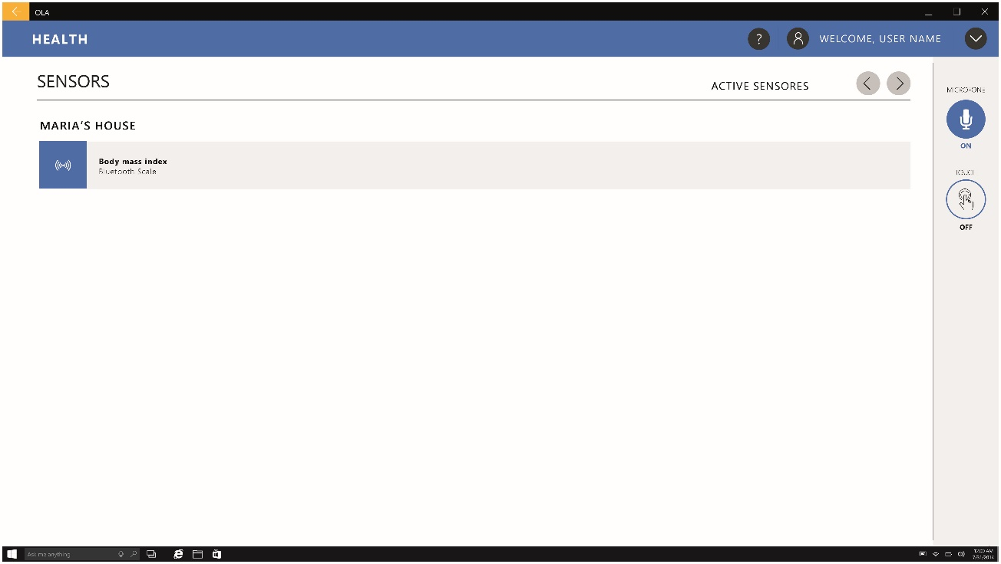

Figure 30 - Sensors Hub, With items

### Adding Sensors

To associate sensors to an account, users have to choose from a list of the locations associated to their account (Figure 31) and then select the desired devices (Figure 32).

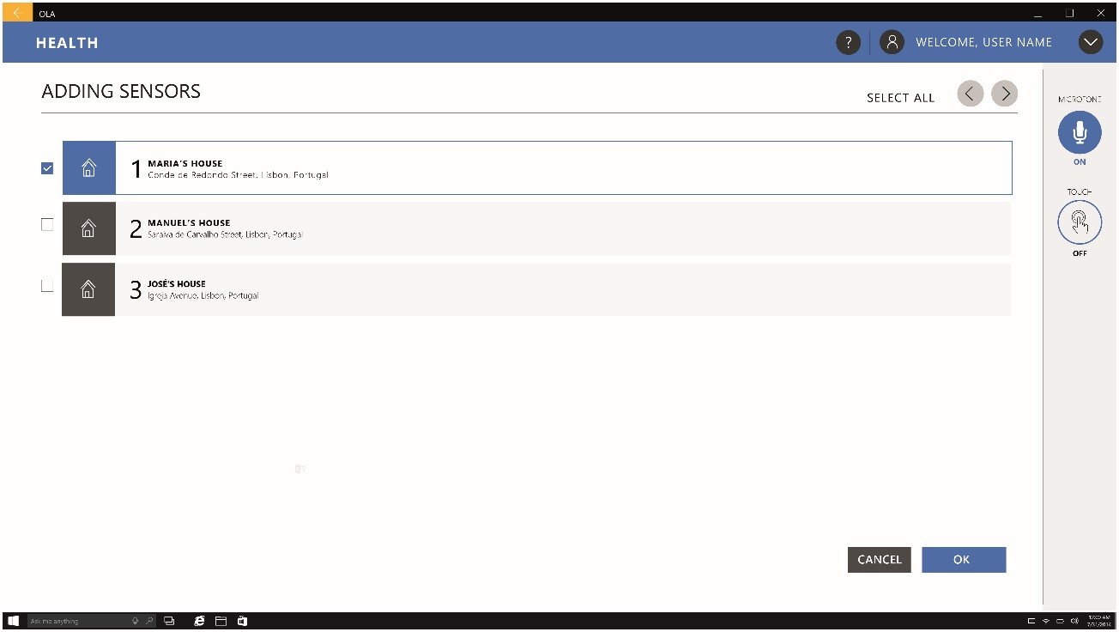

Figure 31 - Adding Sensors, Selection of Sensors Location

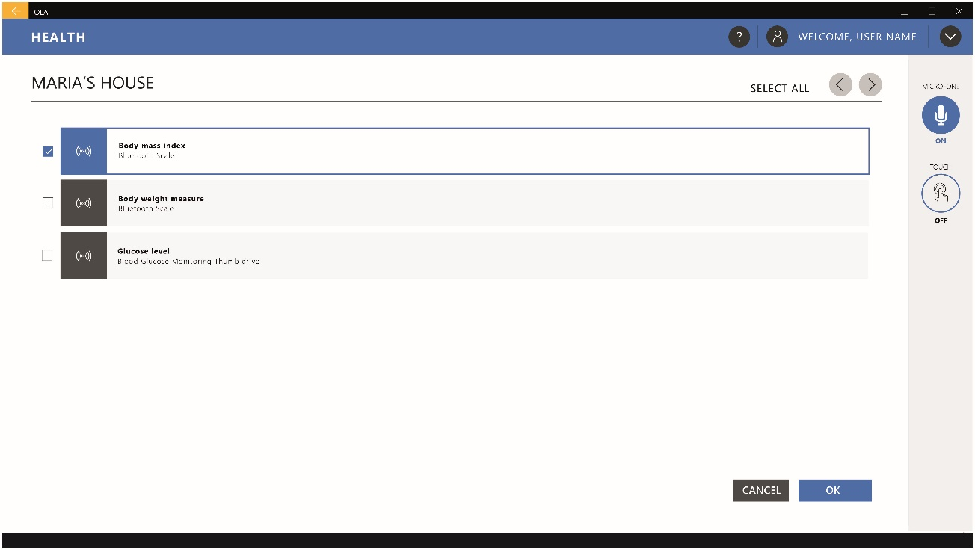

Figure 32 - Adding Sensors, Selection of Sensors to Add

### Heath Data review

Users can check the latest health data collected by the various sensors on the main sensors page (Figure 33) or a graph with the sensor data history on a weekly, monthly or annual view by double clicking on a specific sensor (Figure 34).

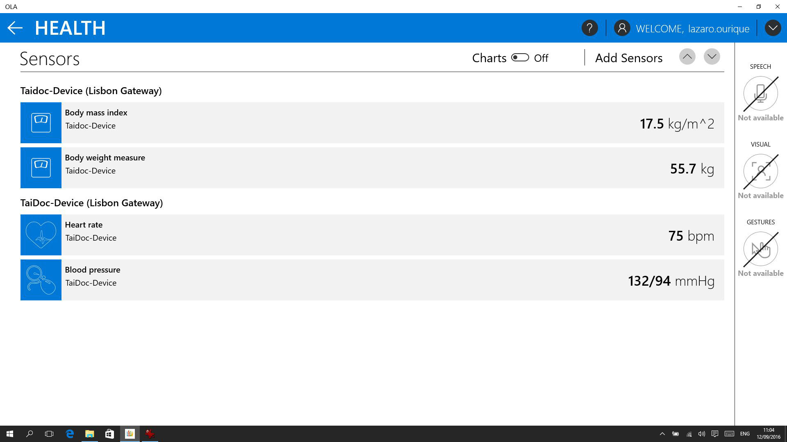

Figure 33 – Health sensor data

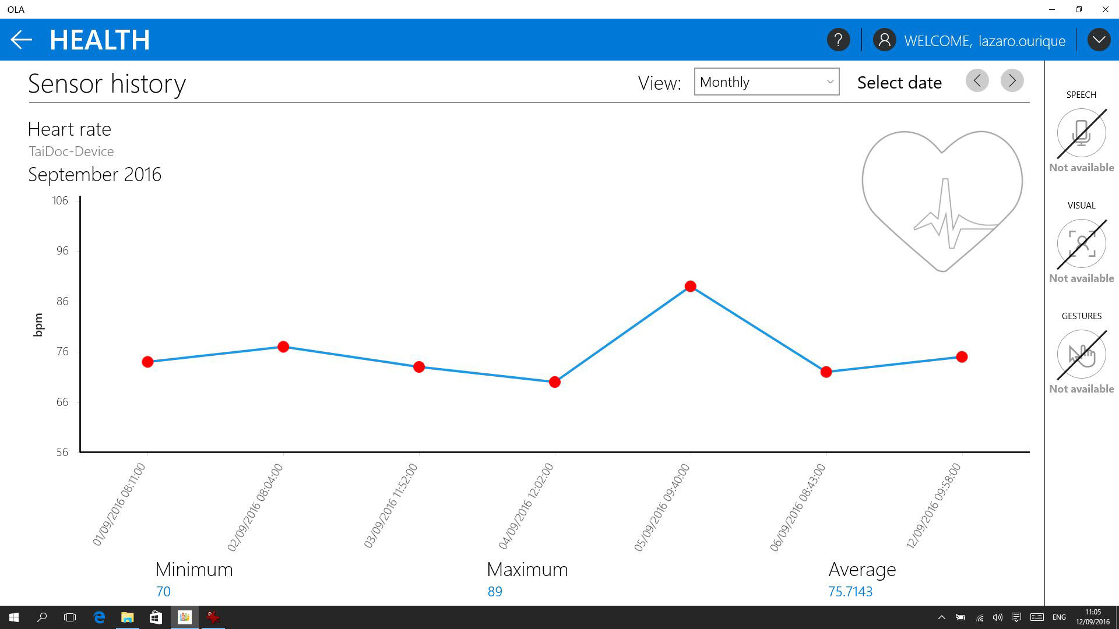

Figure 34 - Health sensor data history

## Settings

To adjust the various application settings a panel was designed considering the following categories: Speech, Location, About, User and Visual.

### Speech

This menu contains two simple bar settings for the voice synthesiser speed and the minimal level of confidence for voice command an d free speech detection (Figure 35). The confidence level is a value, assigned by the recognizer, that represents the likelihood that the output text matches the voice input when compared with other possibilities.

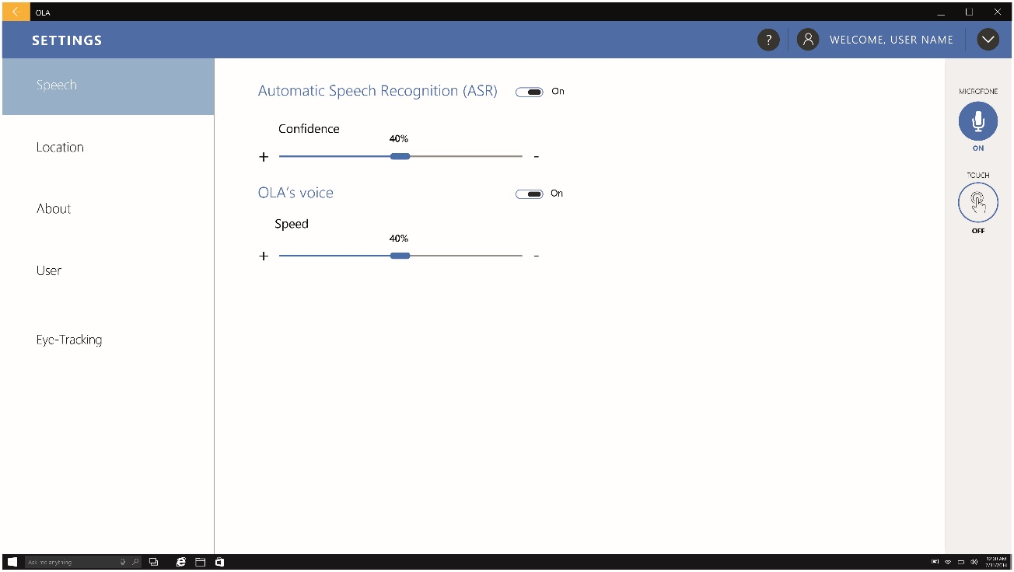

Figure 35 - Speech Settings

### Location

A toggle to accept or reject that the application tracks the users’ location (Figure 36).

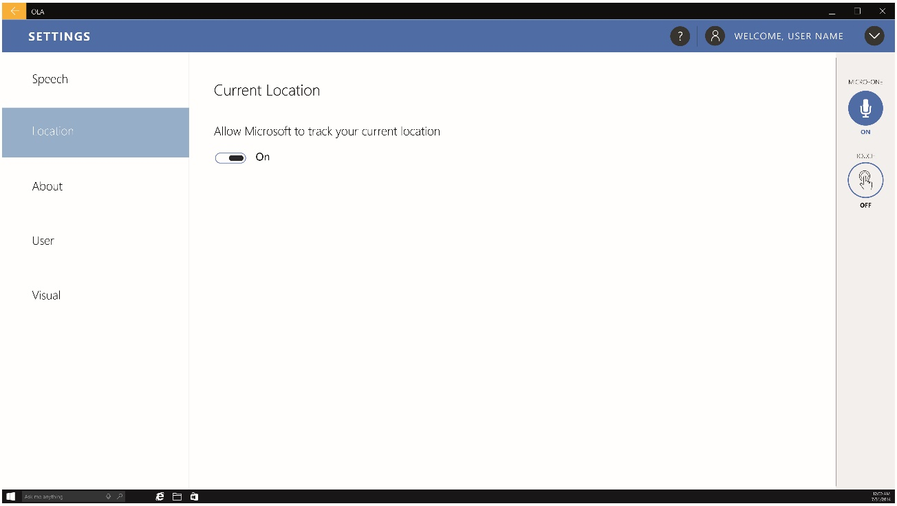

Figure 36 - Location Settings

### About

Allows access to the version of the application, licensing information and other legal information (Figure 37)

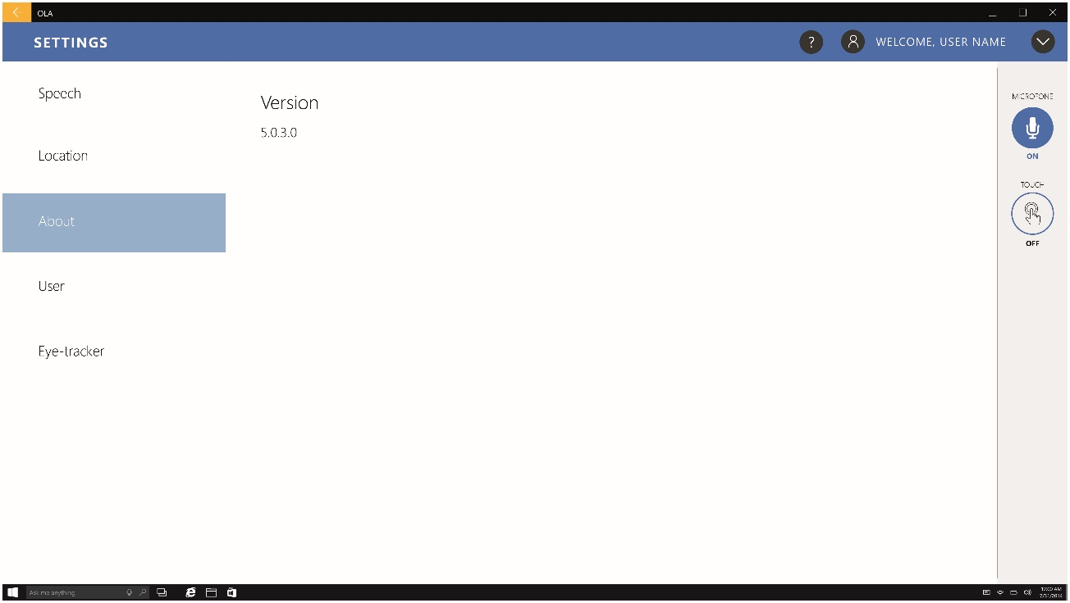

Figure 37 - About the Application

### User

In this menu the administrator can add various user accounts by associating the user e-mail address (Figure 38).

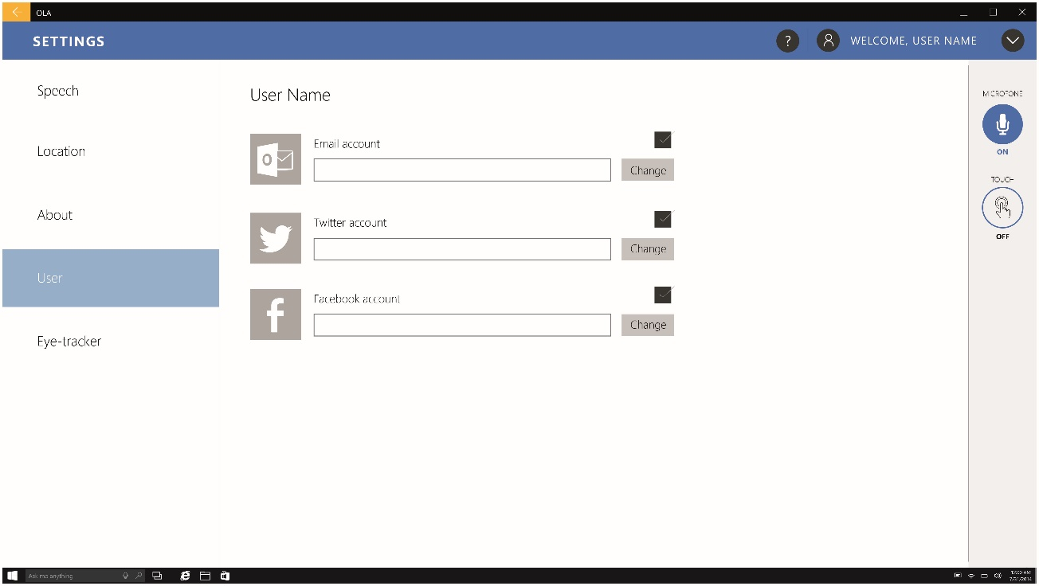

Figure 38 - User Settings

### Visual

Allows to activate or deactivate the navigation with eye-tracking devices (Figure 39).

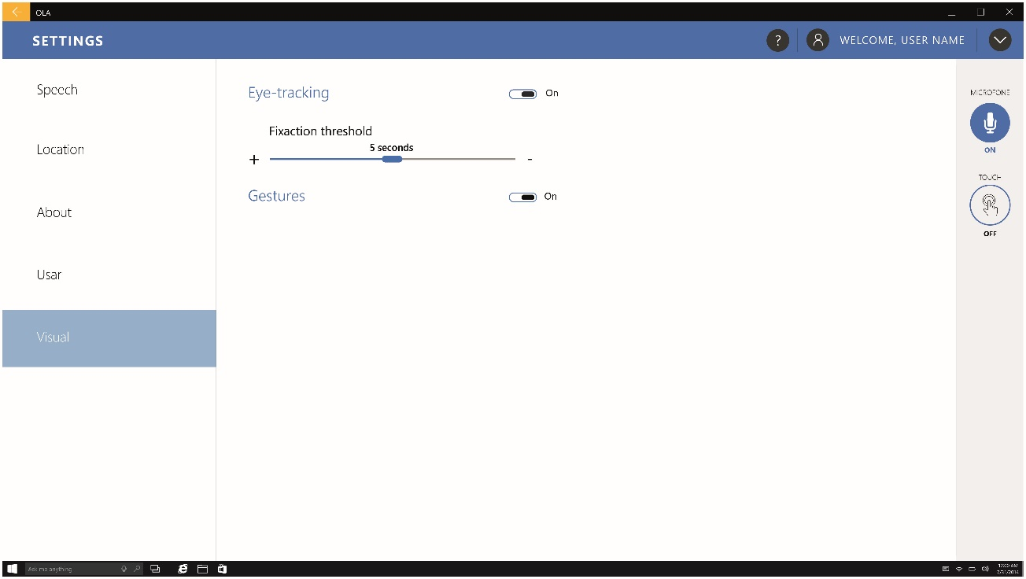

Figure 39 - Visual Settings

# References

Blaschke, C. M., Freddolino, P. P., & Mullen, E. E. (2009). Ageing and Technology: A Review of the Research Literature. *British Journal of Social Work*, *39*(4), 641–656. http://doi.org/10.1093/bjsw/bcp025

Cohen-Mansfield, J., & Biddison, J. (2007). The Scope and Future Trends of Gerontechnology: Consumers’ Opinions and Literature Survey. *Journal of Technology in Human Services*, *25*(3), 1–19. http://doi.org/10.1300/J017v25n03_01

Culén, A. L., & Bratteteig, T. (2013). Touch-Screens and Elderly users: A Perfect Match? In *The sixth Internatiopnal Conference on Advances in Computer-Human Interactions* (pp. 460–465). Nice, France.

Davis, F. D. (1989). Perceived Usefulness, Perceived Ease of Use, and User Acceptance of Information Technology. *MIS Quarterly*, *13*(3), 319. http://doi.org/10.2307/249008

Fischer, S. H., David, D., Crotty, B. H., Dierks, M., & Safran, C. (2014). Acceptance and use of health information technology by community-dwelling elders. *International Journal of Medical Informatics*, *83*(9), 624–635. http://doi.org/10.1016/j.ijmedinf.2014.06.005

Hwangbo, H., Yoon, S. H., Jin, B. S., Han, Y. S., & Ji, Y. G. (2013). A Study of Pointing Performance of Elderly Users on Smartphones. *International Journal of Human-Computer Interaction*, *29*(9), 604–618. http://doi.org/10.1080/10447318.2012.729996

Kijsanayotin, B., Pannarunothai, S., & Speedie, S. M. (2009). Factors influencing health information technology adoption in Thailand’s community health centers: Applying the UTAUT model. *International Journal of Medical Informatics*, *78*(6), 404–416. http://doi.org/10.1016/j.ijmedinf.2008.12.005

Microsoft Corporation. (2016, March). Microsoft Design Language Style Guide. Microsoft Corporation. Retrieved from https://go.microsoft.com/fwlink/p/?LinkId=760679

Microsoft Corporation. (n.d.). Design Universal Windows Platform (UWP) app - Windows app development. Retrieved August 12, 2016, from https://developer.microsoft.com/en-us/windows/design

Motti, L. G., Vigouroux, N., & Gorce, P. (2013). Interaction techniques for older adults using touchscreen devices: a literature review (pp. 125–134). ACM Press. http://doi.org/10.1145/2534903.2534920

Owsley, C., Sekuler, R., & Siemsen, D. (1983). Contrast sensitivity throughout adulthood. *Vision Research*, *23*(7), 689–699. http://doi.org/10.1016/0042-6989(83)90210-9

Peek, S. T. M., Wouters, E. J. M., van Hoof, J., Luijkx, K. G., Boeije, H. R., & Vrijhoef, H. J. M. (2014). Factors influencing acceptance of technology for aging in place: A systematic review. *International Journal of Medical Informatics*, *83*(4), 235–248. http://doi.org/10.1016/j.ijmedinf.2014.01.004

Phiriyapokanon, T. (2011). *Is a big button interface enough for elderly users? - Towards user interface guidelines for elderly users* (Masters). Mälardalen University, Sweden.

Rodrigues, É., Carreira, M., & Gonçalves, D. (2014). Developing a Multimodal Interface for the Elderly. *Procedia Computer Science*, *27*, 359–368. http://doi.org/10.1016/j.procs.2014.02.040

Stone, R. G. (2008). Mobile touch interfaces for the elderly. In *Proceedings of ICT, Society and Human Beings 2008*. Amsterdam: © International Association for Development of the Information Society (IADIS).

Warwas, M., & Dobryszycka, W. (1976). Cathepsins B1 from human fetal membranes. *Biochimica Et Biophysica Acta*, *429*(2), 573–580.