


OLA – Organizational Life Assistant

FOR FUTURE ACTIVE AGEING

D4.3 Dissemination strategy, plan and report






Project Identification
Project Number | AAL 2014-076
Duration | 30 months (1st March 2015 – 31th August 2017)
Coordinator | Carla Santos
Coordinator Organization | Inovamais, S.A. (INOVA+)
Website | http://project-ola.eu/

Document Identification
Deliverable ID | D4.3 Dissemination Strategy and Plan
Version/Date | V1.6 / 27.06.2016
Leader of the Deliverable | INOVA+
Work Status | Work in Progress
Review Status | Reviewed

Deliverable Information
Deliverable Description | The “Dissemination and Strategy and Plan” designs and describes the activities for the dissemination activities of the “Organizational Life Assistant: FOR FUTURE ACTIVE AGEING project”.
Dissemination Level | CO
Deliverable Type | R
Original Due Date | M8

Authorship & Review Information
Editor | Lázaro Ourique (ISCTE-IUL)  Bruno Coelho (INOVA+)
Partners Contributing | Microsoft-MLDC  INOVA+
Reviewed by | Sara Eloy (ISCTE-IUL)  Ricardo Resende (ISCTE-IUL)  Bruno Coelho (INOVA+)

Document History
Issue Date | Version | Change Made / Reason for this Issue
30/06/2015 | V0.1 | Draft Version
10/07/2015 | V1.0 | Frist Version
26/10/2015 | V1.1 | October 2015 Update
25/01/2016 | V1.2 | January 2016 Update
29/04/2016 | V1.3 | April 2016 Update
06/06/2016 | V1.4 | Incremental Update
27/06/2016 | V1.5 | July 2016 Update
20/09/2016 | V1.6 | September 2016 Update

Table of Contents
Executive Summary 6
Document Context 7
Role of the Deliverable 7
Relationship to other Project Deliverables 7
Document Structure 8
Target Audience of the Deliverable 8
Project Description 9
General Description 9
System Description 10
Status and Future Developments 11
Dissemination Plan 12
Audience and Planning 12
External and internal communication 12
Target audience of external communications 12
Action planning and targets 13
Global actions 14
Communication Plan 14
General Communication Materials 14
Web 16
Events, Conferences and Journals 19
Traditional Media 22
Internal Communication Tools 22
Internal mailing list 23
Microsoft OneDrive 23
Microsoft Skype 23
Dissemination Results 24
Evaluation 24
Annexes 25
Disseminations Actions Reports 25

Executive Summary

The current deliverable, entitled D 4.3: “Dissemination Plan” is prepared in the context of work package WP 4.2 “Dissemination” of the OLA (Organizational Life Assistant: for future active ageing project) project. This deliverable describes the objectives of the dissemination strategy from the scientific and commercial point of view, identifies main mechanisms, tools and targets of dissemination as well as some of the dissemination activities that have already occurred or are planned.
Dissemination activities will be undertaken by all partners and include the creation of a web page, newsletters, brochure, social networks presence, participation in international conferences and exhibitions, organization of “open days” at the trials sites and workshops.
This Dissemination Plan with will be updated each 6 months and monitored each 3 months.

Document Context

Role of the Deliverable
The focus of the Dissemination Plan is to identify and define the actions to be performed in order to disseminate the project through the several stakeholders and the community in general including the scientific and commercial point of view. It presents the overall project dissemination strategy, explains the instruments, channels and activities used to facilitate the dissemination of the project and presents the major activities to be performed during the project duration.
Strategies are personalized for each stakeholder and target audience. It is essential to consider the characteristics of each target audience, bearing in mind each group characteristics and adapting the channels and instruments to achieve the defined objectives.
To fulfil these aims, the OLA project will work through various carefully focused work groups and committees through formal and informal mechanisms. Strong channels of communications connecting project partners as well the wider community will play a crucial role in the success of the project.

Deliverable Lead Change
Considering the coordinator change that this project was the subject of (from MSFT to INOVA+), it’s very important to disclose that this deliverable, as well as the underlying task (Task 4.2 Dissemination), is now led by INOVA+. That justifies that some placeholders which are typically single-led have multiple intervenients, as well as the fact that the first dissemination actions were undergone by MSFT. The date for this coordinator change is known, but since dissemination activities were planned in advance, the actual date for the complete takeover of this deliverable can be placed within M17 of the project (July of 2016), which coincides with the periodic report and monitoring of this very report.

Relationship to other Project Deliverables
Deliv. | Relation
D1.2 | This deliverable will provide new content for the video, posters and brochures.
D2.1 | This deliverable will provide new content for the video, posters and brochures.
D4.2 | Dissemination activity.
D4.4 | This deliverable might add new dissemination activities.
D4.5 | This deliverable might add new dissemination activities.

Document Structure
The “D4.3 Dissemination strategy and plan” is organized in six chapters: Executive Summary, Document Context, Project Description, Dissemination Plan, Dissemination Results and Conclusion.
The Executive Summary is a brief and general explanation of the document contents. The current chapter, Document Context, pinpoints the purpose of the document, its relation to other documents of the project and its target audience. The third chapter, Project Description, describes the project. These three chapters constitute the introduction to the document in hand.
In the fourth chapter the Dissemination Plan is presented. It is structured in three main sections: Audience and Planning, Communication Plan and Internal Communication Tools. In Audience and Planning, the general structures of the external and internal communication plan are explored, as well as the target audience and the action plan global objectives. The second section, Communication Plan, further develops on the mediums and tools to be used in the general divulgation of the project. The final section of this chapter, Internal Communications Tool, defines the software and platforms to be used in communication between project partners.
The fifth and final chapter, Dissemination Results, is dedicated to the results and evaluation of each planned action.

Target Audience of the Deliverable
In its first version this document is confidential and is mainly intended for the project partners and funders.

Project Description

General Description
This project aims to offer an answer to the societal challenges by providing an innovative Organizational Life Assistant (OLA), a virtual presence that supports instrumental activities relating to daily living needs of older adults allowing them to be more independent, self-assured and to have a healthier, safer and organized life, while easing caregivers work.
OLA will mediate and facilitate interaction (communication and collaboration) between senior citizens and their informal caregivers or other services or professionals, through technological devices such as standard computers, mobile devices (tablets) and home automation modules. These ICT (Information and Communications Technology) devices will be based on an innovative multimodal model, embracing various physical/healthy and cognitive characteristics of the older adults and will be specifically oriented to increase the level of independence of the elderly, by supporting the possibility of carers' assistance remotely and by improving the accessibility to existing services on the Web, such as on-line shopping services.
Moreover, the OLA will also provide personalized well-being and safety advices to older users in order to avoid unwanted age related health and safety situations in their own home. Such a well-being and safety advisor makes uses of a combination of user information that is collected (personal physical/health and cognitive characteristics) and extracted through emotion recognition and various sensors.
OLA also addresses a major issue that elderly face related to memory degradation and gradual decreasing of their cognitive capabilities, enabling them to remember primary health care and fiscal obligations (e.g. personal hygiene, medical and tax compliance) or helping them to find everyday items such as eyeglasses, wallet or keys. It is based on speech dialogue interfaces and space and object reconstruction and classification to capture and store daily routines and their related contexts.
The primary end-users are the big group of 65+ adults living alone with or without light physical or cognitive age related limitations, who need support from care systems. Secondary end-users are both formal and informal caregivers from public or private sectors, supporting them to cope with the increased demand for care.

System Description
OLA specifically addresses the following main issues:
- Well-being advisor: based on the combination of user information collected (personal, healthy characteristics) and extracted through emotion recognition, sensors and contextual recorder capturing the routines as done by the older adult, the system will propose personal advice adapted to their situation contributing to their preservation and well-being status in home environment. In case of risk (e.g. irregular heart rate, extreme fatigue) the system may ensure an alert to a local medical emergency service.
- Collaborative care organizer: based on the MSFT and LM knowledge of developing human-computer interaction platforms (HCI), OLA will provide online care collaboration between family and professional caregivers, by enabling a local care network to communicate, access sensor data, and coordinate care tasks. With the OLA assistant, seniors will be able to actively participate in the care organization through voice, even when they are unwilling or unable to use traditional applications.
- Safety advisor: based on the combination of collected user environment information through real-time analysis and augmented reality settings, the system will suggest environment changes that increase mobility and decrease accident risk and provide alerts for intruders or other situations that can create hazard situations. In case of risk (e.g. checking intruders or fire), the system may contact local emergency services.
- Every day instrumental daily living activities memory support: the system will anticipate medical and fiscal compliance, remember primary health care and food requirements and can help elderly to find displaced items.
- Environment analysis: algorithms for real-time object recognition and scene understanding based on a number of inputs (i.e. 3D object and space reconstruction by using time-of-flight and augmented reality technology) will be developed in order to analyze and decide which action to be taken in order support the elderly by suggesting environment changes and providing hints/advices for safety and accessible environments.
- Multimodal interaction for elderly: An adaptive organizational life assistant, a virtual presence will be developed in order to facilitating communication and collaboration between older adults and informal caregivers or other services or professionals. This will be a user-friendly system that uses multimodal approaches based on non-invasive and minimally obtrusive technologies (i.e. speech, silent speech, touch, gestures, RGB-D sensors).
The overall OLA system will be an easy to download and install software making use of multimodal integrated settings. OLA is in essence a service that enables the elderly user to reduce the demand of care through prevention and self-management, while at the same time also facilitating the supply of formal and informal care assistance.
A series of well-selected use cases where older adults have been supported by caregivers and care professional services will be developed, as well as pilots representing different use cases. Care units will use the system over a six-month period. A new evaluation approach will be used during the pilots, investigating up to which point the OLA services alleviate caregivers support and maintain, or even improve the self-management, health and safe lifestyle of the older adult at home.

Status and Future Developments
The project is now fully under way, with technical tasks and development efforts being done at the moment and already adding to the dissemination efforts being presented in this very document.

Dissemination Plan

Audience and Planning
The OLA project seeks to provide a virtual presence that supports instrumental activities relating to daily living needs of older adults allowing them to be more independent, self-assured and to have a healthier, safer and organized life, while facilitates caregivers by supporting them on offering high-quality assistance.
This chapter describes how the OLA dissemination strategy will reach and influence its target audiences, i.e., elderly and their formal and informal caregivers on a short and long term basis. In context it informs about the strategic impacts of the dissemination policy, defining the target audience the objects strategies and the tools to be used.

External and internal communication
Communication is a key activity to strengthen a partnership as a whole and to expand its outreach. Our dissemination strategy will be as encompassing as possible, integrating the various types of media available, traditional and new.
We consider OLA’s dissemination plan not only some traditional media actions that will be further described in detail, such as public discussions, publication of articles in specialized media and participation in conferences related to the researched topics (AAL and active ageing) but also a traditional web presence, i.e., website and social media.
On the other hand, it’s vital to promote a robust internal communication between the partners involved in the OLA project, in order to take full advantage of all the potential of the partnership. Internal dialogue and interaction has to be fluid, clear and efficient to promote the effectiveness of this project, based on well-known collaboration infrastructures such as internal mailing list, Microsoft Skype and OneDrive.

Target audience of external communications
Current demographic statistics present a tendency for an increase in urbanization and migration, resulting in more elderly people living alone. This demographic trend creates a high-demand not only for care systems but also on society, making current approaches to care and service delivery unsustainable.
In addiction the ever increasing lifespan of the elderly imply that more resources need to be targeted to help them in dealing with Activities of Daily Living (ADL) (which include tasks such as eating, bathing and dressing) or Instrumental ADL restrictions (which include tasks such as shopping, meal preparation, using the telephone and medication management). However, faced with tight budgets, a recent trend in the EU countries has been to re-direct transfers from public provision of elderly care, for example nursing homes, to informal care.
Considering this information, the target audiences for the OLA’s external dissemination project can be defined as:

Stakeholders I:
- Government Institutions: International, national, regional and local government bodies;
- Public Interest Institutions: National and local foundations and institutes as well as non-governmental organizations (NGO);
- AAL developers: Other organization working in the area of Ambient Assisted Living field, such as associations, opinions groups and academia.

Stakeholders II:
- Public and Private Formal Care Providers: care units, health centres, nursing homes and local associations;
- Informal Care Providers: families, independent workers;
- General Public.
The communication to different target audiences must be driven in a cohesive way and has to transmit the message of well-being and the benefits to be achieved. On the other hand, these actions should also create identity and empathy between each stakeholder in order to enhance new partnerships within the project.

Action planning and targets
The planning of actions to be promoted and their schedule along the project lifespan was the following:
 | Y1Q2 | Y1Q3 | Y1Q4 | Y2Q1 | Y2Q2 | Y2Q3 | Y2Q4 | Y3Q1 | Y3Q2 | Y3Q3
General Communication Materials | X | X | X | X | X | X | X | X | X | X
Web | X | X | X | X | X | X | X | X | X | X
Events, Conferences & Journals |  |  | X | X | X | X | X | X | X | X
Traditional Media |  |  |  |  |  |  | X | X | X | X

Global actions
ISCTE-IUL will coordinate dissemination actions in OLA by defining a detailed strategy and plan for dissemination and continuous monitoring of the activities. The main activities to be produced by the consortium aim not only to promote project concepts, approach and results, to academia, industry and general public, but also to create awareness and set the foundation for exploitation.

Communication Plan

General Communication Materials
Materials and tools that will be produced for a general use in the various dissemination actions along the project.

Brand Proposal - Logo Visual Guide Lines
A Brand Proposal for the project will be developed by ISCTE-IUL and MSFT. This process will start with the design of four main proposals for a distinctive logo (Figure 1 - Logo Initial Proposals), these proposals were chosen by the consortium and the winning one was refined.
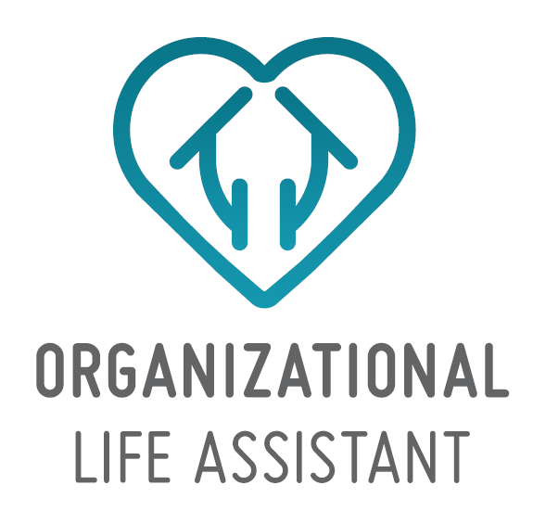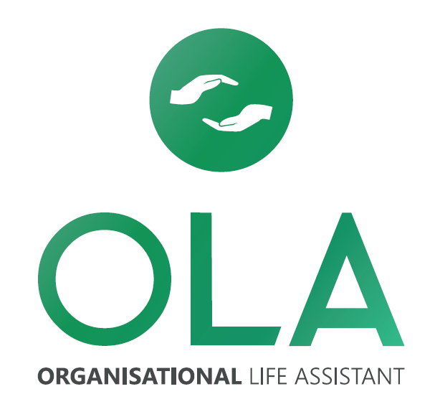
Figure 1 - Logo Initial Proposals
This Logo (Figure 2 - OLA Primary Logo) was and will be included and its Visual Guide Line was and will considered in the design and production of the OLA website, brochures and posters, as well as in all public and private communication material produced by the consortium.
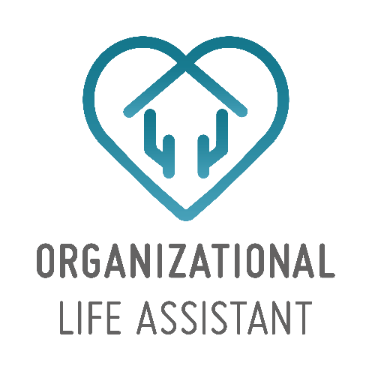
Figure 2 - OLA Primary Logo

Posters and Brochures
A first brochure will be created at the beginning of the project with general information about the OLA project and the activities to be developed. It will provide information about the project as a whole, its objectives and expected results, as well as information about the consortium and its members. This document will be available in electronic format to all consortium partners, to not only better explain the project aims and objectives, but also to ensure the promotion of the project by all the partners when participating in events.
At the beginning of the project a poster will be produced. It will inform on general actions of the OLA project and will be displayed mainly in dissemination events and promotion activities. During the course of the project, a second poster might be designed, depending on future results and knowledge acquired.
It’s advised that an exemplar of the poster also be placed in a visible place of the offices of each partner to disseminate the project activities towards other colleagues of the organizations and external visitors.
If needed, during the deployment phase, publicity material referring to economic and social validation results can be produced and distributed to care organizations, policy makers, user groups, etc. around Europe and to service providers that may be interested in proposing new services.

Video
A concept video of the final product will be produced to not only explain the project aims and objectives, but also allow a new perspective on the project product.
Additionally, at a further stage of the project, a short video covering project implementation and the results of our common activities.
This videos shall be integrated in the site, displayed during promotion activities and released on social media.

General Use Document Templates
Brand Proposal templates for text documents and digital presentations will be defined to create a consistent visual strategy across all mediums of the project.

Web
The web is a very important tool in modern communication and will allow our project dissemination in a long range, reaching people and organizations from countries and regions other than the ones where the partners are located or have a presence.
Our presence in the web will be focused on the project website and on social media.

Website
The OLA website is one of the main sources of public dissemination of the objectives, activities and publications of the project. The website was developed and will be maintained throughout the project lifetime and beyond.
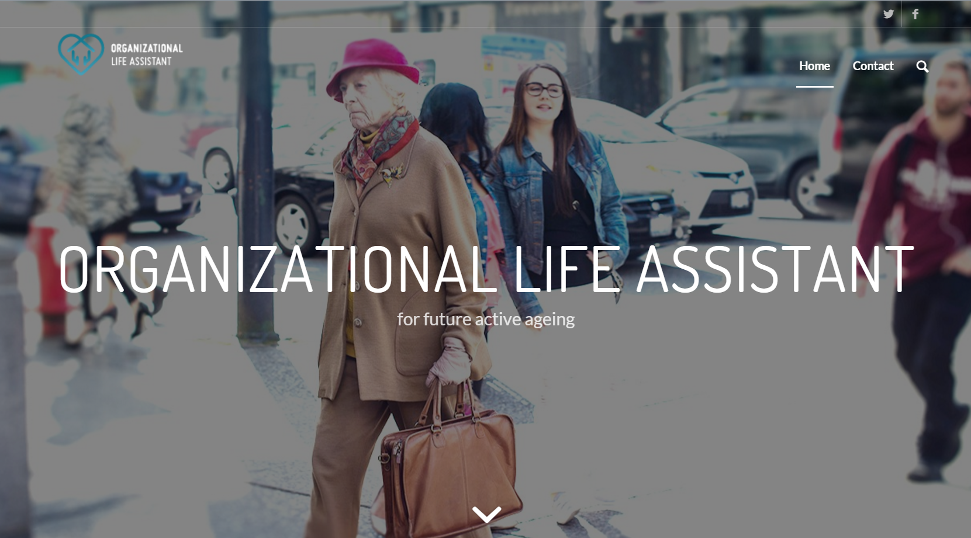
Figure 3 - OLA Web-site, as of 23/10/2015
All the sections of the website shall be updated regularly with material produced by the various project partners, to ensure that users return to the website at regular intervals.
The OLA official website is publicly accessible via the following link: http://ola.istar.iscte-iul.pt/wp/.

Facebook Page
A Facebook page has been created and will remain active along the duration of the project with the main objective of disseminating short news and updates, directing the public to the website for deeper and more complete updates. The page will also be used to share other news relevant to the area of focus of this project.
This social network has a good outreach, which will allow the project to diversify the project’s public awareness. It is an especially effective communication tool for large audiences and will allow us to publicize project updates published on the project website.
The OLA official Facebook page is publicly accessible via the following link: http://www.facebook.com/organizationallifeassistant.
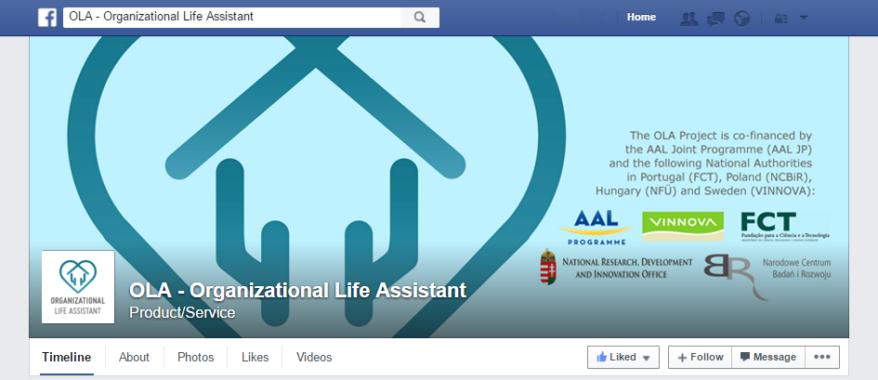
Figure 4 - OLA Facebook Page, as of 23/10/2015

Dissemination through consortium partners web resources
Through the consortium partners existing web resources short news and updates on the project shall be disseminated, in particular the project website and Facebook page will be promoted through partners’ profiles and personal profiles of people who are keen on promoting the project. This will allow to jumpstart the project online dissemination at a first stage of the project and keep a steady growth of the project dissemination online reach.
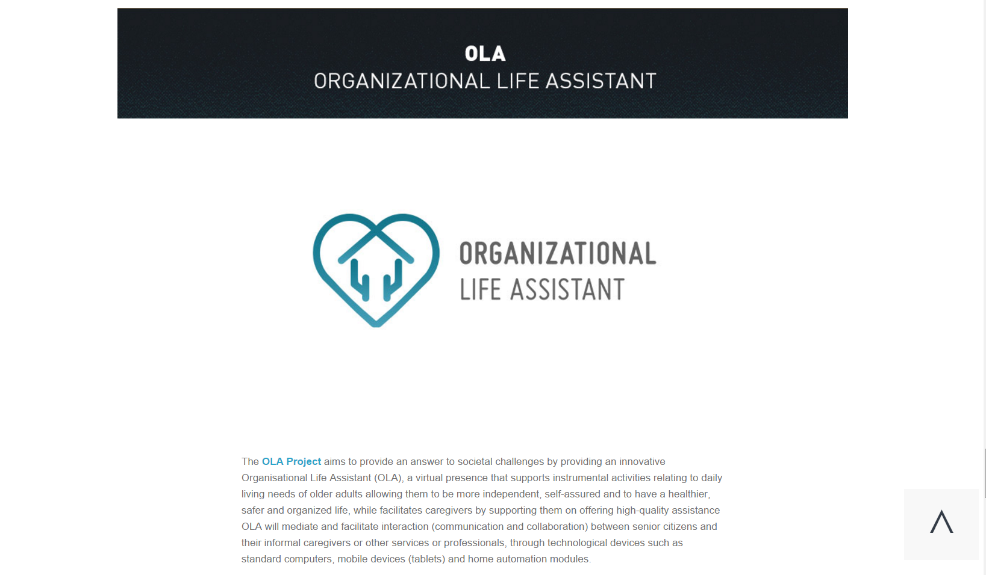
Figure 5 - ISTAR-IUL OLA project page, as of 23/10/2015

Events, Conferences and Journals
In order to present the latest achievements of the OLA project in its area of study to national and international discussion forums, the OLA partners will produce, at a steady pace, articles to be presented in journals and international conferences as well as participate in national and international conferences and exhibitions.
These events constitute a strategic tool that targets the dissemination of information about the project and arouse awareness to the AAL subject, as well as create and strengthen the credibility of consortium.

Scientific Journals
The various partners will propose, individually and collectively, articles of the project achievements to the consortium and work towards the publication in international scientific journals.
This will allow a growth of the project, the consortium and the partners’ recognition on the academic and scientific communities.
The international scientific journals to which the consortium might submit work are:
- J ACOUST SOC AMER - Journal of The Acoustical Society of America,
- IEEE SAP - IEEE Transactions on Speech and Audio Processing,
- Speech Communication, Computer Speech & Language,
- TOCHI - ACM Transactions on Computer-human Interaction,
- UMUAI - User Modeling and User-adapted Interaction,
- IJHCI - International Journal of Human-computer Interaction,
- Journal of Voice
- Journal of Accessibility and Design for All
- Automation and Construction
- Informatika és Menedzsment az Egészségügyben (IME)

International Conferences
To broaden the international dissemination on the academic and scientific communities the OLA partners will prepare presentation of project progress through the organization of an international workshop, in conferences, as well as through the submission and presentation of papers.
Papers with the presentation of project progress will be submitted to conferences such as:
- IEEE PerCom 2016/2017, submission date by September 2015/2016;
- IE - Intelligent Environments 2016/2017, submission date by January 2016/2017;
- IET International Conference on Technologies for Active and Assisted Living
- TechAAL 2016/2017, submission date by September 2016/2017;
- IFIP INTERACT 2016/2017, submission date by January 2016/2017;
- User Modeling, Adaptation and Personalization (UMAP) 2016/2017, submission date by January 2016/2017;
- ICMI - International Conference on Multimodal Interaction 2016/2017, submission date by May 2016/2017;
- Interspeech 2016/2017 (annual conference of the International Speech Communication Association), submission date by March 2016/2017
- ACM CHI 2016/2017 Conference on Human Factors in Computing Systems, submission date by September 2015/2016
- eCAADe 2016/2017, submission date by February 2016/2017
At least eight publications and participation in four conferences are foreseen. Workshops are thought to be organized during international conferences.
Since the beginning of the project the participation on the following conferences have been scheduled and performed.
- SimAUD 2016, London, United Kingdom (16-18 May) - Filipe Gaspar will present the paper "Arch4maps: a mobile augmented reality tool to enrich paper maps." co-author be Steven Gomes, Ricardo Resende, Sara Eloy, Miguel Sales Dias, Mariana Lopes and Nuno Faria.
- 41st IAHS World Congress, Albufeira, Portugal (13-16th September) Ricardo Resende will present the paper "Arch4models: a tool to augment physical scale models" co-authored by Fábio Costa, Sara Eloy, Miguel Sales Dias, Filipe Gaspar, Mariana Lopes, Nuno Faria.

Exhibitions
During the last year of the project, partners should apply to a major exhibition (i.e. IST conference, CeBit). Industrial partners should also attempt to present project achievements in at least two international or national industrial fora or exhibitions. This would showcase the project results and product to potential markets and commercial collaborations.
We expect to exhibit the results of the project at national and international fairs such as:
- Happy Life Lisbon at FIL (October each year);
- Festival IN, International Festival of Innovation and Creativity at FIL (April each year);
- Tektónica, International Building and Construction Fair at FIL (May each year);
- Salus And Ajutec Exhibtion/AJUTEC, International Fair of Technical Aids and New Technologies for Disabled People at EXPONOR, Porto (November each year);
- ENDIEL - Meeting for the Development of the Electrical and Electronics Industries and CONCRETA – Fair for Construction, Rehabilitation, Architecture and Design at EXPONOR (November each year);
- FISTA, Forum of the School of Technologies and Architecture at ISCTE-IUL (March each year);
- HOMEDesign at HungeEXPO Budapest, includes the entire range of topics related to home and home creation (April each year);
- Cooperation Build Expo Fair at EXPO XXI, Warsaw, focused on materials, products and accessories which are used for construction and finishing purposes (May each year);
- Wardae Build - International Building & Interior Exhibition at EXPO XII, Warsaw (September each year);
- Senior exhibition 2016 at Stockholm Stockholmsmässan 20-22 October 2016.

Other events and collaborations
The project partners will publicize project’s results to other R&D project’s consortia in which they participate (i.e. Go-myLife, PaeLife, NITICS, or SIforAGE) by requesting to participate in events that these consortia organize, as well as to the AAL Association (http://www.aal-europe.eu/).
In addition to the already referred actions other interactive collaborations shall be sought out thus giving opportunity to consortium partners for open communication and dialogue with relevant organizations in Europe and beyond.
Through their links with regional and national authorities, professional and end-user associations, project partners will raise national awareness.

Traditional Media
During the last year of the project, partners should produce articles for popular science magazines, newspapers or participate in shows broadcasted in radio or television to increase regional and national awareness to the project and its resulting product.
All partners should produce articles for popular science magazines and newspapers (estimated five articles and participation in two broadcasted shows).
A press release template will be created to help partner communicate with media in a uniformed way. This template will support the development of events and the launch of middle results.

Internal Communication Tools
The OLA project comprises partners in different countries and the development of complex activities which demand the definition of a set of tools to consolidate the know-how of the project deliverables and other suitable information. Additionally, these tools are intended to allow a quick and efficient communication between the partners, allowing and promoting collaborative work.

Internal mailing list
An internal mailing list will be created with all consortium collaborators, this list is the main tool for internal communication regarding organization, shared ideas, project management and support.

Microsoft OneDrive
OneDrive is an online storage and collaboration cloud-based platform, which allows users to easily store structured files, organized in a very similar fashion to a conventional file system. OneDrive has a focus on storage of multimedia content (photos / videos), Word documents, Excel spread sheets, PowerPoint presentations and OneNote notebooks, although it also allows users to upload any kind of files. Users can very easily control access restrictions to the available content.
The platform also enables users to directly edit Word, Excel, PowerPoint and OneNote files using offline tools contained in Microsoft’s Office package, or online through Web Apps made available in OneDrive, through the web browser. The above files, with the exception of the Excel ones, can also be collaboratively edited by multiple users, while keeping track of changes made to these documents.
This service is being used in OLA to store all content related with the project, including, but not limited to, deliverables, meeting minutes and papers produced within the scope of the project, as well as technical and project guidelines for reference purposes. The tool has also been used for collaborative authoring of content by consortium members.

Microsoft Skype
Microsoft Skype presents a unique connectivity experience to its users, by transforming each communication situation into a collaborative, immersive and accessible interaction from virtually anywhere in the world. This tool thus makes communication, and work conducted using it, easier and faster, while available anywhere, and virtually any time, and in the context of other applications. Through the use of a user friendly interface, Microsoft Skype merges audio calls, instant messaging, audio and video conferencing on the web and file sharing into a single, easy to use application.

Dissemination Results
Every 6 months the OLA consortium internally encourages its members to fill a form with planned dissemination information and update the on-going activities. The information provided by each partner is adapted according to its area of activity (Academia vs. Enterprise).

Evaluation
This document is a living document, which means it will be updated on a regular basis and will be improved with new communications, new actions and new feedback along the Project’s lifetime.

Annexes

Disseminations Actions Reports
Dissemination Action | #1 | Consortium Logo Design and Guidelines
Action Leader |  |  | Partners Contributing |  | Status
ISCTE-IUL |  |  | MSFT |  | Closed
Location |  |  | Duration |  | Conclusion Date
Lisbon |  |  | 2 months |  | 10/07/2015
Description
A Brand Proposal for the project was developed by ISCTE-IUL and MSFT. This processed started with the design of four main proposals for a distinctive logo, these proposals were chosen by the consortium and the winning one was refined. The Logo and Logo Guidelines were designed and made available to the partners to guarantee a standard image throughout the project documents and dissemination materials. They will be included and its Visual Guidelines will be considered in the design and production of the OLA website, brochures and posters, as well as in all public and private communication material produced by the consortium.
Connected Actions |  |  |  | Notes
All of the following actions. |  |  |  | One Drive Link - Logo and Corporate Image

Dissemination Action | #2 |  | Website Development and Maintenance
Action Leader |  |  |  | Partners Contributing |  | Status
ISCTE-IUL |  |  |  | MSFT |  | On-Going
Location |  |  |  | Duration |  | Conclusion Date
Lisbon |  |  |  | Total Duration of the Project |  | -
Description
The OLA website is one of the main sources of public dissemination of the objectives, activities and publications of the project. The website was developed and will be maintained throughout the project lifetime and beyond. All the sections of the website shall be updated regularly with material produced by the various project partners, to ensure that users return to the website at regular intervals. The OLA official website was publicly accessible via the following link: http://ola.istar.iscte-iul.pt/wp/; in August 2016, following the completion of the dissemination transition between ISCTE-IUL and INOVA+, it was transferred to the domain http://project-ola.eu/.
Connected Actions |  | Notes |  |  | Coverage
#3 Facebook Page Creation and Maintenance |  |  |  |  | ~200 Views (first address)  *The new address is operating under a new traffic manager, with results due soon

Dissemination Action |  | #3 | Facebook Page Creation and Maintenance
Action Leader |  |  |  | Partners Contributing |  | Status
ISCTE-IUL |  |  |  | MSFT |  | On-Going
Location |  |  |  | Duration |  | Conclusion Date
Lisbon |  |  |  | Total Duration of the Project |  | -
Description
A Facebook page has been created and will remain active throughout the duration of the project with the main objective of disseminating short news and updates, directing the public to the website for deeper and more complete updates. The page will also be used to share other news relevant to the area of focus of this project. The Facebook Page has been updated on average twice a month, but ISCTE-IUL hopes that as the projects gains momentum the frequency of posts increases. The OLA official Facebook page is publicly accessible via the following link: http://www.facebook.com/organizationallifeassistant. INOVA+ was added to the page’s administration following the completion of the dissemination transition from ISCTE-IUL.
Connected Actions | Notes |  |  |  | Coverage
#2 Website Development and Maintenance |  |  |  |  | 73 Likes  707 Post Views

Dissemination Action | #4 | Creation of Project Page on the MLDC Website
Action Leader |  |  | Partners Contributing | Status
MSFT |  |  | - | Closed
Location |  |  | Duration | Conclusion Date
Lisbon |  |  | Total Duration of the Project | 16/10/2015
Description
MLDC has added the OLA project to its institutional website to improve the project dissemination between its team, partners and visitors to the web-site. The project page as a small abstract of the project objectives and links to projects website and the project partners own web-sites. The page will be regularly updated as new information is available.
Connected Actions |  |  | Notes |  | Coverage
 |  |  | https://www.microsoft.com/pt-pt/mldc/ola.aspx |  | ~300 Views

Dissemination Action | #5 | Creation of Project Page on the ISTAR-IUL Website
Action Leader |  |  |  | Partners Contributing |  | Status
ISCTE-IUL |  |  |  | - |  | Closed
Location |  |  |  | Duration |  | Conclusion Date
Lisbon |  |  |  | Total Duration of the Project |  | 16/10/2015
Description
ISCTE-IUL has added the OLA project to its institutional website to improve the project dissemination between its team, partners and visitors to the website. The project page as a small abstract of the project objectives and links to projects web-site and the project partners own web-sites. The page will be regularly updated as new information is available.
Connected Actions |  |  | Notes |  | Coverage
 |  |  | http://istar.iscte-iul.pt/index.php/AAL#ola |  | ~300 Views

Dissemination Action | #6 | Internal presentations of OLA - MSFT
Action Leader |  |  | Partners Contributing | Status
MSFT |  |  |  | Closed
Location |  |  | Duration | Conclusion Date
Lisbon |  |  | ~1 Day | 15/12/2015
Description
Internal presentations of the OLA Project to colleagues from other departments. This action disseminated the project internally and increased awareness about the project subject.
Connected Actions |  |  | Notes | Coverage
 |  |  |  | ~20 people

Dissemination Action | #7 | Advertising of the project’s online presence - Portugal
Action Leader |  |  | Partners Contributing |  | Status
ISCTE-IUL |  |  | MSFT |  | Closed
Location |  |  | Duration |  | Conclusion Date
WEB |  |  | ~1 Week |  | 15/12/2015
Description
Various actions to promote the Projects on-line presence:
- ISCTE-IUL team invited several friends and partners from other projects to like the Facebook OLA page;
- Sharing of the projects publications and news on social media;
- Sharing the project Facebook page and website.
These actions will be performed regularly to achieve a greater efficacy.
Connected Actions |  |  |  | Notes |  | Coverage
#2 Website Development and Maintenance  #3 Facebook Page Creation and Maintenance |  |  |  |  |  | 16 Additional Likes  ~ 100 Reached

Dissemination Action |  | #8 | Promoting OLA on conferences and workshops in Stockholm
Action Leader | Partners Contributing |  |  |  | Status
LM | LM |  |  |  | Closed
Location | Duration |  |  |  | Conclusion Date
Stockholm | ~1 Week |  |  |  | 31/12/2015
Description
Various early actions to promote the project. LM informed about the project while presenting at:
- Workshop on Social Robotics, KTH;
- Information meeting with the Internet psychiatry group at Karolinska Institutet;
- Future project roadmap workshop for the Department of Clinical Neuroscience at Karolinska institutet.
Connected Actions |  | Notes |  | Coverage
 |  | http://www.speech.kth.se/socialrobotics/Social_Robotics_Agenda.pdf |  | ~ 100 people from industry and academia

Dissemination Action | #9 | Architecture Yearbook ISCTE-IUL
Action Leader |  |  | Partners Contributing |  | Status
ISCTE-IUL |  |  | - |  | Closed
Location |  |  | Duration |  | Conclusion Date
- |  |  | - |  | 01/01/2016
Description
In ISCTE-IUL 2014/2015 Architecture Yearbook a page was dedicated to the OLA Project.
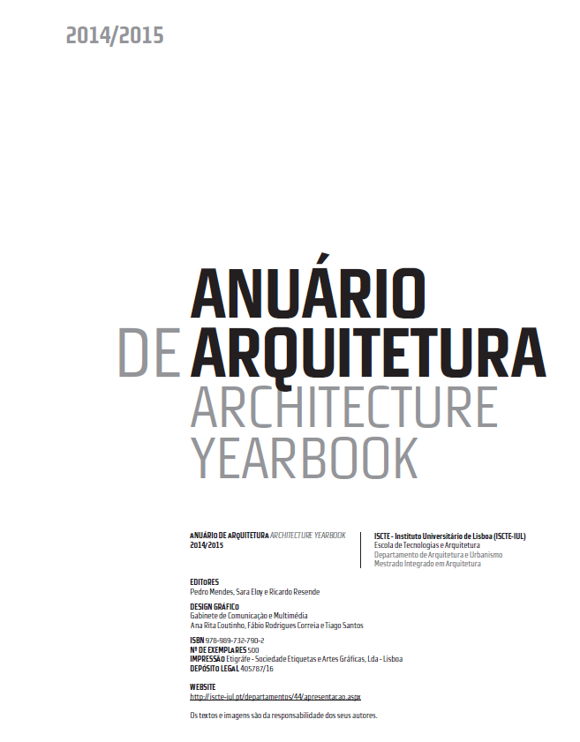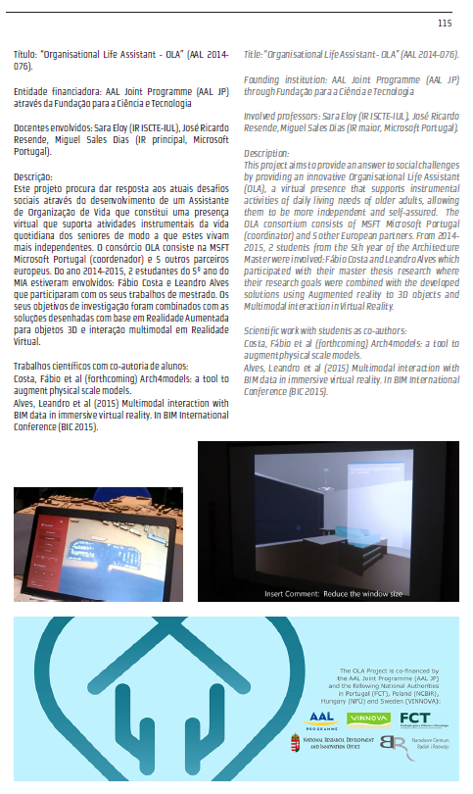
Connected Actions |  |  |  | Notes |  | Coverage
 |  |  |  |  |  | ~500 Prints

Dissemination Action | #10 | Advertising of the project’s online presence - Hungary
Action Leader |  |  | Partners Contributing |  | Status
BZN |  |  | - |  | Closed
Location |  |  | Duration |  | Conclusion Date
WEB |  |  | ~1 Week |  | 20/01/2016
Description
Various actions to promote the project’s online presence:
- BZN team invited several friends and partners from other projects to like the Facebook OLA page;
- Sharing the project Facebook page and website.
These actions will be performed regularly to achieve a greater efficacy.
Connected Actions |  |  |  | Notes |  | Coverage
#2 Website Development and Maintenance  #3 Facebook Page Creation and Maintenance |  |  |  |  |  | 3 Additional Likes  ~ 30 Reached

Dissemination Action | #11 | SimAUD 2016
Action Leader |  | Partners Contributing |  | Status
ISCTE-IUL |  | MSFT |  | Closed
Location |  | Duration |  | Conclusion Date
London, UK |  | ~2 Days |  | 18/03/2016
Description
Filipe Gaspar went to London to present in SimAUD 2016 (16-18 May) the paper "Arch4maps: a mobile augmented reality tool to enrich paper maps.", co-authored by Steven Gomes, Ricardo Resende, Sara Eloy, Miguel Sales Dias, Mariana Lopes and Nuno Faria.
Connected Actions |  |  | Notes |  | Coverage
 |  |  | http://www.simaud.org/2016/ |  | ~100 audience

Dissemination Action | #12 | OLA Project Dissemination at ISCTE-IUL Research Week
Action Leader |  |  | Partners Contributing |  | Status
ISCTE-IUL |  |  | - |  | Closed
Location |  |  | Duration |  | Conclusion Date
Lisbon, PT |  |  | 1 day |  | 01/06/2016
Description
Presentation of the OLA Project by Sara Eloy during ISCTE-IUL Research Week, at ISCTE – University Institute of Lisbon.
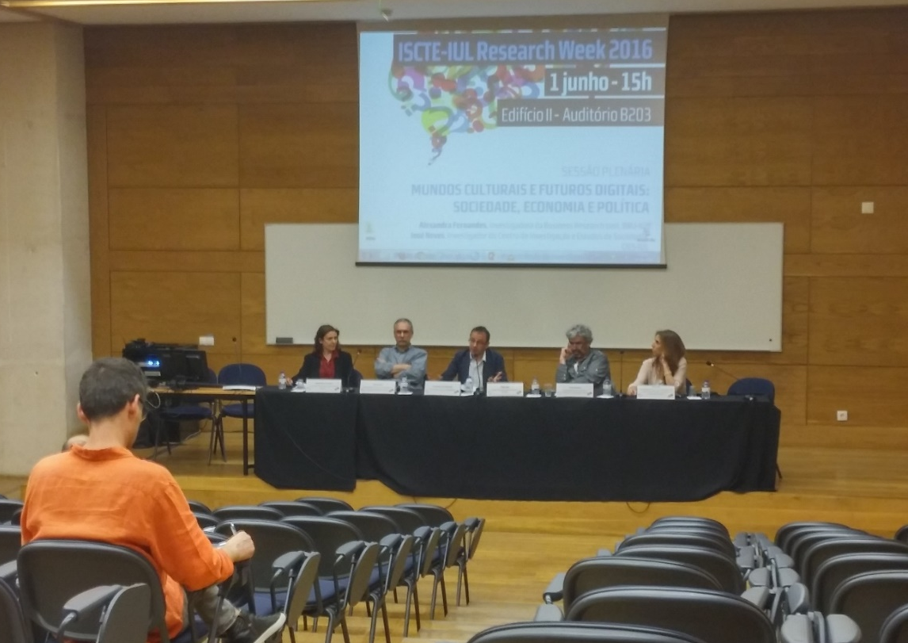
Connected Actions |  |  |  | Notes |  | Coverage
 |  |  |  | http://iscte-iul.pt/Libraries/GCI_-_Documentos_e_Formul%C3%A1rios/ISCTEIUL2016_EN.sflb.ashx |  | ~35 audience

Dissemination Action |  | #13 |  | DCC 2016
Action Leader |  |  | Partners Contributing |  |  | Status
ISCTE-IUL |  |  | MSFT |  |  | Closed
Location |  |  | Duration |  |  | Conclusion Date
Chicago, USA |  |  | ~3 days |  |  | 25/06/2016
Description
Tiago Pedro presented the Environmental Analysis module of OLA project with the communication "Organisational Life Assistant-How gaming logics can raise the Environmental Analysis module acceptance" in DCC 2016 workshop "Games for Design Research and Education", co-authored with Filipe Gaspar and Pedro Caetano.
Connected Actions | Notes |  |  |  | Coverage
 | http://designgamification.github.io/project/2016/05/30/lisboa.html |  |  |  | ~30 audience

Dissemination Action |  | #14 | 41st IAHS World Congress
Action Leader |  | Partners Contributing |  | Status
ISCTE-IUL |  | MSFT |  | Closed
Location |  | Duration |  | Conclusion Date
Albufeira, PT |  | 3 Days |  | 16/09/2016
Description
In the context of the 41st IAHS World Congress (13-16th September, Albufeira, Portugal), the paper "Arch4models: a tool to augment physical scale models" co-authored by Fábio Costa, Sara Eloy, Miguel Sales Dias, Filipe Gaspar, Mariana Lopes, Nuno Faria was accepted into the proceedings (although not presented).
Connected Actions | Notes |  |  |  | Coverage
 | http://www.iahs2016.uc.pt/projectos/iahs2016/index.php?module=sec&id=393&f=1

Dissemination Action |  | #15 | European Researchers Night 2016
Action Leader |  | Partners Contributing |  | Status
INOVA+ |  | INOVA+ |  | Closed
Location |  | Duration |  | Conclusion Date
Porto, PT |  | 1 Day |  | 30/09/2016
Description
In the context of the European Researchers Night 2016, a European-wide simultaneous event, INOVA+ was in charge of one of the venues where the event would happen in Portugal (Porto), for which it seized the opportunity to convey information about OLA to the thousands of people that attended.
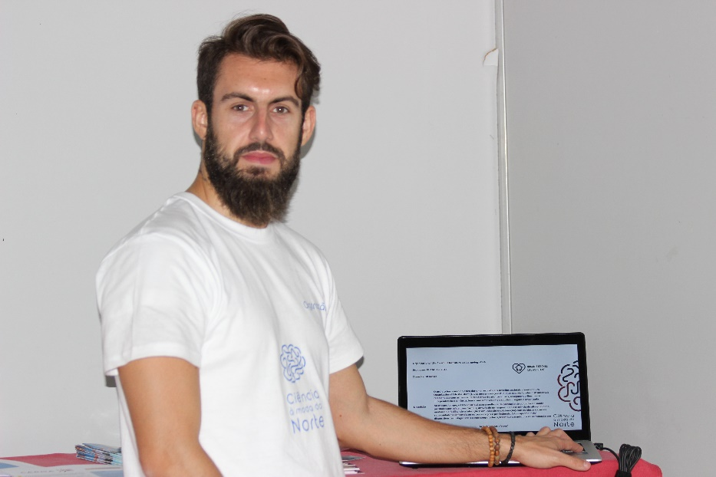
Connected Actions | Notes |  |  |  | Coverage
 | http://noitedosinvestigadores.pt/ |  |  |  | ~5000 audience

Dissemination Action |  | #16 | EXPO SYNC LISBOA 2016
Action Leader |  | Partners Contributing |  | Status
INOVA+ |  | ISCTE-IUL |  | Open
Location |  | Duration |  | Conclusion Date
Lisbon, PT |  | 1 Day |  | 20/10/2016
Description
In the context of the EXPO SYNC LISBOA 2016, ISCTE-IUL will be present to showcase some augmented reality solutions, for which OLA will also be mentioned and put into discussion.
Connected Actions | Notes |  |  |  | Coverage
 | http://exposynclisboa.fil.pt/

Dissemination Action |  | #17 | ECAADe 2017
Action Leader |  | Partners Contributing |  | Status
INOVA+ |  | ISCTE-IUL |  | Open
Location |  | Duration |  | Conclusion Date
Rome, IT |  | 1 Day |  | 2017
Description
In the context of the Education and research in Computer Aided Architectural Design in Europe conference, ISCTE-IUL will submit the paper entitled "Arch4models: a tool to augment physical scale models" co-authored by Fábio Costa, Sara Eloy, Miguel Sales Dias, Filipe Gaspar, Mariana Lopes and Nuno Faria.
Connected Actions | Notes |  |  |  | Coverage
#14 41st IAHS World Congress | http://exposynclisboa.fil.pt/

