Accessibility Test of the SENACA web application Deliverable 3

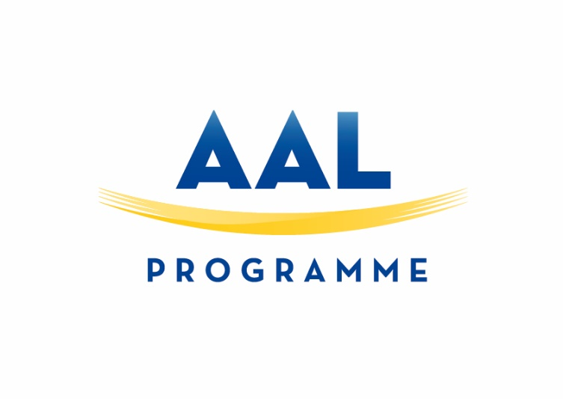

ACTIVE AND ASSISTED LIVING PROGRAMME
Call 2014. Care for the future.

Deliverable identity
Compliance report WAI
Workpackage No. | WP1 | Workpackage Title | Specifications
Deliverable number |  | 1
Deliverable title |  | Compliance report WAI
Workpackage involved |  | WP1 Specifications
Authors: |  | Contribution from all partners
Status (D-draft; F-final): |  | F
File Name: |  | 201702102_D3_WAI_test.docx

Summary
This deliverable contains the results of the Accessibility Test of the SENACA web application

Background
We tested accessibility of the SENACA web application using the tool WAVE (Web Accessibility Evaluation Tool), http://wave.webaim.org/. More specifically, with WAVE Toolbar, which is a plugin for Chrome and Firefox browsers. WAVE is not directly tied to WCAG 2.0 guidelines, but WAVE contains a checklist for an accessible Web pages that are generally accepted best practice.
The WAVE tool group findings as errors, alerts, features, structural elements, HTML5/ARIA elements, and contrast issues. This test report focus mainly on errors. Most of the errors the WAVE tool has identified, are repeated in many of the SENACA web pages. Because of this, we show only a sample of pages. Some errors should not be identified as such, because the complex page delivery process uses Javascript to process the HTML document step by step.
Browser tested: Chrome release 56 (Ubuntu 16.0.4).

User login.
The separate login window was created. All texts and input fields are much bigger and adjusted for screed readers.

Login page.
Errors:
No errors anymore (instead of 3).

Home page after login
After successful login, a summary of the patient’s data is displayed on the home page. In addition, a search icon is displayed.
Errors:
4 errors are reported (instead of 24)
3 x “Empty form label”
1 x “Empty heading”

All errors are hidden. It means that users do not notice them at the moment of the delivery. Depending of the actions of the user on the page, these errors are then solved through Javascript.

PLAN page
Six menu options are available in the menu to the left. As default the menu option “Overview” is chosen, and four navigation tabs are visible: “Plan”, “Target Values”, “Information” and “Calendar”.

Menu option “Overview”

“Plan” tab (default)
Errors:
0 error reported.

“Target Values” tab
Errors:
1 error reported.
1 x “Empty table header”.

“Information” tab
Errors:
0 error reported.

“Calendar” tab
Errors:
1 error reported (instead of 7).
1 x “Empty table header”.

Menu option “Monitoring”
Errors:
0 error reported (instead of 8).

Menu option “Medication”
Four navigation tabs are displayed: “My medication” (default), “Week”, “Day” and “Info”
“My medication” tab
Errors:
2 errors reported.
2 x Empty table header

Menu option “Nutrition”
Errors:
0 error reported

Menu option “Activity”
Errors:
0 error reported

Menu option “Health literacy”
Errors:
2 errors reported.
2 x Missing alternating text

Other pages
The other main pages that the user can choose from the top menu, Statistics, Knowledge, Profile, Journal, basically contains the same accessibility errors as the ones listed earlier:
- Empty link
- Missing form labels
- Empty table header

Outline

Many errors showed in the WAVE tool are usually result of the limitation, how the tool works. The whole HTML document is scanned and hidden fields are wrongly identified which are adjusted later per Javascript. Nevertheless SENACA platform aims to be accessible for all people even with disabilities.

