BANK4ELDER
Deliverable D2.3

Report with banking services

Author(s): | Jaime González Martín, VSF; Diego Bas Insaugarat, VSF; Beatriz López Mencía, VSF; Ilaria Pellini, DIGINTEL;
Deliverable Nature: | Report (R)
Dissemination Level:  (Confidentiality) | Public (PU)
Delivery Date: | February 2012
Version: | 1.0
Keywords: | Banking services, Web, ATM, TV, Mobile

 |  |  |  | 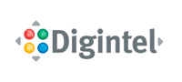 | 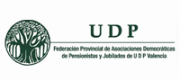 | 
Disclaimer
This document contains material, which is the copyright of certain BANK4ELDER consortium parties, and may not be reproduced or copied without permission.
In case of Public (PU):
All BANK4ELDER consortium parties have agreed to full publication of this document.
In case of Restricted to Programme (PP):
All BANK4ELDER consortium parties have agreed to make this document available on request to other framework programme participants.
In case of Restricted to Group (RE):
The information contained in this document is the proprietary confidential information of the BANK4ELDER consortium and may not be disclosed except in accordance with the consortium agreement. However, all BANK4ELDER consortium parties have agreed to make this document available to <group> / <purpose>.
In case of Consortium confidential (CO):
The information contained in this document is the proprietary confidential information of the BANK4ELDER consortium and may not be disclosed except in accordance with the consortium agreement.

The commercial use of any information contained in this document may require a license from the proprietor of that information.
Neither the BANK4ELDER consortium as a whole, nor a certain party of the BANK4ELDER consortium warrant that the information contained in this document is capable of use, or that use of the information is free from risk, and accept no liability for loss or damage suffered by any person using this information.

Full Project Title: | BANK4ELDER – Innovative ways of banking designed for and by the elderly
Short Project Title: | BANK4ELDER
Number and  Title of Work package: | WP2  Definition of user requirements and design specifications
Document Title: | D2.3 – Report with banking services
Work package Leader (Name, affiliation) | IBV

Copyright notice
© 2011-2014 Participants in project BANK4ELDER

Table of Contents
Table of Contents 3
Executive Summary 4
1 Introduction 5
2 Banking services overview 6
2.1 Web Banking Services 6
2.1.1 Study cases 6
2.1.2 Conclusions 11
2.2 ATM Banking Services 11
2.2.1 Study cases 11
2.2.2 Conclusions 14
2.3 TV Banking Services 14
2.3.1 Study cases 14
2.3.2 Conclusions 19
2.4 Mobile Banking Services 20
2.4.1 Study cases 20
2.4.2 Conclusions 24
3 Identification of the main banking services 25
4 Conclusions 27
References 28

Executive Summary
In this report we summarize the main banking services delivered over four platforms (TV, Web, Mobile and ATM), and we recommend three specific banking services to be considered in the final Bank4Elder banking services requirements definition.
To begin with, we have analysed which banking services are most commonly delivered in each platform. In order to do that, we present here a state of the art considering a number of selected banking companies and the services provided by each of them. Then, we obtain conclusions about the banking services in each platform that these companies have in common.
Secondly we summarize in a Table the information obtained from the previous analyses. From this summary we extract the banking services that can be offered through the four platforms.
Finally, according to these results, we recommend three main services which could be considered in a first approach of the banking services definition for the Bank4Elder project. The selected services are “Account services”, “Transfers” and “Payments”. In addition, we have identified a number of banking services which, although they cannot be delivered over the four platforms (ie. Withdrawals) they are also important to be considered in the definition of the system requirements for each specific platform.
- Introduction
Nowadays, due to the development of new technologies and new ways of interaction, banking services has evolved to new banking modes which aim to make easier the daily banking activities to the users. Thus, apart from going to the branch, users can access banking services using another channels such as mobile phones, ATMs (Automated teller machines), TV, Web, etc..
The objective of the Bank4Elder project is to develop new interfaces for the different ways or modes of banking: online, ATM, mobile and TV, suitable for being used for elderly people. These interfaces would satisfy functional, accessibility, usability and aesthetic needs of each profile of older users previously detected. The idea is to develop smart interfaces able to be customized and adapted to each user, offering elderly users a comfortable and safe interaction. The first step of this project would be to define the banking services that are going to be implemented in these interfaces.
The objective of this deliverable is to provide the identification of the main banking services (consultation, transaction etc.). In order to do this, in this report we identify the main banking services which are being delivered over the four main platforms of the Bank4Elder project (TV, Mobile, Web and ATM). First of all we analyse several banking companies and we identify the banking services that they deliver over each platform. Secondly we provide a summary of the main services delivered jointly over the previously mentioned platforms. Finally we recommend a specific set of main banking services to be considered in the first approach of the system requirements. In addition, we have identified a number of additional banking services that we have considered important to be included in the system requirements from both a platform and user point of view. All in all, we aim to contribute to the identification of the main banking services which are planning to be delivered in the Bank4Elder interfaces.
This report has been structured as follows. In section 2 we present an overview of the banking services offered through the four previous mentioned platforms. We have selected a number of popular companies from the Banking sector and we have analysed the main banking services offered by them. Then we extract conclusions from the services that they have in common, and we perform this analysis through the four main platforms of Bank4Elder project: TV Mobile, Web and ATM. In section 3 we present a summary of the main banking services used among the different platforms and we make recommendations according to the most popular banking services that should be considered in the final system requirements definition. To conclude, in section 4 we present the main conclusions from this analysis.
- Banking services overview
In this section we will analyse the state of the art of the main Banking services regarding to the four main platforms in the Bank4Elder project. In order to gain knowledge about the general banking services offered in each application area, we describe how banking services are being used among different countries and devices.

  - Web Banking Services
Nowadays, web banking services have become a strategic line in the Banking Sector. Online banking has grown exponentially in recent years. This type of banking comprises the provision of information or services by a bank to its customers over the Internet [1]. Looking at the behaviour of online banking in U.S.A., we can see a survey conducted by Pew Internet and America Life in which they state that online banking has been the fastest growing internet activity in the U.S.A. over the last five years. Considering the European side, the number of online accounts in Germany increased almost tenfold between 1999 and 2004, with 40% of all accounts now being online [2]. In addition, a more recent study from Eurostat regarding to the use of internet and computer, points out that Communication and Information retrieval are the most common internet activities, followed by travel and accommodation services and online banking. On the other hand, we can extract from the same source of information (Eurostat) that 18% of the internet users between 55 and 74 years old use online banking, as opposed to 47% of the internet users between 25 and 34 years old. Therefore with the number of online banking consumers steadily increasing, the focus of attention shifts to adapt the online banking services to the ageing population. Thus, in this section we will be focused on the identification of the main online banking services, in order to choose the most appropriated for the target end users of this project during the next phase.
    - Study cases
To begin with, we analyse a number of web pages in the Banking sector (some of them such as Citibank or Standard Chartered has been awarded with the prize of the Best Overall Internet Bank and the best Consumer Internet Bank by Global Finance respectively), and we identify the online banking services that they offer.
      - Bank of America
The main online services offered by the Bank of America for consumers and businesses are
- Transferring: Transferring money between accounts
- View current balance information for their linked Bank of America accounts
- Review available transactions for their linked accounts
- Account Management: re-ordering checks, ordering copies of paid checks, requesting copies of monthly checking or saving statements, stopping payment on checks, changing address, phone, online ID and passcode.
- Contact with the Bank. They allow users to send them secure online mail messages and questions regarding the user online banking service.
In addition, Bank of America offers to their online customers a set of more specific services which are configurable for each user: Bill Payments Services, Quick Payment Expedited Payment Services, Online banking alerts, Additional Services Intended for Businesses, Email/Mobile transfer network service (this service has not all functionalities available for all customers), Financial Management Services and ShopSafe (this is a service which allow users to create a unique, temporary credit card account number for online purchases at a specified merchant).
      - Citibank
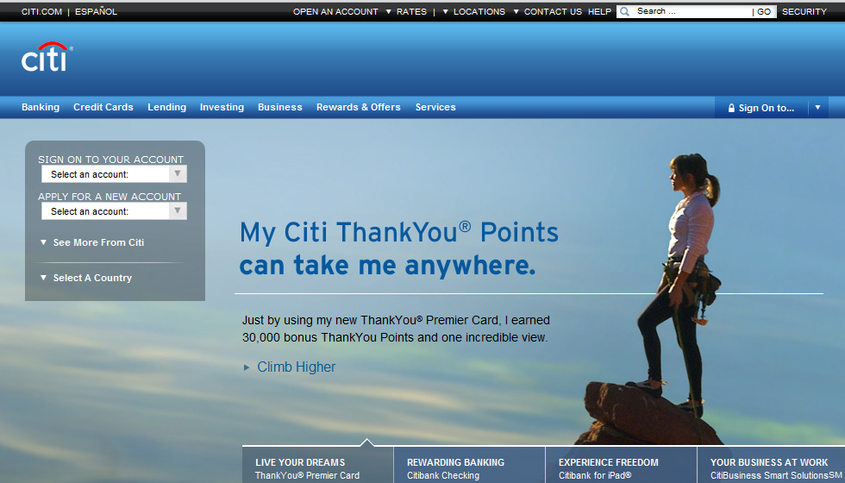

Apart from the online banking, Citibank offers to their customers a Mobile and Tablet banking service, a Text Banking and a Remote Banking Center. Next we focus on their online banking services:
- Free online Bill Payment and receiving the bills electronically
- Online bank statements (receiving a monthly statement online)
- Transfer services
- Online check images (view and print checks customers have written that have cleared)
- 24/7 Customer support
Additionally, Citibank offers other banking services such as Account Alerts, Auto Save service, Online Bill Payments, Inter-Institution Transfers, services focused on increasing the security such as “Protect your Money” and online fraud protection, and a service called “Pay other People” Popmoney (which is a new way to make payments such as sending money to the children at college quickly or a gift of money using the Citibank customers’ existing account).
      - Standard Chartered
Next we are going to describe the Standard Chartered online banking options that this bank offers to their customers, although they also offer services of Corporate Online Banking -they have an Straight2Bank service which allows users to connect to the bank using three types of channels (internet, a dedicated connection and a service integrated with the user’s backend system) to establish a secure connection with the bank services- and Mobile Banking. The main services which are offered with the Personal Online Banking are the following:
- Account services. Users are allowed to view their account information, to download the account statement, to request for a check book, to request for an account statement by mail, to create a new fixed deposit, among others.
- Fund Transfers. They can make an account to account transfer, a telegraphic transfer or a draft and cashier order. They also have the possibility to set-up standing orders to make the process simple and save time.
- Payments. Users are allowed to make utility payments, credit card payments and make a draft o cashier order payment. They also can maintain their utility payment details.
- Investments. Users can view their investments, analyze their risk, buy or sell investment products or switch between investment products.
- Card services. With online banking customers can view their complete credit card details: view the credit card statement, determine the minimum amount due, request for a credit limit increase and make an online card payment.
- Loan services. Users are allowed to access details in their loan account.
- Market watch. They can get to check out current forex rates.
- Personal update. Online banking offers their customers the facility to manage their personal information such as password, address and all other personal information related to the service.
      - Wells Fargo
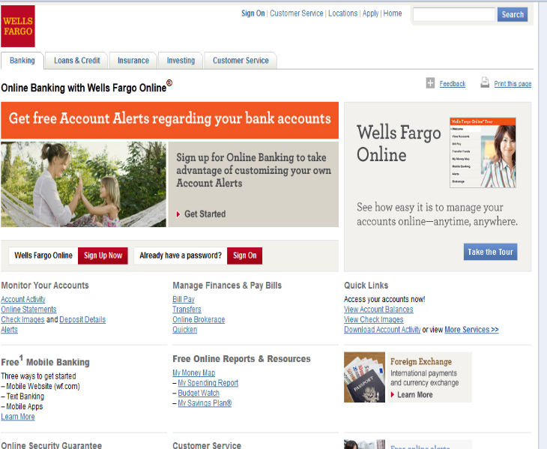

The services provided by Wells Fargo Online Banking are the following:
- View Accounts. Users can view an account summary, in which they have an easy and direct access to popular functions, including funds transfers and bill pay (they also include in this functions the possibility of view online statements, change their address, nickname accounts, view tax documents and view more services). Users are allowed to monitor their account activity (keeping track of where their money goes each month) and downloading the transactions into their accounting software. They can also view their checks as soon as they clear and print and review official account statements.
- Bill Pay. It has a quick option of including a new payee (including a popular payees section). Users are also allowed to pay to saved payee (they can select who to pay, who much to pay and when to pay). They can also receive the bills from the payee in their email.
- Transfer Funds
- My money map. This is a service which allows users to access spending reports, budgeting (watching and creating new budgets) and their saving plans, all in one place. These tools are automatically updated with their latest account information (credit cards, transferences etc).
- Mobile banking. They include a mobile banking service, which their customers can use from the Bank mobile website, mobile apps or text banking.
- Alerts. Users are allowed to view alerts and also to set up and modify alerts.
- Brokerage. They offer a Wells Fargo Advisors service in order to guide users in their investments. Users are also allowed to interact with their investments 24 hours a day, 7 days a week.
- Account Services. Customer service always available (toll-free phone call or internet). They offer also username and password help.
- Security. They offer an online security guarantee service.
      - HSBC
The general services that HSBC offer to their customer in the “Everyday banking” by means of internet banking are the following:
- View Statements
- Transfer Money between accounts.
- Make Payments. Users are allowed to pay bills and to make payments to friends and family.
- Travelling services: Order your Travel Money (thus, users might have the currency delivered to their homes or local branches) and a Fraud Prevention Service, which consists on reducing the chance of their fraud prevention systems by declining any of the transaction users make when they are abroad.
- Regular payments management. Users can view or cancel their direct debits and create amend or cancel standing orders on their HSBC bank accounts.
- Credit Card management. By using a credit card application is possible to request a change of your existing limit or make a balance transfer.
HSBC also offers mobile and telephone banking services and they also have specific business services.
      - Deutsche Bank
DB online banking has several services which allow users to manage their finances and to carry out a number of banking transactions at their convenience. Thus, the offer the following services:
- One-bank view. Users are allowed to view their bank accounts (tracking their balances, downloading statements and getting details from transactions). They can also view details from their fixed deposit accounts, loan accounts or investments.
- Payment Options. There are four services regarding to the payments options: Online bill payment, online taxt payment, db DirectDebit and QuickPay.
- Fund Transfers. Users are allowed to make transfer from Deustche Bank account and to Deustche Bank accounts.
- Value-added Services. Within this services they offer to their customers the option of manage their cheques, receiving alerts and other kind of services such as ordering for a physical copy of users’ savings and current account statement or updating their profile and contact information.
      - BBVA
Next we enumerate the main services offered by BBVA Compass in their online personal banking (they also have a small business banking and commercial banking services).
- Transfer funds between BBVA Compass accounts
- View account balances and transactions
- View images of cleared checks
- View online statements
- Bank alerts
- Downloading the account information into popular money management software programs
They also offer a set of services regarding to online bill pay:
- Pay bills
- Scheduling one-time and recurring payments, days, weeks or months in advance
- Receiving bills
- Set reminders and email notifications for when bills are due
- Pay people with Simple Personal Payments
- Sort and view payment history by individual payee
- Assign categories to each payment for budgeting
- Use a Payment Assistant service
      - Santander
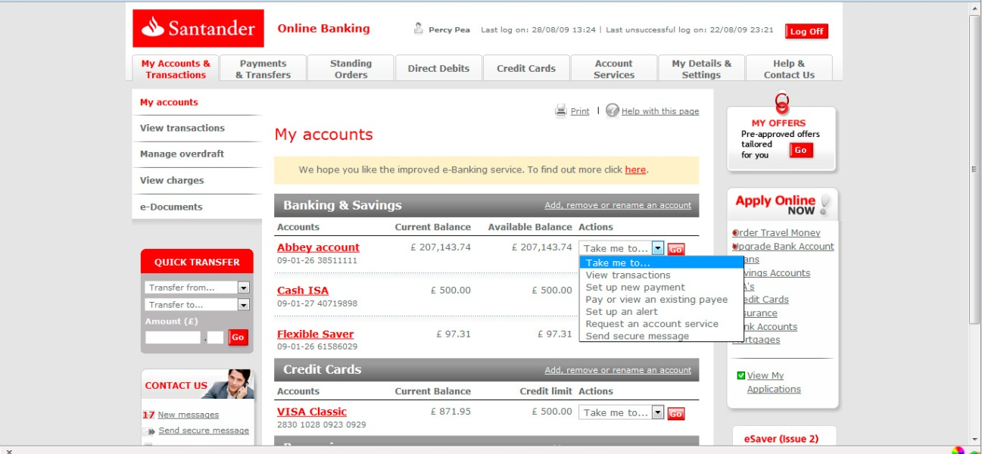

Santander Online Banking offers the following services:
- Day-to-Day banking. It comprises services such as Checking balances and statements; Paying Bills, Transferring money between accounts, Ordering duplicate statements and tax certificates, Ordering replacement PINs, cards and chequebooks, Viewing and updating users’ personal details
- Finance Management. This online service allows users to manage their finances. They can personalise their account summary page, pay bills and also view, setup, cancel and amend standing orders. In addition, users can make payments by a Faster Payment service, they can view and cancel direct debits, they are allowed to set up to receive alerts in their accounts by email or SMS, to download transaction summaries to use in Microsoft Excel or other finance software and they can open a new account or rename and reorder the existing ones.
- Borrowing and Repaying. Users are allowed to set up and overdraft or request a new limit and they can also check and repay their Santander credit card balances.
- Contact with the Bank. This service has available a direct and secure messaging system to contact with the bank.
Additionally Santander offers advances online banking services such as Online Business Banking, Corporate Banking, Online Credit Card and an e-mortgage service.

    - Conclusions
Once a number of highlight banks that offers online banking services have been reviewed, we could extract some conclusion about web banking services. We have observed that there are a number of services which the analysed banks have in common: account services (viewing accounts, downloading statements…), transfer funds, bill payments, reminders (bank alerts…) and contacting with the bank. On the other hand, there are other services which would be more specific, depending on the user profile. They are services such as Market watch, budgeting, checking the investments, loans services, travelling services, etc.

  - ATM Banking Services
Al-Hawari et al. [3] propose a set of factors which determine the quality of an ATM service from a user-centered point of view. They are: secure locations, ATM conveniently located, user-friendly system and ATM functions. In this deliverable we are focused on the last one, the ATM functions. Our aim will be to identify the main ATM Banking service functionalities, in order to choose the most appropriated ones for being developed during the next phase of this project. In order to do this, we first analyze a number of banking services provided by several Banks, and we conclude by summarizing the ATM Banking services which these banks have in common.

    - Study cases
      - Deutsche Bank
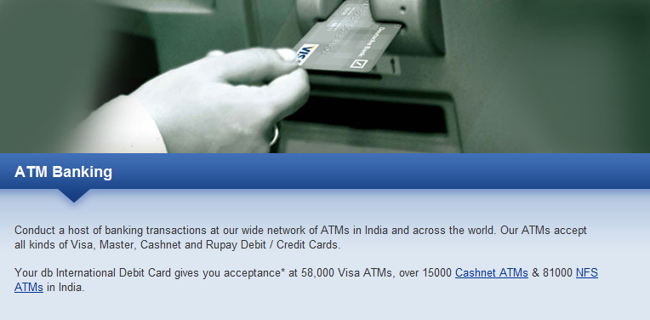

The main banking services offered by the Deutsche bank ATM network are the following:
- Cash Withdrawal
- Cash/Cheque deposit
- Balance Enquiry
- Fast Cash
- Mini Statement (last 10 transactions)
- PIN change
- Funds transfer to any Deutsche Bank account
- Statement request
- Chequebook Request
- Recharge your prepaid mobile card
They also provided a telephone number in order to give you information about the nearest ATM.

      - Bank of America


They offer three main types of transactions:
- Withdrawals. Users are allowed to withdraw fast cash or enter the withdrawal amount. They can also select the account for their withdrawal and to ask for an receipt.
- Depositing cash and checks. Users can make a deposit selecting the deposit type (cash deposit and check deposit), the deposit account. They can insert cash or checks directly to the ATM and finally they receive an image of each deposit check on their receipt.
- Payments, Transfers and Balances. Users are allowed to make a payment or a transfer. They can choose a balance inquiry by selecting previously the desired account, and they can also view or print their balance.
      - Wells Fargo
Apart from the most popular transactions in their ATMs such as dispensing cash, this bank offers a wide range of additional services in their ATMs.
- Get Cash and Deposit Cash
- Deposit Checks
- Envelope-Free deposits
- Favorites. They design their ATMs to automatically remember their customers most frequent transactions and show them as a favorites button on the main menu.
- Stamps. They allow users to buy sheets of stamps at most ATMs, charged to any account linked to their ATM or Debit Card.
- View or print balances and statements. Users are allowed to view or print a statement of their most recent transactions and balances directly from an ATM
- Transfers and payments. Users can transfer funds between accounts or make a payment to a credit card from an ATM
- Electronic ATM receipts. Users can send their ATM receipt directly to their personal email address.
      - Standard Chartered
The ATM services offered in this bank are the following:
- Withdraw cash 24 hours a day 7 days a week
- Pay credit card bills
- Pay utility bills
- Buy prepaid mobile vouchers
- Get a “mini-statement” of your account whenever required
- Request a check book
- Request a statement of account. This will be generated and mailed to the user.
- Funds transfer
- Allows to change the PIN whenever required
      - Citibank
The main services that offer Citibank ATMs are:
- Deposit checks
- Get cash
They have also Talking ATMs for visual impaired customers located at every Citibank branch that has an ATM. In addition there are some online services also available at Citibank ATMs in the U.S.:
- Make transfers (between linked Citibank accounts, to other Citibank accounts and international transfers)
- Change your PIN
- Change your telephone ID
      - BBVA
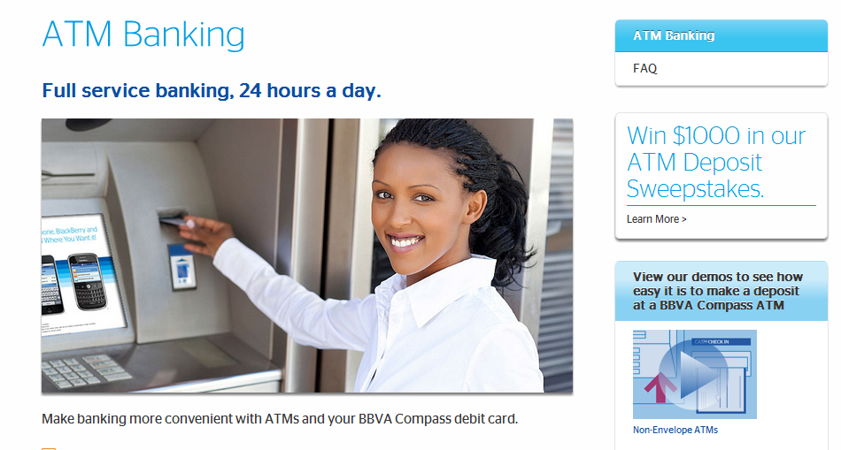

The ATM banking services offered by BBVA Compass are the following:
- Deposits. Cash and check deposits can be made at the most BBVA Compass ATMs
- Withdraw Funds
- Transfer funds. They allow users to move funds between checking accounts and saving accounts that are linked to their debit card
- Split Deposit into multiple accounts at most BBVA Compass ATMs
- Check Balances
- Mini statements
- Customizable services. They allow their customers to customize the fast cash option, the receipt options (to set whether or not they want receive a receipt when they make transactions), and the preferred language.
      - Santander
We can perform the following main transactions in an ATM of Santander Bank:
- Withdraw and Deposits
- Transfers
- Check statements and balances
- Recharge a prepaid mobile card
- Payments
    - Conclusions
We have reviewed several ATM banking services offered by a number of selected Banks. From this analysis we can extract the transactions which all banks reviewed have in common, and therefore we could say they are the “basic” transactions which should be offered as a service in an ATM. These would be: Withdrawals, Depositing (cash and checks) and Payments, Transfers and Balances. There are additional features of ATM banking services such as recharging a prepaid mobile card, buying stamps or tickets and offering customizable services to the user (i.e. favorites, change PIN, …) which might add value to an ATM banking service.

  - TV Banking Services
Interactive Digital Television (IDTV) involves the transmission of digital signals together with a capacity of “interaction” between the service users and the service providers. Some of this interaction relies upon the existence of a “return path”, which enables a two-way communication. Interaction could be provided, for example, through phone line (for satellite or terrestrial viewers) or cable services. Only a set top box and a television are needed. Certainly, 1998 could be considered as the first year for the launch of i-TV (Interactive TV) and enhanced TV in the European Union. An increasing number of projects were announced and almost each of the digital TV (DTV) platforms in the major EU markets included i-TV services. Interactive Digital TV has been used in Europe in order to deliver broadcasting to homes and to offer new interactive services. It offers similar facilities to the Internet: it is an always on service but it is provided with a simpler interface that can be operated from a remote control. Thus, i-TV offerings are usually built around the following services: Electronic Programme Guide (EPG), Information and News, Interactive Games, e-Commerce and T-Banking (television banking), email and Internet access via TV set, etc.
T-Banking is a service that allows access to banking services and performs a number of non-cash transactions via interactive digital television. TV banking operated by enabling registered users to access bank’s website or applications where they could access and check their account, view their balance, transfer money between accounts, pay bills and cancel standing orders, directs debits and cheques.
The main advantage of the T-Banking services is the availability and efficiency of the service to the customer. Customers can get information on the bank (services, offers etc.) and perform actions on their account or credit card without going to the physical branch. They save time without waiting queues, and the bank could also save money regarding to employees’ time and physical branches. In addition, services would be more accessible to the customer (any day and any time). Finally, using the TV for access to the bank services would be an optimal option for people who are not familiar with computers and internet.
On the other hand, T-Banking services could have several inconveniences which should be taken into account when a new service would be developed. The first problem could be that the default technology permits only one way communication (information going from the bank to the customer, but not from the customer to the bank) because implementing two-way communication require specific wiring and phone connection which is not always available in households. The T-Banking services are limited, compared to other methods (web …) and downloading and printing information it is not possible. In addition, there are noticeable privacy concerns, as the TV screen can be viewed by everyone who lives in the house.

    - Study cases
Next we present some study cases in order to provide to the reader an overview about the T-Banking services which has been offered by another companies from the late 1990s to our days.
      - Crédit Agricole
This service was provided in Europe by the French TV network TPS, and it was the pioneer in this kind of services. This service only need a TPS set top box for working properly. Nowadays the bank has the intention to launch on a second French platform, Canal Satellite, in the next 12 months. The services available for the users were: to check their account details and investments, to transfer money between accounts, to send and receive electronic messages from the back and check management.

      - HSBC
It is an experimental project and the technology that they use it is not mature enough. They offer a service available to subscriber to Digital BSkyB via the interactive channel Open and they provide them a secure access via PIN number. The services available for the users are: information of the products from the bank and request products brochures, on-screen loan or mortgage calculator, booking a service in the physical branch for more specific needs.
In the second release the offer new services such as checking the account balances an monitoring credit cards, paying utilities and other bills, transferring funds, buying other financial products (ie, insurances) and applying for a new overdraft limit.

      - The Woolwich
With the arrival of TV banking, the Wookwich claims to be the only UK to deliver fully transactional services to its customers via all channels (branches, Internet, ATMs, 24-hour telephone banking, mobile phone and interactive TV). The service is available to subscribers of digital BSkyB via the interactive channel open and they offer a secure access to the user via PIN number. The services available to the users are the following: to view account details, mortgage information and savings plans, to pay utility and other bills, to transfer money between accounts, to check recent transactions and to change pin numbers.

      - Sakura Bank
Toshiba and IBM Japan developed a system to enable Japanese banks to offer a range of financial services to TV sets, using digital satellite transmissions. Toshiba designed and installed facilities at broadcasting companies an IBM Japan handled television banking system. The two firms set on the market technology for TV banking, and Sakura was the first partner. The offered to the users services such as: checking balances, paying bills or transferring funds.

      - Banco Espírito Santo
This bank offered a TV banking service available to subscribers of Cabo TV, a leading national cable operator with a broadband Hybrid-Fibre-Coas cable network. The available services are the following: checking balances and movements, paying bills, transferring money and showing the investment portfolio.

      - Banco Mercantil
They offer Access to banking services via TV sets through an agreement with the interactive TV applications provider NDS and the satellite TV provider Directv Latin America. Therefore the service is available via DIRECTV Channel and the NDS Back channel provides a secure encryption of the signal during the transactions. The services available to the users are: information about brank branches and general information about the bank and financial news, viewing the account balances and activities during the last twelve months, paying bills and transferring money between accounts and to an external account.

      - Intesa BCI
They offer a service available to subscribers of Stream Pay TV (today Sky). They provide a secure access via bank account secret codes. The services that they offer are: checking accounts (movements, balance and information about the operations), accessing to the investment portfolio, mobile credit recharge and transferring money.

      - Postal Savings Bank of China (PSBC)
PSBC is the first Chinese bank to launch this kind of service in Shanghai at a headquarters level. The service is based on the digital TV network of Oriental Cable Network Co., Ltd. This bank offers the following services: account balance inquiry, money transfer, TV and bills payment and credit card repayment. In addition foreign exchange trading and fund trading are going to be delivered during the second release.

      - Banco de Crédito e Inversiones (BCI)
The services offered by this bank allow users to purchase discount products through a series of BCI retail partners. They offer this service together with the telecom operator Grupo GTD. The services available for users are: checking bank accounts status (balance and movements), money transfer and bank news and information.

      - Agricultural Bank of China
The customer identification is by means of the ABC card number and ID card number. They enter these numbers in the set top box and, after verifying the identity of the customer, the system give to the user a special authorization to use the banking service. The services available are: account balance and inquiries about transactions details, money transfer, fund services, communications to the banks (loss of credit cards …) and ABC information. They also offer services regarding to bills payments (digital TV, mobile phone, gas, donations, newspaper subscriptions, lottery purchase…)

      - ICICI Bank
The service is offered via satellite DTH and also via broadband IPTV. The available banking services to the users are: giving information about bank product and services (latest offers, products features …), interactive features (loan EMI calculators and charts, financial news and updates (investments and interest rate chart), step-by step guides to the service (i.e., how to pay bills online), branch ATM locators and safe bank tips.

      - Mediolanum
This bank gives a banking service “la tua banca” available on the free DTT channel in Canale5. They provide a secure access using the bank account secret codes. The banking services that they offer are the following: checking the bank account, checking the ATM and credit card movements, recharge mobile credit, check the status of investment fund, capital and insurance investments, insurance services and information about the bank.

      - Rabobank
Rabobank was the first bank in the Netherlands to offer TV banking. Households could access the RaboTV site via the set top box supplied by their cable television provider. They offer TV banking via platforms such as Windows Media Center and Nintendo Wii. The channel Tele2 also features this interactive TV channel with Rabobank information including behind the scenes footage at sports teams sponsored by the bank and information about local events and banking services. The services available for users are the following: checking accounts, paying bills and transferring money.

      - Standard Chartered First Bank
They give this service over the satellite broadcasting network and users could use their telephones to interact with banks. Those users interested in using the TV Banking services, should register in Korea First Bank’s internet banking and SkyLife, and install an additional TV receiver. They offer the following banking services: transferring money, check management and view bank information.

      - OKO Bank
The OKO Bank Group was the first Finnish company to open an interactive service on digital television and they implemented an application of TV banking based on the MHP standard. The banking service is broadcast to each digital TV receiver, using the TV signal, and the service is connected to the OKO Bank through a secure return channel. Therefore, the service is compatible with the bank’s existing network service user ID’s and passwords, and it is available on the DTT channel MTV3. The banking services offered are: paying bills and checking transactions and balances.

    - Conclusions
In spite of the beginnings of the TV-banking were not as fruitful as it was expected, during the last few years TV-banking is reappearing in countries such as Chile, India and China. The choice of the products and services to be offered, the broadcasting procedure, the choice of the technology and the development model are still open challenges that TV-banking has to face to. Nevertheless the new developments in web browsing and TV terminals and the increasing number of people who use mobile and internet banking services make it possible to think in the return on TV banking as a service. Thus, the increasing developments on Smart TV could help to boost the TV banking by developing TV banking apps. First test experiment in this field has already been developed. An example is the case of TV banking MATERA, developed in 2011 by Fingers Tip (a Brazilian company of Matera Group) for LG Smart TV.

On the other hand, Google announced partnerships with several electronics manufacturers (Sony, LG, Samsung, Vizio and Nyxio) to boost Google TV embedded devices. According to Google, over 150 TV applications are already available and thousands of Android Smartphone applications can be used within their TV service. In addition, more than 1,400 Smart TV apps are now available in the Samsung Content Market, and they have recently present new interaction modes (such as voice and motion control systems) for controlling their Smart TV sets. Besides, TV manufacturers should develop their own Operating System or establish agreements with Smart TV OS developers. Thus, Microsoft have develop the XBOX Upgrade “The future of TV”, in which users have access to an App Marketplace and retrieve content through motion commands (using Kinect technology) and a new voice control.
All in all, TV sets are evolving and how users interact with the TV is changing, therefore, having into account the previous insights, Smart TV seems to be an appropriate way for promote the banking TV services. Regarding to the TV banking services we could say that all companies previously analyzed usually offer: transfers, bills payments and checking account statements and balances.

  - Mobile Banking Services
The first approach in mobile banking services was mainly related to mobile payments (micropayments, bill payments, etc.) [4]. However, since the evolution of the 3G mobile networks and the maturity of applications and devices, services based on web, applications and texting are being offered by the banking sector. The increasing degree of the advance mobile technology adoption (smartphones, featured phones, …) and the comfort level that mobile banking offers (from a sophisticated mobile web-based banking service to a quick and simple SMS), makes that mobile banking services be an investment in the future for many companies in the banking sector. According to the Nielsen Company, mobile web banking in the U.S. has grown to more than 13 million mobile subscribers (up 129 per cent in just two years). As David Gill, Senior Director of Mobile Marketing at The Nielsen Company, states “People who are comfortable using their mobile phones for mobile banking tend to check their mobile bank site twice a week. These customers are already highly engaged and eager for real-time solutions based on their specific needs”. On the other hand, according to a report delivered by Deutsche Bank Research, in Europe it seems that the mobile banking services are still not widespread but has become much more interesting for customer and Banks [5]. Therefore we would attach importance to the development of banking services delivered over a mobile platform in the Bank4Elder project. We next identify the main mobile banking services provided by a number of selected Banks, some of them such as CIBC or Citi has been rated as the best in Mobile Banking according to the Global Finance Magazine. Our objective would be to summarize the Mobile Banking Services that these Banks have in common.

    - Study cases
      - Bank of America
This bank offers three main mobile banking options:
- Mobile website. They offer a web-enable phone option by accessing online in bankofamerica.com. They offer the following services: checking balances (accounts, saving accounts and credit cards), pay bills, transfer money and locate ATM and banking centres.
- Text Banking. They offer a text message banking to request information about: checking balances (accounts and credit cards), details of users’ credit card account and recent transactions for a specific account, search transactions history, and help for a customer service number for the user’s area.
- Mobile App. A Mobile Banking App is available to online banking enrolees. The services offered are: ATM banking centre locator, using geo-locator, on-the-go management of accounts to check balances, transfer funds and pay bills with optional Bill Pay. Users must have transfers and optional bill pay set up previously in online banking to use these functions in the mobile banking app.

      - Citi
This bank offers four main mobile and tablet banking options:
- Citi Mobile Apps. It offers a number of banking services delivered over the Citibank online platform. It allows paying bills and tracking payments, depositing checks, seeing recent activity, transferring money between Citi accounts, Check balances and paying other people popMoney. They also allow managing Credit Card accounts (such as paying credit card bill or checking balances and the availability of credit lines).
- Citi Mobile for Smartphones. This is a service which allows their customers to access their Citi accounts from virtually any mobile device with a built-in browser (including iPhone, iPod touch, Windows Mobile, Blackberry or Android devices). Customers are allowed to manage their bank accounts- check the balances in their linked accounts (checking, savings, credit card, home equipity or personal lines and loans and mortgages), pay virtually any person or business in the US and track payments, see recent activity and transfer money between Citi accounts-. They can also manage their Credit Card accounts- pay their credit card bill, check their balance, view recent transactions or learn the minimum payment due (and due date).
- Citi Text Banking. This service allow users to check their Citibank account and their credit card accounts just by texting a short command they get the reply in seconds. Users can get their Citi account balances, Credit Cards payment details, Recent transactions, Additional transactions (up to 15), support (online or by phone) and text banking suspension.
- Citi Tablet Apps. Citibank also offers a service optimized for the iPad or Kindle Fire. The banking services offered are the same that in Mobile Smartphones (checking and savings, payments, credit cards,…), but in this case they add rich displays, charts or data which allow, for example, interactive graphics to display and help to visualize their current spending and plan for their future.

      - Wells Fargo
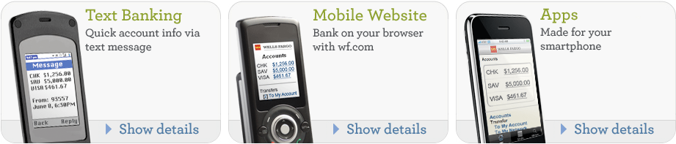

Wells Fargo provides three ways for delivering mobile banking services:
- Text Banking. This is a free service which allows customers to quickly request and receive account information via text message. Users can get information about their balances, recent account activity, credit card due dates, ATM locations, details about their loan accounts. They are also allowed to get Wells Fargo contact information or disable the Text Banking service.
- Mobile Website. The wf.com service allows users to access account information and make transactions from their phone’s web browser. The service is optimized for mobile use, in order to provide a fast free and secure access to their accounts. The banking services offered are: Pay bills, Transfer funds, Send Money to other Wells Fargo customers, Explore detailed account activity, View balance information and find ATMs and locations.
- Apps. Mobile Banking Apps are applications made specifically for a smartphone. They give users fast and free access to their account information and use their phone’s built-in functions to provide a better banking experience. Customers can do everything as wf.com, such as pay bills, transfer funds or get balances. In addition they can use GPS to get one-touch access and directions to ATM/location information and they can also get quick access to Sign on screen.

      - CIBC (Canadian Imperial Bank of Commerce)
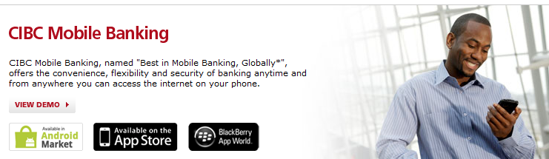

CIBC Mobile Banking offers a full suite of mobile solutions accessible from a wide range of internet-enabled devices to meet the users banking needs. They offer a Mobile Banking App available for Android, iPhone, Blackberry and Mobile Web. The CIBC Mobile Banking App also uses GPS technology to help clients find the nearest branch or ABM based on their current locations. The main banking services offered in this app are the following:
- Accounts (check account balances and review details of recent transactions history for deposit, credit cards and other eligible credit accounts).
- Pay bills now or schedule post-dated payments of the customers’ registered bills. Bills can be registered using the CIBC Mobile banking
- Transfers. Set up a same day or post-dated transfer to a deposit, credit card and other eligible credit account
- Email Money Transfers, using Interact ®
- Upcoming transactions. Review details of upcoming bill payments, and upcoming transfers. Both upcoming transfers and upcoming bill payments can also be cancelled within the CIBC mobile banking.
- Locate branches, bank machines and CIBC Mortgage Advisors.

      - Deutsche Bank
This bank offers both SMS services and Mobile Banking Services:
- SMS services. Customers can keep track of their banking account by receiving important alerts on their mobile. The types of alerts that they are allowed to receive are: bill payments, cheques, loan disbursal alerts, fixed deposit maturity alert, transaction alert, etc. Within this service users can also apply for any Deutsche Bank product or service, and afterwards the bank get in touch with the customer.
- Mobile banking apps. They offer mobile banking services optimized for the smartphone. The services available are: transfers, personal statements, credit card transactions, account balances, branch and ATMs locator, market information or customer service call among others.

      - BBVA
Mobile Banking in BBVA Compass is available to all online banking customers, either through text messaging or a mobile device app.
- The main services delivered in text message banking are the following: to check balances on any BBVA Compass account included their online banking services, to view “posted” and “pending” transaction and to transfer funds between accounts. There is also a Mobile NSF Alerts service that allows users to receive a text message when their checking account is overdrawn or when items are presented against non-sufficient funds.
- The mobile banking app service is supported over several platforms (iPad, iPhone, Android and Blackberry). Users should be previously registered in online banking and then they are allowed to register their mobile device and to download the corresponding application for them. Mobile banking app include these main features: account balances, posted and pending transactions and transfer funds between accounts. Additionally BBVA Compass offers a Location App for iPhone, iPod or Android devices. This application allow users to view nearby branches and ATMs on a graphic map, to use geo-location to find users’ current location or manually enter an address, to automatically call a branch and to receive turn by turn directions with estimated distance and travel time.

      - Santander
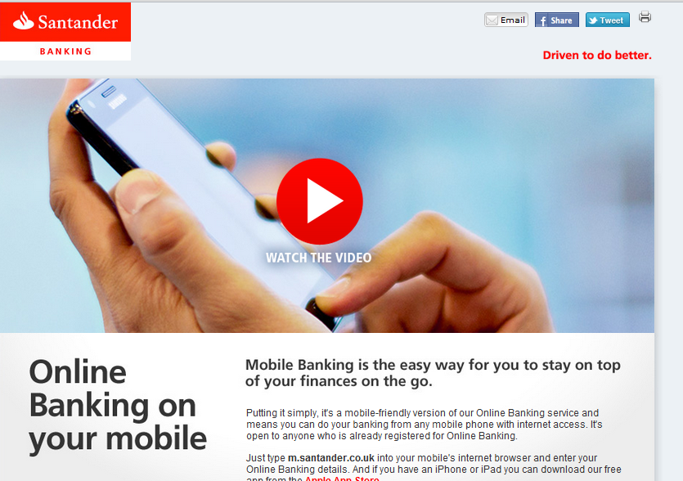

Santander has developed a mobile-friendly version of their online banking service in order their customer can do their banking from any mobile phone with internet access. The mobile banking is open to customers who are already registered for online baking. They have access to this service by using their mobile’s internet browser or by downloading a free app developed for iPhones and iPad platform. The main banking services are the following:
- view customer accounts and credit card balances
- view customers’ latest transactions
- Transfer funds between accounts
- Pay an existing payee who the customer has paid before and view
- Amend and cancel any pending payments or transfers.
- Set up useful account alerts. Users are also allowed to set up two email or text message alerts in mobile banking for when their balance goes above or below a certain amount. They can also see all the other alerts they have set up in online banking such as when a large deposit or debit occurs.

    - Conclusions
We have reviewed a range of Banks offering Mobile banking services. Once we have analyzed the mobile banking services delivered in each of them, we could extract a summary of those mobile banking services which the reviewed Banks have in common. Thus, in general we could say that there are three ways of delivering mobile banking services: Text Messages, Mobile Apps, and Mobile Internet Browser.
The main functionality of the Text Banking service is receiving alerts and, additionally, some companies offers Customer Services (Help, ATM location,…).The alerts received within Text banking are related to: Account Balance, Account Activity, Transactions and Payments (pending and posted).
Focused on Mobile Banking (both Internet browser and apps), we could say the main services delivered over this platform are quite similar to those delivered over web banking: Checking Accounts and Balances, Credit Card Accounts, Payments (Bills …), Transfer funds between accounts and Money transfers. A highlight service of mobile banking service is the location of nearby ATMs and branches on a graphic map, using the GPS and geo-location features of the smartphone.
- Identification of the main banking services
Once we have analyzed the main banking services, in this section we summarize the most popular banking services used among the different platforms (ATM, Web, TV and Mobile). In Table XX we can see a summary of the main transactions and services which are offered in each platform. We would like to remark that in spite of the majority of web banking services can be also delivered as mobile banking services, we have selected in Table 1 the most popular mobile banking services, according to the conclusions obtained in the previous section. It can be seen that TV platform is the most restrictive one, considering the number of banking services that are delivered over this platform. Therefore, in order to make a first selection of a limited set of services which would be suitable to be implemented in all platforms, according to the Table 1 we could say that “Payments”, “Transfers” and “Account Services (viewing accounts, balances,…)” could be chosen to be prototyped at a first phase of the project.

Table 1: Main banking services
 | WEB | ATM | TV | MOBILE
Payments  Bill, Taxes,… | X | X | X | X
Transfers | X | X | X | X
Account Services  Checking  Statements  Balances | X | X | X | X

Table 2: Additional banking services
 | WEB | ATM | TV | MOBILE
User Services  Favorites  Change PINS  Customizable options | X | X | - | X
Location of ATMs/branches | X | X | - | X
Deposits | X | X | - | X
Reminders  Bank alerts | X | - | - | X
Loan services | X | - | - | X
Contacting with the Bank | X | - | - | X
Withdrawals | - | X | - | -
Adds  Recharge mobile  Buy tickets  .. | - | X | - | -

Table 3: Advanced banking services
 | WEB | ATM | TV | MOBILE
Market watch | X | - | - | -
Budgeting | X | - | - | -
Checking the investments | X | - | - | -
Travelling services | X | - | - | -

Nevertheless, with this conclusion we don’t intend to reduce the system functionality but offering a recommendation for building a first approach of the prototype. At this point it is important to point out that we expect to combine these results with the elders’ user opinion - extracted from the first focus group session- in order to define the most suitable set of banking services for elder people to be developed during the Bank4Elder project.
Therefore, in order to enrich the final banking services to be delivered in the future definition of the Bank4Elder project requirements, additional main banking services have been identified in this Table 2. Some of these services are specific from the platform in which the service is delivered (for example, withdrawals are specific from ATMs). On the other hand we would like to highlight in Table 2 some banking services, which are not totally related with banking but with the user interaction with the system. They are user services (ie customization options), location of ATMs and branches, banking contact services and banking alerts. We have also identified in Table 3 other kind of “advanced services” which might help to add value to the service offered in each platform, for example Market Watch or Budgeting are applications useful for expert users in banking services.

- Conclusions
In this report we have presented an overview of the main banking services offered by a group of banking companies using several platforms (Web, ATM, TV and Mobile). First of all we have analyzed all the information for each platform separately. We have identified the main banking services that the analyzed banking companies have in common, and we have extracted conclusions for each platform. Finally we have gathered all the information together into a Table. Thus, we present a visual summary of the main banking services offered over the four platforms that are going to be used in the Bank4Elder project. From this summary we have concluded that there are three main services that a banking service should be appropriated to be delivered over the four platforms. The main services identified are: Payments, Transfers and Account Services (checking accounts and balances).
In addition we have identified a number of highlight banking services that, together with the future user needs report, should be taken into account to design the final requirements in the banking services for the Bank4Elder project. These banking services may vary regarding to the specific platform in which the service is delivered, the user expertise with the system and the user preferences in the interaction with the system.
All in all, after analyzing the banking services over the four platforms used in the Bank4Elder project, we have recommended three main banking services to be considered in first approach of the system definition. They are Payments, Transfers and Account Services. We have also identified an additional set of main banking services which we plan to combine with the user needs information, in order to define the final requirements of the Bank4Elder system.

References
- Daniel, E., "Provision of Electronic Banking in the UK and the Republic of Ireland," International Journal of Bank Marketing, Vol. 17, No. 2:72-82, 1999.
- Floh A. and Treiblmaier H., "What keeps the e-banking customer loyal? A multigroup analysis of the moderating role of consumer characteristics on e-loyalty in the financial service Industry". Journal of Electronic Commerce Research, Vol 7. Nº2. 2006
- Al-Hawari M., Hartley N. and Ward T., "Measuring Banks' Automated Service Quality: A confirmatory Factor Analysis Approach". Marketing Bulleting, 16, Article 1 2005.
- Mallat N., Rossi M. and V.K.Tuunainen. “Mobile Banking Services”. May 2004/Vol. 47, No. 5 Communications of the ACM.
- Meyer, Thomas. “Mobile Banking is still not widespread but has become much more interesting”. Deustche Bank Research. Digital Economy and Structural Change. February, 2010.

Please indicate the dissemination level using one of the following codes: • PU = Public • PP = Restricted to other programme participants (including the Commission Services) • RE = Restricted to a group specified by the consortium (including the Commission Services) • CO = Confidential, only for members of the consortium (including the Commission Services) •
http://epp.eurostat.ec.europa.eu/portal/page/portal/eurostat/home/
http://www.gfmag.com/tools/best-banks/11485-worlds-best-internet-banks-2011.html#axzz1mTMjwiDX
https://online.citibank.com/US/JPS/portal/Index.do
http://www.standardchartered.com/en/online-banking/index.html
https://www.wellsfargo.com/wfonline/
http://www.hsbc.com.au/1/2/personal/services/internet-banking
http://www.deutschebank.co.in/online_banking.html
http://www.bbvacompass.com/online-banking/]
http://www.santander.co.uk
http://www.credit-agricole.fr/
http://www.hsbc.co.uk/
http://www.woolwich.co.uk
http://www.smfg.co.jp/english/
http://www.bes.pt/
http://www.bes.pt/
www.intesasanpaolo.com/
http://www.psbc.com/
http://www.bci.cl
http://www.abchina.com/en/
http://www.icicibank.com/
http://www.bancamediolanum.it/
www.rabobank.com/
http://www.standardchartered.co.kr/newweb/index_eng.jsp
https://www.op.fi
http://blog.nielsen.com/nielsenwire/consumer/mobile-banking-in-u-s-grows-129-in-last-two-years/
http://www.gfmag.com/tools/best-banks/11485-worlds-best-internet-banks-2011.html#axzz1mTMjwiDX
http://www.bankofamerica.com/onlinebanking/index.cfm?template=mobile_banking
https://online.citibank.com/US/JRS/pands/detail.do?ID=CitiMobile
https://www.wellsfargo.com/mobile/
https://www.cibc.com/ca/how-to-bank/mobile.html
http://www.deutsche-bank.de/pbc/ser-onlinebanking-mobilebanking.html
http://www.bbvacompass.com/mobile-banking/
http://www.santander-products.co.uk/mobile/banking.html

