

eCare@Home

WP1: User Requirement and Specification

D1.3: Non-Functional specification:

Data model

|  |  |
| --- | --- |
| Deliverable id | D1.3 |
| Document name | Data model |
| Date | 25.11.2013 |

|  |  |
| --- | --- |
| COVER AND CONTROL PAGE OF DOCUMENT | |
| Project number: | 600451 |
| Project name: | E Care@Home |
| Document id: | D1.3 |
| Document name: | Data model |
| Dissemination level* | Private |
| Version: | 1.0 |
| Date: | 25.11.2013 |
| Author(s): | HOAS; Valentin Garkavy |

|  |
| --- |
| ABSTRACT |
| Data model description and data model diagram |
| KEYWORDS |
|  |

|  |  |  |  |  |
| --- | --- | --- | --- | --- |
| VER. | DATE | STATUS, CHANGES | FROM | REVIEW |
| 1.0 | 22.11.2013 | First draft | HOAS |  |
| 1.2 | 30.12.2013 | Ready for review version | HOAS |  |

Contents

Preface 6

Data model tables and relationships description 6

User types 6

Service users’ data tables 6

ServiceUsers 6

ServiceUser_Calendar 6

ServiceUsers_Data 7

ServiceUser_Messages 7

ServiceUser_MessagePhoto 7

ServiceUser_NurseNote 8

ServiceUser_Photos 8

ServiceUser_Relatives 8

ServiceUser_TaskStatuses 8

ServiceUser_TestStatuses 8

ServiceUser_ServiceRecords 8

ServiceUser_OwnTrackers 9

ServicesUser_OwnTrackerRecords 9

ServiceUser_OwnTrackerNote 10

ServiceUser_Assesments 10

ServiceUser_AssessmentAnswer 10

ServiceUser_ServicePlan 10

ServiceUser_ServicePlanData 10

ServiceUser_Services_FrequancyRecord 11

ServiceUser_Packages 11

ServiceUser_PackageAnswer 11

ServiceUser_ReadingSetup 12

ServicesUser_ReadingRecord 12

ServiceUser_ReadingNotes 12

ServiceUser_Readings_FrequancyRecord 12

ServiceUser_ReadingFrequency_NurseNote 13

ServiceUsers_VideoCalls 13

Assessment_Answered 13

Package_Answered 13

Question_Answered 14

Question_RelatedDataReviewDate 14

QuestionRelatedReadingData 14

QuestionRelatedServiceData 14

RelatedReading_Notes 15

RelatedService_Notes 15

Emergency_Contact 15

Staff Users’s data tables 16

StaffUsers 16

StaffUsers_Data 16

StaffUsers_ServiceRecords 16

StaffUser_StaffTypes 16

StaffUser_Messages 16

StaffUser_VideoCalls 17

Friends and Family users’ data tables 17

FriendsAndFamilyUsers 17

FriendsAndFamily_Messages 17

FriendsAndFamily_VideoCalls 18

FriendsAndFamily_Permission 18

Services and tests data tables 18

Services 18

Services_Stafftype 18

ReadingCat 19

Reading_Information 19

User-System interaction data tables 19

System_Alert 19

System_Messages 20

System_VideoCalls 20

Alerts data tables 20

Alert_Assessment 20

Alert_Confirmation 20

Alert_Information 20

Alert_MissingDates 21

Alert_Package 21

Alert_Response 21

Alert_ReviewDate 21

Alert_Trigger 22

Assessments and packages data tables 22

Assessments 22

Assessment_Versions 22

Assessment_Permissions 23

Assessment_Question 23

Assessment_QuestionPermission 23

Assessment_Groups 23

Assessment_GroupPermissions 24

Assessment_Section 24

Assessment_SectionPermission 24

Packages 24

Package_Assessment 24

Packages_SectionVersion 25

Package_QuestionGroupVersion 25

QuestionRelatedAssessment 25

QuestionRelatedReadings 25

QuestionRelatedServices 26

Service and staff users template data tables 26

ServiceUsers_Template 26

ServiceUsers_Sections 26

StaffUsers_Template 26

StaffUsers_Sections 27

Other data tables 27

AddressControl_Data 27

Config 28

Devices 28

VideoCall_Statuses 28

Data model diagram 28

# Preface

This document describes data model of eCH solution. Data model may change in future releases due to new functionality and in order to comply with EuroRec and legal requirements.

# Data model tables and relationships description

## User types

There are three types of users in the solution:

1. Service Users (or Clients) – users of HomePad, normally senior citizens at home
2. Staff Users – users which provide services to service users – clinicians, nurses, medical professionals. In addition by staff users in this document we understand also IT support and administration personnel, not involved in medical or care services directly. These users mainly use Central Management Portal (CMP) product.
3. Friends and Family Users – normally family members or friends of senior citizens at home, users of FriendsAndFamily portal

All users’ data structure, besides certain mandatory fields are defined using templates.

## Service users’ data tables

### ServiceUsers

Contains all service users of the solution as well as mandatory [non template] fields.

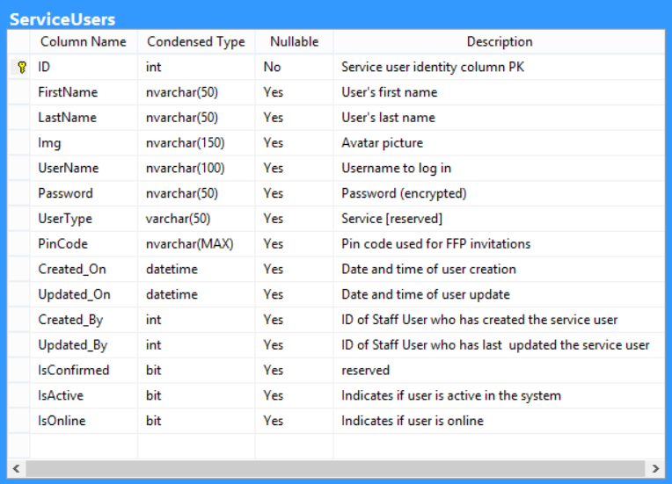

### ServiceUser_Calendar

Contains calendar entries of a service user, such as notes, reminders. Entries can be linked with applications (sections) within HomePad.

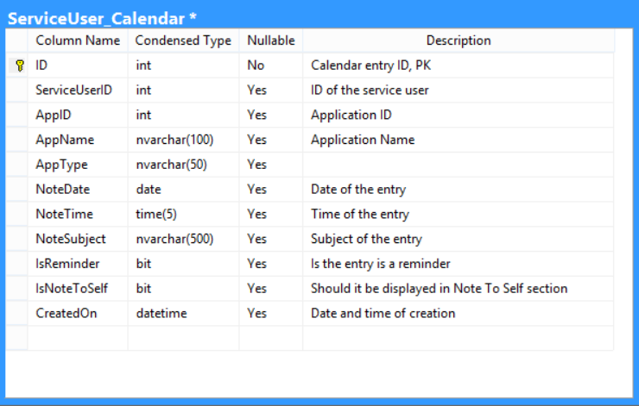

### ServiceUsers_Data

Contains service users’ (patients’) data according to the structure defined in the service user data template (See ServiceUsers_Template table).

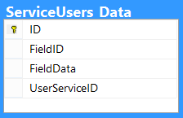

### ServiceUser_Messages

The table contains references to service users’ (patients’) messages.

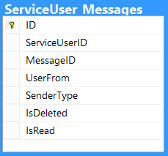

### ServiceUser_MessagePhoto

The table contains references to service users’ (patients’) messages.

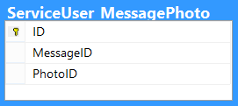

### ServiceUser_NurseNote

The table contains free text notes on patient made by medical personnel.

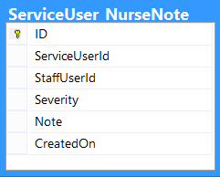

### ServiceUser_Photos

The table contains references to service users’ photos in a gallery.

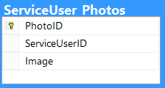

### ServiceUser_Relatives

Lists relatives of a service user (patient), users of Friends And Family portal.

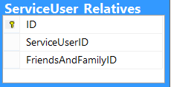

### ServiceUser_TaskStatuses

Contains statuses of services provided to patients by medical personnel (completed, consent denied etc.)

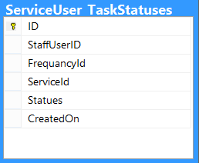

### ServiceUser_TestStatuses

Contains statuses of test provided to patients by medical personnel (completed, consent denied etc.)

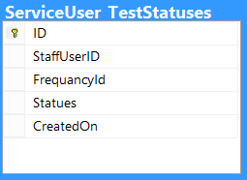

### ServiceUser_ServiceRecords

The table contains service records associated with a service user

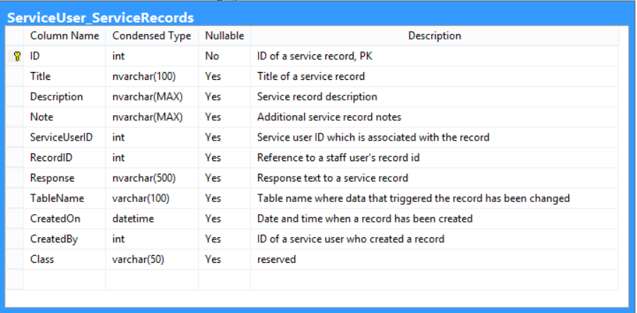

### ServiceUser_OwnTrackers

The table contains custom wellness trackers created by service users themselves (e.g. walking, swimming etc.)

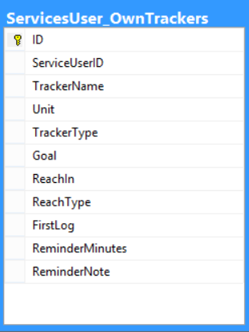

### ServicesUser_OwnTrackerRecords

Contains values of custom trackers created by service users.

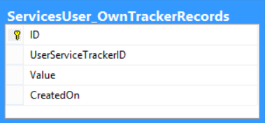

### ServiceUser_OwnTrackerNote

Notes has been made to corresponding records of wellness trackers.

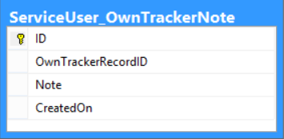

### ServiceUser_Assesments

Contains references to assessments associated with service users.

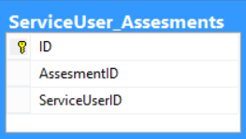

### ServiceUser_AssessmentAnswer

Contains references to assessment results.

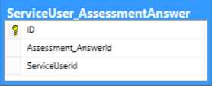

### ServiceUser_ServicePlan

Contains service plans associated with service users and corresponding assessments (if any).

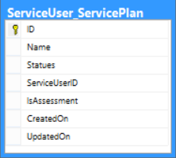

### ServiceUser_ServicePlanData

Contains references to assessments’ or packages’ questions IDs that has been used to create a service plan.

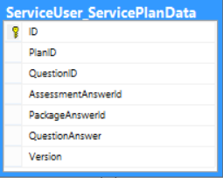

### ServiceUser_Services_FrequancyRecord

Used to store a schedule of frequencies, how often services will be provided to a service user.

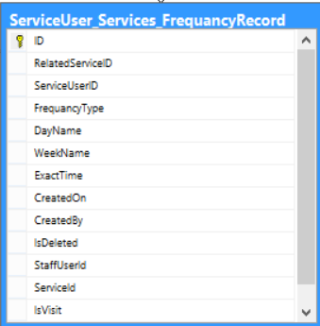

### ServiceUser_Packages

Contains references to packages associated with service users.

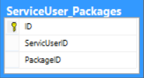

### ServiceUser_PackageAnswer

Contains references to package assessment results.

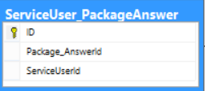

### ServiceUser_ReadingSetup

Contains readings and its settings that has been configured and set up by staff users for service users.

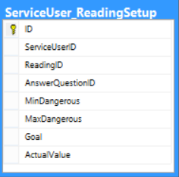

### ServicesUser_ReadingRecord

Contains values for trackers that has been set up by staff users. It is also tracked who has made measurements (column ‘CreatedBy’).

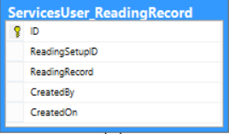

### ServiceUser_ReadingNotes

Contains optional notes made during measurements have been taken.

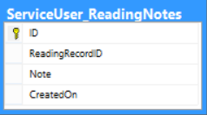

### ServiceUser_Readings_FrequancyRecord

Used to store a schedule of frequencies, how often measurements [tests] should be taken.

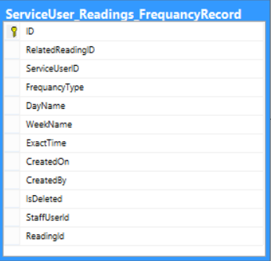

### ServiceUser_ReadingFrequency_NurseNote

Contains special indications on how a test or measurement should be taken for each of a scheduled times.

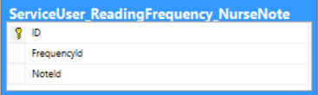

### ServiceUsers_VideoCalls

Contains history of video calls of service users.

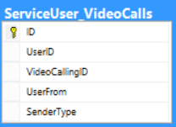

### Assessment_Answered

Contains completed assessments list.

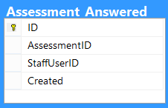

### Package_Answered

Contains completed packages list.

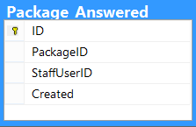

### Question_Answered

Contains assessment answered questions data.

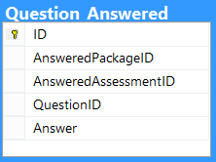

### Question_RelatedDataReviewDate

Contains dates and corresponding notification alert levels when question related data needs to be reviewed

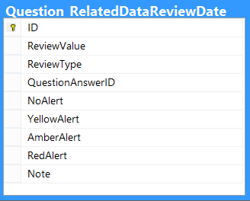

### QuestionRelatedReadingData

Contains dates when question related test data needs to be reviewed.

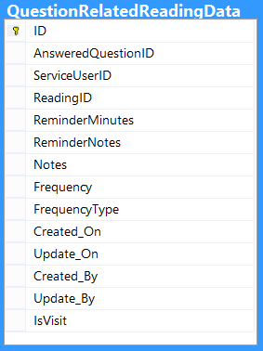

### QuestionRelatedServiceData

Contains dates when question related services need to be reviewed.

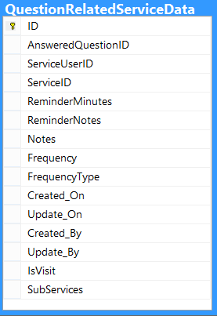

### RelatedReading_Notes

Contains notes on tests measurements.

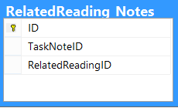

### RelatedService_Notes

Contains notes on services offered or to be performed for the patient.

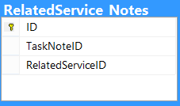

### Emergency_Contact

Lists emergency contacts for service users.

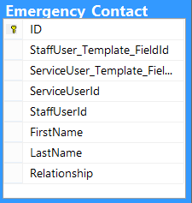

## Staff Users’s data tables

By ‘Staff Users’ in this document we understand users who provide care and medical services, as well as supporting personnel.

### StaffUsers

Contains a list of staff users.

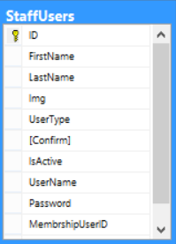

### StaffUsers_Data

Contains staff users’ (patients’) data according to the structure defined in the staff user data template (See StaffUsers_Template table).

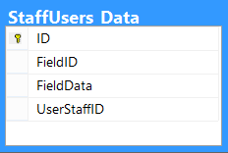

### StaffUsers_ServiceRecords

Contains records of services performed by staff users.

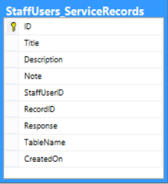

### StaffUser_StaffTypes

Contains roles assigned to staff members.

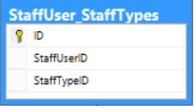

### StaffUser_Messages

The table contains references to staff users (medical personnel) messages.

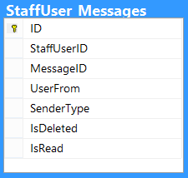

### StaffUser_VideoCalls

Contains history of video calls of staff users.

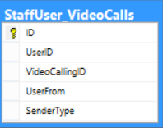

## Friends and Family users’ data tables

### FriendsAndFamilyUsers

Contains a list of friends and family users.

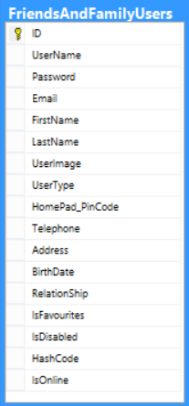

### FriendsAndFamily_Messages

Reference table for friends and family users messaging.

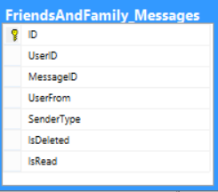

### FriendsAndFamily_VideoCalls

Contains history of video calls of friends and family users.

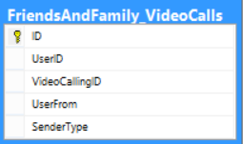

### FriendsAndFamily_Permission

In this table access permissions are defined for friends and family users to a data of HomePad users.

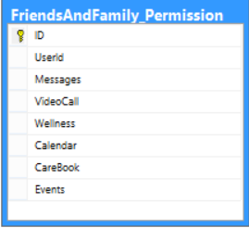

## Services and tests data tables

### Services

List all services (medical and care) within the system. Services can have subservices. Duration can be defined for better scheduling.

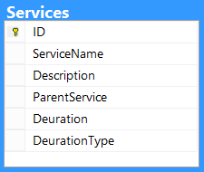

### Services_Stafftype

Lists permissions – which staff types can perform what services.

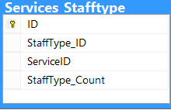

### ReadingCat

Contains all tests (measurements) within the system. Tests can be grouped (for ex. serviced tests and home tests).

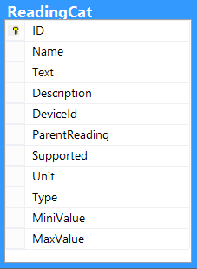

### Reading_Information

Contains default data used to set up tests (dangerous values, etc…).

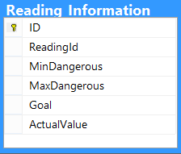

## User-System interaction data tables

Below tables shared between staff-service-friends and family users are listed, used to control interaction between users.

### System_Alert

The table contains all alerts generated in the solution.

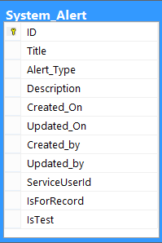

### System_Messages

The table contains all messages generated in the solution.

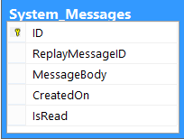

### System_VideoCalls

Contains history of all video calls within the system.

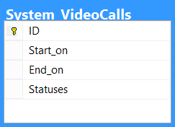

## Alerts data tables

Alerts data tables contain tables that store information about emergency cases, extreme trackers readings and measurements, or missing events or service denied consent cases.

### Alert_Assessment

The table contains alerts referenced to assessments questions.

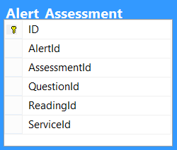

### Alert_Confirmation

The table hold date about when alerts have been acknowledged.

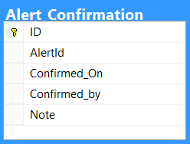

### Alert_Information

The table contains alerts settings, what triggers alerts.

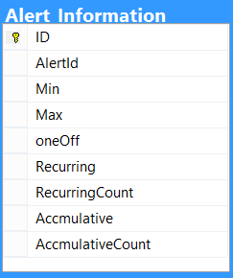

### Alert_MissingDates

The table contains deadlines settings after which alerts we be triggered.

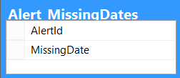

### Alert_Package

The table contains alerts referenced to package questions.

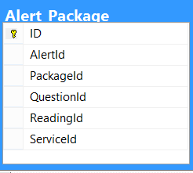

### Alert_Response

The table stores data on emergency contacts and response guidance.

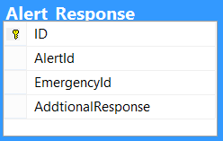

### Alert_ReviewDate

The table stores alerts reviewing dates – when existing alerts’ settings should be checked.

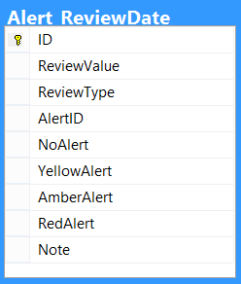

### Alert_Trigger

The table holds all triggered alerts’ dates and values.

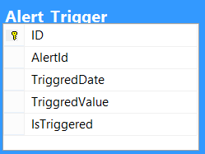

## Assessments and packages data tables

Assessment data tables contain data related to assessments. By assessments in the solution we understand normally group of questions asked to patients (Service Users) to identify their health conditions and general well-being. Assessment questions can be linked to services, tests and other assessments, which means that depending on answers to an assessment questions relevant service plan can be created, which includes these services and tests or another assessment to be performed is auto-assigned to a patient.

Packages are used to combine several assessment or individual questions from assessments to one set of questions used for example to evaluate patients groups with certain health problems.

Assessment and packages are based on templates, e.g. it is up to a user what fields/questions, sections and groups each assessment and package consists of.

### Assessments

The table contains a list of all assessments.

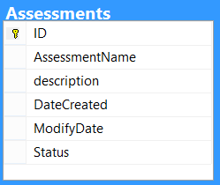

### Assessment_Versions

The tracks version changes of assessments.

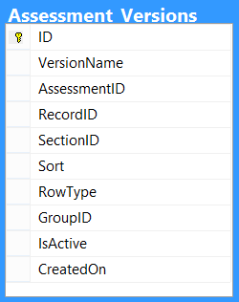

### Assessment_Permissions

In the table listed permissions to access assessments by staff types.

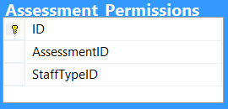

### Assessment_Question

The table contains assessment question definitions – fields, types, etc.

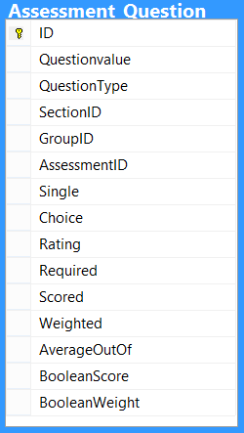

### Assessment_QuestionPermission

In the table listed permissions to access assessment questions by staff types.

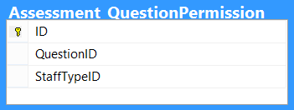

### Assessment_Groups

The table stores assessment groups. The group contains assessment questions.

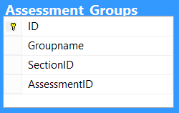

### Assessment_GroupPermissions

The table is used to define group permissions – what staff types can access assessment groups.

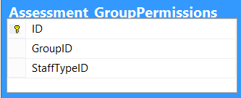

### Assessment_Section

Assessment section is used to define assessment sections. Assessment section can contain questions or groups with questions.

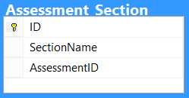

### Assessment_SectionPermission

The table is used to define section permissions – what staff types can access assessment sections.

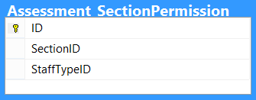

### Packages

The table contains a list of all packages.

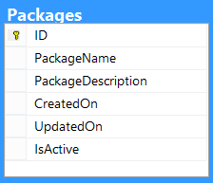

### Package_Assessment

The table contains list of assessments referenced to packages.

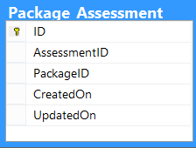

### Packages_SectionVersion

The table stores data on package sections version changes.

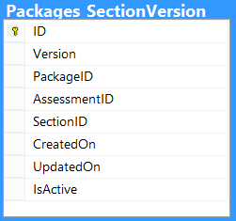

### Package_QuestionGroupVersion

The table stores data on package questions groups’ version changes.

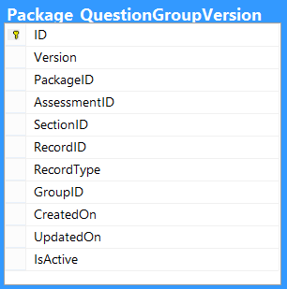

### QuestionRelatedAssessment

Assessments related to questions are listed in this table. If a question has a related assessment, then this assessment is assigned to a patient if the question has been answered positively.

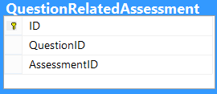

### QuestionRelatedReadings

Tests related to questions are listed in this table. If a question has a related test, then this test is assigned to a patient if the question has been answered positively.

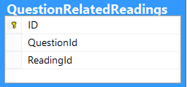

### QuestionRelatedServices

Tests related to questions are listed in this table. If a question has a related test, then this test is assigned to a patient if the question has been answered positively.

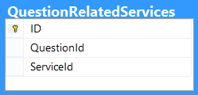

## Service and staff users template data tables

The data structure of service and staff users are template based, except certain fields with are essential for system operation, defined in the tables ServiceUsers and StaffUsers. So it is possible to adjust what data fields these users have based on deployment scenario, such as level of integration with other systems, national requirements, etc...

### ServiceUsers_Template

The table describes a structure of data for a service user (patient).

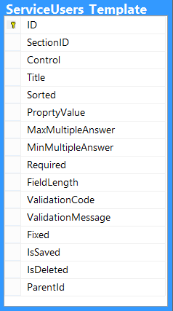

### ServiceUsers_Sections

The table list sections (logical groups of fields) for a service user (patient)

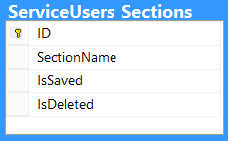

### StaffUsers_Template

The table describes a structure of data for a service user (patient).

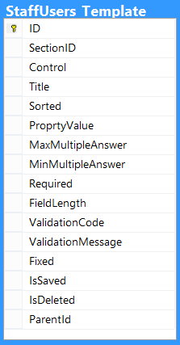

### StaffUsers_Sections

The table list sections (logical groups of fields) for a service user (patient)

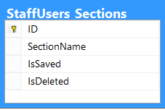

## Other data tables

The list below contains other miscellaneous tables that directly not belong to any classification/tables group above.

### AddressControl_Data

The table stores address data for users of the system.

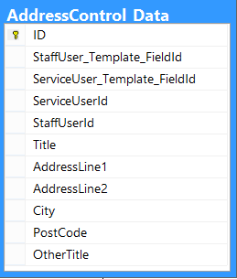

### Config

The table cointains solution-wide configuration data, such as default language, mail server params, etc… 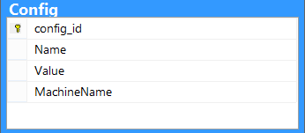

### Devices

Lists devices (sensors) supported in the solution.

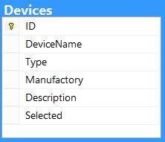

### VideoCall_Statuses

Contains list of all possible video call statuses (Call in progress, missing, etc…)

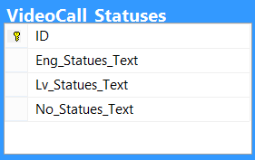

# Data model diagram

Data model diagram is shown in APPENDIX 1 of the document.