iCarer
Collaboration Portal
Dec 2013

Project ID: AAL 2012-5-239
Call: AAL Call 5
Full Title: Intelligent Care Guidance and Learning Services Platform for Informal Carers of the Elderly

Table of Contents

1 Summary 3
1.1 Events 3
1.2 Work Plan 3
1.2.1 WP1 Progress 3
1.2.2 WP2 Progress 4
1.2.3 WP3 Progress 5
1.2.4 WP4 Progress 5
1.2.5 WP5 Progress 5
1.2.6 WP6 Progress 6
1.2.7 WP7 Progress 6
1.3 Q7 Planned UK Partner Activities 6
1.4 Milestones 6
1.5 Effort & Financial Claims 7
1.6 Issues 7
1.7 Deliverables 7

Introduction
The iCarer Collaboration Portal (iCP) was created and made available to the Consortium Partners in December 2013.
iCP is a web-based tool based on an off-the-shelf product called Cyn.In. It is a secure web application with access only provided to authorised users based on a username/password combination. All communications with iCP are secured and encrypted using internet-standard SSL encryption.
iCP is available at https://collaborate.tunstallresponse.co.uk/home/eu-projects/icarer with a link available on the main iCarer website.

iCP Structure
Once valid users have logged in they are provided controlled access to a collection of secure “spaces”. Each space represents a location to store documents, share information (links, comments), review and feedback, submit progress reports and track progress. Figure 1: Web site structure of iCP below shows a partial layout of iCP, illustrating the types of content managed and how this is organised:

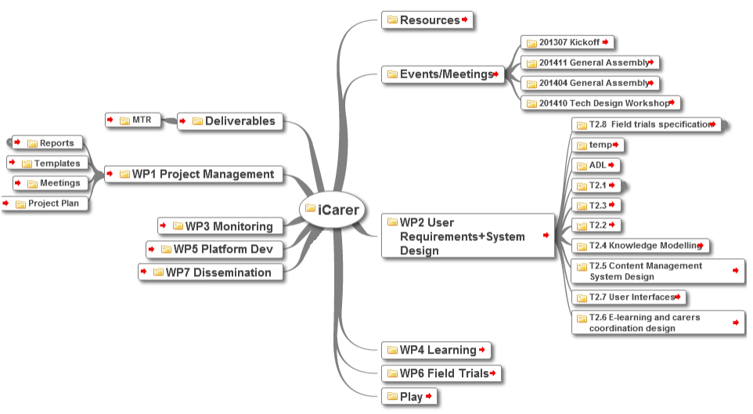
Figure 1: Web site structure of iCP
Whilst it is not intended to describe the full structure of iCP here, as the tool is intended primarily as an internal tool used by the Consortium, it should be noted that access has also been provided to the appointed UK Monitoring Officer to facilitate easy access to all published deliverables (made available in the Deliverables space).
Below is a screenshot of the iCP Welcome screen
