iCarer
Quality Plan

Deliverable Number: D1.4
Version: 1.0
WP: WP1
Dissemination Level: Restricted
Date of submission:

Project ID: AAL 2012-5-239
Call: AAL Call 5
Full Title: Intelligent Care Guidance and Learning Services Platform for Informal Carers of the Elderly

Document History
Version | Date | Comment | Author
0.1 | 02/10/2013 | First draft of section 3 and 4 | Rafael Llarena
0.2 | 11/10/2013 | Incorporate review comments | Rafael Llarena
1.0 | 14/10/2013 | Final version | Rafael Llarena

Table of Contents

1. Introduction 3
2. Document Quality Management 4
2.1. Exchangeable Documentation 4
2.2. Document Storage 5
2.3. Mechanism for producing and accepting Deliverables 6
3. Quality Assurance 8
Annex 1 – Review report template 9

- Introduction
The aim of the present document is to describe the Quality Assurance Plan for the iCarer project. This document includes all the planned and systematic activities implemented within the quality system to provide tools that ensure the project will satisfy the relevant quality standards and will be performed throughout the project as a continuous process. This document includes a set of guidelines and metrics to monitor the evolution of the project and support the project co-ordinator and the consortium in the assessment of the quality of the project results.
The tools and procedures defined in the quality plan will be used in all Work Packages and tasks of the iCarer project. The scope of the quality plan includes the production of every outcome of the project, from documentation, to software, and any other outcome of the work done in the Work Packages. Thus, this deliverable is an input to the rest of Work Packages in the project.

- Document Quality Management
All documents generated in iCarer should be based on the template of the project. The template file, iCarer Template.dotx, has been provided as a Microsoft Word template. The template has been designed for deliverables, however in order to maintain coherence between the documents exchanged within the consortium all documents should utilise the same template.
  - Exchangeable Documentation
The document repository included in the private sectin of the portal will be used by the different partners to colaborate in the preparation of the documents. In order to facilitate the cooperation between the partners and to keep track of the different versios of a work-in-progress document, the following controls are defined:
- All documents will be in .doc format, and the track changes tool will be activated in order to review and accept the changes.
- The cover page will always include the following information:
  - Document title
  - Deliverable Number
  - Version
  - WP
  - Dissemination Level
  - Date of submission
  - Project ID: AAL 2012-5-239
  - Call: AAL Call 5
  - Full Title: Intelligent Care Guidance and Learning Services Platform for Informal Carers of the Elderly
- The naming of the document will comply with the following structure: yyyymmdd-Document Title – AAA – vX.Y.doc where
  - yyyymmdd : date of the current version
  - Document title: if an official deliverable, it must include the deliverable identification in the description of Work (DX.Y)
  - AAA: Acronym of the authoring Partner
  - vX.Y: where Y represents minor changes in the document with respect to version X. The version number X is changed when major changes are incorporated.
Structure of the deliverables:
A deliverable will always include the following sections:
- Cover: first page must be completed ensuring that all the information is correctly provided.
- Document history: information about the different versions of the document and its authors.
- Table of Contents: An index of the deliverable contents.
- Executive Summary: Usually one page describing the general objective of the project and focussing on of particular objectives of the deliverable and how this deliverable contributes to the consecution of the objectives of the WP.
- Introduction: A short description about how is organised the information within the document and which aspects have been taken into account.
- Content: Deliverable body or substance. The rest of the documents will be annexed to the deliverable.
- References: List of documents that have been used as a reference to this document.
- Annexes: additional documentation to support the contents of the document.

  - Document Storage
Documents will be stored in the private section of the website. For the sharing of documents, the Cyin.in collaboration portal will be used. This tool allows for the sharing of documents, but also the sharing of information, articles, discussions forums and other collaborative tools to ensure the smooth communication among the partners. A dedicated installation of the portal will be used for the purposes of the iCarer project.
In principle, the following functionalities will be used for the coordination of the project activities:
- Spaces: group all information related to the project or a single WP. A general space for the project will be created, as well as one space for each WP. Each space comprises several tabs for different purposes. In the iCarer project, the following tabs will be used, but other tabs could be used if the consortium decides upon particular needs:
  - All: summarizes all the latest activity in the space.
  - Discussions: allows to open discussion topics and to follow up with replies from the different participants.
  - Events: provide information about past and upcoming events. It will be used for both internal events (General or specific meetings) and external events that could be of interest for the project’s objectives and for dissemination purposes.
  - Files: document sharing tool. Allows to upload multiple documents and to control different versions, modifications and authoring.
- Subspaces: if the WP leaders deem it necessary, subspaces for particular tasks or deliverables could be created.
- Collections: by the use of tags, smart collections can be created to perform predefined intelligent searches on the contents.
- People: directory of users of the system, including contact information and user activity.
All partners has access and permissions to upload and download documents, writing in forum, open discussions and add new events.
For management purposes, the tool also allows to see reports of the users’ activities and the contents created in the portal.
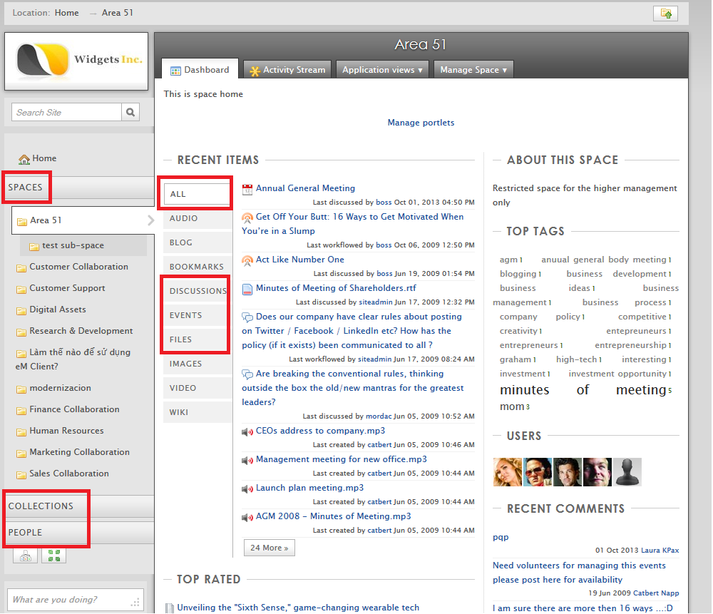
Figure 1: Structure of collaboration portal

  - Mechanism for producing and accepting Deliverables
All project deliverables described in the Description of Work that will be submitted to the Project Officer will be subject to a project internal review procedure. The objective of this procedure is that all the documents comply with the quality standards defined in this document and fulfil the scientific objectives defined in the project. Thus, the review process includes two parts: a review of the document format and consistency, and a technical review of the contents.
For each deliverable, an internal peer reviewer will be appointed. This reviewer has to be different from the people that wrote the document, and also different from the WP responsible. When performing the review, two aspects will be key:
- Formatting issues: format, compliance with the template, legibility including language and typos, etc.
- Contents: scientific and technical correctness, alignment with the project and WP objectives, relevance, innovation, inclusion of references, , etc
Procedure
The following procedure describes the steps to produce and approve a deliverable:
- The Deliverable responsible will elaborate a first outline of the document, including a summary of what the document is intended to provide, as well as a Table of Contents describing the structure of the document. This outline will be distribute among the contributors of the document, as well as the Project Co-ordinator and the Technical Co-ordinator. The table of contents must include which partners will contribute to each of the sections.
- The first outline must be approved by all parties involved, the process of writing the document begins.
- All partners involved will collaborate (using the internal portal and the track changes functionality) to prepare the Draft Version of the document. This document must contain a preliminary version of all sections of the document and has to comply with the formatting rules and the provided template.
- The Draft Version will be shared with the appointed peer reviewer. The peer reviewer will provide a report on the review, including comments or suggestions, issues found and a recommendation of whether to release or not the document.
- The Technical Co-ordinator will coordinate the discussion between the deliverable responsible and the peer reviewer if needed. Once the results of the review report have been incorporated to the document, a second draft will be released for a second peer review.
- This iterative process will be done until the review report recommends the releasing of the deliverable. When the review process is finished, the document will be released as Final Version.
- The Project Co-ordinator and the Technical Coordinator will perform a last review of the final version before submission.
- The Project Co-ordinator submits the official final deliverable to the Project Officer and informs the consortium.
A template for the review report is provided in Annex 1.

- Quality Assurance
In order to contribute to the overall success of the project, a quality assurance procedure will be established in iCarer. Quality of project outcomes will be internally assessed during the whole lifetime of the project, and correcting measures will be taken if necessary. Within this section, main components of this procedure will be defined. These comprise the elements which quality will be measured and the criteria and methodology to measure their quality.
A set of quantitative and qualitative metrics are defined. This section describes the metrics defined, including the expected value to evaluate the success of the project.
Type | Metric ID | Description | Minimum expected value
QT | QT1 | On time delivery of deliverables: number of deliverables submitted on time | 95%
QT | QT2 | On time completion of Milestones: number of milestones completed on time | 95%
QT | QT3 | Accepted deliverables: number of deliverables accepted | 100%
QT | QT4 | Number of users recruited: number of users involved in the two pilots | 100% (48)
QL | QL1 | Service user satisfaction: percentage of users satisfied with the system | 80%
QT | QT5 | User compliance: percentage of users completing the full duration of the pilots | 80%
QL | QL2 | Platform tests: the final platform implemented complies with the requirements defined
QL | QL3 | Field trial analysis: the outcomes of the field trials show a positive impact in the carers quality of life
…

This metrics will be monitored during the project to ensure that corrective actions can be taken if needed. At the end of the project, the final report will include an evaluation on the level of compliance with this quality indicators.

Annex 1 – Review report template

REVIEW REPORT FOR DELIVERABLE DX.Y

Document Title
Responsible
WP
Author(s)
Expected submission

Relevance
Is the content of the document relevant to the project and WP objectives?
Contents
Is the document covering the expected scope, in relation to the objectives of the WP and the impact in other WPs?
Is the level of detail appropriate? Does it provide sufficient information, with an adequate depth?
Does the document contain all the definitions or references to ensure the contents are clear?
Are the conclusions of the document well supported?
Formatting
Is the document complying with the format? If not, indicate where and why
Are there any language problems that have not been solved?

OVERALL EVALUATION:
Can the document be accepted for submission?

YES NO

Reviewer:
Date:

