Project ref no | AAL-2012-5-239
Project acronym | iCarer
Project full title | Intelligent Care Guidance and Learning Services Platform for Informal Carers of the Elderly
Dissemination level | Public
Date of delivery | 2/26/2014
Deliverable number | D7.3
Deliverable name | D7.3. Dissemination plan
Type | Report (R)
Status | Draft
WP contributing to the deliverable | WP7
Main contributors | TUNSTALL
Other contributors | <Other contributor 1: other contributor 2…>
Author(s) | <Short name of participant institution 1 (author 1; author 2, …), Short name of participant institution 2 (author 1; author 2, …)
Keywords | <Add keywords separated by semicolon>
Abstract (for dissemination) | <Add abstract>

Intelligent Care Guidance and Learning Services Platform for Informal Carers of the Elderly
AAL-2012-5-239
Deliverable
D7.3
D7.3. Dissemination plan

Public
© 2013-2016 iCarer Consortium

VERSION HISTORY
Version | Edited by | Date | Description
0.1 | Tunstall | 26/02/2014 | Draft for review
0.2 | UPM | 07/04/2014 | New draft for review
0.3 | Tunstall | 22/11/2014 | Updated dissemination events
0.4 | UPM | 09/02/2015 | New events included

Table of Contents
1. Introduction 5
Summary 6
2. Introduction 7
3. Multi-channel Dissemination Strategy 9
a. Partners involvement 9
b. Potential Target Groups 10
c. Dissemination Success Indicators 10
d. Raising Awareness and Critical Mass Aggregation 11
e. Dissemination Instruments 11
f. Dissemination Activities 18
4. References 21

Summary
This document presents the first draft version of the dissemination plan that will be updated at the end of each project phase. Also updated versions of the dissemination plan will be part of deliverable D7.5 (iCarer business and exploitation plan)
The goals of the iCarer dissemination and awareness activities are to:
- disseminate the project objectives towards the potentially interested stakeholders thus generating broad awareness
- obtain valuable feedback on intermediate project results
- establish valuable liaisons with relevant research initiatives in the relevant project fields
- prepare for early and broad adoption of the iCarer services after completion of the project
The first part of the document provides a general overview on the dissemination methodology, including:
- main results to be disseminated throughout the project
- target groups to focus on
- dissemination channels and instruments
- indicators to assess the impact of various dissemination actions
In the second part, the multi-channel dissemination strategy is detailed including the main planned dissemination activities for the coming period per each partner.

Introduction
iCarer dissemination will be implemented by using gradual and progressive release of information. To this end, the project is designed so as to regularly contribute to dissemination:
- during the first year of the project the ideas behind the proposal will be turned into concise presentations or posters, to illustrate the project goals to the interested stakeholders and early adopters
- starting from project month 27, the first version of the iCarer system components and services will be available and the initial results will be disseminated through papers
- in the third year, users involved in the project will document their experience.
The overall approach described in this chapter defines relevant steps for successful dissemination of the results during the lifetime of the project.
In the domain literature, three levels of dissemination for a project are defined:
- Awareness about the project itself, its objectives and its outcomes needs to be risen. This can be achieved using various dissemination media and communication channels.
- The work done in the project needs to be understood by the stakeholders. The disseminated outcomes of the project have to be well adapted for particular target groups and their standard of knowledge.
- Actions involving a change of practice that is caused by the eventual adoption and use of results of the project need to be defined. Therefore the target group for this way of dissemination is the industry sector as well as all enabling organizations (e.g. public authorities), that are in the position to prepare a favourable political ground which will facilitate the adoption of the project main outcomes.
An appropriate dissemination strategy will raise awareness and deeper understanding of the project and will lead to action based on the work undertaken within the project. Also, dissemination activities in this approach will ensure a wide visibility and identification of the project and will be based on a marketing driven dissemination. The main actions are listed below:
- Design of the iCarer brand (logo, colour scheme, document templates)
- Design of promotional materials such as posters, flyers, etc.
- Participation in exhibitions, workshops, specialised international meetings, etc.
- Articles in magazines, e-journals, forums, mailing lists, press releases, etc.
- Media coverage (TV, radio presence, etc…).
In general attracting relevant stakeholders and aggregating critical mass of interested potential users and early adopters will strongly contribute to the widespread adoption of iCarer services.
The main outcomes of iCarer will become available through a group of public deliverables agreed with the European Commission in the Description of Work. The following table shows the deliverables which will be available for public access on the project website.
Table 1. iCarer Public Deliverables
Id | Title | Delivery Date
D1.2 | Start-up of the management  and collaborative portal | M6
D1.3 | Action Items List, Document  list, Progress Reports | As per scheduled meetings
D1.4 | Quality plan | M12
D1.5 | Final report | M36
D2.1 | Users’ requirements and iCarer scenarios | M9
D2.2 | iCarer specifications | M12
D3.5 | Validation results report | M20
D5.4 | Platform test results | M27
D6.1 | Usability tests results | M15, M25, M28
D6.2 | Field trial analysis | M36
D7.1 | Project Presentation and Press Release | M6
D7.2 | iCarer project web site | M6
D7.3 | Dissemination plan | M9

Multi-channel Dissemination Strategy
A proper multi-channel dissemination strategy will be defined with the aim of using the right combination of media channels and the most suitable mix of promotional material at the right time in the project.
In order to allow the project to effectively communicate with the external world, we have defined the following key points, which will help us shaping the dissemination plan:
- Involving all partners into the dissemination campaign
- Identifying the most promising potential target groups
- Defining the objectives of the dissemination and planning their achievement along the project lifetime by the definition of suitable Dissemination Success Indicators
- Awareness raising on the project vision and outcomes, which will be based on a continuous critical mass aggregation aimed at creating significant liaisons with the most relevant communities and international / national initiatives on Ambient Assisted Living
- Dissemination instruments identification for each target group (flyer, communication papers and booklets, questionnaires, brochures, etc.)
- Planned dissemination activities to promote and present the on-going results of iCarer and more generally the benefits of the proposed technologies and tools to the interested stakeholders

Partners involvement
All partners taking part in the project are involved in the dissemination activity. For a quicker decision making and organizational process we foresee the need to constitute a restricted dissemination team consisting of one representative from each partner. The dissemination team will be in charge of:
- Coordinating dissemination activities;
- Updating the document whenever new dissemination activities and results occur;
- Reviewing the documentation.
The following activities must be carried out by each partner of the consortium:
- Help identify potentially new interested stakeholders
- Contribute to the project website
- Produce and distribute press releases
- Facilitate occasions for the involvement of external actors in the project’s activities
- Promote the organisation of focused events by publicizing them on the project website
- Participate in relevant events where the project can be introduced and displayed.

Potential Target Groups
A fundamental issue for delivering a suitable dissemination plan is the identification of potential target groups, each of them being approached with a different yet specific communication message. The expected target audiences of the project are likely to be comprised within the following categories:
- Older adults living at home
- Older adults living in care homes
- Informal carers
- Health agencies and organizations
- Standardisation bodies
- Local authorities and national/regional public bodies

Dissemination Success Indicators
In order to assess the effectiveness of the dissemination activities in comparison with the planned objectives along the project lifetime, a set of dissemination Success Indicators have been defined in Table 2. If expectations are met, according to these indicators, then the dissemination activities will be regarded as successful.
Table 2. Dissemination Success indicators
 | Awareness impact metrics
Id | Tool | Type | Success Indicators | Coverage
1 | The web site - one of the main ways to validate and disseminate results for the project | Quantitative | ≥ 1000 accesses per year | Worldwide,  general and specialised target
 |  |  | ≥ 100 downloads per project lifetime
2 | Press echoes from all over Europe showing the relevance of the project to the public | Quantitative | ≥ 5 | Europe
3 | Scientific papers | Quantitative / Qualitative | ≥ 10 | World wide
4 | Conferences, exhibitions and other events indicating the interest on the various topics covered by iCarer | Quantitative / Qualitative | ≥ 5 | Worldwide,  specialised target
5 | Focused workshops designed for the potential iCarer users and researchers | Quantitative | > 1 | Europe
6 | Co-operation with other initiatives and AAL projects | Quantitative | > 1 | Europe

Raising Awareness and Critical Mass Aggregation
For establishing iCarer as a significant entity in the above identified targeted domains it is necessary to ensure the continued success of the project. Raising project awareness will be achieved through a variety of tasks which will be specifically correlated to presenting iCarer into new domains and to new audiences. This process will be performed by all partners in order to maximize the publicity of iCarer goals and initiatives. The design and distribution of iCarer dissemination material at different events (conferences, workshops, or EC events) constitutes an integral part of the dissemination campaign.
The involvement of a critical mass of stakeholders around the project is a crucial point that will guarantee the creation of strong impact around iCarer. In this respect remarkable effort will be dedicated to attracting and collaborating with the existing initiatives and all the experts operating in the field of ambient assisted living and informal carer support.
Interaction with working groups focusing on informal carers and older adults in international consortiums will be pursued. Also, similar projects will be contacted with the aim to foster synergies and collaboration. Table below illustrates the possible relevant initiatives with which iCarer project can interact.
Table 3. Initiatives relevant to iCarer project
Id | Initiative | Website | Description
1 | EIP-AHA (European Innovation Partnership on Active and Healthy Ageing) | http://ec.europa.eu/research/innovation-union/index_en.cfm?section=active-healthy-ageing | The European Innovation Partnership on Active and Healthy Ageing will pursue a triple win for Europe:  - enabling EU citizens to lead healthy, active and independent lives while ageing;  - improving the sustainability and efficiency of social and health care systems;  - boosting and improving the competitiveness of the markets for innovative products and services, responding to the ageing challenge at both EU and global level, thus creating new opportunities for businesses.
2 | AAL Forum | http://www.aalforum.eu/ | The AAL Forum is the annual platform for the increasing European AAL community to meet and discuss seceral topics, relevant for improving the AAL JP as well as the adoption of AAL solutions in the market. It is an initiative of the AAL Joint Programme.
3 | eVIA (Platform For Health and Independen Living Technologies) | http://evia.imasdtic.es/ | eVIA is a platform that acts as a network for scientific-technological cooperation to promote a innovative research, development involvement of R&D stakeholders
X | Other initiatives to be added here

Dissemination Instruments
Different dissemination materials have been professionally designed and new materials will be produced throughout the entire project lifespan according to different communication needs, to various event typologies and, of course, to the evolution of the project.
Two dissemination types will be addressed: (i) End User-oriented Dissemination and (ii) Scientific Dissemination. Both dissemination instruments and channels will be tailored to the specific dissemination type. However the following subset of dissemination and communication instruments are be common to both types:
- Branding Strategy (Logo, Document templates)
- Project Website
- Promotional Material (Poster, Flyer, etc.)
- Press Releases
- Twitter account
- White papers and presentations
- Participation in conferences, exhibitions, workshops, seminars or demo booths
The Scientific Dissemination will be specifically based on:
- Scientific Publications in conferences and in peer reviewed scientific journals
- Lectures, Symposiums

Branding Strategy
A suitable branding strategy has been designed in order to increase the visibility and the exposure of the project, including the logo and the document templates

The iCarer logo
The logo was designed to reflect the personality of the entire project and create a clear visual identity for the project. It was selected from a number of proposed designs by the consortium considering that it should be easily used in printouts, projected slides and on the web. It’s imperative that every event, presentation, newsletter, deliverable (both public and restricted), dissemination material, and web site make use of this image and be consistent with its style. This graphic gives people an attractive insight into the project vision.
Figure 1. iCarer logo

Document templates
A template for Microsoft PowerPoint presentations and written documents (excluding those that are to be created according to fixed format specifications, e.g. scientific papers) is available on the project web site private area (see Figure 2 screenshots). It enables uniform appearance, and ensures to provide essential information about the project and acknowledgements.
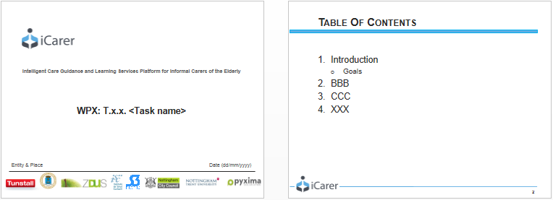

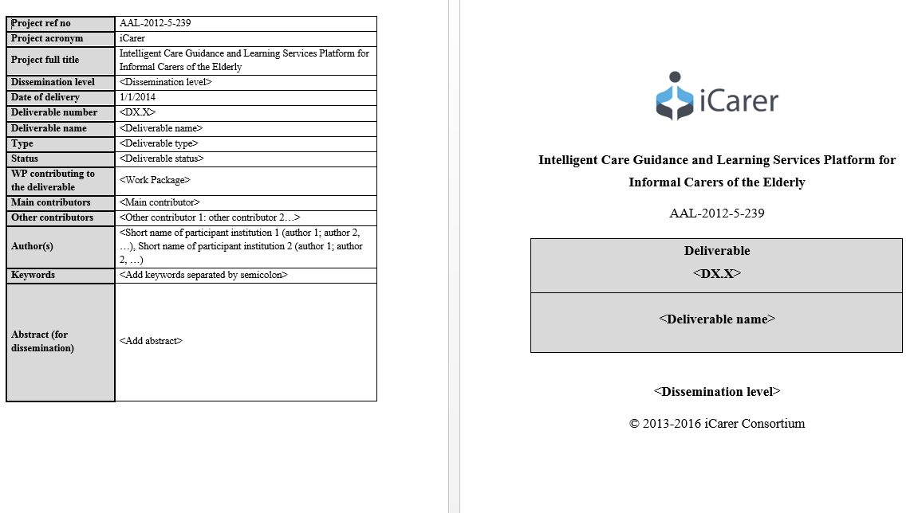

Figure 2. iCarer templates (ppt and doc)

The iCarer Website
The website is available at the URL: http://icarer-project.azurewebsites.net/. It plays an essential role in the overall project because it works as a main communication tool to disseminate and validate project results. It provides a wide array of functionalities including document uploading/downloading and news. The website will publish information about the project, and about its initiatives such as events, participation to conferences, workshops, etc. It provides to consortium partners user centric content management system that allows users to autonomously publish several types of content and to collect feedback. The website provides an access to the project general objectives and the main results. It will be updated regularly to inform on the progress of the project. Specific areas on the consortium, contact and links are also available on the website. The website will also aim to attract the interest of authorities, AAL professionals and citizens. It will include topics on project development as well as official documents (deliverables, questionnaires, etc.). Figure 3 shows a screenshot of the website home page.
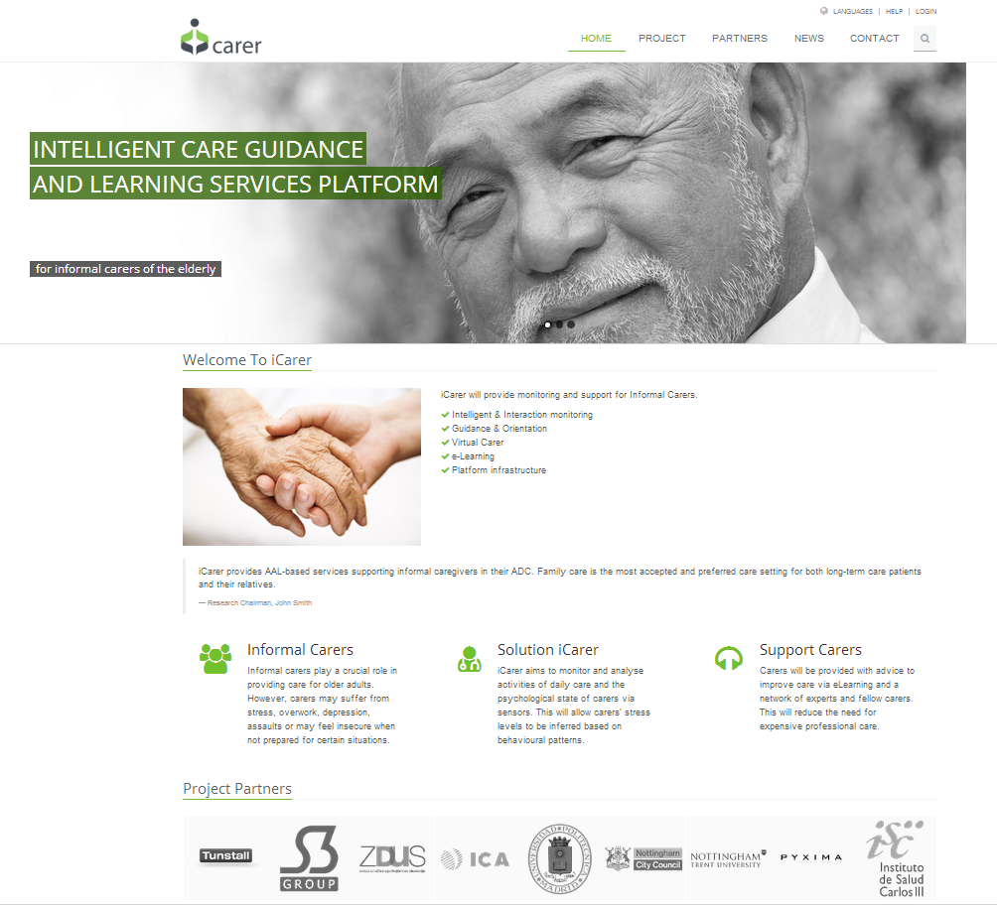
Figure 3. Screenshot of web site homepage

The public area contains all information related to the project overall description, approach, objectives, project phases, activities, results, updates. The public area sections of the website are detailed in the table below.
Table 4. iCarer Website structure
The partner’s private area is accessible via the homepage, but restricted to the partners. This private area will support the internal status of the project, containing all confidential documents to be shared among project participants (in both, draft and final versions).

Poster
A poster for the iCarer project has been designed to serve, along with the project logo, as a first and essential step for the iCarer project in achieving such a brand (see Figure 4). The poster text has been initially produced and agreed among partners in English. The text will later be translated to the Consortium national languages. The project poster will be available to be downloaded by the project web site under the Publications public area. Another edition of the poster will be produced towards the end of the project, addressing mainly the outcomes of the project.
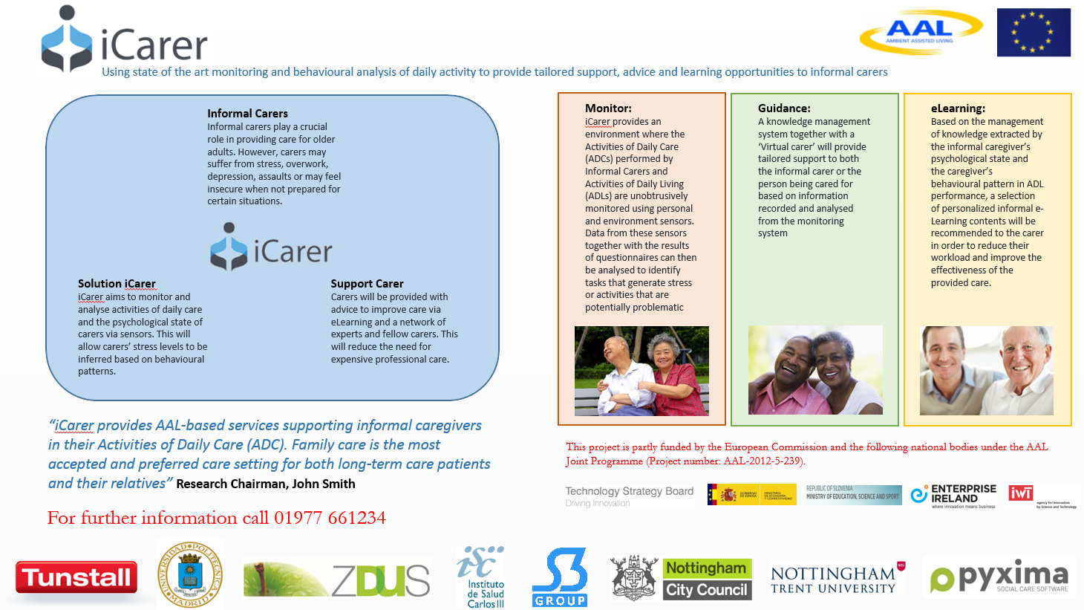
Figure 4. iCarer Poster

Press Releases
It is the intention to also disseminate and circulate the results of the project via the publication of press articles / releases in both the general and specialised press. These articles will be released to give journalists information about project activities in general, or to highlight the quality of the work completed. Additional information about project results, products, or specific scenarios activities will be included in future press releases according to specific needs. These articles will contain general information about iCarer and the Consortium, the opportunities offered by the iCarer Community to various sectors, and indicate the main channels where to find out other relevant information. Press releases will be mentioned in the “Dissemination area” of the project website.
Special events throughout the project lifecycle that that may call for a press release include:
- The project’s beginning, in order to inform the public about the project and its goals and the end of the project, to show the outcomes of the project
- iCarer workshops
- Special occasions for a consortium partner
- Announcement of significant strategic alliances
- Adoption by a very important player of iCarer solutions

Twitter Account

Scientific publications
Scientific papers that discuss aspects of the work conducted in iCarer, or that make significant mention of iCarer methodologies and technologies, should be published on the project’s communication website whenever not infringing the IPR matters. In this last case, the abstract of the paper will be made available on the project website. Each paper will be reported according to the procedure outlined in this document. When appropriate, the papers must acknowledge the total or partial financial support of the European Commission through the iCarer project.
Relevant journals, which are indexed in the journal citation reports, addressing ambient assisted living where scientific publications can be used for dissemination are presented below:
- IEEE Journal of Biomedical and Health Informatics
- Journal of Ambient Intelligence and Smart Environments
- Artificial Intelligence in Medicine
- Expert Systems with Applications
- Medical & Biological Engineering & Computing
- International Journal of Data Mining and Bioinformatics
- Journal of Telemedicine and Telecare,

Lectures and presentations
Selected presentation slides on iCarer are made available online on the project’s communication website. Every formal or informal presentation of iCarer, including academic lectures and seminars concur to the dissemination activities and should therefore be reported according to the procedure outlined in this document. The official iCarer template for presentation slides available on the website must be used.

Events
The iCarer project will be represented in a number of international relevant scientific, technical and/or political level conferences and symposiums in the field of Ambient Assisted Living, through specific workshops co-located within planned conferences, or through a booth within the exhibition area of a conference or a fair. Some project domain focused conferences where potential adopters can be met or attracted are already identified:
- AAL Forum http://www.aalforum.eu/
- AHA.si – Active and healthy ageing in Slovenia
- Eurocarers Conference
- Raate Conference (http://www.raate.org.uk/)
- Naidex Conference (http://www.naidex.co.uk/)
- Occupational Therapy Show (http://www.theotshow.com/page.cfm/ID=1)
Also, an initial list of conferences and workshops in which one or more iCarer partners have either taken part or aim to take part will be presented in table 5
One international iCarer workshop will be organized with the aim of presenting and discussing the impact of iCarer services. The workshop will tailor scientific experts in the field of Ambient Assisted Living and decision-makers coming from the industrial world. The workshop will be organised within relevant conference in the field, in order to exploit the people already attending the conference. The proceedings of the workshop will be published.

Dissemination Activities

Dissemination Reports
The outcomes of dissemination activities are collected from all Consortium partners and periodically assessed by the consortium partner responsible for dissemination activities in order to document the project dissemination, to determine the most effective dissemination channels, to highlight best practices, and also to find areas of improvement. The evaluation and research of development work through surveys and user requirement collections will also help direct dissemination initiatives and identify specific user needs.

Individual Partners Dissemination Plan
The table below reports all the dissemination initiatives attended or planned by partners. Updated partner dissemination plans will be delivered at project month 18 (D6.1) and project month 36 (D6.2).

Table 5. Partner individual dissemination
Id | Event | Date | Location | Audience | Objective | Instruments | Partners
1 | AAL Forum 2014. | 2014 | Bucharest, Romania | Scientific and Industrial Audience / International | Interaction with similar initiatives, AAL board discussions | Interactions | TUN, NTU
2 | AHA.si – Active and healthy ageing in Slovenia | 2014 | Slovenia | policy makers and stakeholders on national level; public social and health sector in Slovenia | to include icarer as an example of good practice: how to ensure independent living of seniors with the help of ict in long-term care;  possible recommendations for developing a national strategy of healthy ageing |  | ZDUS
3 | Eurocarers | 2014 | Helsinki | members of Eurocarer – European Association working for carers; stakeholders: Association of Social Service Employers Finland, Carers UK, Central Association of Carers in Finland; policy makers: Ministry of Social Affairs and Health of Finland, European Parliament Interest Group on Carers | networking with stakeholders, possible interested parties for iCarer final products; networking with INNOVAGE project partnership , possibilities for cooperation/exchange between the platforms
4 | RAatE Conference  http://www.raate.org.uk/
5 | Naidex Conference http://www.naidex.co.uk/
6 | Occupational Therapy Show  http://www.theotshow.com/page.cfm/ID=1
7 | Nottingham Trent University Showcase | 30/4/14 | Nottingham
8 | XXXII Annual Congress of Biomedical Engineering Spanish Society (CASEIB 2014) | 26/11/2014 | Barcelona (Spain) | Scientific researchers, industry professionals, and biomedical engineering | Scientific paper which describes the main features of the iCarer project | Scientific paper (Poster) | UPM
9 | Tunstall web page | 01/12/2014 |  |  | Press release describing the main targets of the iCarer platform | Press Release | TUN
10 | Medical Informatics Europe Congress | 27/05/2015 | Madrid (Spain) | Scientific researchers, industry professionals, and biomedical engineering | Scientific paper which describes the iCarer project. Name of the paper: “ submission iCarer: AAL for the Informal Carers of the Elderly” | Scientific paper (Poster) | ISCIII

References
[1] Reference 1.
[2] Reference 2.
[3] Reference 3.

Note: In order to use the same bibliography style in all documents, the style suggested is IEE Reference order. If you are not used to it, please use a similar one.

S. Harmsworth and S. Turpin. Creating an Effective Dissemination Strategy.TQEF national Co-ordination Team, 2000.

