Project Fact Sheet

Name of the project and acronym
SOcial Networks for Older adults to Promote an Active Life (SONOPA)

Coordinator (company or organization):
Docobo Limited

Duration of the project and starting date:
36 Months Starting May 2013

Partners:
Docobo | SME | UK | www.docobo.co.uk
Saxion University of Applied Sciences | R&D | Netherlands | http://www.saxion.edu/
Smart Signs | SME | Netherlands | www.smartsigns.nl/en/
University of Deusto | R&D | Spain | www.deusto.es/servlet/Satellite/Page/1334665535266/_ingl/%231334665535266/cx/UniversidadDeusto/Page/HomeTPL
SpringTechno | SME | Germany | www.springtechno.com/
Blue Danube Robotic | SME | Austria | http://bluedanuberobotics.com/index.php/en/
E-seniors | End-user | France | www.e-seniors.asso.fr
Camera-Contact | SME | France | http://camera-contact.com/offre.html?&LANG=en_US
iMinds/Ghent University | R&D | Belgium | www.iminds.be/en
The Christelijke Mutualiteit | SME / End-user | Belgium | www.cm.be/international-website/index.jsp

Objective of the project (7 lines-no more no less):
SONOPA will employ a set of available ICT technologies to develop an end-to-end solution for stimulating and supporting activities at home. Collected data will enable the system to track variations in the daily activities over time in order to detect the right time to provide a recommendation. This allows for timely access to quantitative data from the user and allows the activation of individual and social recommendations. The offered recommendations can be in the form of suggesting individual activities at home, such as preparing meals or social interactions with peers.

Project Overview (Including technology in use, end-users involvement – 12 lines sharp):
SONOPA will achieve its objective through a data collection and fusion structure which merges real measurements of the user’s activities in order to encourage activities with their peers. Reminders and recommendations come through personalized easy-to-use wall displays placed at the user’s home. SONOPA will employ data analysis techniques to derive a model for the wellness of the user along four dimensions: social, nutrition, leisure habits and mobility. Technologies include: (i) measurement systems that monitor and register the activities of the user at home and with their peers, (ii) behaviour modelling and user profiling techniques, delivering a pattern of the user’s activities over time by analysing and summarizing the large sensory data and registered logs; and (iii) a user interface providing personalized recommendations and reminders, encouraging activities to the user. End users from 3 countries will be involved in designing and testing Sonopa during the entire project life cycle.

Expected results and impact (7 lines sharp):
The goals of the project are in line with the goals of the end-user organizations. Each organization is expected to agree on an expected outcome with their end-users and work with them to achieve this. The ideal goal is that the individual end-user will develop an increased personal confidence and competency from using the system and recognize it as a user-friendly and easy-to-use technology device with flexible features. It is expected that end-user organizations working on the project will continue to suggest features that can further enhance the service.

Total budget of the project:
€3.238.818,93

Public Contribution (National + EC):
€1.444.061,22

Images or graphic (Logo, images or photos showing the product or service):
Images or photographs (also graphics where needed) are mandatory. Send ftp link or esp file.
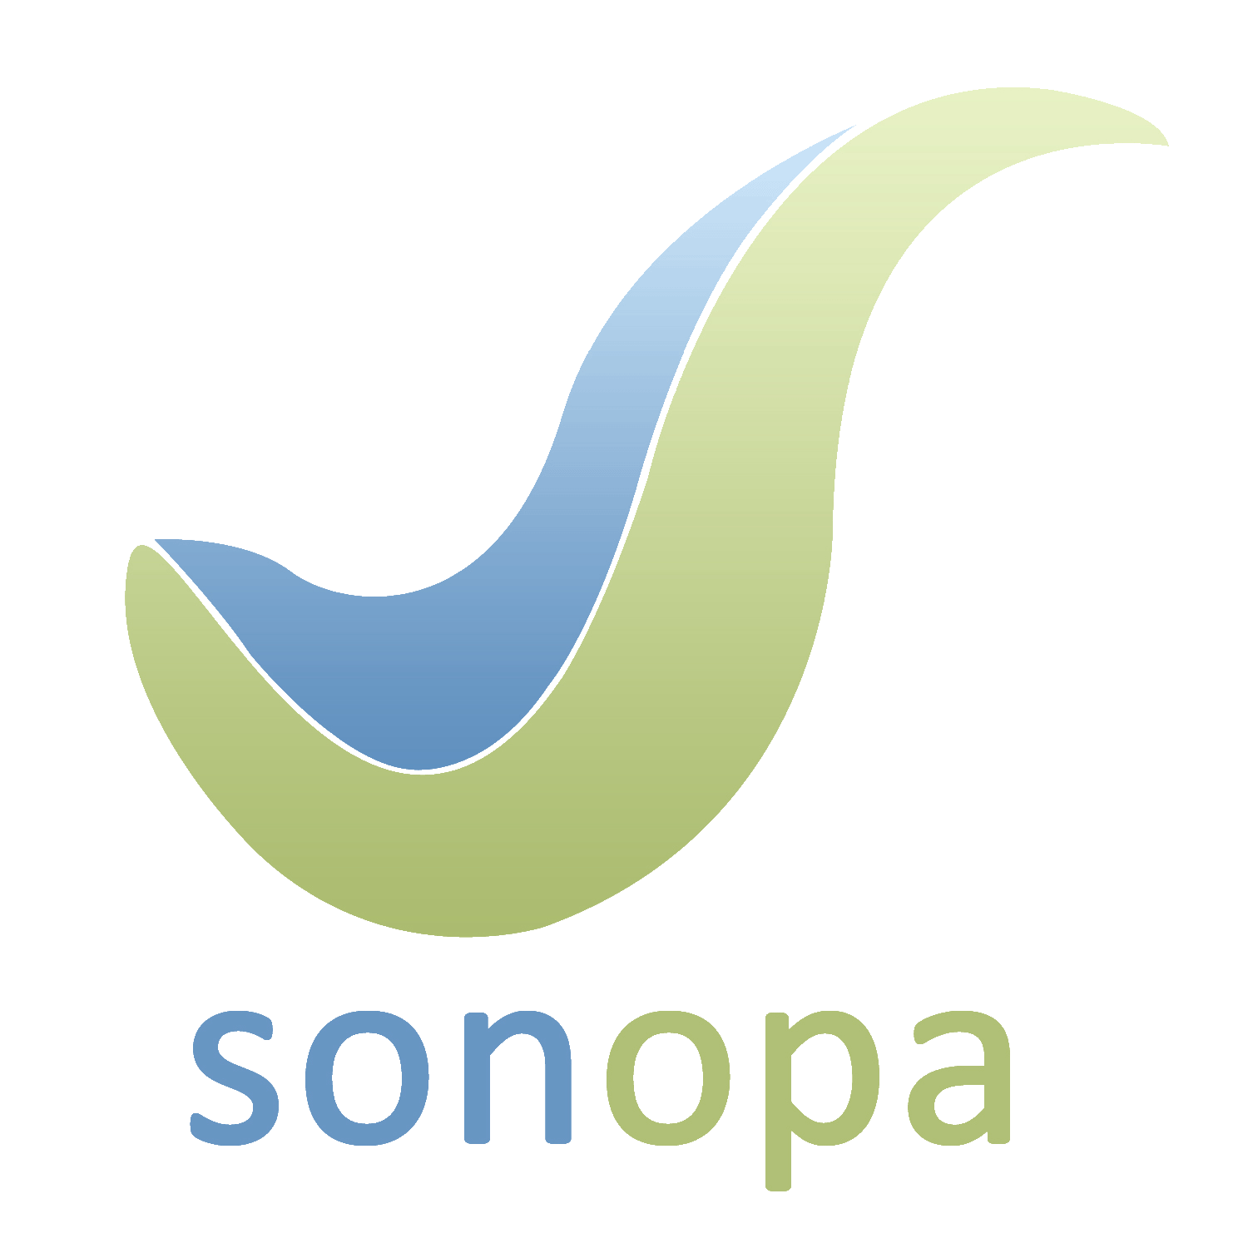

Website link(s):
www.sonopa.eu
Contact person (e-mail, phone, address):
Richard Plumbridge, richard.plumbridge@docobo.co.uk, +44 (0) 1372 459866, Docobo Limited, The Old Granary, 21 High Street, Bookham, Leatherhead, Surrey KT23 4AA, UK

