WP4 Planning, Deployment and Evaluation of Trials

Task 4.2 – Obtaining ADL Datasets

Contract number: | AAL-2012-5-187
Project acronym: | SONOPA
Project title: | SOcial Networks for Older adults to Promote an Active life

Deliverable D4.2 ADL Test Dataset Report

Author(s): | Francis Deboeverie, Ghent University - iMinds
Partners contributed: | Maria Lijding, SmS  Serge Smidtas, CCC  Aitor Almeida, DU  Mona Komulainen, ESE
Type of deliverable: | Report
Dissemination level: | Public
Deliverable deadline: | M23 - March 2015
Contact: | Francis Deboeverie  Ghent University - iMinds  Francis.Deboeverie@UGent.be

Release History
Release number | Author | Date | Release description / changes made
V0.1 | Francis Deboeverie, iMinds | 18/02/2015 | First report version for partners review and contribution
V0.2 | Mona Komulainen, ESE | 19/02/2015 | Revision of the report structure
V0.3 | Serge Smidtas, CCC  Francis Deboeverie, iMinds | 20/02/2015 | Revision of the parts related to the visual sensors and Visage-screen.
V0.4 | Maria Lijding, SmS | 04/03/2015 | Input for the parts related to the PIR-sensors.
V0.5 | Mona Komulainen, ESE | 05/03/2015 | General revision.
V0.6 | Mona Komulainen, ESE | 09/03/2015 | Content adding in all sections
V0.7 | Richard Plumridge, DO  Aitor Almeida, DU  Mona Komulainen, ESE | 16/03/2015 | Section 3.3,  Section 4.2,  General layout
V0.8 | Francis Deboeverie, iMinds  Maria Lijding, SmS  Mona Komulainen, ESE | 19/03/2015 | General layout  Section 4  General parts
V0.9 | Mona Komulainen, ESE  Daria Kyslitska, ESE | 25/03/2015 | Final review
V1.0 | Maria Lijding, SmS | 30/03/2015 | Section 4.3

Table of Content
1. Introduction 5
2. Installation in Belgium 6
2.1. Role of the Partners 6
2.2. Installed Sensors 6
2.2.1 Visual Sensors 7
2.2.2 PIR Sensors 9
2.3. Rollout of the Data Collection Phase 11
3. Installation in the UK 12
3.1. Role of the Partners 12
3.2. Installed Sensors 12
3.2.1 Visual Sensors 12
3.2.2 PIR-sensors 14
3.2.3 Visage Screen 18
3.3. Rollout of the Data Collection Phase 23
4. Data Analysis and the SONOPA-system Development 24
4.1. Collected Data and Data Protection 24
4.1.1 Diary 25
4.2. Obtained Data – Basis for the User Modelling Algorithms 25
4.2.1 Standard Mode 25
4.2.2 Premium Mode 26
4.3. Availability of the Obtained Data 28
4.3.1 Protocol for Requesting the Sample Data 28
4.3.2 Safe Storage of the SONOPA ADL Data 28
4.4. Visualization Tools 28
4.4.1 Statistical analysis of presence information 29
4.4.2 Visualization of sensor data 31
4.4.3 Heat maps 31
4.4.4 Fast Forward Animation 33
5. Conclusion 36
Annexes 37
Annex 1: Example of the Informed Consent in England 37
Annex 2: Participant information Form in England 40
Annex 3: Examples of the Diaries from England 44
Annex 4: Confidentiality agreement for obtaining data sets 47

List of Figures
Figure 1: Room layout and the visual sensor positions 7
Figure 2: Pictures from Dendermonde 8
Figure 3: Images produced by the visual sensors. 8
Figure 4: Setup of PIR sensors in flat in Dendermonde. 10
Figure 5: Examples of sensors installed in the flat. 10
Figure 6: Example of photo with PIR sensors 11
Figure 7: Room layout of the ground floor and the visual sensor positions. 14
Figure 8: Picture from installation in Surrey 14
Figure 9: Ground floor (left) and first floor (right) of the house in Surrey 15
Figure 10: Control during the installation. 16
Figure 11: Sensors are glued to furniture 16
Figure 12: Multi-hop Zigbee network 17
Figure 13: On-line visualization of sensor data 17
Figure 14: Visage screen camera view 1 18
Figure 15: Visage screen camera view 2 18
Figure 16: Visage screen location 19
Figure 17: Visage screen App menu 19
Figure 18: Example of an RSS feed 20
Figure 19: Visage screen user interaction with different Apps 21
Figure 20: Visage screen user interaction with different games 21
Figure 21: Motions during the day 22
Figure 22: Motions during the day 2 22
Figure 23: Motions during the day 3 22
Figure 24: Motions during the day 5 23
Figure 25: Link between WP4 and WP3 24
Figure 26 Steps of the activity recognition in Dense Mode 27
Figure 27: A tab showing all weekdays related to presence information 29
Figure 28: Visualization of user’s presence in bedroom 30
Figure 29: Visualization of user’s presence in Living Room 30
Figure 30: Visualization of user’s presence in kitchen 31
Figure 31: Example of a timeline with sensor data 31
Figure 32: Heatmap 1 32
Figure 33: Heatmap 2 32
Figure 34: Heatmap 3 33
Figure 35: Heatmap 4 33
Figure 36: Snapshot 1 34
Figure 37: Snapshot 2 34
Figure 38: Snapshot 3 35
Figure 39: Snapshot 4 35

List of Tables:
Table 1: Essential information of the visual sensors in Dendermonde 7
Table 2: Essential information of the PIR sensors in Dendermonde 9
Table 3: Essential information of the visual sensors in Surrey 13
Table 4: Installation of PIR-Sensors in the UK 15

Introduction
Obtaining ADL Datasets is the task 4.2 (running between M11 and M23) in the WP4 and it is coordinated by ESE. The aim of the task is to collect raw sensor data using a basic sensor infrastructure. This raw sensor data will be used as real dataset in order to guide the development of the User Modeling module and the corresponding algorithms.
The technical partners (iMinds, CCC and SmS) have an essential role in this task as they are in charge of the installation of the sensors, managing the data collection procedure and analyzing the collected data.
In line with the new version of the description of work (DOW), this data acquisition phase is conducted in two different installations, one in the UK and another one in Belgium, with representatives of the user group of the older persons. In consequence, the end-user organizations in the two countries (DO in the UK and CM in Belgium) recruited the voluntary participants, ensured that the entire data collection procedure respects the end-user’s rights and offered support when necessary.
This report, that is additional to the gathered dataset results, describes in details how the data collection procedure was carried out in the two installations. The first part will focus on the installation in Belgium, the second part will detail the installation in the UK and finally, the third part will explain how the collected data will be used for developing the SONOPA-system.

Installation in Belgium
The first installation of the visual SONOPA sensors is located in Dendermonde in Belgium and the Belgium project partners, iMinds and CM, manage it. Moreover, the installation, which started in February 2014, is situated in a service apartment of the CM, where an older person lives permanently. The voluntary older person participating in the installation is 83 years old person with diabetes and decreased mobility due to a little paralysis. However, the resident has a very clear mind.

Role of the Partners
The technical responsible of this installation is iMinds who develops the visual sensor sets that are integrated in the SONOPA-system. iMinds manages all the technical aspects of the installation and makes sure that the sensors are running and gathering data correctly. In case of technical trouble, they intervene in the test apartment. They went to the flat biweekly to swap hard disks and to transfer the data to their server.
CM, end-user partner of the SONOPA consortium, recruited the test person (TP) agreed to participate in the SONOPA experiment on a voluntary basis. CM’s main role is to preserve the TP’s rights (such as provide the informed consent and handle exit situations) as well as to respond to all questions that the participant has concerning his engagement in the SONOPA project.
Smart Signs Solutions installed the PIR sensors since the 19th of February 2015. The sensor data is stored locally in one of the computers installed by iMinds and can be accessed remotely by Smart Signs Solutions for analysis.

Installed Sensors
As the Belgium apartment is the very first installation, the SONOPA system installation was done in two steps:
As a first step, in August 2014 iMinds installed 10 visual sensors and two computers in a rectangular room of 25m². Five visual sensors are connected with wires to one computer. The visual sensors are prototypes and thus installed in a wired setup and powered by mains electricity. The visual sensors are fixed on the wall with double sided tape. One visual sensor produced a video file of 8GB per day in AVI format accompanied by a file with timestamps. In total, the visual sensors in the flat produced 80 GB per day, stored on a server at the Department of Telecommunications and Information Processing at Ghent University/iMinds. The hard disks were swapped biweekly by iMinds.
As a second step, in February 2015 Smart Signs Solutions installed 8 PIR sensors and a gateway. There is a PIR sensor monitoring each of the living areas in the house:
- bedroom,
- bathroom,
- living-room sofa,
- living-room comfy chair,
- eating/computer table,
- kitchen,
- storage,
- entrance hall.

Visual Sensors
Table 1 details the essential aspects of the installation in Dendermonde. The raw data was collected with 10 visual sensors. In addition to the collected data, the Test person was asked to fill in a diary (see Annex 4) enabling to verify the number of visitors per day, the time of waking up and the time of getting to sleep. This diary was designed and translated in Dutch by SUAS.
Table 1: Essential information of the visual sensors in Dendermonde
 | Details
Installation date: | 26/02/2014
Sensors: | 10 visual sensors, 2 computers
Data capturing under T4.2: | 26/02/2014 – 31/03/2015
Data: | The visual sensors produce 80 GB per day, stored on a server at the department of Telecommunications and Information Processing at Ghent University/iMinds. The hard disks were swapped biweekly.
Additional tools: | A diary of activities is being kept by the inhabitant.

The test apartment is a studio and the visual sensors located in different areas of the test apartment, see Figure 1.

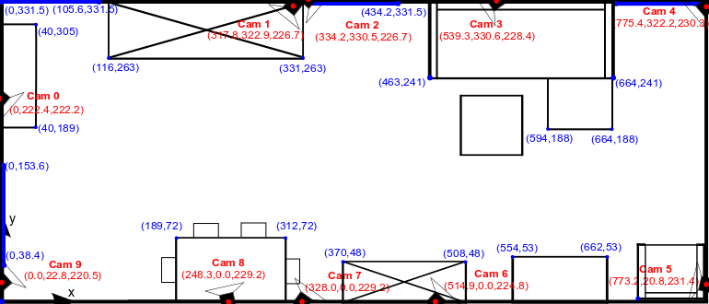
Figure 1: Room layout and the visual sensor positions
The photos in Figure 2 illustrate the test person sitting in the sofa of the test flat (the picture on the left) and an example of the visual sensor installed in the test flat (the picture on the right).

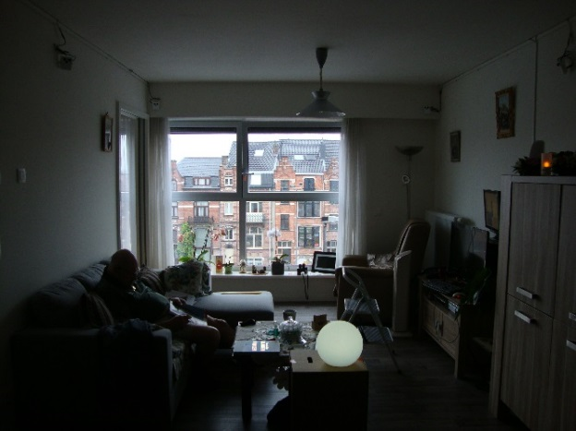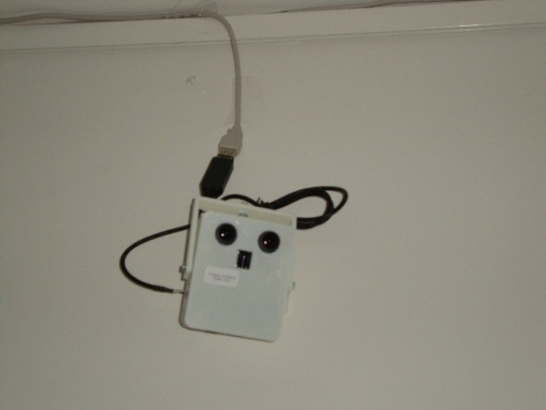
Figure 2: Pictures from Dendermonde

Data Collection with Visual Sensors
The images produced by the visual sensor are in a low resolution of 30 by 30 pixels. Figure 3 gives an example of these images. In these images privacy is maintained, since it is for instance hard to recognize faces. However, they are very useful in computer vision to recognize activities, behaviour and behavioural changes of the elder person. Examples of activities are going outside the home or receiving visits. An example of a behavioral change is increased or decreased mobility measured from speed or walked distance.

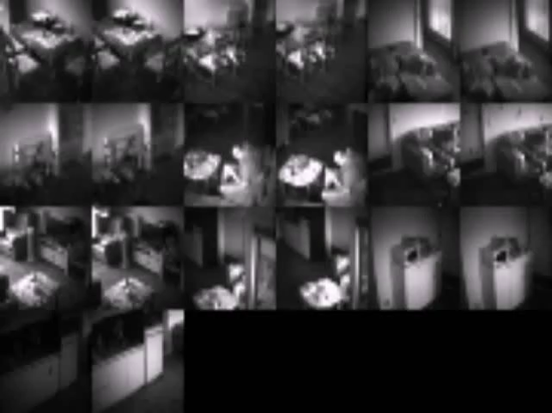
Figure 3: Images produced by the visual sensors.

PIR Sensors
Table 2 details the essential aspects of the installation in Dendermonde. The raw data was collected with 8 PIR sensors. In addition to the collected data, the Test person was asked to fill in a diary (see Annex 4) enabling to verify the number of visitors per day, the time of waking up and the time of getting to sleep. This diary was designed and translated in Dutch by SUAS.
Table 2: Essential information of the PIR sensors in Dendermonde
 | Details
Installation date: | 19/02/2015
Sensors: | 8 battery powered ZigBee PIR sensors, 1 ZigBee gateway
Data capturing under T4.2: | 20/02/2015 – 31/02/2014
Data: | The PIR sensors produce very little data compared to the visual sensors. The data is stored locally in a Postgres database in one of the two computers installed by iMinds. Smart Signs Solutions can access the data for analysis remotely.
Additional tools: | A diary of activities is being kept by the inhabitant.

The test apartment is a studio and the PIR sensors located in all relevant areas of the test apartment as shown in Figure 4 (in which half sensors indicate that they are attached on the wall at some angle, while full circles indicate that they are glued flat on the ceiling). There were no privacy concerns of the elderly person regarding the placement of PIR sensors in private rooms, such as the bedroom and the bathroom. Figure 5 illustrates the PIR sensors in Belgium: on the left a sensor placed very near the favorite sitting position of the elderly person; on the right a sensor covering the entrance hall.
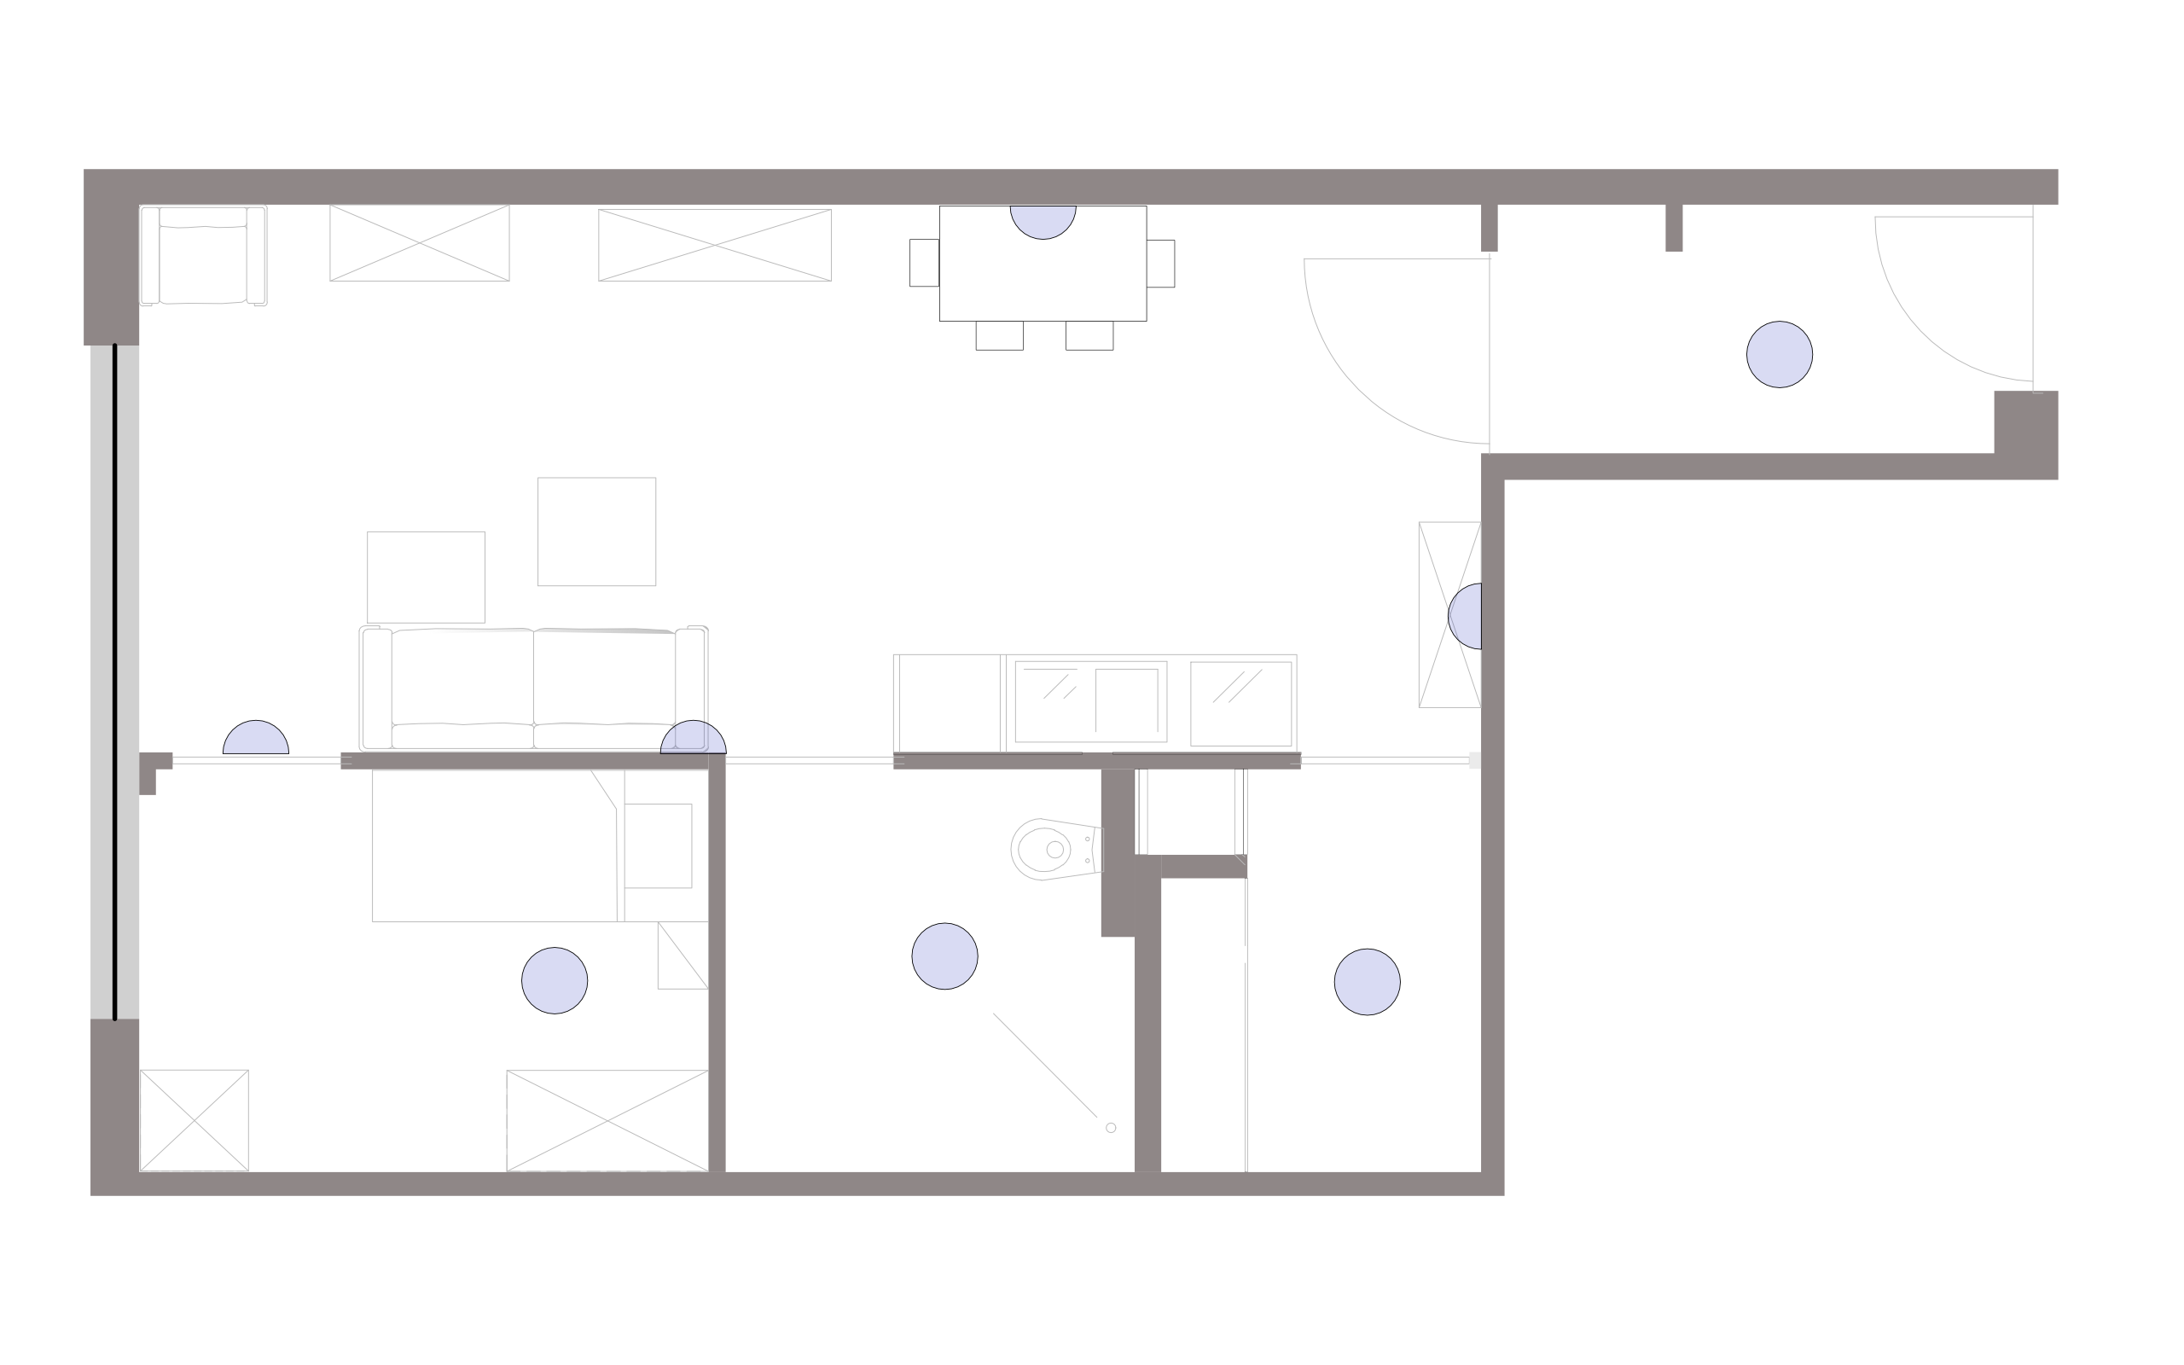
Figure 4: Setup of PIR sensors in flat in Dendermonde.
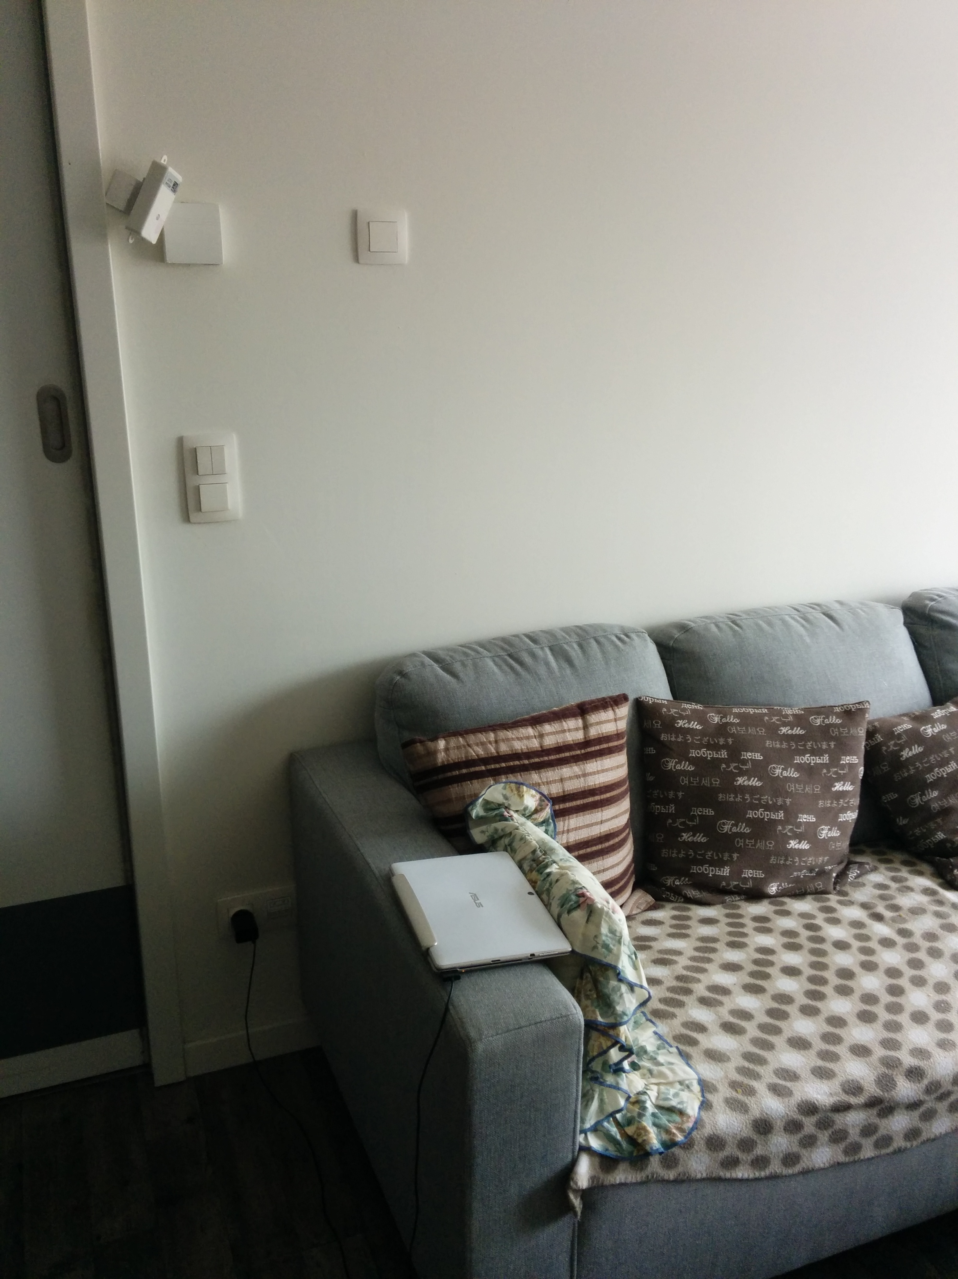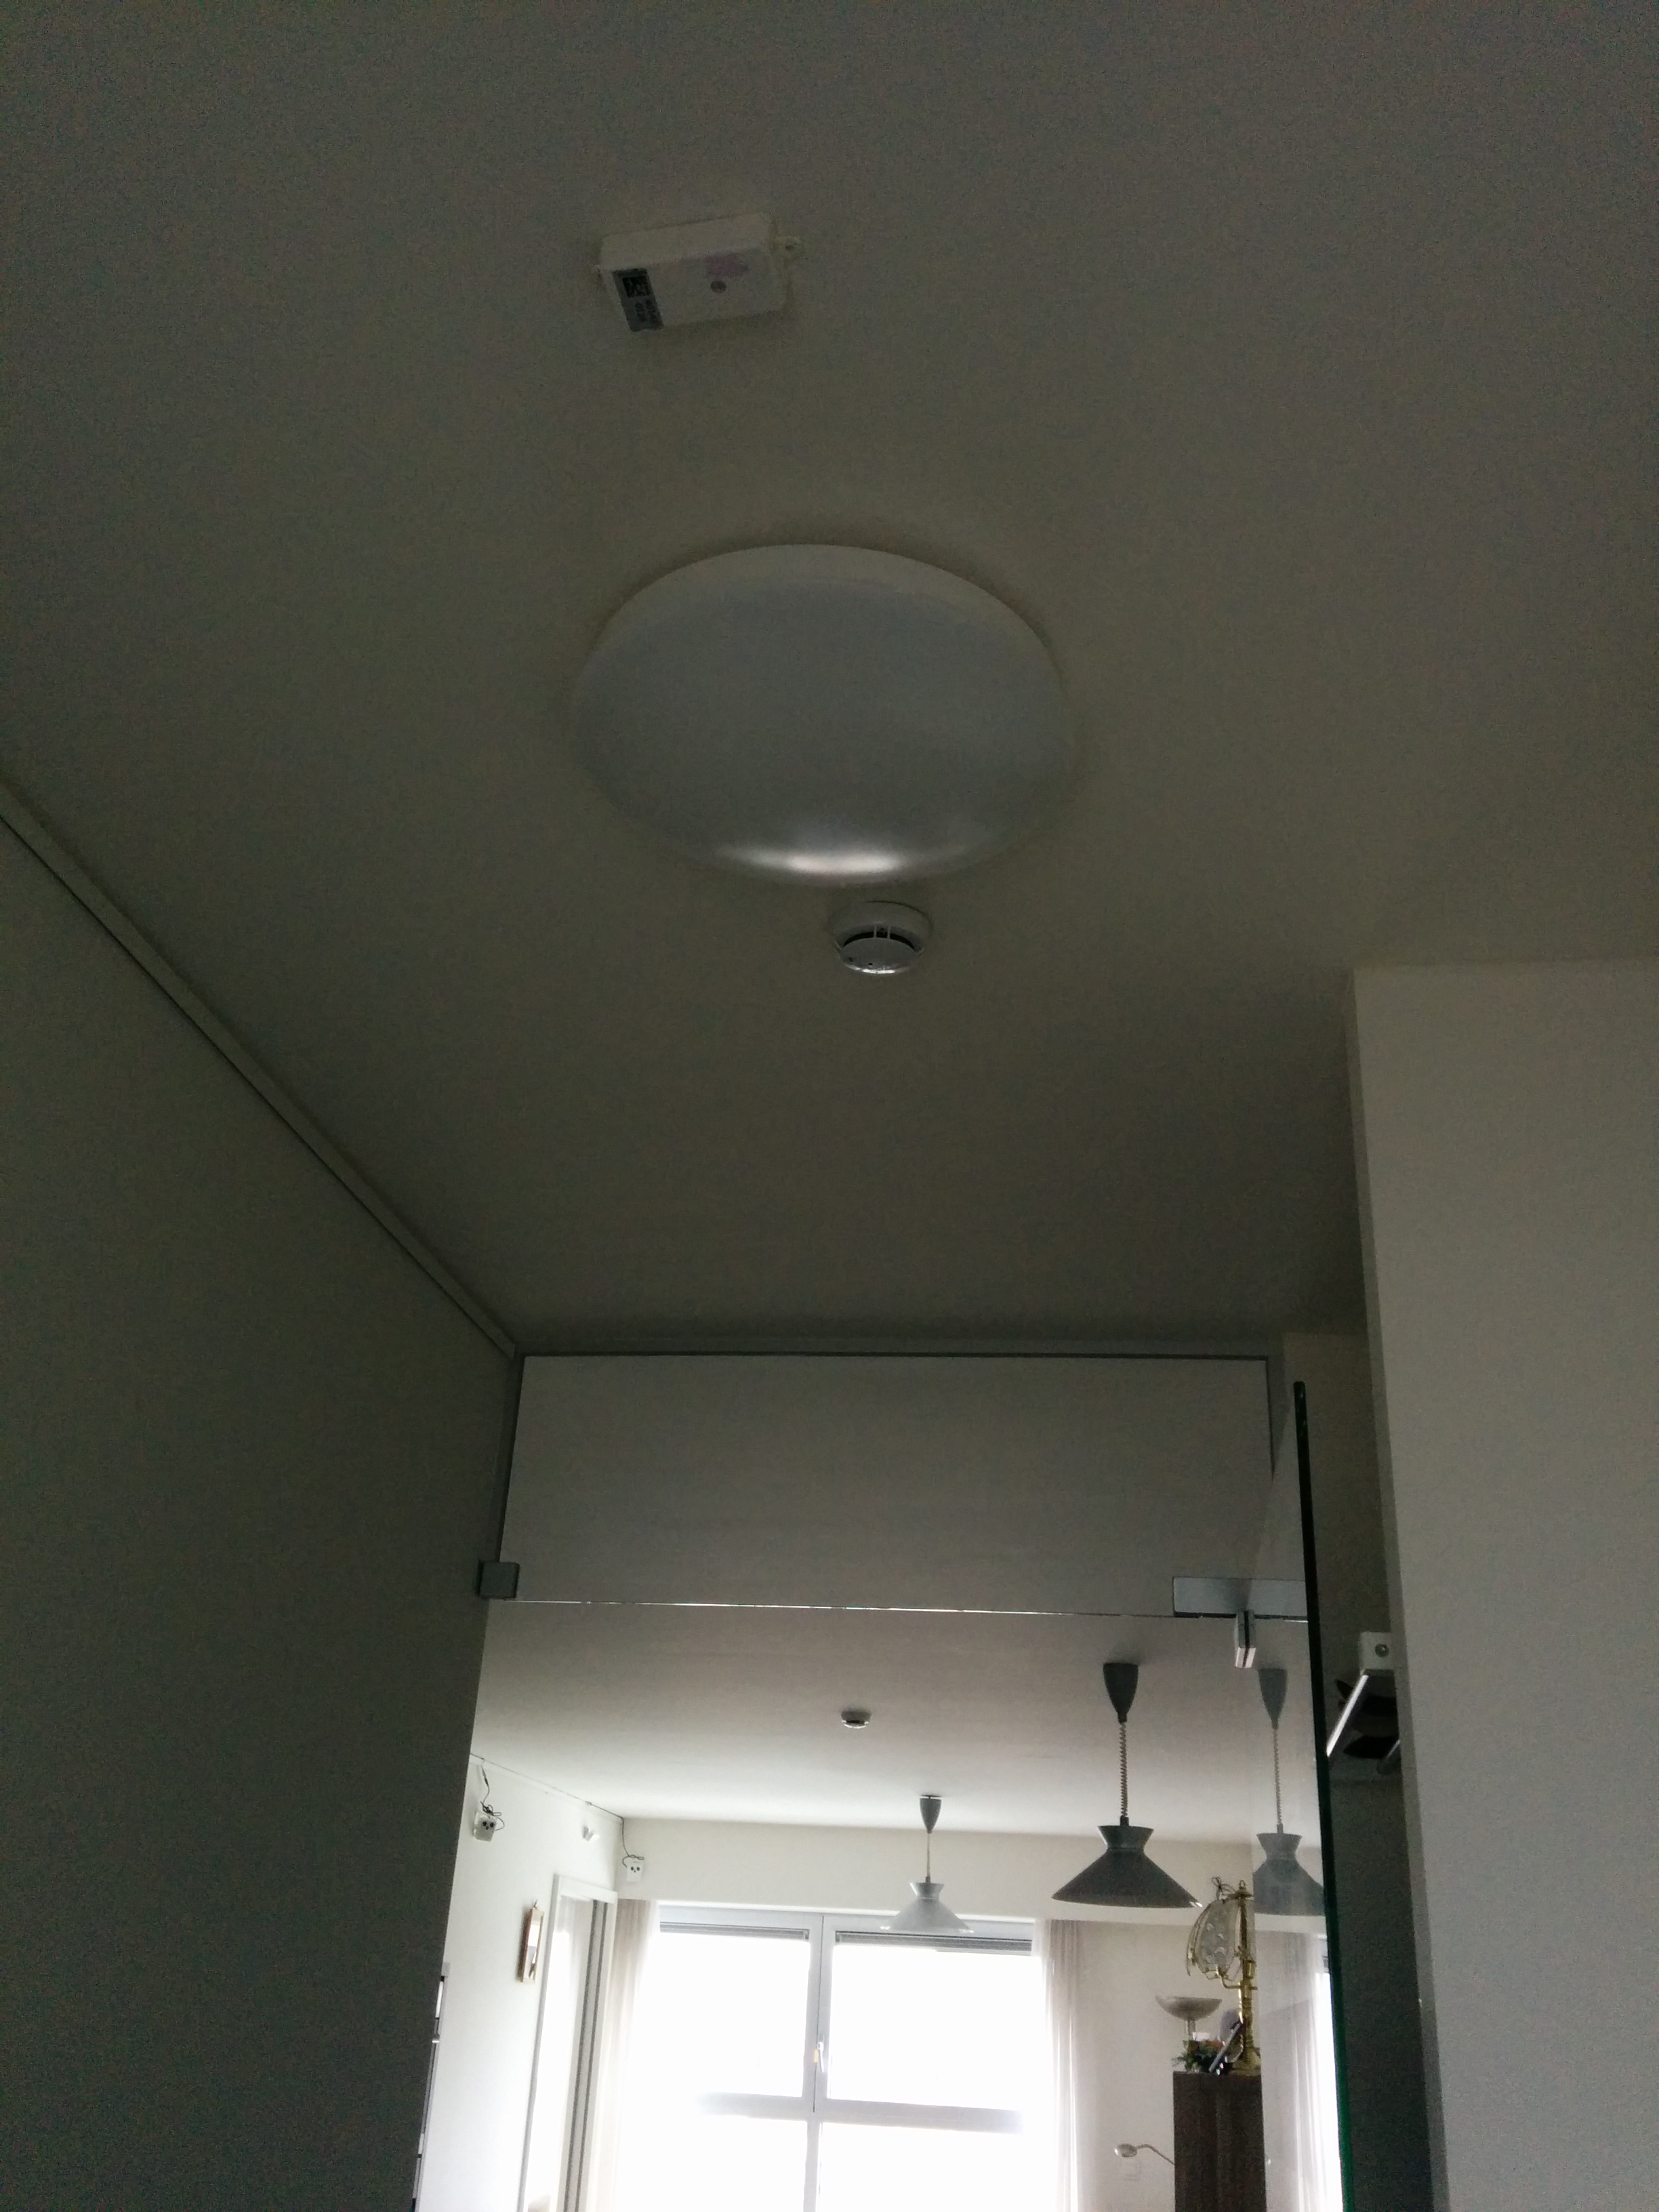
Figure 5: Examples of sensors installed in the flat.

Data Collection in Belgium with PIR Sensors
The sensors were installed on February 19th 2015 by Smart Signs Solutions with assistance of iMinds and as part of T4.2 that will collect data until the end of March 2015. CM provided support by explaining the installation of the PIR sensors and discussing the position where the sensors should be placed.
The installation took roughly 6 hours; most of the time was spent in setting up the Virtual Machine on one of the two computers present in the home. After this installation we verified the correct installation of the sensors and detected that the sensors over the sofa and on the eating room were not sensitive enough to detect small amounts of movement. We changed the position of those sensors to optimize the detection of even small amounts of movement.
As additional documentation, we made photos from the position of the sensor, such as the ones shown in Figure 5. These photos are useful for documentation and as an indication of the area covered by each sensor. Because the angle covered by a PIR sensor on the ceiling is wider than the angle captured by a mobile phone camera, we also tested the detection range and sensitivity of each sensor by standing, sitting and moving at different distances of the sensors. As explained earlier, these tests lead to the reallocation of two sensors. Figure 6 illustrates a photo taken from position of the sensor monitoring the kitchen and the eating table.

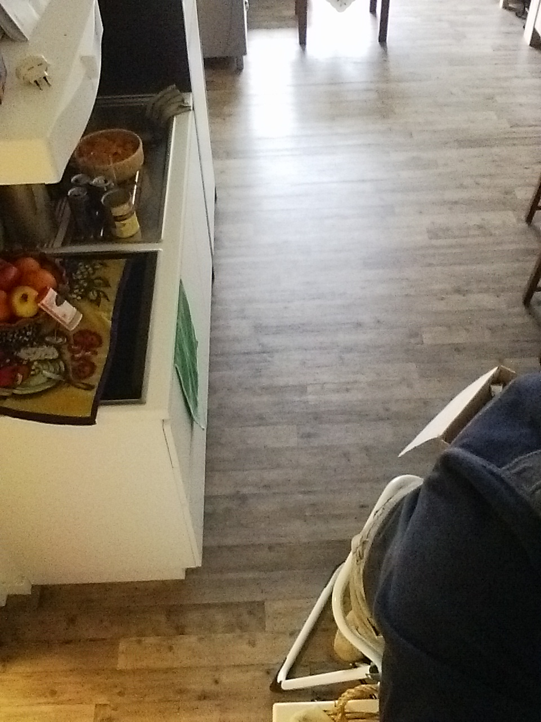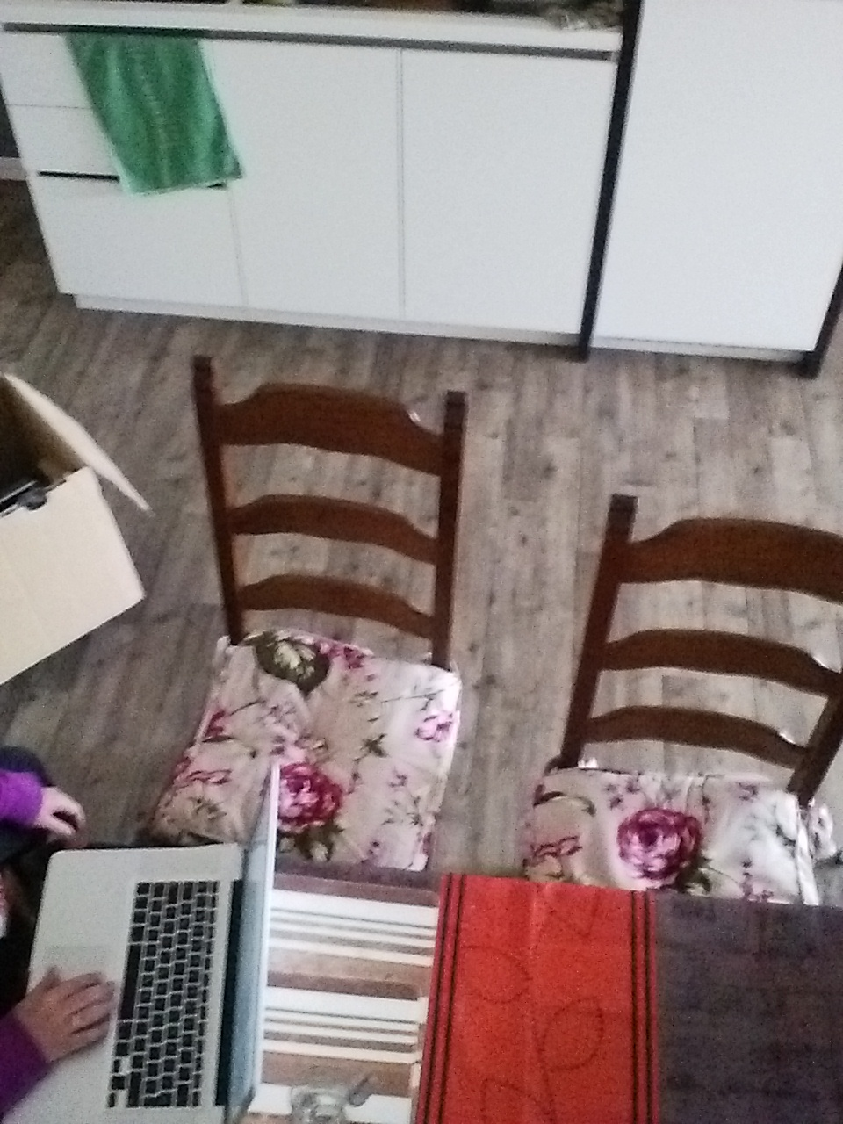
Figure 6: Example of photo with PIR sensors

Rollout of the Data Collection Phase
The data collection phase runs smoothly and all minor technical issues related to the Visual sensors were resolved quickly by iMinds. Moreover, in the first weeks of the installation in Dendermonde in Belgium, iMinds had to solve technical issues with the visual sensors, such as bad communication due to bad serial to usb converters.
The Test person was visited regularly to provide support, to check that the system was running correctly. iMinds was in charge for disk swapping and CM for the diaries. Furthermore, the data collection continued during the period when the test person was sick. The data in this period is a good test case for the algorithms about behavioural change analysis.
In the beginning of the installation, there was an interview with the resident together with iMinds, CM where the test person was given a present. In the end of the data collection period, iMinds and CM had a lunch together with the resident as the closing event.

Installation in the UK
The second installation of the SONOPA sensors is located in Surrey in the UK and it started running in August 2014 in the private home of the voluntary test person. Docobo (DO) runs the installation in cooperation with the involved technical partners. The participant is a lady of 81 years old. She is living entirely autonomously.

Role of the Partners
DO was in charge of finding the voluntary test person who is motivated to participate in the data collection phase of the SONOPA project. The test administrator from DO visited the test person in order to explain well her engagement in this phase before the installation was launched. During the data collection, DO visits the test person’s apartment on a regular basis in order to collect the data from the servers and to check that everything is going well with the test person. The test administrator is in charge of supporting the test person (i.e. to give her the informed consent, to respond the questions and to handle exit situations). iMinds and SmS remotely check on a regular basis if the installation is working correctly.

The technical partners (iMinds, SmS and CCC) are the essential part of the data collection phase in Surrey, as they are in charge of the installation, monitoring that the collected data is usable and offering technical support for the test administrator. iMinds and SmS went to Surrey on the 12th of August to install their respective sensors.
The technical partners manage the following sensors in Surrey:
- iMinds: Visual sensors
- SmS: PIR sensors
- CCC: Visage screen

Installed Sensors
The English test house is equipped with the different SONOPA sensors: visual and (several) PIR sensors in each room and one Visage screen in the living room. In addition, two computers recording the data were installed.

Visual Sensors
iMinds was in charge of installing the visual sensors in the test apartment in Surrey as described in Table 3. The 10 visual sensors were installed in the living room, the dining room, the kitchen and the hallway, in order to get as much activity data as possible from the different rooms that serve the test person during the different times of the day.

Table 3: Essential information of the visual sensors in Surrey
Actions | Details
Installation date: | 12/08/2014
Sensors: | 10 visual sensors (in addition PIR sensors in each room, 1 visage screen, 2 computers)
Data capturing under T4.2: | 12/08/2014 – 31/03/2015
Data: | The visual sensors produce 60 GB per day, stored on a server at the department of Telecommunications and Information Processing at Ghent University/iMinds. The hard disks were swapped monthly.
Additional tools: | A diary of activities is being kept by the inhabitant.

Data Collection with Visual Sensors
Figure 7 illustrates the locations where the visual sensors were installed in the ground floor of the apartment. iMinds installed 10 visual sensors and two computers. Four visual sensors in the living room and two visual sensors in the dining room are connected with wires to one computer, two visual sensors in the kitchen and two visual sensors in the hallway are connected with wires to the other computer. The visual sensors are prototypes and thus installed in a wired setup and powered by mains electricity. The visual sensors are fixed on the wall with double sided tape. One visual sensor produced a video file of 6GB per day in AVI format accompanied by a file with timestamps. In total, the visual sensors in the home produced 80 GB per day, stored on a server at the department of Telecommunications and Information Processing at Ghent University/iMinds. The hard disks were swapped monthly by Docobo.

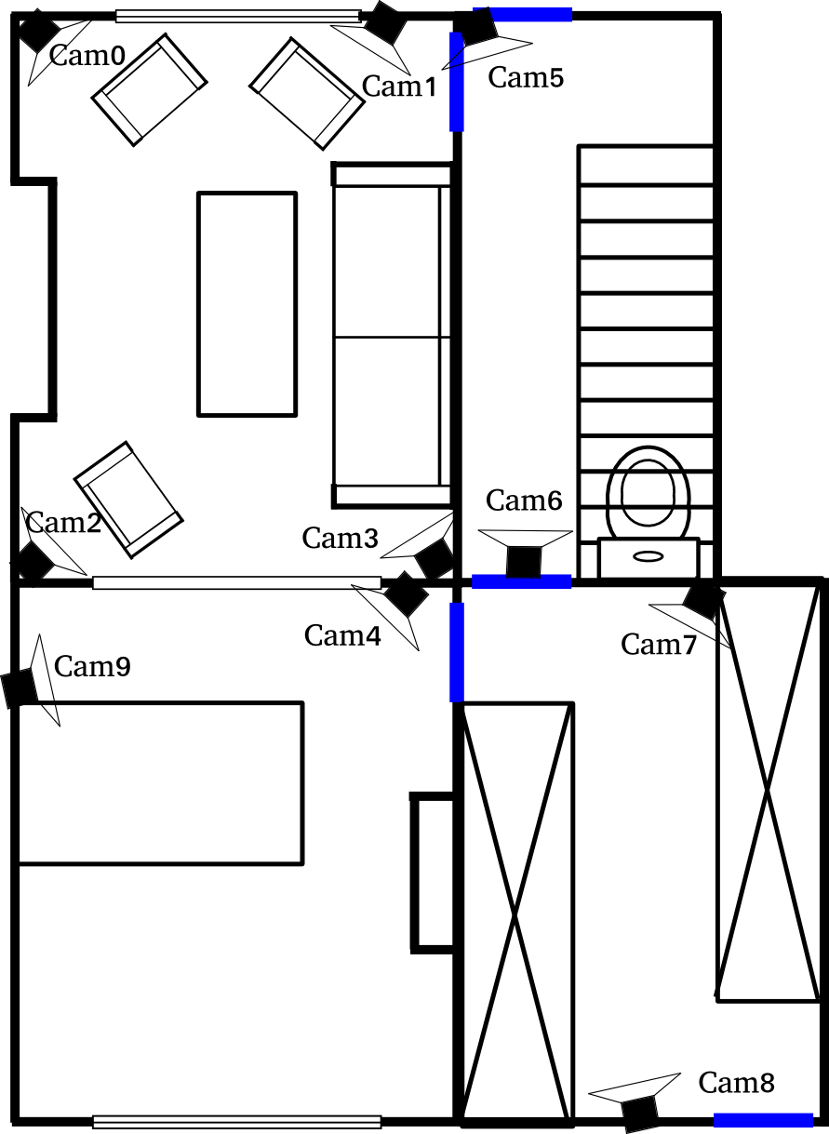
Figure 7: Room layout of the ground floor and the visual sensor positions.
Figure 8 illustrates examples of the visual sensor and the PIR-sensor that was installed in the Test person’s living room.
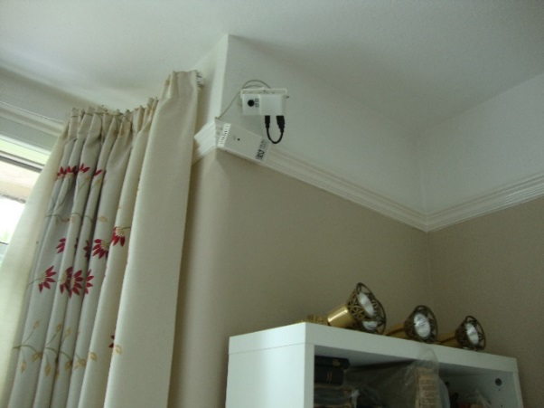
Figure 8: Picture from installation in Surrey

PIR-sensors
14 PIR-sensors are installed in all rooms of this test house, both on the ground floor and the first floor: Table 4 sums up this installation. Some rooms have two sensors installed for better coverage of the areas. However, we believe that a future setup can be done with fewer sensors, taking in consideration that in rooms with multiple sensors, such as the living room, both sensors provide very similar event patterns. SmS ensures the installation and the good functioning of these sensors by regularly remotely checking that data is stored in the database.
Table 4: Installation of PIR-Sensors in the UK
 | Details
Installation date: | 12/08/2015
Sensors: | 14 battery powered ZigBee PIR sensors, 1 ZigBee gateway, 1 Zigbee router
Data capturing under T4.2: | 13/08/2015 – 31/03/2015
Data: | The PIR sensors produce very little data compared to the visual sensors. The data is stored locally in a Postgres database in one of the two computers installed by iMinds. Smart Signs Solutions can access the data for analysis remotely.
Additional tools: | A diary of activities is being kept by the inhabitant.

PIR sensors were located in (as illustrated in Figure 9):
- bedroom,
- bathroom,
- 2 x drawing room,
- box room,
- hallway upstairs,
- 2 x living-room,
- 2 x dining room,
- kitchen,
- winter garden (general),
- winter garden (reading corner),
- entrance hall.
. 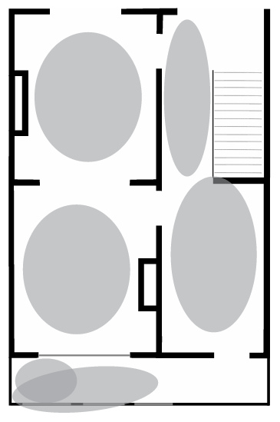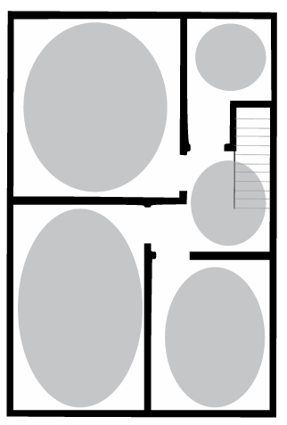
Figure 9: Ground floor (left) and first floor (right) of the house in Surrey
Figure 10 shows a photo which is taken from the position of a PIR sensor.
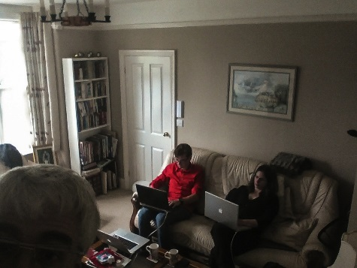
Figure 10: Control during the installation.
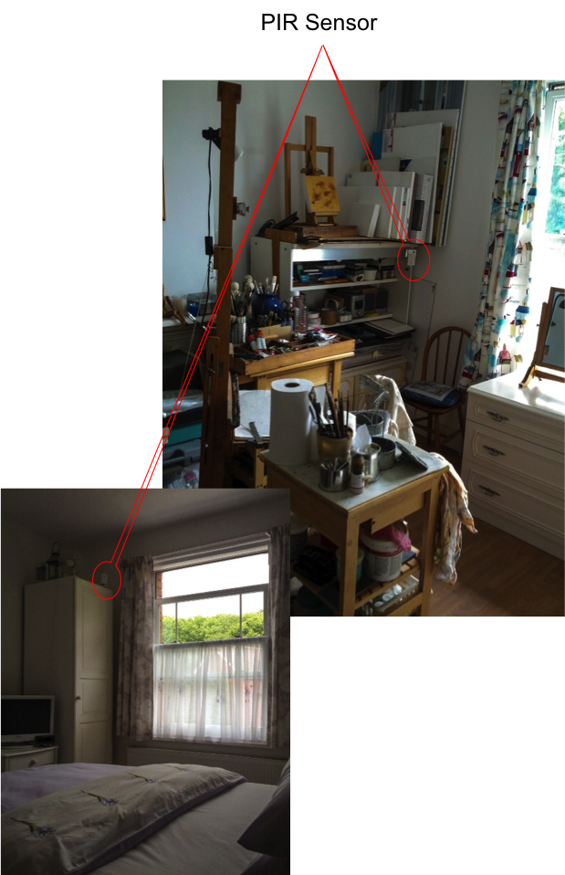
Figure 11: Sensors are glued to furniture
The sensors are glued to ceiling railings and furniture with double sided tape (unobtrusively to furniture in order not to spoil the paint and the wallpaper): this can be seen in Figure 11. When necessary, small flexible metal wedges were used to get the right angle. The sensors connect to a ZigBee gateway (Zigbee to Ethernet), which is in the utilities closet, either directly or through a Zigbee Roter (Zigbee to Zigbee) forming a multi-hop network as shown in Figure 12. The router is used to be able to cover the sensors upstairs. The sensors only send data when movement is detected. After reporting movement, they sleep for two minutes in which the PIR sensor and communication module are switched off in order to save the battery.
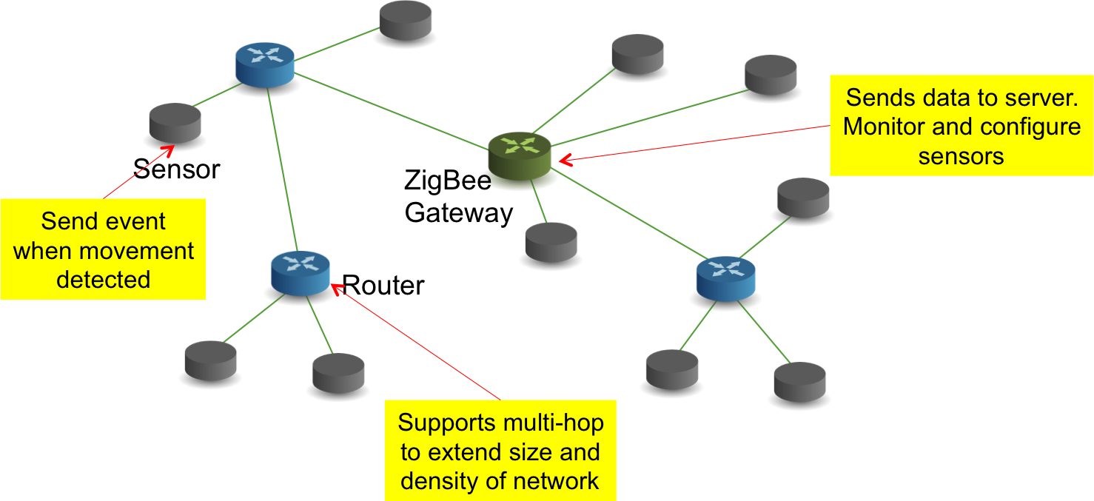
Figure 12: Multi-hop Zigbee network

Data Collection with PIR Sensors
The data is collected in Postgres database which is installed in one of the two computers from iMinds. We record both movement events and control data to verify that the sensors are indeed active. Smart Signs Solutions can remotely access the database to verify the correct functioning of the system and to perform data analysis. The data is further shared with the SONOPA partners for developing activity and socialization algorithms and to double check the quality of the data that they collect.
Through an on-line visualization interface (screenshot in Figure 13), the partners can see the results of the data being gathered.
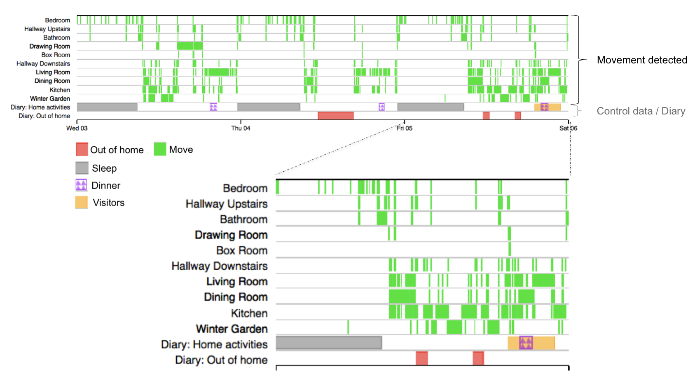
Figure 13: On-line visualization of sensor data

Visage Screen
As a part of the SONOPA-system, the Visage screen, created by CCC, is included in the data collection installation in England with the specific aim of collecting ADL data when the user interacts with the screen, or in front of its camera.

CCC dispatched the screen from France to England (for DO). Firstly, DO tested the device from the 26th of June till the 2nd of July 2014 in the Docobo’s office ensuring that it functions correctly. Then, DO installed it in the test apartment in Surrey from the 1st of August till the 1st of September. Before installation, DO presented the screen for the Test person so that she could get familiar with it.

The screen was placed on the table in the living room; Figure 14 shows the vision of the screen.
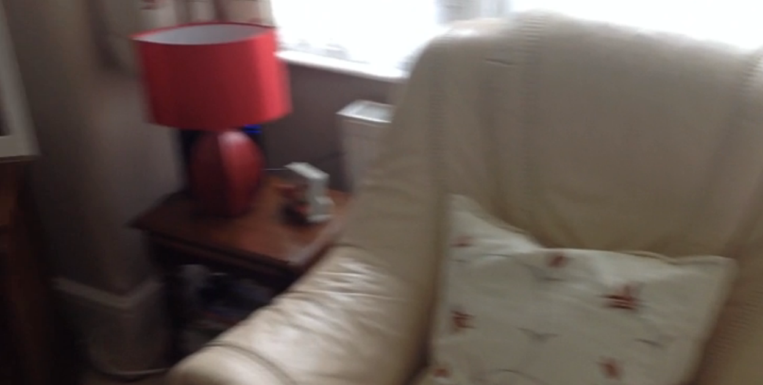
Figure 14: Visage screen camera view 1
Figure 15 illustrates the space in front of the Visage screen, seen by its camera
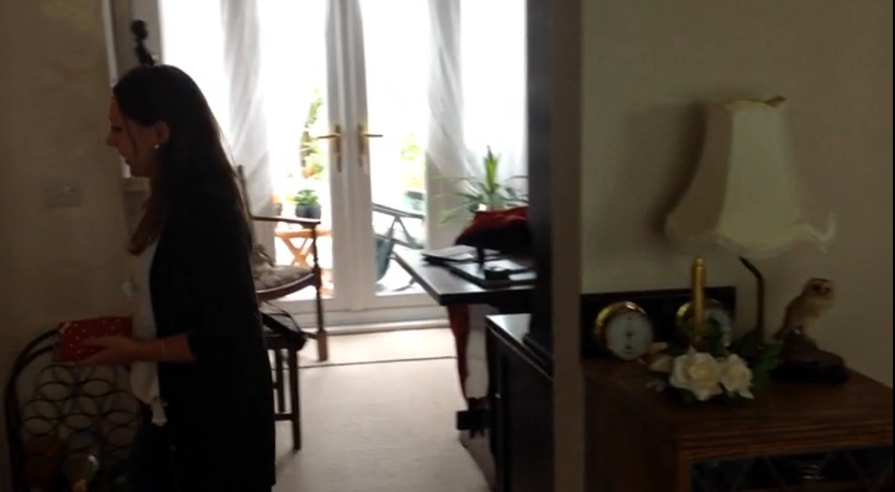
Figure 15: Visage screen camera view 2

Figure 16 indicates the Visage screen location in the test apartment.
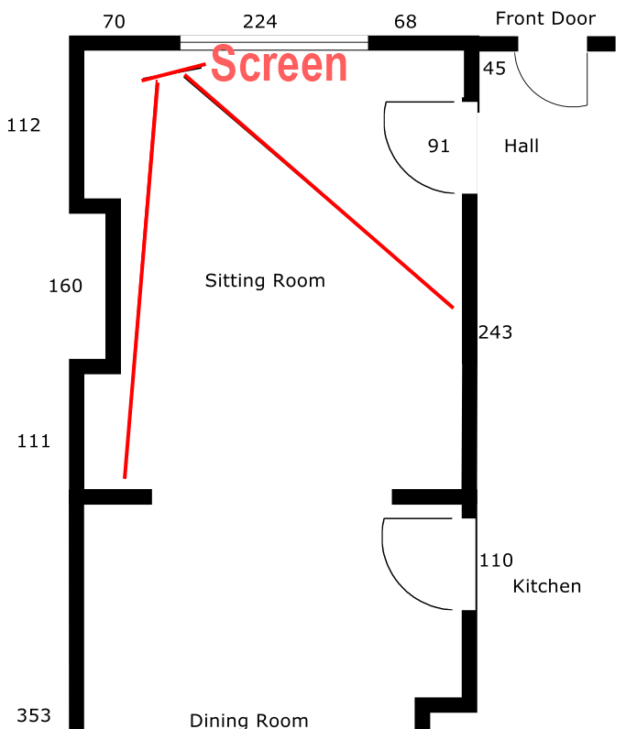
Figure 16: Visage screen location
In addition to the data collection, the aim of the Visage screen is to display the stimulating information and the small programs for the user. Initially, the Visage screen content was developed in French, thus some parts of it were translated in English for the test person in Surrey, so that she could understand the displayed information. As a result, the Visage screen proposed a selection of information and programs in English which were related to varied topics such as: quality of sleep tracking system, games on geography, questionnaires, movies, physical activity, health, drawings, observational game, slideshow of pictures, chat rooms, memory games, library, music player or more general games and local RSS feeds about weather (see Figure 18). Figure 17 shows the user interface that was proposed for the user at this stage.

Figure 17: Visage screen App menu
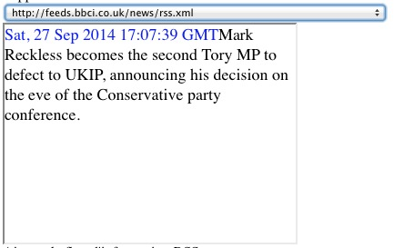
Figure 18: Example of an RSS feed
In addition, the Visage screen proposed a slide show with 25 pictures from the test person’s family that they had communicated to Docobo for the SONOPA installation (in order to preserve the persons’ privacy the family photos are not illustrated in this report).

Data Collection with the Visage screen
The goal of the Visage screen installation in England was to test the device in England and compare the ADL data from it with the data recorded by other SONOPA sensors. The Visage screen provides data between the first and the last interactions that the user had with the device, this is between Fri, 01 Aug 2014 15:44:17 +0200 (time in Unix format 1406900657) to Mon, 01 Sep 2014 11:22:52 +0200 time in Unix format 1409563372).

Some broadcasted programs made the user to interact with the system by clicking on the screen. One of the objectives of the services that are broadcasted is to develop the interest of the older person and to encourage her to interact with the screen. This is a way good to keep her active.

Some examples of the data analysis that can be done with the Visage screen data:
- During the month of August, the test person touched the Visage screen 1957 times.
- The user played with the games only on the 1st of August, the 25th of August and the 29th of August. As these dates are rare, they could correspond to time when there were visitors at person’s home.
- Before the 25th of August, the user clicked on the screen 325 times. In the afternoon, on the 25th of August, from Mon, 25 Aug 2014 13:22:20 +0200 to Mon, 25 Aug 2014 19:07:10 +0200 he clicked 1590 times.
- A Visitor, that came on 25th of August, liked Hanoi Tower game as he played it from Mon, 25 Aug 2014 15:28:16 +0200 to Mon, 25 Aug 2014 15:39:07 +0200 moving tiles on the screen every second during these 10 minutes.

Figure 19 and Figure 20 illustrate how many times the user interacted with each apps and games on the Visage screen during the last month. The larger green part corresponds to games in Figure 19 and the latter Figure 20 gives the details related to the played games.
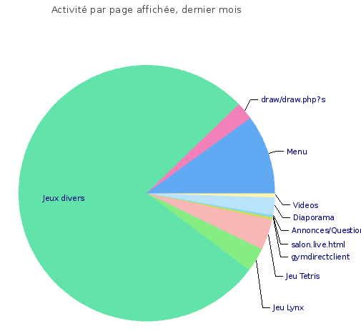
Figure 19: Visage screen user interaction with different Apps
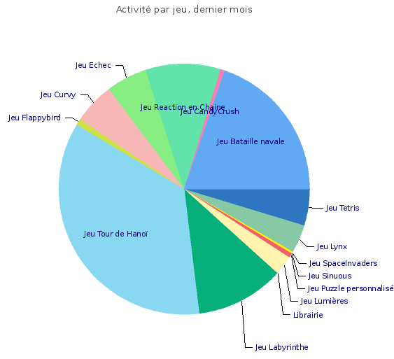
Figure 20: Visage screen user interaction with different games
The Visage screen includes a small camera that worked from the 1st of August to the Mon, 11 Aug 2014 17:56:02 +0200. After this period, the test person chose to hide behind a small cover and no more analysis could be made then using the camera.

Finally, the Visage screen enables the altimetry analysis. The altimetry was possible during the first period of the experiment as during the second period the camera sensor has been physically disconnected. Here we present a selection of some results on the altimetry analysis.

Below (Figure 21, Figure 22, Figure 23 and Figure 24) is shown the graphical representations of activity measured during the period, during a typical day. There is a 2 hours shift due to the fact that there were a shift of 2 hours between UK and France. The blue line corresponds to the average activity on the last 30 days, covering the full period when the camera was used. The red line corresponds to the last week. Because the period of work lasts only a bit more than a week, blue and red curves match a lot. In case of longer experience, without caching the camera, the red curve could be used for example, to determine a long term change of behaviour.

Motion detection in the living room:
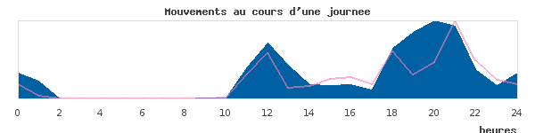
Figure 21: Motions during the day

During this period, the user also looked (face detection) at the device and this occurred during certain periods of the day:
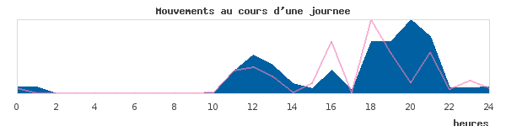
Figure 22: Motions during the day 2

The user interacted (touched) with the screen at other periods shown below:
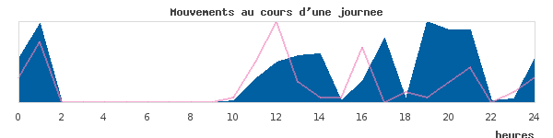
Figure 23: Motions during the day 3

The activity days after days during the last week of experiment is shown below:
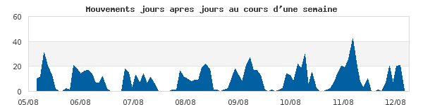
Figure 24: Motions during the day 5

Rollout of the Data Collection Phase
Two PCs, each with 4 hard drive bays were used to collect the visual sensor data at the UK installation. The data disks, one in each PC with a capacity of 2Gb, filled with data after about a month of running. They were then replaced with two fresh disks while the collected data was extracted and sent to iMinds for analysis. This process was repeated after each month.
It was discovered from analysing the first month’s data that there was a bug in one of the dynamic link libraries that was corrupting the captured images, rendering them black. Once this was identified and resolved, daily checks were made to ensure there was no further corruption.
The only other issue was that the USB bus on one of the PCs hung at one point and had to be rebooted. But only a few hours data collection was lost due to this issue.
In addition to the monthly disk swapping, other visits to the volunteer were made approximately every two weeks in order to talk about her experience and any perceived difficulties. This time was also used to collect completed diaries kept by the volunteer.

Data Analysis and the SONOPA-system Development
The Task 4.2 is prior to the SONOPA system pilot phase: it enabled to set up the different SONOPA system modules in two installations and to collect very different kinds of data that will be used in the development of the SONOPA system. In consequence, as Figure 25 shows, the analysis of the ADL data (collected under T4.2) is closely related to the WP3 “Development of SONOPA modules” and more closely to the task 3.3 Activity Recognition and User Modeling Algorithms. The data analysis process respects the data protection principles.

Figure 25: Link between WP4 and WP3

Collected Data and Data Protection
Before any SONOPA research activity takes place, all involved individuals are asked to sing in an informed consent (Annex 1) and to read carefully the participants information document (Annex 2). They are informed that the test administrator (contact communicated in the participant information document) is available at all times to respond to questions, technical problems etc.

In addition, several strict measures are applied by the SONOPA consortium to safeguard the involved users’ privacy and rights:

The visual data, obtained from the visual sensors, results in presence indications listed in text files as the persons should not be recognizable in the collected data, whereas the data from PIR sensors and Visage screen is raw data.

Not recognizable persons in the images: The images produced by the visual sensors are in a low resolution of 30 by 30 pixels. In these images privacy is maintained, thus it is for instance hard to recognize faces. However, those are very useful in the SONOPA system as those recognize activities, behaviour and behavioural changes of the elderly. Examples of activities are going outside the home or receiving visits. An example of a behavioral change is increased or decreased mobility measured from speed or walked distance.

Controlled access to the data samples: As the PIR Sensors allow to follow the user in the house etc. its data discloses some sensitive data (related to the user’s movements) and for this reason it needs to be controlled who obtains this data and for which usage. In consequence, the SONOPA consortium has created the sample data confidentiality agreement (see Annex 4) to control the access to the collected ADL Data that was listed as “public” in the DOW.

Anonymity of the users preserved: Furthermore, the identities of the test persons are made anonymous, only the responsible test administrator at each test site is able to identify the test persons, which means that their personal data is not revealed. The technical partners visited the test site in order to manage the sensor installations but the personal data of the test person was not communicated to them. This measure is taken in order to preserve the involved person’s privacy and to be in line with the Ethical methodologies of the project (D2.3 and D2.4).

Diary
In addition to the sensors, an additional data collection tool was filled by the end-user participants: a diary (see example in Annex 4). The data in the diary allows checking the eating times, waking up and going to bed times, periods outside home and periods with visitors. We use the diary information to validate the data gathered by the sensors and also to validate the information computed at this level. We also use this information in order to validate the data gathered by the sensors.

Obtained Data – Basis for the User Modelling Algorithms
This obtained data will be used to model the user behaviour and offer better recommendations based on in. The SONOPA System will be able to work in two different modes (as defined under T3.3):
- Standard mode: This mode includes few sensors, and is thus feasible as a starting step. The user modelling algorithms in this mode is limited to ascertaining the user activeness and socialization levels.
- Premium mode: This mode includes a more dense deployment of sensors, including visual sensors. It is a more expensive mode that uses more sensors to improve the activity recognition capabilities
A more detailed explanation of the algorithms can be found in “D3.3. User Activity Recognition System”.

Standard Mode
The Standard Mode uses fewer sensors than the Premium Mode but is the more economic option that will normally be used in the most of deployments. The Standard Mode sacrifices the quality of the inferred data to achieve more affordable and realistic deployments. This mode uses sensor data to infer the following metrics:
- Activeness: sensor activations are processed to infer the user’s activity level during the day.
- Minimum number of people in the house: Using the limited number of sensors available, the SONOPA system can infer at least how many persons are currently in the house. Using only the PIR sensors that are deployed in each room in this mode is not possible to infer the actual number of persons. E.g. If two persons are on the same room the PIR sensors cannot infer that the activations are produced by two different sources.
- Socialization: this metric combines the minimum number of people in the house during the day with the number of interactions in the social network to measure the socialization levels of the user.
- Room occupancy levels: using the sensor activations, the SONOPA System provides a daily report of the room occupancy levels.

Premium Mode
The Premium Mode will use data analysis algorithms to identify the users’ activities and movement patterns. The movement patterns are inferred based on the visual sensors data.

The activity recognition is based on a knowledge based approach. Knowledge-driven activity modelling is based on real world observations that the list of objects and functionalities to perform an activity are always very similar. There are some essential concepts that are always present for each activity. The idea is to use this prior knowledge to create rough activity models. The implicit relationships between activities, related temporal and spatial context and the entities involved (objects and people) provide a diversity of hints and heuristics for inferring activities. The advantages and drawbacks of knowledge-driven approaches are discussed in the following:

Advantages:
- No cold-start problem: knowledge-driven approaches model activities using generic knowledge rather than data, so activity models are built before deployment and the system does not need any training/learning process before beginning to work.
- Interoperability and reusability: especially true for ontology-based approaches, but also for all the other approaches, as activity models are modelled using knowledge engineering techniques and the models built are generic and not specific to a concrete user.
- Clear semantics: activity models are semantically clear and can be understood by human beings. This allows interpreting how the system works and developing easier auxiliary systems that work on the top of the activity recognition system, such as notification systems, recommendation systems, etc.

Disadvantages:
- Weak in handling uncertainty: inference and reasoning are usually based on certain facts, rather than, uncertain sensor information. There are some approaches that work using fuzzy logics and/or probabilistic reasoning, but they are not fully integrated with modelling techniques yet.
- Weak in handling temporal information: inference and reasoning mechanisms used for activity recognition do not usually consider temporal aspects of activities. In order to tackle this limitation, there are already some approaches that, for example, integrate ontological and temporal knowledge modelling formalisms for activity modelling.
- Static activity models: knowledge-based activity models are static, since once they are defined, they cannot automatically evolve. This means that if a user changes its way of performing activities, initially defined activity models will still be used for activity recognition.

The approach proposed in SONOPA uses several steps to detect new user patterns and these steps are explained in details in D3.3. User Activity Recognition System. These steps can be seen in Figure 26.
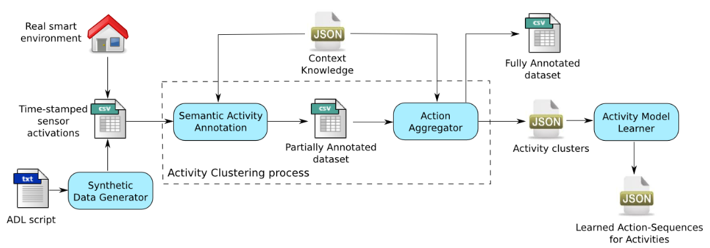
Figure 26 Steps of the activity recognition in Dense Mode
The collected data will be the basis for the SONOPA algorithms for which University of Deusto (UD) is responsible. UD will perform the data analysis in cooperation with the partners who were in charge of the data collection.

Availability of the Obtained Data
The DOW states that the SONOPA ADL sample data will be public. To preserve the privacy issues of this data, the data sets will be available for scientific purposes only upon a request. Furthermore, no visual files but text in order to safeguard the privacy of the person and also all collected data is anonymous (i.e. the test person’s identity is not given anywhere).
The person who is interested in using this data for scientific work should request the sample data from the SONOPA consortium and fill in the SONOPA Data Confidentiality Agreement (see annex 4).
The end-user participants in the ADL collection phase were informed about the ethical aspects related to the usage of the collected sample data:
- Before any SONOPA research activity started they signed in an informed consent (see Annex 1)
- And we asked to read carefully the participants information document (see Annex 2)

Protocol for Requesting the Sample Data
A protocol will be established for all public who wants to obtain the SONOPA data:
- Person sends the request to SONOPA consortium to obtain the data;
- This person is asked to fill in a confidentiality agreement;
- Once the confidentiality agreement is correctly signed by the person requesting the sample data and the project coordinator, the person obtains access to the data;
- The access is a safeguarded code that the person uses to obtain the data files;
- The data can be for instance in a Zip file.

Safe Storage of the SONOPA ADL Data
This data is stored in MyMinds platform that is used by the consortium to store all the project work. This platform offers server service that stocks the data safely and controls the access to the data files; only registered and appointed users (username and password) have access to the data files. With this platform the different data captured from the various SONOPA sensors can be stored in the same place and easily combined for further analysis.

Visualization Tools
SmS, iMinds and CCC cooperate to illustrate the collected data with a Data Visualization Tool accessible in a protected web interface (https + username + password). In line with the data protection principles, the data can be visualized upon the request and by signing the SONOPA data sample confidentiality agreement. These visualization tools will also be used to illustrate the T4.2 work for the European Commission.

The envisioned users of the tool are mainly the SONOPA partners, both the technical partners who are developing the algorithms, as the behavioral science experts and the partners working with the elderly. Access can also be provided to external researchers after complying with the formality expressed above and other experts. The tool can also be used by the elderly themselves in order to understand further what is being done with the data, but it should be noted that at this stage of development these tools are firstly indented for the researchers and not the interface is not designed with the elderly in mind.

There are different views into the data:
- Presence detection on each location in the house, distinguishing between the really measured presence (e.g. motion on a PIR sensor) and ‘computed presence’. By computed presence we mean that with a high certainty we can assert that the person is in a given location, even if no sensor data is generated. That is the case for example of the person sleeping during the night. The person is last detected in the bedroom by a PIR sensor and then no longer detected for 2 hours. When the detection occurs again the person is in the bedroom. The activity level in that period is clearly low.
- Timeline visualization of the data gathered by the sensors. We are currently working into adding to this timeline the computed activity level and socialization level values.
- Heat maps showing the percentage of time that a person spends in different locations in the house in the course of the day.
- A fast forward animation showing how the person moves in the house in the course of the day.
- Out of the scope of this report, is the on-line interface on which the elderly can follow his trend in activity and socialization, compared both to his goals and previous performance, and to the activity and socialization level of other users of SONOPA.

Statistical analysis of presence information
This view provides average information about how much a location is used in different times of the day. The data is grouped by month and differentiated by week day, given that many people have week patterns, both for performing an activity, such as painting, for going out to appointments or for others to come home, such as a home help. There is a tab for each day of the week and a general tab showing all weekdays (Figure 27).
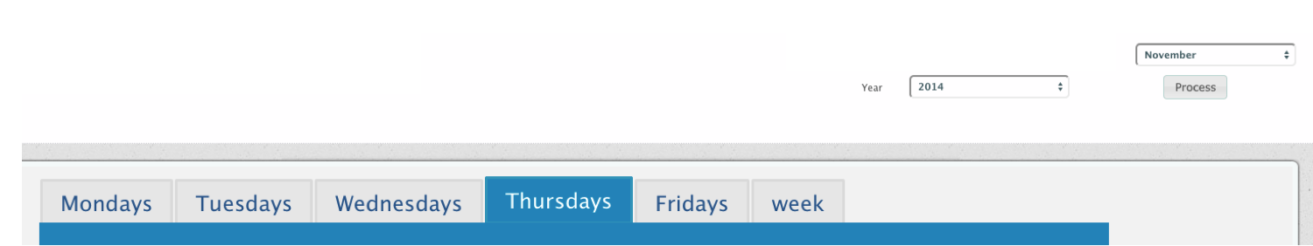
Figure 27: A tab showing all weekdays related to presence information

Within tab there is a list of all the rooms or locations in the house being monitored, plus an entry for ‘outdoors’. Intensive red shows the percentage of time in which presence was detected by a sensor and faded red, the percentage of time in which presence could be determined with high accuracy. As examples we choose the bedroom (Figure 27), living room (Figure 28), and kitchen (Figure 29), to show extremes on which the sensors detect little activity, medium activity and high activity. The pie charts on the right show both the percentage that the room was used during the whole day and during the waking hours, which in this case have been determined to be 7 to 23.

The buttons at the button right, open a popup to see the details measured on individual days, in this case each Thursday in September.

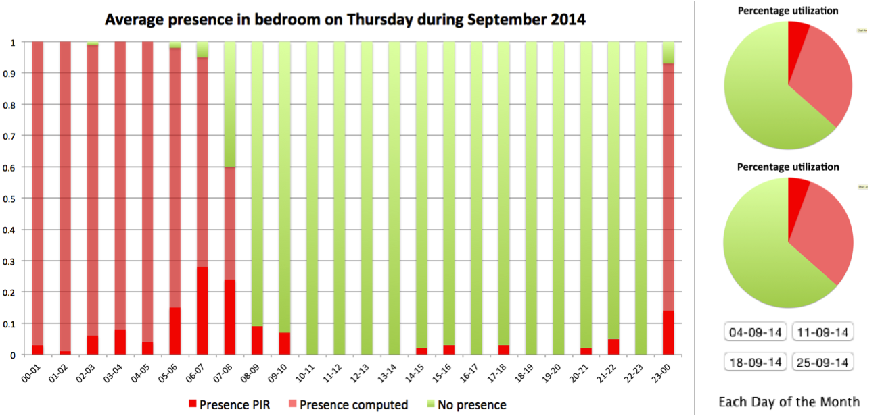
Figure 28: Visualization of user’s presence in bedroom
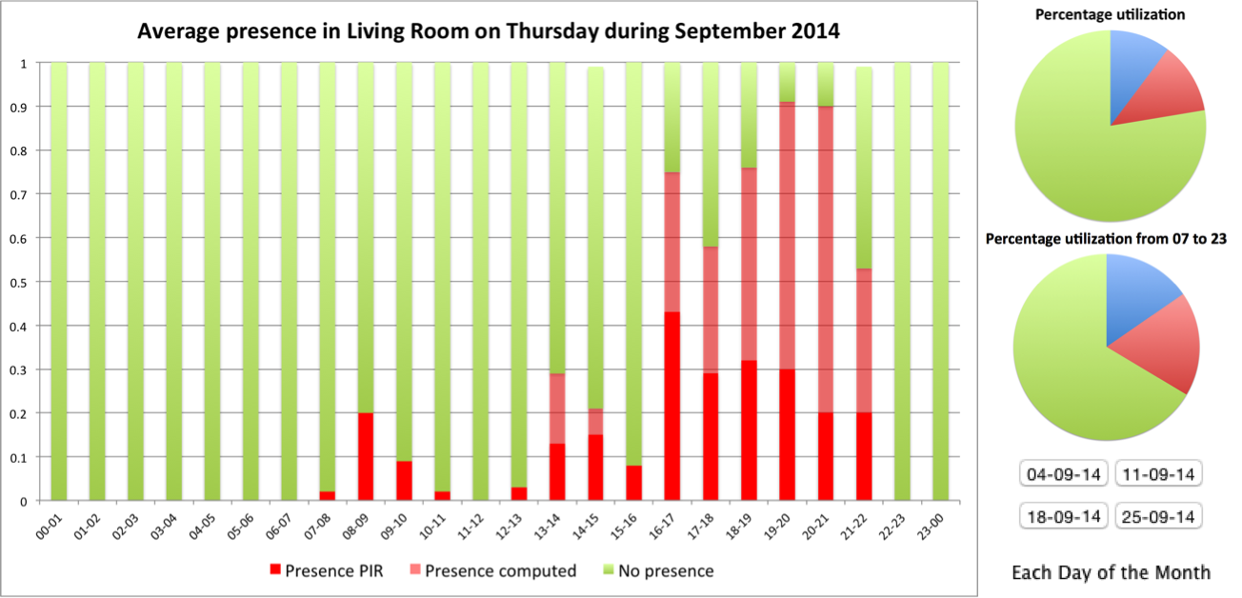
Figure 29: Visualization of user’s presence in Living Room
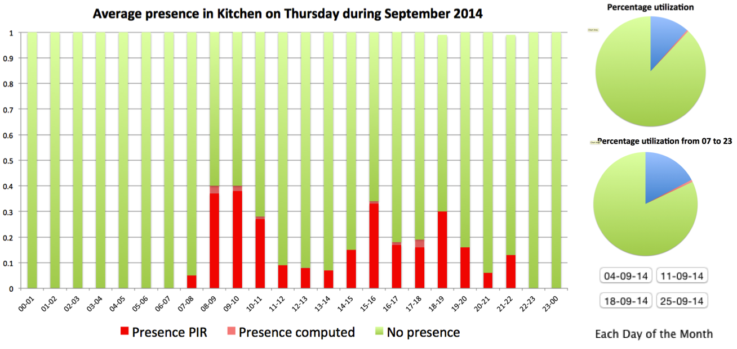
Figure 30: Visualization of user’s presence in kitchen

Visualization of sensor data
On a timeline (Figure 31) we show the sensor data gathered. When available we also show in this timeline the diary information filled in by the elderly person. The user can easily move along the timeline and zoom into different periods, as this example one day.
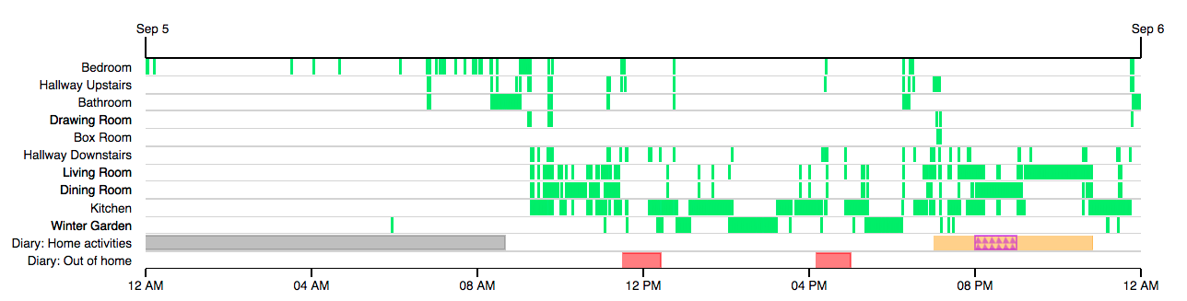
Figure 31: Example of a timeline with sensor data

Heat maps
A heat map shows through a color scale, how much time the person spent in a monitored location during a certain period of time. In the examples below we show heat maps for different times during a day, sliced in different ways, such as only 1 hour or from 7 to 22 to show the versatility of the visualization type. These examples show the data of one day alone, but they can also be combined to show a whole range, for example every morning in the month, or every Monday afternoon.

Figure 31 shows a heatmap of presence in the home during one day from 07.00 to 22.00
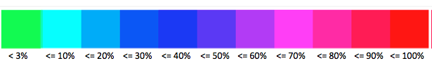
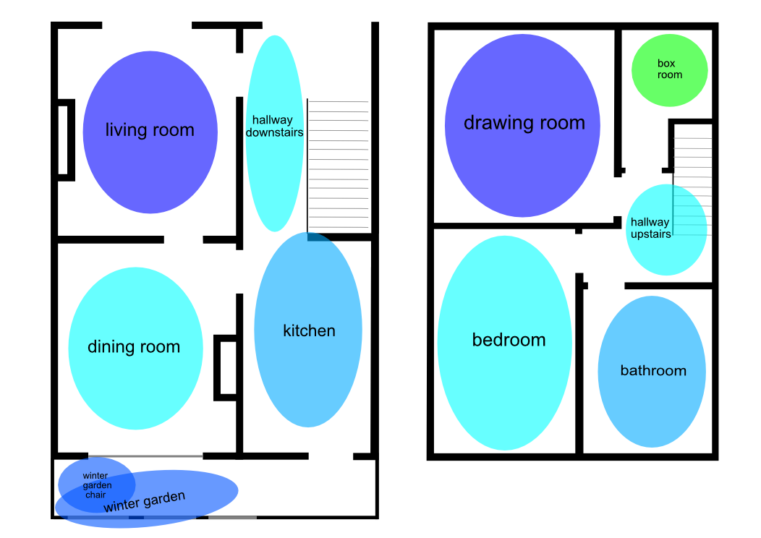
Figure 32: Heatmap 1
Figure 32 shows a heatmap of presence in the home during one day from 21.00 to 22.00.

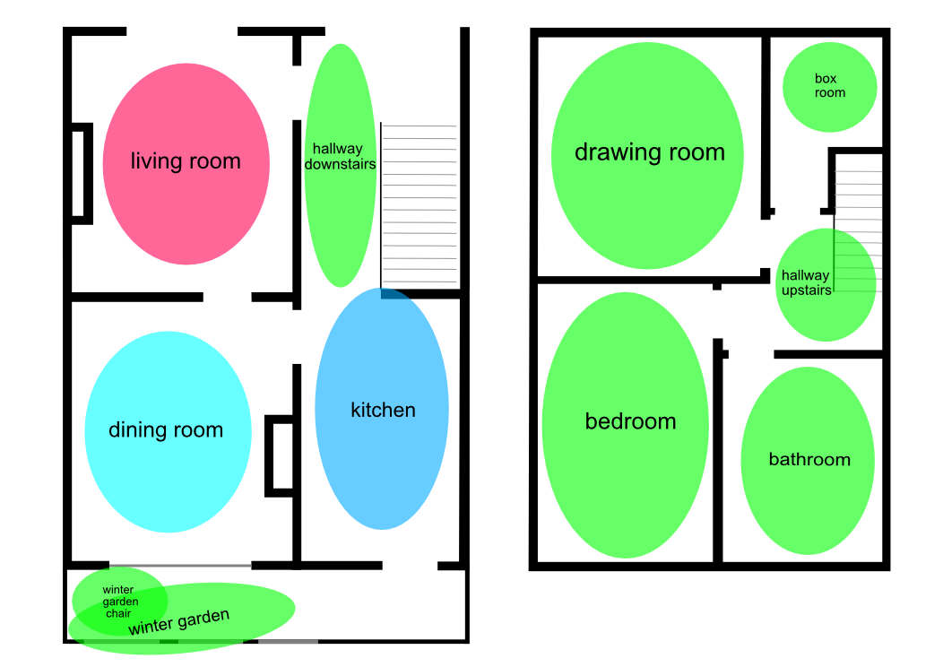
Figure 33: Heatmap 2

Figure 33 shows a heatmap of presence in the home during one day from 00.00 to 01.00.
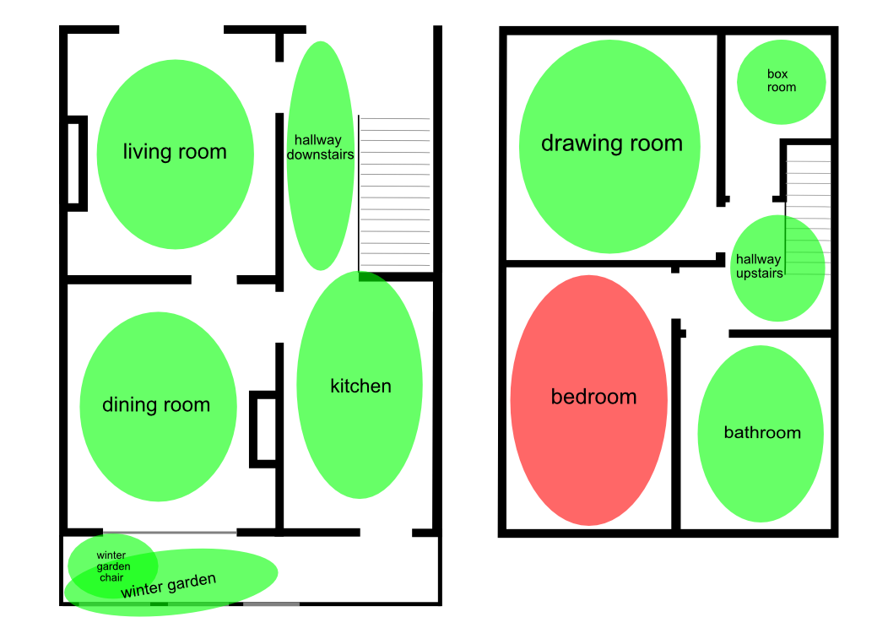
Figure 34: Heatmap 3
Figure 34 illustrates a heatmap of presence in the home during one day from 8.00 to 09.00.

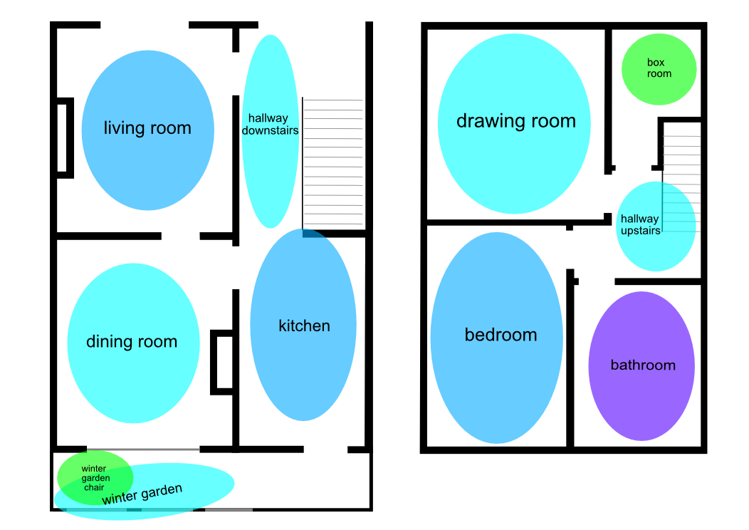
Figure 35: Heatmap 4

Fast Forward Animation
While heatmaps show a percentage value over a period of time, the fast forward animation provides a snapshot of the occupation at a specific moment in time. A fast forward animation allows for example to visualize the occupation during a whole day or week by visualizing every minute in one second. The parameters such as the start time, end time, step size in time (e.g. 1 minute), and speed of the animation can be easily configured in the web interface.
The following examples show snapshots of different time of day. Red indicates that the location was occupied at the time shown.
Figure 35 gives a snapshot of presence in the home during one day at 00.04.

Figure 36: Snapshot 1
Figure 36 of presence in the home during one day at 07:47.
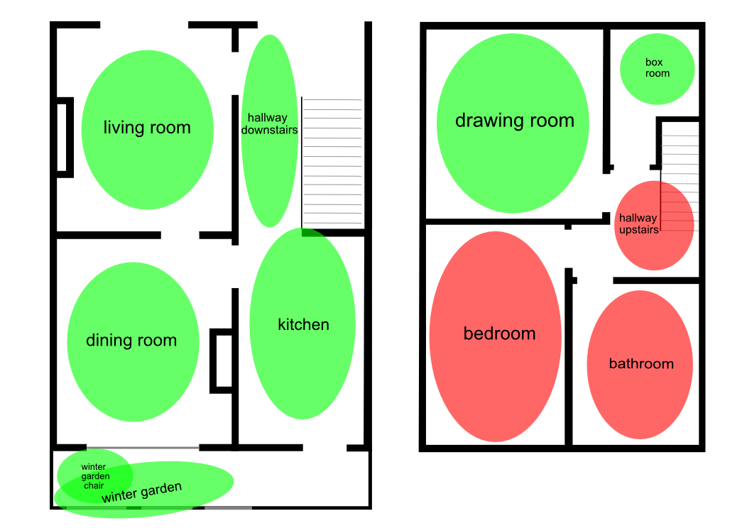
Figure 37: Snapshot 2
Figure 37 shows a snapshot of presence in the home during one day at 09:20. The elderly person is moving downstairs.
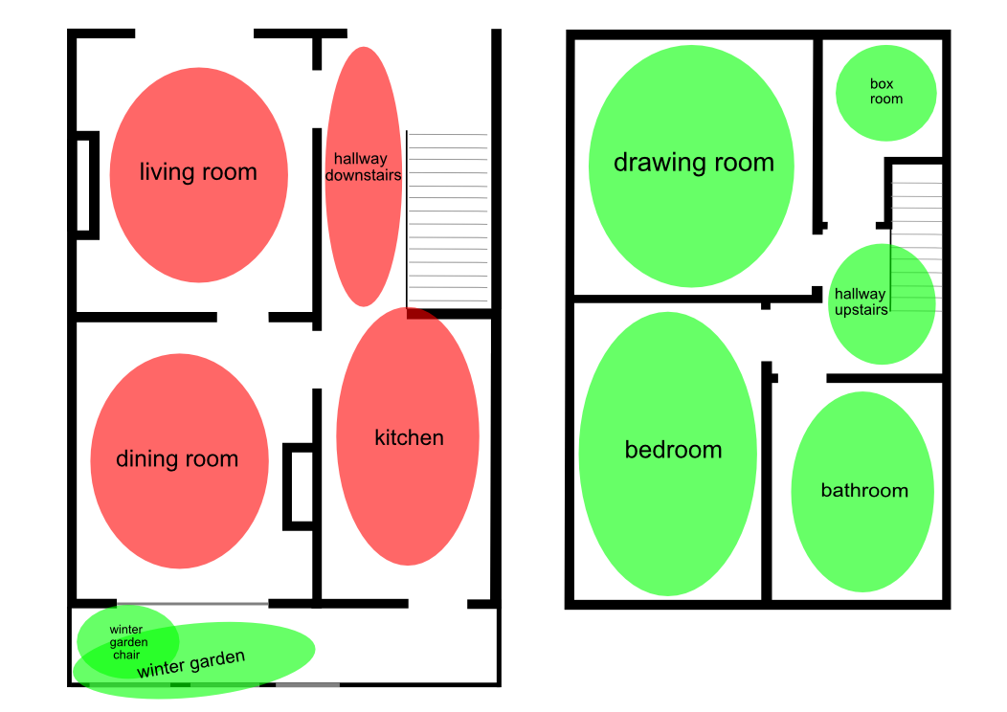
Figure 38: Snapshot 3
Figure 38 gives a snapshot of presence in the home during one day at 21.30.
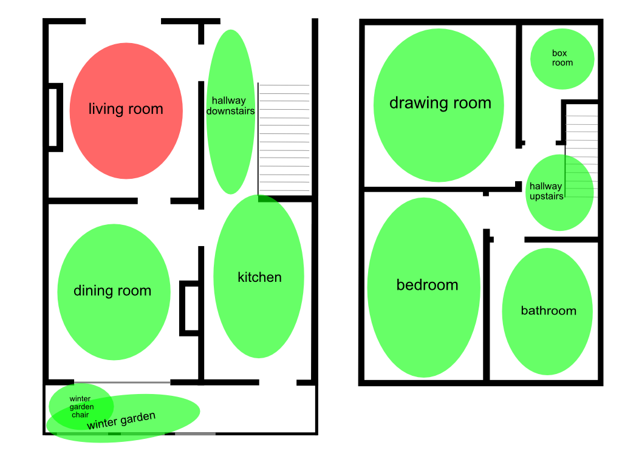
Figure 39: Snapshot 4

Conclusion

The Task 4.2 is prior to the SONOPA system pilot phase and it enabled to set up the different SONOPA system modules in two installations. These successful installations under the task 4.2 were running until the end of March 2015. However, the participants agreed at the both sites (Belgium and the UK) to take part in the SONOPA pilot phase, which means that these installations will be maintained and that the user experiences will be analyzed a part of the SONOPA pilot sites.

The essential results of this task are the data sets that enable to create the algorithms for the SONOPA system. The consortium gives an important attention to the privacy issues related to the collected end-user data. As a result, examples of the SONOPA ADL data sets can be obtained for research purposes upon a requested and with signing the SONOPA confidentiality agreement.

The visualization tools of the gathered sample data are firstly used by the project researchers for the SONOPA system development but those also enable to design how the relevant gathered user data could be displayed for the system users.

Annexes

Annex 1: Example of the Informed Consent in England
The informed consent was also translated in Dutch for the participant in Belgium.

PARTICIPANT’S INFORMED CONSENT

Partner responsible for  the installation | Docobo
Address | Old Granary, 21 High Street, Bookham, SRY KT23 4AA,  England
Phone | +44 (0) 1372459866
Project name | SONOPA (AAL-2012-5‐187)
SONOPA Representative | Richard Plumbridge (the project coordinator)

I the undersigned,

………………………………………………………………………………………………
(SURNAME, FIRST NAME)
living at

………………………………………………………………………………………………..
(ADDRESS)

accept freely and voluntarily to participate in the “Activities of Daily Living (ADL)” dataset collection phase of the SONOPA project. I certify that I have been informed about the SONOPA project and that I have received all necessary information regarding my involvement in this phase. Furthermore, I confirm that I have had an opportunity to ask questions about the details of my involvement in the interview and other aspects of the SONOPA project.

I understand that my participation is voluntary and I can withdraw from the ADL data collection period at any time and without delay.

I have been informed that all personal information acquired during the project will be kept in secured archives. This information can only be used for project related and scientific purposes. Furthermore, the results of the research will be published only in aggregated terms, and all information will be made anonymous if used for scientific or project related purposes.

As a result, I authorize SONOPA project partners to process my personal information (i.e. gender, residence type, living situation, age, education, employment status, former occupation) to be used exclusively for research purposes in the framework of the SONOPA project.
□ YES □ NO

I authorize the SONOPA project partners to come and install the test sensors at my home, in the preselected rooms and spaces, as well as to record the sensor data captivated in my home environment during my participation in this project phase:
□ YES □ NO

I authorize the SONOPA project partners to take and use photographs as well as video- and/or audio-recordings during my participation in the project:
□ YES □ NO

I authorize the use of this audiovisual material during conferences and scientific publications exclusively related to the SONOPA project.
□ YES □ NO

I authorize the use of this audiovisual material for PR and marketing activities strictly related to SONOPA project (e.g. the content of the website).
□ YES □ NO

In respect of the European Personal Data Protection Directive (95/46/EC), I understand that I have the right, now and at any time in the future, to oversee, correct and delete information relating to my personal information.

By signing this document, I give my informed consent for participating in the SONOPA project.

Organisation Name  (SONOPA Representative will sign) |  | Participant  [ID number:………………………………………...........]
Date and Place: …………………………………………  Signature |  | Date and Place …………………………………………..  Signature
Name: …………………………………………………..  Position: ………………………………………………...... |  | Name: ………………………………………………………

This document is to be made in two original copies, the first of which must be kept by the investigator, and the other given to the person giving consent.

Annex 2: Participant information Form in England
This document was also translated and adapted in Dutch for the participant in Belgium.

Participants’ information document

I. Information about the organisation
Project title | SONOPA (2012-5-187)
Name of the organisation: | Docobo
Address: | Old Granary, 21 High Street, Bookham, SRY KT23 4AA,  England
Name of the test administrator (to be contacted for all questions etc.) | Richard Plumbridge
Telephone number: | +44 (0) 1372459866

II. SONOPA project abstract

SOcial Networks for Older adults to Promote an Active life (SONOPA) is a research project that receives funding from the European Union. The main objective of the project is to promote healthy and active lifestyles to senior citizens throughout Europe.
The purpose of SONOPA is to develop an easy-to-use social network application that promotes and encourages social interaction such as service exchanges or leisure activities. Our aim is to preserve SONOPA users’ level of activity and independency through interactions, with their neighbours, friends and families as well as through personalised recommendations through interactive wall displays.
This way the SONOPA users will be empowered to enjoy an active and autonomous lifestyle in their own home as well as preserve their general wellbeing.

III. Description of end-user involvement
- General Methodology
In order to develop a product that meets the users’ needs, we need constant feedback. By involving users throughout the project we will get insights into their needs, expectations and feelings about the SONOPA technology as well as identify potential improvements or opportunities to enhance the SONOPA system.
Methods to be used in order to capture the users’ perspectives at this stage of your involvement are:
- Interviews and diaries: questions related to the SONOPA technology are discussed in-depth during a face-to-face meeting and you daily activities are recorded in diaries (so that all the collected data can be correctly checked).
- Trials: includes the testing of the device in realistic conditions. The trials will cover two separate pilot phases; during the first phase (Pilot 1), different sensors are installed in the participants’ home in order to create an activity profile. This will enable the researchers to develop the system according to the users’ needs.
During the second phase (Pilot 2), the functionalities of the system will be evaluated. This will take place in the participant’s home environment. The subjects will be asked to use the SONOPA technology for a defined period and based on their experience evaluate different aspects with regard to its functionality.
During the second pilot, the users will be asked to complete a questionnaire and provide feedback on different devices such as a tablet or smart phone. Before the pilots, a short training workshop will be organized in order to make the participants feel comfortable (and to ensure trial uniformity).
- Time requirement
The project phases involving end-users will be carried out during a period of 32 months (between September 2013 and April 2016). Each user will be invited to participate in all the phases of the project.
Trials: The first part (collection of ADL data sets) takes place between August 2014 and March 2015. You are invited to take part in this phase as a representative of the end-user group. The second field trial phase will be conducted between April 2015 and March 2016.

The specific time requirement for your ongoing involvement:
- Installation of the test sensors in your home environment: between the 4th and the 8th of August 2014.
- Test sensors collect your activity data in your home environment: between the 9th and the 31st of March 2015.

- What can be expected from you at this stage
You have been informed that the “Activities of Daily Living” ADL data collection phase aims at capturing and recording data about your activities and movements that you do in your daily living. This data is captured with four different sensors that are installed in the preselected spaces of your home on your agreement. These captured data will help the technological SONOPA partners to specify and refine the SONOPA system design.

You agree that the data of your daily activities, especially your movement in your home environment, can be recorded strictly for research and scientific purposes of the SONOPA project.

You agree that the following sensors are installed at your home in the preselected rooms and spaces:
- PIR sensors: 14 PIR-sensors are installed in all rooms, both on the ground floor and the first floor with the agreement of the test person
- Visual Sensors: 10 visual sensors were installed in the living room, the dining room, the kitchen and the hallway
- Visage Screen: one will be installed in the living room
Also, one server that records all data will be brought in your home environment.

You agree that a test facilitator from Docobo Ltd. comes to your home in the begging of the phase to install the different sensors, during the test at least once every two weeks to retrieve the captured data and in the end of the phase to uninstall all the sensors. The test facilitator will also be your support person who responds to all questions and gives technological help if needed.

You are expected to fill in four different diaries on a daily basis during the data capturing phase. These diaries, which the test facilitator will provide for you, are the following:
- Sleep diary
- Accident diary
- Visitors diary
- Dinner diary

You agree to participate in two short interviews during the testing phase. These interviews enable to analyze better your testing experience.

During the whole data collection phase:
- You are free to cease participation at any time, without delay.
- You should read and understand the informed consent form before signing it.
- You may ask questions at any time.
- You agree to take care of all test equipment that is loaned to you during the project.
- Recording issue
Your home activity data will be recorded. Please fill in the informed consent form before starting any activity related to SONOPA. Similarly, during field trails, audio and video recording may be used, with appropriate user consent.

IV. DATA PROTECTION
In respect of the European Personal Data Protection Directive (95/46/EC), the participant has the right to oversee, correct and delete information related to his/her personal data. The results of the research will be published only in aggregated terms, and all data will be made anonymous if used for scientific or project related reports. All processed data will be archived in a secure manner. This data will be used for scientific and project related purposes only. Furthermore, if another research project wished to deploy samples of the collected SONOPA data, they need to fill in and sing a sample data confidentiality form and respect its clauses. This confidentiality process is managed by the project coordinator.

Annex 3: Examples of the Diaries from England
- The diaries were updated according to the running month by the test administrators
- The diaries also translated in Dutch for the participant in Belgium.

Accident diary (e.g. falls,) week 33 + 34
Mo August, 11 | Tue August, 12 | Wed August, 13 | Thu August, 14 | Fri August, 15 | Sat August, 16 | Sun August, 17
Yes, at:  ___:___ o’clock  Accident type:  ______________  No □ | Yes, at:  ___:___ o’clock  Accident type:  ______________  No □ | Yes, at:  ___:___ o’clock  Accident type:  ______________  No □ | Yes, at:  ___:___ o’clock  Accident type:  ______________  No □ | Yes, at:  ___:___ o’clock  Accident type:  ______________  No □ | Yes, at:  ___:___ o’clock  Accident type:  ______________  No □ | Yes, at:  ___:___ o’clock  Accident type:  ______________  No □

Dinner diary week 33+34
Mo August, 11 | Tue August, 12 | Wed August, 13 | Thu August, 14 | Fri August, 15 | Sat August, 16 | Sun August, 17
I had dinner at:  ___:___ o’clock | I had dinner at:  ___:___ o’clock | I had dinner at:  ___:___ o’clock | I had dinner at:  ___:___ o’clock | I had dinner at:  ___:___ o’clock | I had dinner at:  ___:___ o’clock | I had dinner at:  ___:___ o’clock

Sleep diary week 33 + 34
Mo August, 11 | Tue August, 12 | Wed August, 13 | Thu August, 14 | Fri August, 15 | Sat August, 16 | Sun August, 17
I got up:  ___:___ o’clock  I slept at:  ___:___ o’clock | I got up:  ___:___ o’clock  I slept at:  ___:___ o’clock | I got up:  ___:___ o’clock  I slept at:  ___:___ o’clock | I got up:  ___:___ o’clock  I slept at:  ___:___ o’clock | I got up:  ___:___ o’clock  I slept at:  ___:___ o’clock | I got up:  ___:___ o’clock  I slept at:  ___:___ o’clock | I got up:  ___:___ o’clock  I slept at:  ___:___ o’clock

visitor diary week 33+34
Mo August, 11 | Tue August, 12 | Wed August, 13 | Thu August, 14 | Fri August, 15 | Sat August, 16 | Sun August, 17
I arrived at:  ___:___ o’clock  I left at:  ___:___ o’clock  Maggie left with me  yes / no | I arrived at:  ___:___ o’clock  I left at:  ___:___ o’clock  Maggie left with me  yes / no | I arrived at:  ___:___ o’clock  I left at:  ___:___ o’clock  Maggie left with me  yes / no | I arrived at:  ___:___ o’clock  I left at:  ___:___ o’clock  Maggie left with me  yes / no | I arrived at:  ___:___ o’clock  I left at:  ___:___ o’clock  Maggie left with me  yes / no | I arrived at:  ___:___ o’clock  I left at:  ___:___ o’clock  Maggie left with me  yes / no | I arrived at:  ___:___ o’clock  I left at:  ___:___ o’clock  Maggie left with me  yes / no

Annex 4: Confidentiality agreement for obtaining data sets
SONOPA Sample Data Confidentiality Agreement

Project Coordinator | Docobo LTD (the United Kingdom)
Project name | SONOPA (AAL-2012-5‐187)
Project website: | www.SONOPA.eu
SONOPA Representative | Richard Plumbridge  Phone: +44 (0)1372 459866  Mail: richard.plumbridge@docobo.co.uk
I, the undersigned, agree to the following:
- All provided SONOPA sample data is anonymous and in text format to preserve the individual’s privacy.
- In order to respect the data protection, all sample data provided by the SONOPA consortium shall be used strictly for scientific and research purposes. This data cannot be used in any type of commercial activity.
- Only I have the right to analyze and use this data. This data sample shall not be given to any second or third parties without written permission from the SONOPA consortium.
- I agree to communicate the purposes for requesting the SONOPA sample data so that the SONOPA consortium can verify that it complies with this agreement.
- I shall provide SONOPA with copies of any publications containing, or created from, this data, to be approved by SONOPA before publication.

- I shall acknowledge the project SONOPA in any/all publications containing, or created from this data.

- I shall acknowledge Ghent University/iMinds in any/all publications containing, or created from the visual sensor data.
- In addition any breach or suspected breach of the present confidentiality agreement shall be reported immediately. Any intentional violation of this agreement shall be the basis for the termination of this agreement.

Information about the Sample Data Request
Name
Institution
Address
Purpose of the sample data analysis (project name and goal)
Contact | Phone number:  e-mail:

_____________________________(Signature of the person that requests the data)

__/____________(Date, Place)

_____________________________(Signature of the SONOPA project coordinator)

_/_____________(Date, Place)

This document is to be signed in two copies: one is for the SONOPA consortium record and the other one for person requesting the data.

